
How Celestials are helping humanity prepare for Extraterrestrial Contact and World Peace: An Exopolitics Perspective

Panel Presentation
Call for World Peace from The Universal Brotherhood
Istanbul Turkey
November 1st, 2011.

Michael E. Salla, M.A., Ph.D.

Abstract

Celestials are defined as beings able to move through space-time without any kind of physical technology. The have attained high states of “unity consciousness” and have been witnessed together with service-to-other or ethically evolved extraterrestrial races. This paper gives a number of examples of celestials using a typology of civilizational evolution first developed by the Soviet Astronomer Nikoli Kardashev in 1964, and later popularized by Michio Kaku. Celestials are argued to belong to a Type IV civilization that can tap into an unseen universal energy grid, and are best described as a universal brotherhood.
Presentation
It’s an honor to present my research to a conference dedicated to World Peace and recognizing that humanity is not alone, and is being helped by an unseen universal brotherhood. So thank you to the conference organizers for inviting me to speak, and opportunity to share my research on the contribution of exopolitics to World Peace.

It’s always pleasant to speak at conferences such as this because you can share insights about what it is you are seeing and feeling around you. What I’m seeing is something to be really excited about. There’s a fundamental transition that we are about to witness in slow motion. The transition is “reconnection” - reconnection with the Universe. We have been living for thousands of years as a pretty isolated planetary culture. We really have been very insular – look at the history books. What do the history books write about? Go back to the ancient Greeks, the ancient Persians, the Romans, the Ottoman Empire, the Chinese and so forth. History is very limited to the recorded events of a select number of civilizations on this planet. Our history is much richer, however, much older, and it is Cosmic! It’s Galactic! It goes beyond the planet. It’s been hidden from us for a long time.

This is why it’s so exciting because I am witnessing changes in slow motion. Like many of the audience, we want things to change quickly. We only have 30, 40 or 50 years, or so to really contribute to life around us with our ideas and energy. We want things to happen quickly, and we want it to happen in that period when we can see them. The changes I’m speaking about are going to happen within the next few years. Within the next decade, I am very confident that we will transition from an isolated planetary culture into a galactic culture. What I’m going to give you today is really a kind of a snapshot into what lies ahead. It’s really exciting, and something to look forward to because we’ve got a lot of friends out there in the galaxy.

We have a lot of friends, but we’ve forgotten them. We don’t know who they are so in a way I hope that I can reintroduce some of you to our galactic friends. Those that have been helping us from the sidelines, and supporting us as we move forward in a very dark period in our collective consciousness. This is an experience for humanity where we have chosen to experience a dark night of the soul – collectively! With any dark night, however, it ends eventually. We are now going to experience a wonderful awakening which involves reconnection with our Galactic family. So that’s what I’m going to be doing.

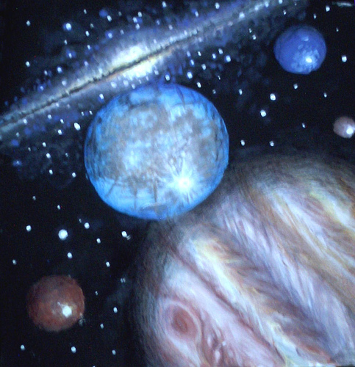
I want to begin with the question of “what would extraterrestrial life be like?”. There are many approaches to answering this question, but the one that has become most popular with scientists was first proposed in 1964 by a Russian astronomer, Nikolai Kardashev. Kardashev wanted to develop a scientific way of categorizing extraterrestrial life. So he came up with a way of categorizing extraterrestrials on how well they use energy around them.

So Kardashev argues that they evolve based on the ability to use energy at different macroscopic levels, so now I’ll explain what that means.

A Type 0 Civilization is like the Earth where we use energy in a very limited way. We use fossil fuels such as oil, coal and gas, and other limited energy sources such as Uranium. These are limited resources found around the planet that we use for energy consumption and they are non-renewable. Competition over the control of these energy sources has led to many wars and misery on our planet. The dangers of nuclear energy have even threatened our planetary survival.

A Type I civilization is able to use energy at a planetary level. It’s able to tap into the energy of the ocean, or of the Earth’s core, or volcanic/seismic activity. A Type I civilization can even tap into the energy grid of our planet. Our planet has an electrical energy grid as discovered by pioneers such as Nikola Tesla. There are also other ways in which energy even more subtle flows around the planet. All of these are renewable energy sources which makes them very different to the limited energy sources used by Type 0 civilizations. A Type I civilization can tap into these planetary energy sources without ever exhausting them, and use them for many purposes.

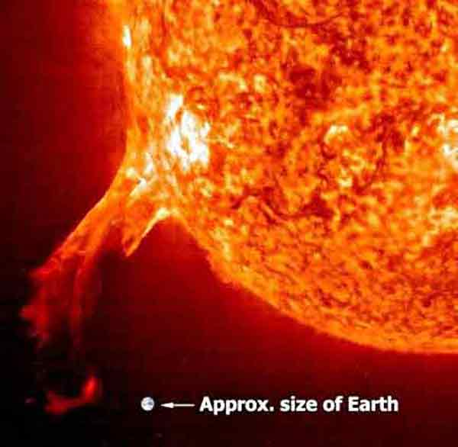
Type II civilizations can efficiently use energy from an entire sun. The sun is constantly emitting energy. We know that. We see the light, we feel the warmth. It’s not just the warmth and the light. The sun is constantly emitting enormous amounts of plasma energy in all directions – 24 hours a day, seven days a week. It never rests. Some of the solar flares, Coronal Mass Ejections coming from the sun are incredible in size. [Powerpoint Graphic] This is the size of the Earth in relation to the Sun which we know is big. Look at the size of one of these Coronal Mass Ejections – it’s huge compared to the Earth. If one of those ever hit the Earth directly we’d be in big trouble. So Type II civilizations can harness the energy of a sun like that.

Now we get to Type III civilizations. For many we are getting into the realm of science fiction – they can use energy from the Galactic Core, and deal with galactic wide energies such as Galactic Superwaves. Just as our sun is constantly emitting plasma energy that goes out filling our solar system – just as a Type II civilization can use that energy – a Type III civilization can utilize energy emitted from the galactic core – galactic superwaves going in all directions.

Also, type III civilizations can create or manipulate black holes. One of the things about the creation of black holes was that Carl Sagan when he wrote his book, Contact, he asked a very famous astrophysicist by the name of Kip Thorne to see if it was possible for a wormhole to be created through a black hole. And found that yes, it was possible provided that there was something that could keep a black hole open. He called it exotic matter. It was theoretically possible but our science was very far from being able to do anything like that. In contrast, this would be possible for a Type III civilization.

Type III civilizations can also move or engineer entire solar systems, and even create a galactic GPS using pulsars. Pulsars are like galactic beacons. They have a frequency that is pretty constant so you could navigate the galaxy by pulsars. So Type III civilizations can tap into and use Galactic wide energy.

That’s where Nikoli Kardashev stopped in his typology because it was enough for scientists to wrap their minds around these kinds of advanced extraterrestrial civilizations. A civilization that could use the energy of an entire galaxy, there wouldn’t be a need to think about anything more evolved than that. But of course it would evolve. Life evolves. If life evolves from Type 0 to Type I, and from Type I to Type II, and Type II to Type III wouldn’t it evolve from Type III to Type IV? Of course, but what would a Type IV civilization be like?

A Type IV civilization would be able to tap into energy at a universal level. Not just the galactic core or the energy of an entire galaxy but something that is truly extra-galactic or universal in scope. As you can tap into energy at a universal level, your consciousness would evolve, naturally! So you have reached the point where your civilization’s collective consciousness would be very familiar with and can easily tap into universal energy. It would be very obvious for a civilization at that level, because that’s what they are tapped into.

Just as our planetary consciousness is really focused on fossil fuels, oil, coal, etc. Think about it. Our entire culture is fixated on it. We ask what happens when oil prices skyrocket, what happens when the oil runs out? Our whole culture is fixated on that limited energy resource because the way we use energy as a civilization is what is going to have a very large impact on our consciousness. Similarly for a Type I civilization, they use energy at a planetary level so their consciousnesses evolves on this basis. The same happens as civilizations go through the different levels.

So if we are talking about a Type IV civilization that uses energy at a universal level, their ethics, philosophies and spirituality is going to be focused on universal consciousness, or a universal force or a universal energy. Once you have developed consciousness to that degree that you can tap into and link with the universe itself, you would be able to do incredible things compared to what we are familiar with. So are there examples of this? There are examples in our science fiction literature.

What I’m going to do is give you a snapshot of what we were exposed to in the Star Wars movies. When I saw Star Wars for the first time, I was elated. I was so happy with Star Wars because for the first time it talked about something universal. It talked about “the Force” – it was great. Thank God they’ve finally begun talking about something universal that goes beyond technology, beyond what we can utilize for our technologies. That is beyond anything that our culture is identifying with. That is something that I’m sure many millions, like me, celebrated. All of a sudden it was like new idea entering into our collective consciousness. Now we can talk about the Force, something truly universal.


Star Wars when it first came out, it was an example of how you can train to use this Force, trap into this universal energy that pervades all life. And the Star Wars series has been one of the very few Sci Fi movies, series or franchises that has talked about this universal energy field that we can learn to tap into with our consciousness. It was something that broke new ground, and I think is part of the reason why it’s such a big favorite for so many of us who can watch it again and again; because it reminds us that yes, we have that ability! We can do that! We can tap into this universal force. We know how to do it! Sure, we’ve forgotten how to do it, maybe our society doesn’t encourage it, but we know deep down inside that we know we can do it. That’s why Star Wars was something that was pioneering.

Other sources of literature also talk about ways of tapping into this universal energy field, here we have examples of that in terms of what would a civilization be like. How would it be structured? If you have a Type IV civilization that is able to tap into this universal energy grid, or this field, what would it be like? Would it take on the parameters of a civilization that we are familiar with? We have another version of what a civilization like that would be like.

The Keys of Enoch is a book written by Dr JJ Hurtak. It came out in the 1970s, and he talked about various levels of universal spiritual orders that comprise celestials. The celestials are beings similar to the Jedi Knights in Star Wars that are able to use energy at a universal level and possess a kind of cosmic consciousness. So Hurtak was talking about these orders, these brotherhoods that exist throughout all planetary systems, throughout all galaxies. Civilizations, in this model, evolve and reach a point that they now become members of a brotherhood or sisterhood that expands throughout the universe. They comprise beings with a Type IV consciousness where they can tap into the universal energy grid.
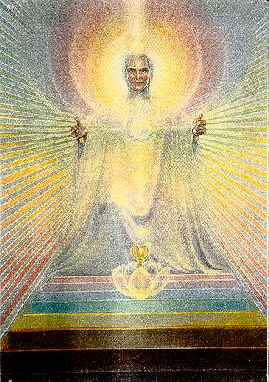
One of the orders is the universal Order of Melchizadek. It’s interesting that the Old Testament refers to the Order of Melchizadek in Psalms 110. Melchizadek (depicted at right) is someone of major mportance since he was the father of Enoch, a very old pre-diluvial figure in the Hebrew scripture.

What I would like to do is talk a bit about celestials, and who these beings are that have this universal consciousness. How do they operate? What are they like? A really good introduction to celestials is a series of books by Baird Spalding, called Masters of the Far East. He described how 11 scientists traveled to the Himalayas in the early 20th century. Along the way they were helped by a group of beings that were basically Ascended Masters. These Ascended Masters had all of the abilities seen in the Star Wars movies. But these Ascended Masters had these abilities fully developed. They could levitate; they could bilocate; telepathy was something they could do very easily; telekinesis – they could raise objects easily. Within the Masters of the Far East series you read story after story of how these Ascended Masters helped that scientific mission. The mission was there for a number of years, and these celestials or Ascended Masters ensured that Baird Spalding’s expedition could be introduced to the philosophies, to the sacred wisdom of the Far East. Spalding was certainly incredibly impressed about that and wrote his series of six books about what happened there. The interesting thing about the Ascended Masters was that they described themselves as part of a vast brotherhood, that wasn’t just on the Earth, but beyond as well. Again you have that idea of a universal brotherhood.

This is something that Helena “Madam” Blavatsky talked about in terms of the Great White Brotherhood. She was the first to describe them as this association of Spiritual Adepts. They could do things through the power of consciousness alone – move through space-time, manipulate matter, incredible powers of telekinesis, bilocation, all of those psychic abilities. These Ascended Masters had these abilities to a very high level. She went into great depth into the Masters. I give this as an example of a civilization – it’s probably more appropriate to call them a brotherhood. That’s why they are called the Great White Brotherhood. There are other terms used such as the Brotherhood of Light.

These are beings who through spiritual development, spiritual discipline, have been able to rise beyond the limitations of the body, thinking of the mind, to truly embrace and connect with a universal energy field so the power of their mind and intent was so focused that they could instantly do things. If we look at ourselves, we have very great difficulty in silencing and focusing our minds – even for ten seconds. Yet the Great White Brotherhood, or beings that have been able to go through the spiritual discipline and practices, have been able to train themselves to do that. We know it can be done. There are many examples of those that have been able to discipline their mind to do these incredible things. So we know it can be done, it’s just a matter of disciplining yourself so you go through or rise beyond the point of where you are thinking about silence, to where you actually begin to be silent. That’s where the power really comes in.

One of the quotes that I want to mention was by Charles Leadbeater a theosophist from the early 20th century. He said:

The Great White Brotherhood also includes members of the Heavenly Host (the Spiritual Hierarchy directly concerned with the evolution of our world), Beneficent Members from other planets that are interested in our welfare, as well as certain unascended chelas.

So Leadbeater was basically putting in a very concise way what the Theosophical Society believed. The Ascended Masters, the Great White Brotherhood, The Brotherhood of Light, wasn’t just limited to the Earth. This was a Universal Brotherhood of celestial beings.

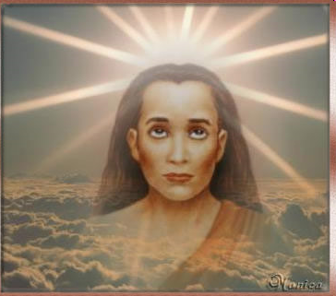
An example of an Ascended Master is from India - Babaji. He was described at length by Paramahmsa Yogananda who write that very influential autobiography, Autobiography of a Yogi. I remember reading that about four times. It’s one of those classics that you read again and again. It’s like being in a desert and you find this Oasis and you think you got to drink deeply because there’s a lot of desert to walk over. Yogandanda talked a lot about Ascended Masters and the beings in his particular spiritual order, Kriya Yoga. So Babaji was described as living for thousands of years in the Himalayas, and maintains a youthful appearance. That’s something that’s pretty important. These ascended Masters are not necessarily long bearded men with gray hair but maintain a youthful appearance for a long time. Personally I think that’s important to keep in mind as we move into these possibilities of a greater connection with the Galaxy and the Universe. Even the aging process is not an iron law of the universe. Babaji and other ascended masters illustrate that.

So, to summarize so far. Celestials are highly developed ethical beings that have been described in the literature in many different ways, as Angels, Ascended Masters, Elohim, etc. The important thing is that they share that one characteristic, that they can tap into to the universal energy grid and work with that energy in developing high states of cosmic consciousness, and manifest things in their lives and around them for the benefit of society.

Now we get to the question of what’s the difference between celestials and extraterrestrial life? I began to talk earlier about extraterrestrial life and the growing scientific interest them. So what’s the difference with celestials? Well, celestials travel through the universe using the power of consciousness alone, and they are not confined to any one physical location. They don’t need technology to move. An Ascended Master, one of these celestials, can move instantaneously just by using the power of consciousness. That distinguishes them from these different extraterrestrial civilizations that I spoke about earlier, Type I, Type II etc., that really need technology to be able to move through space and time.

Celestials have attained that advanced state of consciousness – oneness with the universe – and they don’t identify themselves with one particular place in space-time. So if you think about it, because we are a Type 0 Civilization we identify ourselves primarily as American, Australian, Italian, Turkish, etc. For Type I civilizations it would be a planetary system, from a planet in the Pleiades, or Sirius star systems, and so forth. These Type IV civilizations would identify themselves with the Universe, they don’t identify themselves with any particular place in space and time.

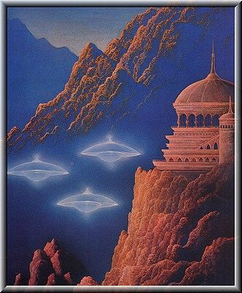
The interesting thing about literature dealing with extraterrestrial life is that extraterrestrials are often seen in the presence of Masters of Wisdom, Ascended Masters, celestials, whatever you call them. Also, the extraterrestrials regard the celestials as teachers, as mentors. That’s really fascinating. Something we need to think about deeply. I expect that most in this audience would almost take it as self-evident that a being of higher consciousness would be revered by those with more highly developed technology. Most people, however, would ask why would any advanced civilization flying around the universe in starships, be impressed by someone wearing robes and living in a cave?

There are many contactee reports describing how celestials have been interacting and intervening in the modern era to encourage policy makers make better policy when it comes to things like nuclear weapons. There are examples of this.

The first contactee to report about celestial intervention is George Van Tassel back in the 1950s. Each year he organized major conventions at Giant Rock, California. The biggest one ever had 11,000 people, that was in the early 1960s.

Van Tassel said that the Ashtar Command is a fleet of extraterrestrial ships headed by this being Ashtar who works directly under celestials. The celestial that is referred to in the literature is Sananda. In the metaphysical literature, Sananda is referred to as a Christ-like being, and Ashtar is representing the executive branch of a Galactic legislature headed by this ascended hierarchy of masters. So that was very interesting.

It was in 1952 and this is what in fact happened. George van Tassel relayed information given to him by Ashtar to the US Air Force at Wright Patterson AFB just prior to the detonation of the very first Hydrogen bomb. Just before it happened, Ashtar advised George Van Tassel to send a message to the U.S. Air Force not to go ahead with this testing of Hydrogen bombs, and instead seek peaceful cooperation at an international level. All this happened around the time of the 1952 Washington flyover which was a demonstration of force by the Ashtar Command. This is something the Ashtar Command was involved in.
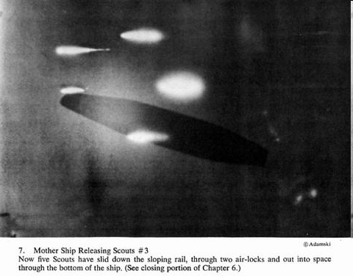
Another contactee who gives even more insight into celestial intervention is George Adamski who was first known for photographing spectacular extraterrestrial motherships and their scoutcraft. So you have there [on left] a mothership, and these are the scoutcraft coming out of the mothership. He took these back in the early 1950s.
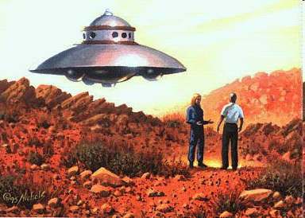
That’s George Adamski [on left] having a meeting with Orthon, an extraterrestrial that came out of a scout ship, one of the smaller ships that came out of the larger mothership. That was back in Nov 20, 1952. The date’s important because this was only a few weeks after the testing of the first Hydrogen bomb. The intervention of the extraterrestrials we see that entering a new phase once we have the development of Hydrogen bombs. He described being taken into one of the motherships and meeting one of these masters.

Adamski was sitting at the table with the extraterrestrials on board of their ship when he met one of their masters of wisdom. This is what Adamski said:

Now as we sat around the table, all eyes turned to the older space man as he began to speak. Although it was only later that his stature on all planets was explained to me, it was impossible not to realize that I was in the presence of a greatly evolved being, and the attitude of all present clearly indicated that they, as well as I, felt very humble before him. I learned that his age, in his present body, was close to one thousand years

So not only was Adamski impressed by this being, this Master of Wisdom, the extraterrestrials also revered him. It was beyond just one planetary culture that he was revered, but he was revered by many planetary systems. So again that’s an example of this kind of universal brotherhood that spans the Galaxy.

The celestial warned Adamski of the dangers of nuclear weapons, and this is what he said:

Our main purpose in coming to you at this time is to warn you of the grave danger which threatens men of Earth today. Knowing more than any amongst you yet realize, we feel it our duty to enlighten you if we can. Your people may accept the knowledge we hope to give them through you and through others, or they can turn deaf ears and destroy themselves. The choice is with the Earth’s inhabitants. We cannot dictate.

This is a warning about the dangers of these nuclear weapons, and about the policies we are following as a planetary culture.

Another example is Enrique Rincon from Colombia who was taken by Pleiadian extraterrestrials to meet with a group of 24 contactees in a remote location in the Andes. So here you have 24 other people having experiences with extraterrestrials who were taken to the Andes for training. A kind of ambassadorial training to prepare humanity for the truth of extraterrestrial life.

This is what Rincon said at the end of the training, a culmination of the three days he was up there. He and the other contactees were taken to meet with a Master of Wisdom or celestial.

The instructor [an ET] approached the entrance to a tunnel carved in the living rock and clasped his hands twice. He retired to one side, and the most incredible Being made his appearance. We were astonished beyond description. That being looked exactly like Jesus, the Master. I thought immediately that the Pleiadians had brought us here with the purpose of meeting Jesus Christ, who was here again, fulfilling the prophecies…

So this is an example of Pleiadian extraterrestrials with advanced technologies taking someone who they recognized as having potential to embrace their message for the benefit of humanity, to a remote location in the Andes where he meets with someone who lives in a cave. Importantly, extraterrestrials also revered this cave dweller.

The Master of Wisdom then dispelled Rincon’s belief that he was Jesus Christ.

I am not who you believe I am. My name is a thousand names, give me any, and That I Am. I am ancient before you, not in age, but in knowledge… My name is Age, for I am the Ages and the Time. I am Wisdom, and my name is Wisdom. I hold thirty five percent of universal wisdom.”
That last statement that he said, “I hold thirty five percent of universal wisdom,” is pretty important. If you have a society or culture that learns how to tap into the galaxy, or beyond the galaxy into the universe, then what you would value is the ability of those that have learned to be able to access universal energies to be able to channel that creatively for constructive purposes. You would probably develop a way to measure a person’s ability to tap into universal energy.

This being, was incredible. The Pleiadians recognized and revered this person. For Rincon, this magnificient being was Jesus. This being said, however, “I hold thirty five percent of universal wisdom.” So he is actually saying “as exalted as I may appear before you, I am not that really high up in the universal order of things.”

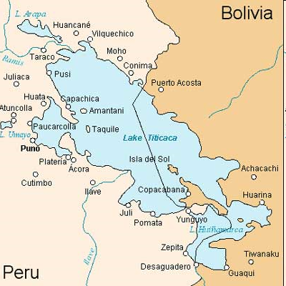
Another contactee example is Luis Fernando from Bolivia. He met with extraterrestrials from the Confederation of Planets and they had established a base underneath Lake Titicaca, Bolivia. [Pointing to picture on left] So there’s Bolivia, there’s Peru and there’s Lake Titicaca. The border between the two countries is there. Notice the Island of the Sun, and a number of small islands throughout Lake Titicaca. I mention those a little bit later. It’s important to remember that this is a vast lake at 13,000 feet in the Andes, and you have islands there.

Luis Fernando was taken to Venus. This is what he said happened to him:

“After three years of preparation, I was in the middle of the Andes. They told me that at eight o’clock at night a ship was going to come to a valley called "Valle Potosi". This ship was going to monitor the materialization of the door through which I would be able to get in touch with them, and through which I would arrive at a city not located on this planet, Earth, but on Venus in a valley known to them as … the Valley Of Silence. This is a place where there are concentrated the academy of the spiritual science of this civilization.”

He describes actually meeting with the Venusian Masters of this civilization. It’s important to point out that this civilization on Venus is not on the surface. He says it’s an interior civilization. It’s within and under the surface of Venus.

Luis did a recreation, an animation of what happened to him.

[Translation of Luis in video clip] This is a way to concentrate solar energy and this is how the inhabitants of Venus receive solar energy, and forward it on to other places. There is vegetation in this valley, and they live subterraneously. Not a dark cave, but it looks like the sky is within the cave itself. They manifest it when human beings reach this understanding they’ll take the reins in their own hands and change the future. Positive not only in itself, but for everyone else.

The important thing here is that again you had this example of this advanced technological civilization in the interior of Venus, an underground civilization. Again you had these masters of Wisdom occupying leadership positions.

Luis also talked about how the Confederation of Planets communicated with him. The interesting thing was that he had these experiences. He was taken up and had this experience on Venus. He was meeting with extraterrestrials from Venus and at a certain point in time they said to him, “we want you to meet someone. We want to introduce you to someone. There’s this being who lives right where you are, very close. He is a Master of Wisdom, and a descendent of the ancient Tiahuanaco civilization that was itself a remnant of Atlantis. He is an Ascended Master and we want to introduce you to him.”

So that’s what the extraterrestrials did. They introduced him to this Ascended Master or Master of Wisdom from the pre-Incan Tiahuanaco civilization. The really important thing to recognize here is that you have an example of a contact experience where the extraterrestrial tells the contactee we want to introduce you to an Ascended Master or Master of Wisdom and he is indigenous to the Earth.

So here you have a couple of examples that I’ve given. First, with Enrique Rincon with the Andes where you had that Master of Wisdom that the Pleiadians introduced him and the other 24 contactees to. Second, you have Luis Fernando also being introduced to one living in this area, in this underground forgotten city under Lake Titicaca. That whole region in the Andes is filled with these underground caverns.

This is archetypally symbolic of what we have become as a society, as a civilization. We’ve forgotten about the Masters of Wisdom, we don’t care about them. We are interested as a culture in advanced technologies, and extraterrestrial civilizations. Now that’s wonderful since it is a mind opening and consciousness elevating experience. When however you do go down that path eventually these extraterrestrials gently tap you on the shoulder and say “hang on, you really need to get in touch with these beings because they’re really special.” So if the extraterrestrials are telling us that, how long do we have to wait for? Finally, Luis said that Lake Titicaca is interesting because there’s a Confederation of Planets base there, and there’s also this ancient city established by the remnants of this pre-Inca Tiahuanaco civilization.

In conclusion, celestials are here to help. Contactees work directly with extraterrestrial groups, and these extraterrestrials are working in tandem with these celestial beings, and helping humanity prepare for some of the challenges posed by contact. When contactees talk with celestials/Ascended Masters they learn that most intelligent civilizations in the universe are peaceful. They have a vast brotherhood and they recognize truth-tellers. They recognize the suitability of these Ascended Masters to be leaders of their worlds, of their cultures, their civilizations. No wonder then that you have the authorities scrambling really hard to suppress information like what George Van Tassel was talking about, about the Ashtar Command, the Vrillon message. Of course, the authorities don’t want us to know about that. They want us to know about a very different reality concerning extraterrestrial life. Our world is being thrust from a very insular shallow planetary civilization where we think it’s only us, to a civilization where we recognize there’s a much bigger reality happening out there.

So we are going through this great change and the scientific community is starting to come on board, thinking about the possibilities of extraterrestrial life. That’s a very good thing. More scientists are talking about what extraterrestrials are like, using the typology developed back in the 1960s by the Russian astronomer Kardashev.

Eventually as we understand the evolution of civilizations from Type 1 to Type III, in future people will begin appreciate that there are Type IV civilizations out there, and ask, what are they like? Maybe an example is these Ascended Masters, Masters of Wisdom, Great White Brotherhood, or celestials. It’s interesting that celestials are not only found throughout the galaxy, throughout the universe, but they are also here on our planet Earth. Sometimes we lose touch with that reality. We get focused on the possibility of life out there and forget about the incredibly evolved conscious beings that live on the Earth.
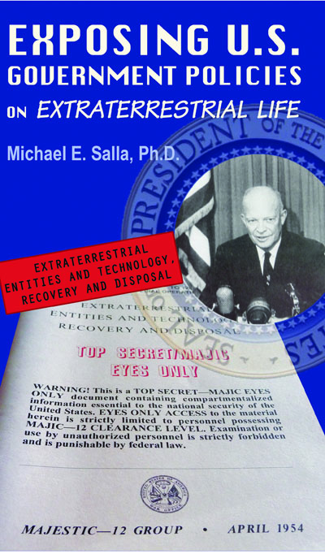
Celestials are here to help us rectify the imbalance between technology and consciousness. That’s one of the things I talk about in my book, Exposing U.S. Government Policies on Extraterrestrial Life. For more than sixty years the U.S. government has been secretly liaising and developing agreements with some extraterrestrial civilizations that are very far removed from this celestial universal consciousness that I’ve been focusing on for much of my presentation.

This is something that has been happening secretly and not been a good thing. So it’s really important to expose these policies, and this book does that. It’s important to expose because not even the elected governments or even appointed militaries of the United States and NATO countries such as Turkey has control over this any more. It’s become privatized in corporations. Exposing such policies is what I call in the book the primary “Challenge of Exopolitics.”

So what lies ahead? We will learn that the vast majority of extraterrestrial life is friendly and willing to assist in humanity’s evolution in positive ways, and helping us achieve world peace.

Celestials and more evolved extraterrestrials will assist humanity in transitioning from a Type 0 civilization reliant on fossil fuels into a Type 1 society using free and alternative energy sources. Along the way, exopolitics will help us develop transparency and wise response to the many different extraterrestrials wishing to provide us technology, and the wisdom of celestials. We are poised to become a galactic civilization where world peace and universal brotherhood become important markers of who we are to become. This is our future [two pictures below].

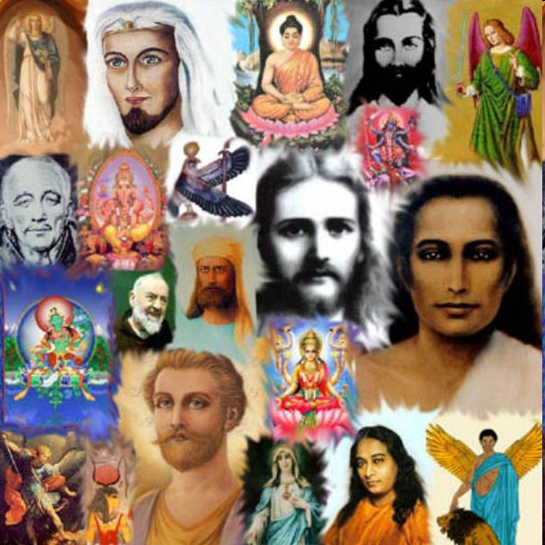 | 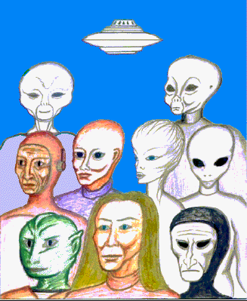

***

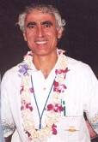
About the Author: Michael E. Salla, PhD., is the author of Exposing US Government Policies on Extraterrestrial Life (2009) and Exopolitics: Political Implications of the Extraterrestrial Presence (2004) He has held full time academic appointments at the Australian National University, and American University, Washington DC. He has a PhD in Government from the University of Queensland, Australia. He is the Founder of the Exopolitics Institute (www.exopoliticsinstitute.org ) and the popular internet website Exopolitics.Org; Chief Editor of the Exopolitics Journal, and Co-Organizer of the Earth Transformation: New Science, Consciousness and Cosmic Contact conferences in Kona, Hawaii. Main website: www.exopolitics.org

