

Transcending the Hall of Mirrors:
The Simultaneity of Discourse, the Third Space and Adopting Multiple Ways of Viewing the Construction of Human-Alien Identities

Natasha Acimovic, M.A., PGCE

Abstract

As new formations in human-alien interactions continue to emerge, new perceptual frameworks should be utilised for the purpose of widening our understanding of them, as well the impact upon the human condition. Furthermore, alongside new forms, existing research can additionally be re-examined to provide these new insights, and as a method for altering established preoccupations with particular themes that possibly occlude the emergence of others. The purpose of this paper is twofold: to provide a rationale as to why such frameworks should be adopted and to draw attention to some possible implications for Exopolitics, and then to outline the use of some theoretical models that can be usefully adapted. It will utilise the simultaneity of discourse, the Third Space and place and displacement to examine the experiencer narrative and then address some possible implications of this. The main aim of this is to outline core models as part of an on- going dynamic process in the analysis of human-alien interactions.

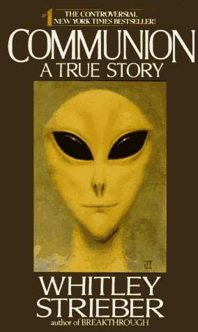
The illustration of a grey alien being on the cover of Whitley Strieber’s Communion (1987) has arguably become an iconic image in contemporary culture, and the proliferation of the alien abduction narrative within public consciousness is characterised by a familiar discourse. This typically includes such recognisable themes as being forcibly taken on board a craft by small beings with huge black eyes, and undergoing various medical procedures. The establishing of such commonalities by the pioneering work of early abduction researchers has provided invaluable insight into a complex and compelling phenomenon. Nevertheless, the drive to identify the reality of the experience has most likely led to a privileging of particular approaches and themes in the pursuit of validating what is authentic. This is evident in a recent publication of UFO Matrix magazine. The cover contains the heading ‘ALIEN ABDUCTIONS – FACT OR FANTASY?’ and Nigel Watson’s article entitled ‘The Reality of The Abduction Experience’. The treatment of the subject is also familiar. Although Watson acknowledges that there is no standard model for the abduction experience, he outlines what can be regarded as the typical features: missing time, paralysis, medical procedures, screen memories and human physical markings. Whitley Strieber also observes this issue while acknowledging the paradoxical nature of the dilemma. While discussing letters that the Communion Foundation had received, from those who described alien encounter experiences, he remarks:
‘We found that people were not reporting the scenario of abduction and manhandling that is so often referred to in the media and UFO publications. The script of being approached by odd little beings, taken aboard a UFO, and subjugated to bizarre medical intrusions appears to be rare. Far more commonly, people report interactions at a far higher level of strangeness. However, I do not want to belittle the work that has been done by those who feel that the abduction scenario is true...Suffice to say that it may be only one part of a spectrum of relationship so broad as to be presently difficult to fully classify.’

The uncomfortable question that we are faced with then is why has this occurred? Nonetheless, the inscription of these themes into the alien abduction narrative has undoubtedly shaped subsequent research. If the Newtonian/ Cartesian world view influences Western perceptual frameworks and is utilised in dominant models, such as psychology that views sleep paralysis to account for the alien abduction phenomenon, then the authorising of authentic themes and approaches runs the risk of structuring a sub-dominant order, whereby mimicking the practices of the dominant structures. It is what Homi K. Bhabha refers to as the ‘structure of symbolisation’, or what Basil Bernstein articulates as ‘the modalities of practice’, that need to be continually read anew and recontexualised to avoid the politics of ‘fixity’. This is of vital import if we are to allow new perspectives to surface.
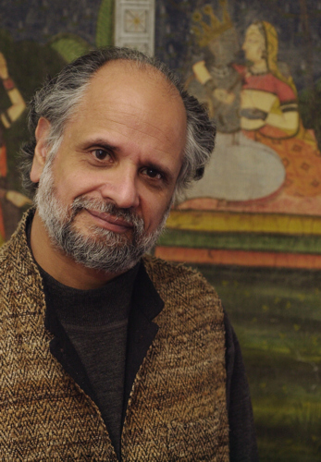
Homi K. Bhabha

My position is not to suggest that diverse accounts of human and extraterrestrial interaction are non-evident within current research or that the establishing of themes as a practice is problematic, but, rather, that it is the privileging of particular themes, or methods of analyses, that has the potential to create what Fredric Jameson describes as “strategies of containment” within the area as a whole. Consequently it is perhaps the visibility of particular themes, what we can term as the more fathomable, that is partially responsible for the paradox the Whitley Strieber delineates and ensures that the more complex or abstract themes are overlooked and or hidden from view.

A strategy for disrupting the process outlined above is to find new and (or) multiple ways of viewing human-alien interaction by drawing upon diverse disciplines to inform alternative perspectives. The intention should not be to supplant current methods of inquiry or interpretations with alternative models, but rather to adopt new perceptual frameworks that add to the Exopolitical initiative. Exopolitics, with its integration of diverse disciplines, inhabits a unique space. To ensure that it continues to remain a multi-faceted framework, well equipped to address the ET issue, it should seek to mobilise new theoretical models for two very important reasons: firstly to attract wider public interest in an attempt to raise awareness and mobilise political action, and secondly to deepen our understanding of the extra terrestrial hypothesis (ETH).

Like Exopolitics, literature is informed by complex socio-historical conditions. Some of the theories typically used in the analysis of literary texts and (or) culture, can be usefully adapted for the analysis of the abduction/contactee phenomenon as a necessary approach to understanding the ETH. Considering that experiencers’ narratives are communicated to society via oral and written narrative forms then literary theory is appropriately situated (and as valid an approach as any other) to provide a close textual analysis of their accounts. Furthermore, I aim to demonstrate that in doing so useful insights are revealed. However, it is firstly necessary to provide a summary of some of the key theoretical models that will be utilised. I will then outline how these can be adapted and transposed as frameworks for alien encounter narratives, and then apply these models to show how critical insights come into view.

The Simultaneity of Discourse

A useful framework that can be adapted from Post-structuralist theory is the ‘simultaneity of discourse’; a model proposed by Mae Gwendolyn Henderson. Firstly however, a brief definition will be provided for the use of the term ‘Other’.

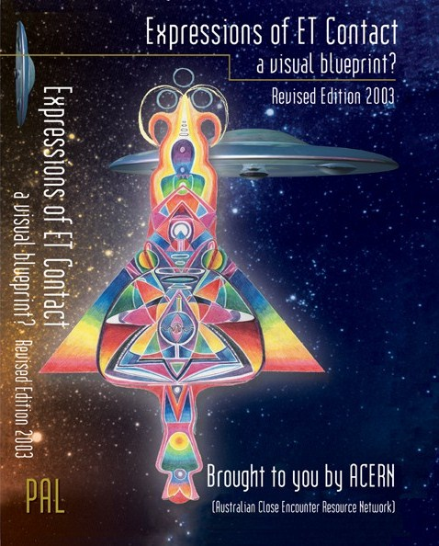
The notion of the ‘Other’ is used to indicate a person or group that is different to one’s self. How we define the other is a result of how we define ourselves, since these constructs are dependent upon one another. Henderson however employs the use of the term ‘other(s)’ to account for both race and gender, and how they interrelate, in an attempt to move away from a reductive paradigm of “otherness”. Thus black women, as both female and black, inhabit the sites of ‘racial difference within gender identity and gender difference within racial identity’ enabling them to simultaneously speak ‘both to and from the position of the others (s); the other(s) being representative of white men, black men and white women. In the process a ‘relationship of difference and identification’ emerges. Additionally, ‘internal dialogue’ with ‘plural aspects of the self’ informs this perspective. This is important since interior voices reveal internalised ‘distortions’ of societal values and ideologies. These multiple voices of external and internal engagement, that reveal points of difference and identification, are also evident in experiencer narratives. In my redeployment of Henderson’s approach I will utilise these points.

The Third Space
Homi K Bhabha’s articulation of the ‘Third Space’ can be utilized to extend Henderson’s approach to inform both experiencer narratives and Exopolitics as a whole. Bhabha, a Postcolonial critic, rejects the idea of complete or totalised cultures. Any claims to a unique collective identity, untouched by other cultural influences, are unsupportable. As Bhabha points out, ‘Cultures are never unitary in themselves, nor simply dualistic in relation of Self to Other.’ Instead, it is during the process of when two or more individuals or groups interact and subsequently articulate their differences from one another that the “in-between” space, the third space essentially, opens up and ‘new signs of identity’ can emerge. Crucially, this site disrupts the notion of polarity or binary opposition. The notion of polarity is the foundation of Western philosophical frameworks and John Mack states that various disciplines are informed by a ‘dualistic view’ of the psyche or self and other. Duality as a construct however does not sufficiently account for the complexities of the ETH. Instead, Bhabha asserts that ‘it is the production of meaning’ that calls for the ‘I’ and the ‘You’ (or self and other) to be ‘mobilized...through a Third Space’. This third space, a hybrid form, is representative of both the circumstances surrounding language and what is implied, and interpreted, via the act of communication. In addition, the ‘structure of meaning and reference’ is an ambivalent and unconscious process. However, the hybrid model should not be regarded as an uncomplicated blend of ‘new and old elements’, whereby the merging of two seemingly different forms is resolved ‘in some grand cultural synthesis’. Rather, we should think of the third space as a fluctuating process, whereby subjects are ‘caught in a continuous process of hybridity.’ This constant process is expressed as ‘cultural uncertainty’, and Bhabha employs the use of Frantz Fanon’s term, “the zone of occult instability”, to provide a metaphor for this process. The notion of hybridity, as intended by Bhabha, is an important one in regards to experiencer narratives. I will demonstrate how it can be of use by adapting his notion of the third space.

Mapping the Simultaneity of Discourse and the Third Space onto the Experiencer Narrative
If we are to transpose Henderson’s simultaneity of discourse and Bhahba’s concept of the Third Space onto the experiencer narrative, and in turn use it as a lens for viewing the issue, then, in the words of an experiencer, aspects of ‘the invisible can be made visible’. In my revision of Henderson’s and Bhabha’s approaches, I have renamed this framework as the Triadic Space.

The construction of human-alien selves and interaction with off planetary and (or) inter-dimensional intelligences simultaneously interrelate, via external and internal forms of engagement, to inform experiencers worldviews. This paradigm is not a fixed construct, but rather a fluctuating one that reveals how points of identification and difference (or agreement and conflict) are continually negotiated and reappropriated through contact with ETs. As with Henderson’s model, experiencer narratives demonstrate alien difference within human identity and human difference within the perceptions of alien identity. Significantly, it is through this lens for viewing the construction of human-alien identities that we can, in part, map the evolution of the experiencer’s consciousness by understanding how it becomes transformed. In fact, it is the points of agreement and conflict that can result in moments of merged consciousness. This hybrid form, which is representative of the triadic space, is neither human nor alien but simultaneously both. In both written and oral modalities we can identify moments of merged human-alien consciousness within language. Indentifying the hybrid space then can be approached by examining what is expressed in language and other visual forms. The triadic space can be understood by examining when polarities overlap or dissolve, and by identifying how different forms can disrupt language. This latter point can be approached in multiple ways, but a useful way of thinking about this space is as the ‘interstices’ or in-between spaces that rupture known linguistic forms, such as telepathy, symbolic forms of communication, ‘heteroglossia’, known as ‘speaking in tongues’ and the intervention of alien language(s). Consequently, what is expressed in language when hybridised moments of consciousness occur, as well as the various forms that disrupt the process of language, is indicative of the triadic space. My use of the term human-alien identities is being deployed as an umbrella term and is not intended as a reductive paradigm that obscures other differences between experiencers, such as gender and ethnicity, and in fact the inclusion of such aspects can provide further constructive insights.

John Mack’s work with experiencers will be primarily referenced in this paper, since his work has produced profound and in-depth accounts, and it is his methods which have allowed the ‘less tangible’ to surface. These narratives then can be used as a primer to compare to other abduction cases, but in order to provide a comprehensive overview other accounts will also be examined.

Inhabiting the Split Space and the Fragmented Self
In this section I will draw attention to how multiple consciousness relates to experiencers’ awareness of human-alien selves and how this frequently results in a sense of fragmented identity. To do this I will state why Postcolonial models are relevant and then adopt the notion of place and displacement to demonstrate how this can be applied to experiencer narratives, highlighting what is revealed in the process, and then end by outlining some implications for Exopolitics.

A facet of the contactee and experiencer phenomenon which is not, I believe, sufficiently explored is how the manifestation of the alien presence impacts upon the construction of human identity. One vital aspect of this is how statements made by experiencers reflect the state of inhabiting a ‘dual consciousness’. Mary Rodwell defines this term as the recognition by experiencers that ‘one part, or one aspect of them, has this ET nature, whilst the other feels human’. Employing the use of such a term provides us with a valuable focal point for recognising when experiencers explicitly articulate this condition and (or) make statements that are indicative of this state. However, in light of Henderson’s model, a more suitable term such as multiple consciousness, to account for the many internal and external similarities and differences encountered when engaging with the alien presence, would allow for a more in-depth and multi-layered understanding of identity to emerge. This is particularly relevant when we consider that some experiencers engage with more than one extraterrestrial race, so it is entirely feasible that different species would impact upon human identity in diverse ways. Therefore, adopting this multi-layered lens for viewing identity enables a more thorough understanding of the ET nature to emerge.

Another vital reason for identifying the manifestation of multiple consciousness in experiencers’ accounts is that this often reveals a sense of a fragmented identity as a result of negotiating human-alien selves. This is crucial because this state, amongst many others demonstrative of alien encounter experiences, closely resembles those explored by Postcolonial theorists. Although the definition and use of Postcolonialism as a critical framework is still debated to this day, its main concern is with examining the effects of and the cultural legacy of colonisation from the point of contact to the post-independence era. Indeed, the breadth of Postcolonialism as a discipline addresses such diverse areas like migration, slavery, indentured labour, language, race and gender, a few of which are not fundamentally postcolonial in nature but are utilised to inform its analysis. As a result, aspects of postcolonial models are relevant to the experiencer narrative because both exhibit how the psychosocial dynamics impact upon subjects when two or more cultures intersect in differing ways and it is in this regard that similarities can be detected and parallels can be drawn. Although it is beyond the scope of this paper to discuss this in-depth, of particular use to the Exopolitical framework in widening the understanding of the experiencer phenomenon are notions such as ambivalence, borderlands, dislocation (or place and displacement) double consciousness and exile. Of particular use here is how the model of place and displacement has relevance to the experiencer’s sense of a fragmented identity. I will therefore define this model and show how it relates to the experiencer narrative.

The model of place and displacement highlights how the ‘crisis of identity’ comes into play via attempts to develop or recover an ‘effective identifying relationship between self and place’. Inherent within this concept is that a sense of dislocation has occurred. If we adapt this premise to apply to experiencers’ accounts then their narratives often include the insertion of unfamiliar extraterrestrial environments that disrupt the earthly, terrestrial sense of location, and subsequently the sense of self. Additionally, the earthly parameter of temporal sense is often ruptured in some way and the feature of missing time, often highlighted in the abduction narrative, represents only one aspect on the spectrum of temporality. The fragmented identity, attributable to traversing the human-alien selves, is further complicated since the establishing of a relationship between self and place is problematic. This is because there is no familiar alien locale that can be fully identified with in relation to the ET aspect of their identity. Indeed, location frequently informs the multifaceted tapestry of identity but where is home for experiencers who find themselves caught in the ‘split space of enunciation’, between the earth and alien realms? The alien locale is unknowable to a large extent and the sense of dislocation from the Earth domain is further exacerbated by the omnipresent consensus view in human society that the experiencer phenomenon is groundless. The resulting displacement therefore, that contributes to the sense of fragmented identity, produces an ‘alienation of vision’ and a ‘crisis in self image’. The question is then, is do experiencers recover a sense of connection between place and location, and if so how is this achieved? In the following section I will highlight some examples of when experiencers narratives demonstrate this rupture in identity.

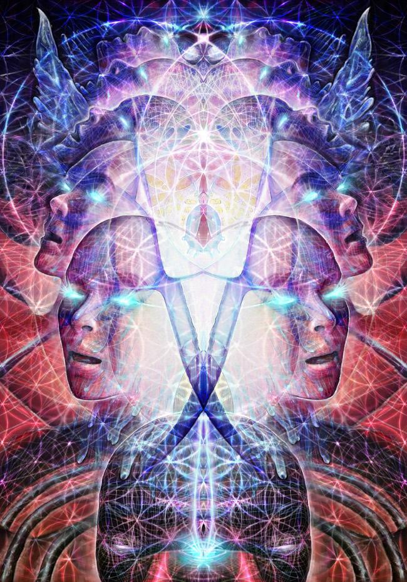
Peter Faust’s narrative exemplifies how the sense of self becomes fragmented when attempting to negotiate his experience of living “in two parallel worlds”. The crisis of identity results from the discovery that in he is in some way “part alien”. This leads to his “loss” of “identity” and subsequently a concern about being removed from his “earthling family”. This reveals how the fragmented identity results, in part, from a dislocation between self and place. Joe’s statement also closely resembles Peter’s when he describes a sense of ‘torn allegiances between the alien and Earth realms’. As a result he feels that he is “betraying his Earth partners”, and affirms “I don’t know where I belong”. This sense of conflict, symptomatic of an either or polarity, leads Joe to declare that he feels “split” from leading a “secret life”. Alternatively, Paul identifies home with being on the ship. While discussing the impact of human-alien selves upon experiencers’ identity, Paul astutely observes that, ‘It’s harder for us to be fragmented like this”. This struggle is representative of being caught “in the middle”, or in the “in-between” space. Similarly, when Scott discovers his ET identity he expresses a desire to be “one of them” while simultaneously wanting to be human. A point of conflict emerges when he remarks that he “can’t be both”. When asked why he responds with “Then I’m never home either way”. Again, the rupture between self and place, influenced by the either or polarity, results in a sense of a fragmented identity.

What are the implications then for Exopolitics? Certainly, there are some obvious differences between the postcolonial and experiencer spheres but while the ramifications of the former can be more effectively established the latter presents us with a paradox since we are dealing with impact of an unfamiliar, extraterrestrial paradigm. Furthermore, this is complicated by the denial of the ETH as a part of consensus reality. A similar concern is explored by Professors Alexander Wendt and Raymond Duvall. They examine how the UFO as an ‘authoritative taboo’ is actively produced via the mechanism of sovereign rule. This political necessity propagated by the union of science and the state, even if this pact forms a somewhat uneasy one, ensures the stability of it. They contend that since the UFO issue includes the possibility of extraterrestrials as a plausible hypothesis then modern sovereignty is faced with a ‘physical and ontological threat’ to its rule. I would suggest that if this is true of the UFO subject then this is even more so in regards to the issue of inter-dimensional and (or) off planetary intelligences interacting with the Earth’s human citizens. Accordingly, the UFO issue represents a sort of double entrapment since to disclose the former would lead to a questioning of the latter, and it is this site in particular that poses ‘ontological threats to identity or social being’. Subsequently, if the psychosocial dynamics of experiencers’ narratives shares similarities with those identified by postcolonial theorists then it is a political imperative for Exopolitics to explore this further for a number of significant reasons. Firstly, aside from the psychological framework utilised by John Mack and others to account for the validity of the abduction and contactee phenomenon, we have a comparative psychosocial framework that lends further weight to the issue by showing that the impact of the alien presence constructs states of being that are representative of how multiple human cultures intersect. Secondly, it is ethically imperative for Exopolitics to do so. When left to the skeptics and scientific authorities to examine such an area, and in this particular point I am referring to how Wendt and Duvall situate the sceptic and science as sources of authority, then we are presented with the type of analysis that is representative of Dr Mark Newbrook’s treatment of the experiencer, as a sort of interplanetary hoaxer or dissident determined to confound the application of authoritative, scientific linguistic modes via their use of alien languages. Needless to say, if Exopolitics as a discipline does not venture further into the territory of academia to reappropriate sites which are critical to a deeper understanding the ETH then those who speak with sovereign authority will be able to maintain the ‘epistemology of [UFO] ignorance’. In the process the modern state is able to uphold its public discourse that, using Mark Newbrook words, ‘the balance of probability’ regarding the ETH does not ‘warrant further focused attention’. Thirdly, the ethical imperative is that it is experiencers themselves who are left to deal with the psychological fallout from the machine of sovereignty, and what is it Exopolitics if not a site of resistance and a counter cultural discourse?

Points of Difference and Identification and the Representation of the Body
In this section I will provide some brief examples of when experiencers simultaneously encounter points of identification and difference, or conflict, in the process of navigating human-alien selves. Indeed, this is often apparent throughout much of the experiencer narrative and the sense of a fragmented identity, explored earlier, is also representative of this space. However, what is less evident perhaps is that experiencers also fluctuate between inhabiting the sites of either their human or ET identities more, to ‘changing degrees of intensity’. Subsequently, during particular moments of consciousness, perception is particularly appropriated via the human or alien lens.

Perhaps more so than any other type of written or oral account, the experiencer narrative highlights the recurrent fluctuating states between the points of conflict and identification. During one encounter episode, Peter feels a sense of fear and hate but simultaneously articulates that “there’s understanding here” as he believes that there is a “meaning to this”. Shelia, during one encounter, experiences a sense of struggle between to wanting to look into the eyes of the aliens while simultaneously wanting to make them “go away”. When a connection is established she suddenly feels more relaxed while simultaneously like she could “be crazy”. Joe also experiences a similar event when he describes wanting looking into Tanoun’s eyes, his alien guide, while at the same time he wants to avoid his gaze to reduce the power of the connection. The fluctuating states between resisting and identifying with the alien presence demonstrate that the influence of both aspects of human-alien identities, and subsequently their human-alien perspectives, are present to varying degrees. However, a moment of consciousness that is predominantly influenced by the human perceptual lens is provided by Scott. Again, like Shelia and Joe, he resists eye contact with the aliens as “my humanness doesn’t want to see this” since it “can’t handle the other side”. The basis for this is revealed when he responds with “because I’d be looking at myself”. In seems in this instance that it is his alien identity that provides the source of conflict. What happens then, when experiencers connect with their alien selves?

A thought provoking aspect of the encounter narrative is when experiencers find themselves to physically inhabiting the site of the alien other. During one encounter Joe discovers that he exists in an alien body that is approximately seven to eight feet tall, in a form that keeps changing like a “chameleon”. In addition, as ‘Orion’, he senses that he has the ability to make his body taller or shorter. While inhabiting this state he observes that he feels “so much more comfortable” which he describes as “Etherical”, “fluid”, with a feeling of “vastness”. He then suddenly experiences a sense of struggle with his “humanness”. At this moment it is his human sense of identity that provides the source of conflict. Furthermore, Joe, as Orion, is able to explain the purpose of the alien breeding program via the alien perceptual lens. Carlos also describes a similar state since during numerous encounters he discovers himself inside an alien “helmet”, which enables him to view his environment with an ‘alien quality’. When this occurs, he becomes more like the “examiner” in the study of humans. Again, an example is provided of when experiencers are appropriated via the alien lens.

It is Interesting to note that even Joe’s body does not necessarily inhabit a fixed physical state with his apparent ability to alter its size. This raises ontological question about the purpose of the body with the alien encounter experience and demands an examination that stems beyond a purely paradigmatic preoccupation with the physical experimentation that abductees undergo.

The Mountains Rose and Made Gaps: The New Terrain of Hybridity & Alien Communication
The beginning part of this title, ‘the mountain rose and made gaps’, acts as a suitable metaphor for the in-between state that is implied in Bhabha’s delineation of the third space. The ‘gaps’ between the mountains, spoken of by an experiencer, appropriately situates the domain of the triadic space. In this section I will be examine this site to illustrate how simultaneous moments of merged human-alien consciousness is represented in various ways. Although these forms are interconnected, or equally present, they can be conceptualised as moments of hybridity that relates to location, visuals, physical states and language.

Joe’s narrative provides us with numerous examples of the physical and visual representations of the hybrid space. He describes an early event in which he gazes at his reflection in a mirror. He suddenly experiences a sinking sensation and finds that he is looking through a window instead, and looking back at him, “face-to-face”, is the image of the alien. To be looking outside of a window can be read as the internal self looking outwards to an external view. This concept is disrupted however by the notion that the window is perhaps, simultaneously, also a mirror that casts back a reflection of the self and thereby reinforcing the insertion of the alien other. In this moment, the simultaneous appearance of the human-alien selves can be conceived of as a triadic site: a visual reinforcement of a hybrid identity. This event is particularly interesting when we consider that, later on in his narrative, Joe comes to physically inhabit the site of his alien other.

In another encounter Joe is subjected to a procedure whereby a group of grey ETs appear to integrate aspects of his human-alien selves. He then experiences a compelling image of seeing his body as if in “a hall of mirrors”. He sees himself “on many different levels” and appears to walk though “different membranes” as the multiple aspects of his human-alien identities begin to integrate in a “harmonious” order. This event appears to coincide with an evolutionary shift in conscious and he experiences a sense of “oneness”. This unification can be viewed as a physical and (or) spiritual hybrid endeavour that results in a triadic moment of being.

In the experiencer narrative, language and forms communication are represented in a variety of different ways, some of which are significantly diverse from one another. Although an extensive analysis cannot be adequately provided here I will include a summary of how particular modalities, as neither human nor alien but simultaneously both, can be viewed as a hybrid endeavour that ruptures established forms of language and (or) modes of communication. They reflect the hybrid enterprise since they are the result of human-alien interactions.

The phenomenon of channeling extraterrestrial entities is often encountered in the experiencer narrative, and Peter, Eva and Scott’s accounts include this characteristic. During one such event with Eva, John Mack observes that her perspective appears to alter to that of the alien community as she adopts the use of the pronoun “we”. However, by end of the regression she alludes to the idea that her consciousness is present in some way, so although she states “It’s like I’m not speaking” Eva also asserts “It was me. I know it was me...But it was another me”. In view of this, the use of Eva’s “we” perspective can be read as indicative of both human and alien modalities, and therefore reflective of a hybrid state of being and mode of communication. In essence, Eva’s channeling is neither the result of a human or alien consciousness, but rather it is simultaneously both. Crucially, like many other experiencers, Eva appears to gain access to information during alternative states of consciousness that would possibly have been unavailable otherwise. In addition these states can be triggered by an evolutionary shift in consciousness. Under hypnosis while Eva is discussing how to travel from one dimension to the next by “contracting and expanding at the same time” (a process that can similarly be viewed as a hybrid state) then the shift to the “we” perspective occurs. Curiously, at this stage in her account, the aliens are suddenly absent and Eva finds herself staring at the frame of a white triangle. She gains access to the knowledge that the aliens require “somebody that’s closer to the human being”. This is necessary in order to “slow down the transmission” of information because it is of such a “high intensity”.

Dr John Mack

This notion is symbolically underpinned by the image of the triangle since it can viewed to represent a hybrid mode of communication by the merging of alien and human forms. This concept is again later reinforced from Eva’s “we” perspective when she states that the aliens need to “adjust our communication from higher vibratory levels to those of earthly (verbal) vibration.”

Jim Spark’s observation of the alien language training he received highlights a similar concept. He remarks ‘I started seeing it as something that was a middle-ground form of communication.’
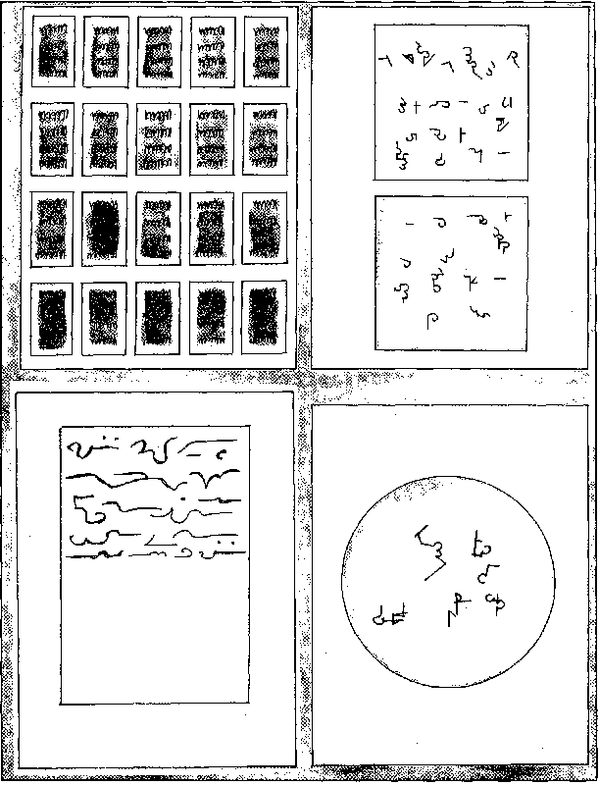
Jim Spark’s Alien Symbols/Language

The body, in the negotiation of hybridity, appears to play a pivotal role. Eva’s encountering of the triangle is described as “intense” and “causing damage” to the physical body. Since the triangle can be viewed as a symbolic representation of hybrid communication then Eva’s experiencing of physical pain may be an indicator of humanity’s current physical and mental limitations in being able to utilise such modes. Furthermore this may help to shed light on the existence of multiple alien languages, and some experiencers’ abilities to use more than one mode, since not all may be the aliens’ specific languages. Central to this idea is the role of the body in human-alien interactions as some modes of ‘alien languages’ may not function as a language at all, but instead serve an entirely different purpose. If some extraterrestrials are required to “adjust” their communication, a hybrid undertaking, then what is it adjusted to and what are implications?

Paul, Scott and Carlos all describe receiving downloads of images during alien encounter experiences. Scott states that the process is unfamiliar as “there’s a massive amount of information in my head that I can’t even understand”, and Paul receives images so rapidly that he is unable to comprehend them. Similarly to Paul, the speed in which Carlos receives the images reveals the limitations of human consciousness and language when he endeavours to refer to the imagery using descriptive words, while simultaneously attempting to hold onto the next flow of images. Human cognitive boundaries then perhaps explain the purpose of particular modes of alien communication in the encounter experience. Jim Spark’s narrative can be read as a response to these limitations. For instance, his middle-ground or hybrid form of alien communication involves training in the use of holographic symbols: a telepathic mode of communication whereby ‘a great deal of information’ is compressed ‘into very small symbols’. Viewing the symbols can then facilitate an instant download of the information. Similarly to Jim, Becky Andreasson also receives training in alien symbols via the use of ‘dual raised alien keys with moving symbolic symbols’. This symbolic language is taught via the use of the ‘mind, sense of touch, colour and sound’. Additionally, Becky also has the experience of touching ‘a page of light’ in a book that sparks a compulsion to spontaneously draw symbols. This appears to be a necessary step to some type of training, and later on Becky has her hands ‘measured’ to determine ‘how much symbolic knowledge’ she has managed to ‘absorb’ Becky’s contact with the book, an appropriate metaphor, indicates that a physical absorption of information has occurred that triggers her physical response to depict the symbols. Spark’s tracing of the alien letters again situates the body as an intrinsic part of this process.

Mary Rodwell’s work with experiencers has also unearthed some compelling results. As the experiencer narrative evolves so too do the manifestations of hybrid forms of alien languages and communication, and, although the complexities and depth of her case cannot be discussed at length here, Tracey Taylors’s narrative can be viewed as representative of this shift. Like Becky Andreasson, Tracey also depicts symbolic imagery. However, many of the images she has created are extensively detailed and multifaceted, and her ability to channel them is sparked as a result of a richly symbolic encounter episode that involves, rather intriguingly, the use of a triangular image that contains two concentric circles within it. She is then struck by ‘an intense wave of energy’ and the event triggers her ability to ‘channel through the geometric symbols and messages’. The purpose of the geometric designs is to ‘trigger some new awareness deep within our psyche’. Furthermore, Tracey also produces alien scripts and has the ability to spontaneously speak in multiple alien languages. This is especially interesting since Tracey also engages with many inter-dimensional and (or) extraterrestrial entities, and the ‘information’ she receives for her geometric designs ‘come through’ from these various beings. Again, this site can be interpreted as a hybrid endeavour.
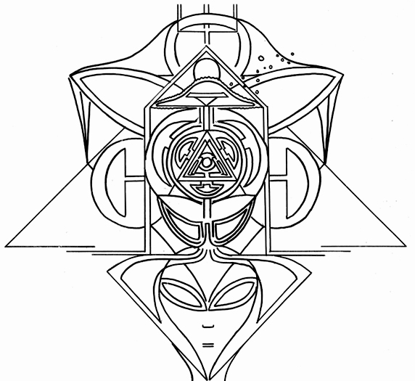
Drawing by Tracy Taylor

Evolving formations of the Psyche and Some Implications of Hybridity
The hybrid endeavour should be viewed as an ‘integrated, open, expanding code’, and not a fixed locale that unities human-alien consciousness to create a new, totalised form. Instead, the Third Space should be regarded as a site that ‘enables other positions to emerge’. The varieties of alien communications in the experiencer narrative, from the diversities of alien languages to the differences in visual forms, are a testament to this. All these sites are manifestations of hybridity that experiencers move in and out of, as Henderson’s sites of difference and identification also reveal. Additionally, their movement from a sense of fragmented identity to a site of integration, like Joe’s transcending the hall of mirrors, does not necessarily imply that this state of integration is complete. Certianly, experiencers’ narratives reveal otherwise, so the hybrid should open up the space for new questions to emerge as we deepen our understanding of the ETH. Peter Faust defines the process of human-alien interaction as ‘open-ended’ and ‘very uncomfortable’, but it is precisely this uncertainly that often triggers evolutionary shifts in the experiencer’s consciousness. What’s more, the hybrid forms in this paper demonstrate a continually evolving process, particularly in regards to the purpose of alien language. It is the indentifying of this third space will enable more diverse readings of the encounter narrative to emerge.

Ultimately, it is the experiencers themselves that represent a threat to the stability of sovereign rule. Bhabha defines the notion of ‘the non- sovereign self’ where difference can be articulated and yet lived with. Experiencers, in the negotiation of their human-alien identities, already inhabit this site and yet it is this state that creates the potential for disruption to sovereignty since their experiences ‘allude the politics of polarity’ and cannot be regulated by the state. It is the very possibility of unknown hybrid forms that cannot be acknowledge by the state. A way of resisting this site is to create the opportunities for the experiencer narrative to emerge, and Exopolitics can play a significant role in this process.

About the Author
 | Natasha Acimovic is a lecturer in Further Education and currently teaches Adult Literacy and Academic Study Skills at a British college. An interest in various theories, language and constructions of identity led her to complete a degree in Creative Writing and English Literature, an MA by Research in English Studies and a PGCE in Adult Literacy. An interest in the UFO phenomenon early on led her to research the less well known elements of the field including the human-alien identity, comparative literature of contact and abduction, the impact of the alien Other on language and symbolic communication forms. She also contributes to the UK Exopolitics Initiative and can be contacted at Natasha@exopoliticsunitedkingdom.org

ENDNOTES

See front cover, UFO Matrix: Volume 1 Issue 2, 2010.
Nigel Watson, “The Reality of the Abduction Experience,” UFO Matrix: Volume 1 Issue 2, 2010, 14-17.
Whitley Strieber, Breakthrough: The Next Step (Great Britain: Pocket books, 1997), 97.
See Homi K. Bhabha’s essay, Cultural Diversity and Cultural Differences, available in: Bill Ashcroft, Gareth Griffiths, and Helen Tiffin, eds., The Post Colonial Studies Reader (USA, Canada: Routledge, 1995), 207.
Basil Bernstein, Pedagogy, Symbolic Control, and Identity: Theory Research and Critique (London: Rowman and Littlefield, 2000), 3.
Carole Boyce Davies, Black Women, Writing and Identity: Migrations of the Subject (USA, Canada: Routledge, 2002), 154
See Mae Gwendolyn Henderson’s essay for a more a detailed account of the simultaneity of discourse, Speaking in Tongues: Dialogics, Dialectics, and the Black Woman Writer’s Literary Tradition, available in: Cherly A. Walls, eds., Changing Our Own Words: Essay’s on Criticism, Theory, and Writing by Black Women (Great Britain: Routledge, 1990), 17.
Henderson, 18- 19.
Henderson, 19-21. The idea of a subject who is “en-gendered in the experiencing of race” and “racialized in the experiencing of gender” is best highlighted when Henderson states ‘black women enter into a testimonial discourse with black men as blacks, with white women as women, and with black women as black women. At the same time [however] they enter into a competitive discourse with black men as women, with white women as blacks, and with white men as black women...this dialogic of difference and dialectic of identity characterise both black women’s subjectivity and black women’s discourse’ (bold emphasis mine).
Bhabha, 207.
http://rowenasworld.org/essays/newphil/bhabha.htm
See Fredrick Fahlander’s chapter, Third Space Encounters: Hybridity, Mimicry and Interstitial Practice, available in: Per Cornell and Fredrick Fahlander, eds., Encounters, Materialities, Confrontations: Archaeologies of Social Space and Interaction (UK: Cambridge Scholars Press, 2007), 23.
http://www.johnemackinstitute.org/ejournal/article.asp?id=25
Bhabha, 208.
Fahlander, 22.
http://rowenasworld.org/essays/newphil/bhabha.htm
Fahlandar, 19.
Bhabha, 207.
John Mack, Passport to the Cosmos: Human Transfromation and Alien Encounters (London, USA: Thorsons), 160.
Henderson, 22-23.
Mary Rodwell, Awakening: How Extraterrestrial Contact Can Transform Your Life (UK: New Mind Publishers), 276.
Mary Rodwell, Awakening, 228.
Bill Ashcroft, Gareth Griffiths, and Helen Tiffin, eds., The Post Colonial Studies Reader (USA, Canada: Routledge, 1995), 2.
Bill Ashcroft, Gareth Griffiths, and Helen Tiffin, eds., The Empire Writes Back: Theory and Practice in Post-Colonial Literatures (USA, Canada: Routledge, 2002, 8-9.
Mack, Abduction, 320-328.
Mack, Abduction, 181-184.
Mack, Abduction, 225-229.
Mack, Abduction, 102-103.
http://ovnis-usa.com/DIVERS/Wendt_Duvall_PoliticalTheory.pdf
http://magonia.haaan.com/2009/the-aliens-speak-and-write-examining-alien-languages-mark-newbrook/
http://ovnis-usa.com/DIVERS/Wendt_Duvall_PoliticalTheory.pdf
http://magonia.haaan.com/2009/the-aliens-speak-and-write-examining-alien-languages-mark-newbrook/
Henderson, p37.
Mack, Abduction, 310.
Mack, Abduction, 86.
Mack, Abduction, 181.
Mack, Abduction, 104-106.
Mack, Abduction, 185-186.
Mack, Abduction, 360-361.
Mack, Abduction, 266.
Mack, Abduction, 180.
Mack, Abduction, 250-256.
http://www.seancasteel.com/JimSparksSidebarArticleAlienAlphabet.htm
Mack, Abduction, 250.
Mack, Abduction, 96.
Mack, Abduction, 358.
http://www.seancasteel.com/JimSparksSidebarArticleAlienAlphabet.htm
http://ufoexperiences.blogspot.com/2005/07/becky-andreasson-daughter-of-betty.html
http://members.iinet.net.au/~starline/
Bhabha, 208.
http://ojs.ed.uiuc.edu/index.php/pes/article/viewFile/1806/516
Peter Faust, Touched, DVD. Directed by Laurel Chiten (San Francisco: Bind Dog Films, 2003)
http://ojs.ed.uiuc.edu/index.php/pes/article/viewFile/1806/516
Bhabha, 209.

