

The Andromedans & Mentoring Humanity

Alex Collier

Earth Transformation: Super-Healing, New Science, Consciousness & Contact Conference, January 9, 2010

Abstract
Alex Collier discusses his most recent contact experiences with the Andromedans, and how they are helping mentor humanity in the transition to a galactic society. According to the Andromedans, open contact with extraterrestriasls requires great discernment. Not all extraterrestrials have our best interest at heart according to what has been revealed to Alex. The Andromedans warn that some groups will bare gifts and then ask for something that we could not possibly give. And turn on us… For 2 thousand years religions have believed in the Book of Revelations. And the universe is going to oblige us by playing it out. Except it's not about being saved, it’s about self-responsibility, voluntary introspection and spiritual evolvement.

Transcribed by Richard Tretowski
Hi ladies and gentleman, thank you so much for attending this presentation. I want to thank Dr. Salla, Angelika [Whitecliff] and all the staff of this incredible conference. This is remarkable, my wife and I are thrilled to be here we love the islands and it's a great escape from the mainland. What I don't want to do today is go into a lot of background, there is more than enough information out there. I thought if you just type in my name some things will come up, both pro and con, and I would just encourage you to research it and make up your own mind.

What I want to do though is, I want to just get right into it, I’m traditionally a very slow starter in a talk and I want to avoid that. The bulk of the talk will be about mentorship. I want to spend about 15 to 20 minutes just kind of bringing you up to speed with things that are going on in the world. Obviously I’m going to assume you're all paying attention to what's going on. The world politically is changing dramatically. We are moving towards a fascist world government. Individual liberties and rights are disappearing all the time. In fact here in the United States the only reason we have a Bill of Rights is because of the Second Amendment - because they haven't figured out how to get the guns. The Constitution is essentially gone; they’re doing whatever they want, whenever they want regardless of the boundaries and the chains that the Constitution limited them to.

We have a world financial crisis, all these things are done as a matter of control and essentially what we have is, we have had a global government for some time actually, but now they’re just becoming more and more overt about it because they feel so confident that they have everybody exactly where they want them.

The next couple of years are just going to be absolutely amazing, its going to seem like 50 years all the changes that are going to occur, in the end however we will look back at it and say, my God, what a blessing, because clearly what we’re doing and what we have created for ourselves isn’t working. It is only detached us so much not only from the earth, but from who we actually are as souls, as beings. So it's not sustainable in any way shape or form. Even if the governments of the world came clean and said – okay, we are colonizing Procyon and Altair, and we have found all of these resources and were bringing them to the earth and everything is going to be okay, it is still unsustainable and the reason for that is we are not living a spiritual life and that's what we are, we’re spiritual beings okay We are not a natural resource to anything or anybody.
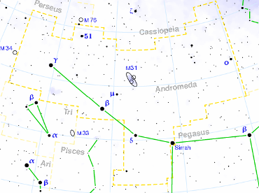
And over the years being with Morenae and Vasais of the constellation of Andromeda and others, what’s been very difficult for me, the learning curve for me, was being able to shift my perspective to how they view us. That’s been a real challenge, because you know this reality is so real, it is so solid, and having been born and raised a Catholic and come from a very large family, I’ve gone through the dogma, the indoctrination that many of us have gone through as kids. It’s been pretty tough to just push it away and just take that huge leap of faith that, okay, this is all wrong or it isn't sustainable. It isn’t right I'll just take that leap, that risk and just kind of move away from it, pretend it isn’t there and try something different. There have been enormous challenges and I know I’m speaking to the choir I know that this is a very evolved group and I know that you have all gone through that. Vision quests, tremendous losses in our lives, all of these things challenge us and those events help define who we are and who we’ve become.

Earth is complicated; there is a darkness that is here that is present on earth and under the earth, and around the earth. I don’t want you to think that it doesn't exist. Earth is a great example of duality and it's taken me a very long time to get to this place where I'm actually very grateful at this point for that duality for that darkness for learning about that darkness because I have spent a lot of energy challenging it, butting up against it, saying how dare you, fighting it, talking about it etc. Now it does exist, it is real and it is partially us and then there's an element of it that is not us. It is not human, okay, it’s dimensional, spiritual whatever you want to call it, but what it's done is that it's helped me realize what it is I don't want.

So once you've come to the place of realizing what you don't want in your life, you can actually begin work of building what you do want because intention is everything. You have to have intent in order to create anything, even ourselves. There had been the initial intention to want to experience, to want to create physicality, to want to leave eternity, to come down and begin this journey of physicality. Whether it's here on Earth, whether it’s in Andromeda, the Pleiades, Orion, it doesn't matter, they’re all doing the same journey. We’re just at different levels, that's all. I can tell you that the Andromedans, which are fifth density beings, wouldn't want to walk third density. I've given them plenty of opportunities to trade places with me: Noooo, they weren’t interested, okay. Not interested at all.


In fact the first-time I put it out there, Morenae and Vasais looked at each other and Morenae said to Vasais telepathically (because they are telepathic) ‘how would we ever use money?’ Because they don’t use money, they don’t have a monetary system, it's completely… they just don’t go there - they didn't understand. If you've looked at some of the research, I did a presentation on money for them, Morenae had asked me to do, and after several contacts of going through this presentation, Vasais just looked at me when it was over and he goes ‘I don't understand why do you have to pay to live on a planet you were born on?’, and that question still haunts me to this day.

The changes that are coming are going to be nothing short of profound. Now I know there’s a lot of talk about 2012 I don't know the exact dates, I don't think anybody does because we are still creating our future. We’re creating it every day, every moment, individually and collectively; but there are some remarkable things that are coming out not only in science, medicine, quantum physics, [etc.] and many wonderful speakers here at the show [Earth Transformation Conference] were talking about that; and there are many other people out there in the world talking about these things. Literally proving that there is so much more to us then we’ve ever imagined. For a lot of you, it’s like ‘duh’, we already knew that. You know we've been beating that horse for years trying to get people to come into that place to finally get it. Well, miraculously people are starting to get, at least they are asking the questions, which is huge. They are open to the idea of well, maybe there is more to this!

The biggest leap that the extraterrestrial races are excited about is the idea of us being opened to extraterrestrial life, number one; and number two, to the idea of letting go of our dogmas; because if we cannot let go of the dogma, we cannot embrace other possibilities. What we’re going to find out is that many of the dogmas that we have held as cherished truths, were false all along; and we have been building civilization on lies, and that's why none of it has held up.

There's also a program that a gentleman by the name of the Cliff High has created called half past human ‘web bots’. I don’t know if any of you are familiar with it, I would suggest you research it, as it's fascinating. You know s,hort note, cliff notes version of it - essentially what it is, he has created spiders, and he puts in looking for verbiage in words, and he's been able to essentially tap into the entire global Internet of language. What he's tapped into I believe is the subconscious of humanity, which is fascinating. It’s dire, its grim, but if you realize the conditioning we've had for Armageddon to believe that Armageddon had to occur, that there had to be an end of the world, that there had to be a final judgment of everything we've done; then it only makes perfect sense that that this would be the steps that we would take to get to that place to prove ourselves right.

The truth is we don’t have to create any of that; it’s an opportunity for us to take a look at these possible scenarios and say you know what, I don’t want that. I’m done with that, I’m choosing this and then we can start to build and create something different and that's literally where we are as a society, as humanity. In service to each other we will remain free, and it's about freedom. All of this is about freedom, free will and freedom, true liberty, earth was never meant to be a slave planet. You were never meant to be slaves!

You should absolutely resist going there because it is not who and what we are, I can’t say it any simpler than that. Now [that] doesn't mean that it is turn the other cheek, and it doesn't mean that you don't stand up for yourself. You have to! To do nothing, to say nothing, you're condoning the actions of others. That doesn't mean you have to march, but what you should do is make the choice, send your intention out every day, every moment that something comes your way then you're not happy about. Send an intention to change that situation. It will create a sphere of energy, of conscious energy which is happening already around the world. I know this is somewhat of a review here I will tie this in to where were going with the presentation.
What’s fascinating also is that I move in a lot of different circles, I have been in aerospace for a great deal of time. I have worked with the military on many different levels, in lasers and network security things like [that]. What's fascinating is that these guys are actually starting to get it. They really are, and there are quite a few issues within the ranks where they realize that the path we're going can only lead to the destruction of the country and to World War, and they [don’t] want to go there. There's a lot of pushback, a lot of pushback, they’re beginning to pull back the other way. The veterans who've already been through this nonsense, they already know, and they're digging in; and they're getting ready to say no, so this is all very positive. It may not look like it because there's a lot of friction but it is positive because what we're doing is for standing up and saying, enough is enough and that is the first step, it really is the first step. That's encouraging to many of the extraterrestrial races who have been sitting up there watching us, who have been visiting the earth, who have been in underground facilities in the ocean, who have been interacting with humans, and having contacts with many different human beings all over the planet.

Billy Meier is not the only one [to have met with extraterrestrials], there are many. They’re encouraged because now they feel like they have something to work with, because whatever they do to intervene, to intercede it has to empower us. Otherwise it's futile if we will not take responsibility for ourselves, for our homes, for our planets, for each other, there's nothing to work. They’re extremely encouraged, so much so that the Andromedan Council has begun discussing mentorship of earth and as of right now there are four races who are already signed up and genetically they are connected to earth! Now genetically connected to earth means that they have been here in the past. They have probably been some of the gods that have been worshiped, who have left offspring, and have created civilizations here, and we’re the remnants of. So we have already so many different races, there’s a lot more to this.
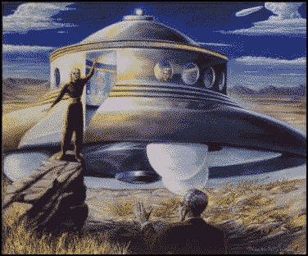
George Adamski meets Orthon in Nov 1952

We also have a situation where our solar system is moving through a very particular part of the galaxy. We are moving through a plasma belt, we are moving through the galactic plane and this causes a lot of shifts. It changes everything. It's like the ultimate Mercury retrograde. Which can be pretty scary actually.

So, here's the deal, the bad guys are about to play their last trump card, they’re done, they’re already done, okay. We have begun the process of freeing ourselves from all this shit. Bravo, bravo, we have done what centuries of human beings have not been able to do, and that is get the big picture and realize that we are all one, that no matter how much we disagree, you're my brother and my sister and there's nothing I can do to change that. We have to figure out how to live together, and in reality we can live together, we can. It's ridiculous to think we can’t, in fact we really have to work hard at not learning to live together. War is the enemy, it is not the solution. It has become the enemy. We have technology that we simply cannot control, and we have technology that we don't even know about.

Free energy, you’ve heard Mr. [Sterling] Allen’s talk last night for those of you who are here. There are many others talking about free energy, we have it. In fact cold fusion has been nailed, it does exist, a program working under DARPA has solved it, and literally for under $2 million they can build a system that can power a city of 50,000 people indefinitely. It’s a done deal, but they’re sitting on it. They’re sitting on propulsion systems that could take us to the stars. They’re sitting on magneto drives that we could put in automobiles that can run forever. Electric cars they’re sitting on it. Even though you paid for it, we built the technology, we don't own it, private corporations do, but that's okay, that’s okay, because in the end they won't be here, they’re done. It's all done, now what we have to focus on is what we want to create.

Mentorship is not where we are saved, we are rescued, they’re going to come down and police our streets. That is not what this is about okay. In their [the Andromedans] opinion the idea of mentorship is to show you the possibilities. The first thing that they would do, would be number one, introduce us to ourselves. Give us some real genuine history and probably show us on the planet where that history is. So we can then dig it up, and prove to ourselves, this is who we are and this is where we come from, this is what really happened, and this is where all the programs of war and hate and greed have come from. These are all learnt behaviors, ladies and gentleman, these are all learnt behaviors. When we left the creation, when we left God, Great Spirit, we didn’t have this crap with us. These are all learned behaviors. We all fell into time and then we decided to try the light, and then try the dark ,and then try the light, and then try the dark, and see how far we can go, and how we would come back home. It’s all been an experiment, all in the process of creating ourselves. It's amazing, absolutely amazing especially when you can step out of the concept of time.

And you realize that we’ve been doing this dance forever, forever and ever and ever. Now, as far as initiating mentorship, I was so asked at the Awake and Aware Conference for Project Camelot to float it, in other words to put it out there. They wanted to see, the Andromedans and the other groups wanted to see what would happen with the idea of it moving out through consciousness. I’ve been asked to take it to another step now. They are excited about this, because this mentorship is literally our initiation into a much larger galactic family which I can’t even tell you how incredible it was, and it isn't anything where we need in any way shape or form to feel inferior about. In fact we are really, despite everything else, we are really pretty far along.
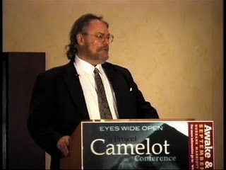
Alex Collier at 2009 Awake & Aware Conference

An example, in mentoring, one of the things that the group will do is they will discuss spirituality. Now in discussing this I have been told that there will be at least four or more perspectives on spirituality that will be presented to us, not just one. They all have things in common but different civilizations have different ways of expressing themselves, and there isn't just one way to express yourself. This is a very touchy subject, which is why I’m bring it up first regarding spirituality. These are not religions, these are not dogmas, these are things that you will be able to test yourself, prove to yourself about yourself. It will be about the science of the soul. Hard physical proof that you do exist as a soul, so there's no more question you know, you live beyond.

You know that you retain consciousness, you know that you have cellular memory and the reason you have cellular memory in your bodies is because of your soul. All of this will be shown to us, proven so that we will beyond a shadow of a doubt know that we don’t have to go to hell and we aren’t going to hell. That we’re not going to go to purgatory, none of that crap. It’s bunk, it’s all bunk okay. We can let go of that dogma, that’s done. There is karma, but we set that up for ourselves. Those are all lessons but you can balance those things, we’ll cover that a little bit.

Technology
I had a lot of questions regarding technology, free energy, things of that nature. According to Morenae [an Andromedan extraterrestrial] we pretty much have most of what we already need, its just been suppressed, in the technology sphere. In fact we have technology now we’re using every day that we could improve dramatically to make it last forever. Circuit boards, there are things apparently we can do apparently with circuit boards that we use today that in our narrow shortsightedness we’re not implementing to its fullest capacity or potential. So we have most of what we need here.

Planetology, what they call planetology which we call geology here, is when you talk about energy. They would teach us the cycles of the earth, how oil is created, petroleum is created, fossil fuels are created and essentially what those cycles are; so that if we decided to stay with those, we would be able to rotate between fossil fuels, natural gas, solar etc. so there would not be any disharmony. We would not overuse the earth's resources in any way shape or form but we don't know those sciences. All we do is we find it, we pump it out of the hole, we fill it full of seawater and then we move on. Eeeh! Wrong answer.
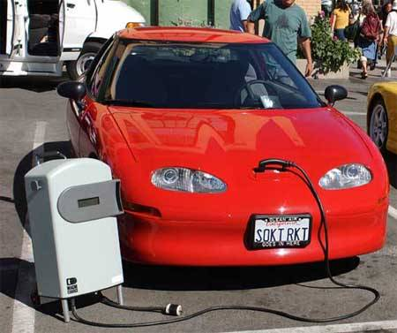
Electricity. We have electric cars, there is technology that already that already exists that can be improved, they literally do not have to give us anything else at the moment, except ideas that we can create. Their thoughts were why aren't all the major cities, inside the cities, using electric vehicles? Because you're traveling short distances inside major cities.
Why not use electric there, and then use petroleum on the outside for longer distance and for shipping, things like that, at least to start? They have so many suggestions that we could use right off the bat. The biggest change, the biggest mentoring would be with health.

They have a camera, a holographic camera, and it was interesting Mr. Mellon Thomas [another conference presenter] made reference to this yesterday night in his talk. They have this camera, and I've talked about this in the past, where they take a picture of you and it’s a holographic camera. It's you from inception to now, physical. They can take the slide out, this holographic slide; and they can look at your body and sequences. They can pull areas where your body was strongest - whether it be liver, kidneys, bone structure, nervous system, brain waves - it can be anything. What they do is wherever your body was the strongest they will pull that slide out, they will put it back in the camera and they will reinvigorate, re-heal your body with your own imprint and apparently we have the ability to create such a thing. All the components are spread out, they’re not pulled together yet, but we can do that. We’re talking about healing without surgeries, that's not to say that there won't be times where there may not be an immediate surgery, I don't know that.

Politics - The mentoring ship of politics. They consider politics and religion the same thing. Okay, this is the area where they're very reserved regarding us; and the reason for that, is how will we know… Let me rephrase, can we, will we, let go of traditions and dogma to embrace something we don't know. I’ll give you an example. The ‘Bill of Rights’, individual liberties, it took thousands and thousands and thousands of years to get to a place where humanity on a subconscious level was so done with monarchies, tyrants, kings and princes that we decided collectively to create individual liberties, and it manifested physically in the creation of the United States. Here we are 232 years later and were about to lose those liberties that took thousands and thousands of years to create, to manifest for all of humanity.

Now what’s interesting is that the rest of the world, they’re stunned that Americans could be this stupid. In fact, in traveling in Europe I had the occasion to see some Swiss students get arrested; and one of the things they said to the cops were, you know you better read me my Miranda rights, cause they were watching American television and the Swiss police said ‘You'll don’t have any rights’. Now I bring this up only because this is an issue, this is an issue of freedom, and this is important in the global grand scheme of things. If you protect your freedoms you are stating to everyone including yourself, I am responsible, and that is the number one priority to taking the next step forward into advanced maturity in meeting face-to-face with benevolent extraterrestrial races. They are not going to baby sit. It never works, it’s not their job. Their job is to give us a start because we have been so manipulated for so long, which would seem like forever, and we haven’t even been aware of it. But the people are waking up, people are beginning to become aware of it but we have to protect our freedoms.


The world, Earth, was never meant [to be] a slave colony, a slave planet, that was not the intent at all, and we should never put up with or tolerate it in any way shape or form. We need to tell him to kiss our ass. So that's the big concern, will we make that leap, will we let go of having to be right in order to know what the truth? I've had that very question put up to me, said directly to me.

Can we also truly learn to forgive, because everybody's had a role to play here? We’ve all had a role to play in creating this scenario, this game, now. This whole thing [is] about advanced maturity, this whole thing about extraterrestrial life, this whole thing about a resurgence of spirituality, this whole thing about relearning mother Earth and living in harmony, and finally giving indigenous cultures their due and their acknowledgment because they were right all along. Okay, we were wrong. Industrial civilizations, they're not in balance. That’s not to say they can't be created, but what we’ve created is completely out of balance, and has pushed the earth to her limit. So we have to give them their due.

This is all about us. We are the ones calling this forward. We are the ones who have asked for this. We are the ones who are making this change ourselves, within ourselves. We are the ones, nobody else is responsible for this, but us. Apparently on some level we have decided this is as far as it goes. Whether it's a conscious or not, globally, but there's enough of it, enough conscious people who are making these choices to decide this is as far as it goes, the way it is, and it is ending. Life the way we have lived is going to be changing. It could happen very quickly, it could happen somewhat gradually. Gradually would be better but right now it looks like it's going to be happening quickly. Now is the world going to end? No. It’s not going to end. That's not our destiny, we didn’t work this hard and go through this much crap just to have it end okay. No, that's not how it’s going to go, but there is going to be change and it's going to be a physical as far as our bodies. It’s going to be physical as far as the Earth; and I think psychically, that's going to be the biggest challenge for everyone.

Because we have lived in a predominantly material life only to find out that all the energy we put into investing in creating a material life has done nothing to fill the voids inside of us. People [will] have their own dark nights of the soul. When they come to that place, and they look at themselves and they just say, ’Oh Shit!’ it was it was all for nothing, okay. I know lots of people who are going through that right now, especially men that did all the right things, said all the right things worked all the right jobs, dedicated themselves, gave themselves away, all to find themselves completely empty. They’re having to look at that, and they’re having realize everything that they had been taught, much of it, wasn’t what its about at all.

It’s going to bug the men the most. Ladies you're already so intuitive, you’re just, you know … ‘I told you so’. Okay I already hear it, ‘I told you so’ so I said it for you. But the guys now, the guys are going to have to reach down deep inside of ourselves and we’re going to have look for that intuitive piece. We’re going to have to learn to trust that intuition, and not just our ability to mentally strategize everything that's going to happen in the world - will if this happens I can do that, if that happens I can do this, if these two things happen I can do that, but then there’s this, so I need to compensate for that. I mean we make ourselves crazy doing this!

Okay, because we haven't really learned to get to that place inside where we just learned to trust the flow, because we've not embraced the flow in a very long time and I don't necessarily mean the gentleman in the group here, okay, but I am talking about the outside world. There are a lot of people really struggling because they're done all the right things and they cannot understand why it doesn't work and they’re blaming God, blaming the relationships, they are blaming everything, the government, and it isn't any of that. It’s just that we've been on the wrong path and we've been building the wrong kind of life and now we have an opportunity to do something different. What we need to do though is a need to focus on what is it that we want to create? What does the planet of peace look like? What does a planet without war look like? Do we still want to have a planet that has a monetary system? Do we want a planet where there are no pharmaceutical companies? We just use natural ways of healing, color, light and sound.

These are not overnight transitions, but it’s a preparation. Those of us who have gotten it, and have been about it for 20, 30, 40, 50 years, you're now finding yourselves coming to a clearing and there are going to be people waiting for you saying ‘how did you know?’. ‘Can you teach me everything,’ ‘I need to know now everything’, because our survival instinct is so strong, and we realize that the system we have isn’t working. It's coming apart, and we’re blessed that it hasn't happened all at once, that we can take this gradually but it is happening. The blinds are being lifted people are coming out of their comas and this is what it's about and it’s happening in all walks of life.

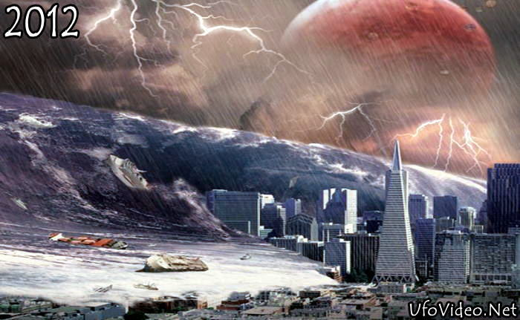
Let’s take the 2012 scenario for a moment. Let’s suppose there was going to be a pole shift. Okay, this is strictly a hypothetical alright, and it’s an interesting lesson/exercise. Let us suppose for a moment that there was going to be a pole shift, and half the world's population was going to be gone. That the world could only sustain half, and the government came out forward and said ‘hey this is really what's going to happen’! That the world could only sustain half, and we’ve been preparing ourselves, we built our own facilities, sorry they're not for you! We’ve been building bases on the moon and Mars, sorry they're not for you! And we have all of this advanced technology, but there's no point giving it to you because all this is going to happen to the planet, you’re on your own. Not that they would ever, ever, be that honest. Okay, so let’s just suppose, so let’s suppose you now knew for a fact that we had year and a half to two years, no one knew who was going to make it. You didn’t know where the safe places were, what would you do different with your life? What would you do with those last two years?

Would you, start selling real estate? Would you become an artist? Would you allow yourself to fall in love again? Would you allow yourself to give forgiveness that you've been denying someone? Would you want to heal old relationships? Would you want to write a book? Would you want to travel? Would you want to learn to swim? I mean whatever, what would you do differently if you knew you had two years? Now I’m talking about as a planet. Now individually people face these realities every day, through disease, cancer, and the such, you know, and they're the bravest people in the world, because they know, they've been given a diagnosis that’s terminal. Many don't die, but others do, but they live with that that every day, and every day they have the courage to get up and keep doing whatever it is they want to do. What would we do differently as a society, as a global planet this is not just an American issue. This is a planetary issue, and I have to tell you, the extraterrestrials don’t see us as Russians, Chinese, Americans, Japanese, don't see any of that, we are one race. Regardless of our differences in our languages, we are one race to them. Only we don't believe that, we’re the only ones that don’t believe that. What would we do differently, what would you do with your life, how would you live it? Would you be the most benevolent person you know? Would you go the other way, you know, would you be a gangster, you know, would you sing love ballots or would you sing rap? The reason I asked this is that the future isn't set.

Now there’s talk, I heard something recently about a star going nova that’s about thirty two hundred light years from earth. Don’t worry about that, there is more than enough help here that that's not how it's going to go for us okay, that’s not going to happen. I mean it may go nova, but technology exists; and there are plenty of resources in our particular solar system right now to ensure that that's not how we're going to end, because there are a lot of people very very curious about us. Now the reason I say that is that we are a planet that has 22 very specific genetic markers. We are a collection, a collage, a compendium of many different extraterrestrial races living together, this is not common out there. Especially in 3rd density in a very complex ecosystem like we have, there aren't that many, and they're here to watch us because we are as a civilization at a place where many of them have been before; and that is that we are spiritually evolving. At the same time we have created technology that we barely know how to contain and use. The technology was created in the space of fear, those using it, holding it, maintaining it, controlling it, are in the space of fear. Humanity however is at a space where it’s beginning to step out of that reality to create something new. So what you have is, you have a consciousness that sees itself becoming completely irrelevant, which makes them unpredictable, and nuclear weapons are no laughing matter, ever!

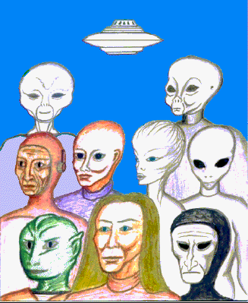
Now, there are extraterrestrial races, benevolent extraterrestrial races having contact with some military sources on earth from different countries. God, there is just so much going on, and the wildcard here really is us, we’re the kingpin, we need to continue on this movement of not only sticking together but focusing on what it is that we really want. What kind of world [do] we really want? We really can't be serious about wanting to create a global government that controls every aspect of our lives, look at what they've done with the world already, why would we trust them with anything else? We can’t, we simply can't, because they're not us, they see us as a natural resource, therefore we need to turn our focus completely away from them and create what we do want, so that their paradigm completely collapse on itself, and it needs to because it isn’t real, it’s not us, its all about them. So, what is it that we would want?

The protocols for contact, this is a very difficult [issue] and what makes it difficult isn’t that the actual ‘okay here we are, now you see us, here’s our ships, now you know were real’, the difficult part is, how we set up the protocols, how we approach them as an equal? Without worshiping them because that will make them leave in a heartbeat. The benevolents, anyway, they’re not into that. The regressives, they’d be more than happy to allow you to worship them, cause we’ve got a history of that already. It’s in the Bible, Old Testament, Egyptian books, Sumerian texts, we have plenty of history of that, that’s never served us either.

Begin within yourselves to begin visualizing what the protocols would look like. Now in the last conversation that I had, I asked who would be the most likely people at the moment, the way things are now, that they would contact to begin a dialogue regarding mentorship. The answer would probably surprise you. It definitely isn’t the United States even though we have probably the most advanced technology the world’s known since Atlantis. It’s the Japanese; it would be the Japanese government at this moment because of their prudence, because of their integrity, because of their dedication to their own people. Now that's something to think about. This is a country that took two nuclear weapons, and look at how far they've come.

So when will this happen? Not exactly sure, I do know that between now and fall of this year huge events are going to occur, some absolutely wonderful and some not. I also want you to know that the Andromedans are very concerned about the earth moving through this gravitational plasmic field, which we call the galactic plane, it is their concern that the planet itself when it hits it, because of its vibration, its frequency is going to bounce off of it at first creating a huge global quake.

There have been discussions as to whether to intervene, to in other words align something in front of the earth to open the pathway through it, or to allow this to occur naturally. The natural part is this, when the earth moves through the galactic plane the Schumann Resonance of the planet is going to change. It is going to become much much higher than what it is right now. All indigenous life on the planet will then have to change its harmonic frequency to match that of earth, many species will not be able to. A lot of human beings will not be able to, but those that do, it will be a natural transition into what we know as fourth density and in some respects fifth density.

Those kids that are coming in with three strands of DNA, they will be able to go between three to four, four to five, they will be telling us, coming back and teaching us what is ahead of us. They will become the educators. Half of them are ET’s anyways, who have volunteered to come into this place simply because none of our forefathers have ever experienced this before. So I don't know if they’ll be intervention on that, or not. There will be earth changes though.

And I don't know at the moment if that happens where the safest place to be is. I don't know at this point. If I find out I’ll definitely let you know, but intuitively you will get it. I'm sure you will get it, that you will be exactly where it is you're supposed to be, and you will know exactly what it is you're supposed to do. You have to know that because that's what this is about. When we pass through this plane, we will become an agrarian society once again, which I thought was fascinating because Mr. Mellen Thomas talked about that yesterday, as well last night, based on his death experiences that's what he was shown as well, that we become an agrarian society again. It’s not to say manufacturing will go away, it won’t but we will become indigenous people once again with the planet.

I'm also told that many people, once we have passed through this transition, this change in frequency and harmonics, that many people will opt to go to different star systems and represent Earth, represent our civilization. There is a huge perk to being the only planetary society to actually go through such a shift as this, and the fact that we represent 22 different extraterrestrial races here genetically, and are considered genetic royalty that we will be invited to participate on levels absolutely unimagined to us at this point. We will become ambassadors, we will be teaching other societies basically what not to do, okay, because we’re the professors, we have become the professors.
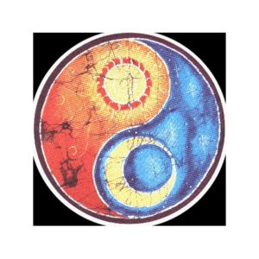
A gentleman, and I’m not sure if he is here, his name was Gilbert, I spoke with him yesterday, he asked me to give him in one sentence the bottom line to all this, and I've been searching for that one sentence that bottom line, all my life. But I heard someone else say it yesterday, and it is simply ‘love your life’, you can’t say it any better than that. You know we’ve lived in the duality of light and dark, but we've almost completely ignored the fact that there's a third duality here and that’s balance, we have always been somewhere between the two never realizing that the balance is actually its own duality as well, and none of us have given that space enough credit.

And we certainly don't teach that in our spiritual philosophies or religions of the earth of just finding the balance. Many of the indigenous cultures have known that all along. They've known about the balance and in saying that I brought that up specifically because what needs to be acknowledged here is that the United States changed the world, it changed its perspective, it changed the direction. Up until now it has probably done more good than harm but the consciousness of America has radically changed for the last 60 years, we've been creating enemies, fighting enemies, creating enemies, fighting enemies, fascism, communism, tyranny; and then creating tyranny, communism, fascism. So much so that our government, has now become the monster that it has been fighting all along. There’s a great lesson there in holding onto something and putting too much energy into something that you actually become that which you hate. We’re faced with that.

I want you to know that there is not a single benevolent extraterrestrial race, up there, the Andromedans, at all, that are going to do anything about our government. That's our problem, we let this get out of hand, we let them get out of control, we let them usurp our rights, we’ve let them build all this technology without sharing it, we’ve let them run amok, we have not managed our constitutional republic and we have let them take our rights away, that's our responsibility to fix. Now I'm not advocating overthrowing the government but what I am advocating is the fact you absolutely stand up for yourselves and don't take this horse shit any longer. We simply can’t do it, it's become a detriment to the planet, and we are responsible for that.

Now having said that, this is an unintentional plug for Dr Salla’s book [Exposing U.S. Government Policies on Extraterrestrial Life], but I was going to talk about this anyway. In the late 50s, the United States government signed a treaty with an extraterrestrial race who they believed to be benevolent, and agreements were reached and there were terms to that treaty. Shortly after that treaty was signed and agreed upon, the extraterrestrials broke the treaty, because technologically they are far more advanced than we believed they were. So the government was tricked into it, however, we called that up upon ourselves. We brought that experience to us because of our treatment and our behavior with treaties. Just ask the Native Americans, we signed 263 treaties with the Native Americans, and we broke 263 and it goes on and on and on. So if you need proof of karma there’s one for you, we drew that to us, because we haven't walked our talk. We talk about it, we sing about it at sporting events, you know we beat our chests but we haven't walked it at all, it's in our face ladies and gentleman, it’s in our face.

And once again America is at the forefront of this. This economic crisis in the end will be a godsend because what will happen is the ridiculous laws and restrictions and regulations we have put on ourselves will all fall away because there will be nobody to support them. That’s number one. Number two, what makes us great is that we think out of the box, we create something out of nothing, we create solutions to impossible problems. That's what's made us great. We need to re-embrace that spirit, that wild spirit that freed the world, that changed the world. It doesn't mean that we cannot share that spirit with other nations, because other nations are getting there. Hell, Russia is as free as we were 25 years ago. Now, they're changed so dramatically, they realized what they were doing no longer works - there's a lesson there. Putin was very specific don’t go to communism it doesn't work. This is not about politics this is about control. This is about control, it's about you, it’s about me, it’s about us, it’s about our kids, it is time to create something.

All you need to do, all I've been asked to tell you is to consciously intentionally start thinking about what the world looks like, what a new world looks like, the way you want it. Do you want centralized government? Do you want a monetary system? Do you want to use fossil fuels? Do you want free energy? What is it that you want? We cannot allow a handful of people to decide the direction of all of humanity. They are only going to be self-serving, this is our responsibility, because this is our reality. We’re creating this together, and if we embrace that, if we take responsibility for creating all of that reality, we can change this so fast it will blow your minds! Because we're all extremely powerful, look at what we've done, look at what we’ve done already, it’s stunning!


An experience that I had… when I go on board [an Andromedan ship], they’re fifth density beings, immediately that I come onboard, a belt is put on me and essentially what the belt does is that it holds all of my atoms together, so that I don’t I'll fly apart because I’m a third density being. My vibration is very slow compared to them, this belt regulates it, regulates the speed of my atoms so that I can actually coexist with them. Now what’s fascinating about that, what's fascinating about fifth density as a third density being is that my body is moving before my thoughts are. In other words, if they start walking, I'm walking before I start to think about walking, because I’m now I’m connected directly to my higher self, to my soul. I’m not waiting for my ego to click in and say ‘okay start walking’.

The other thing that was very very difficult, I’m going to give Joan Ocean credit for this because she brought it up yesterday in a conversation we had, is you feel like you’re loosing yourself, you feel like your just dissipating, becoming invisible and you’re actually not. What’s happening is that on a higher vibration your ego doesn’t exist, it falls away, it simply cannot exist in that harmonic, it has no relevance whatsoever. And then what happens is, and it that takes some time to adapt, is you're confronted with who you really [are]. You're introduced to yourself, and at first you don't recognize it because we’re so conditioned to this. You know, we’re so conditioned to all of this, that this is what feels real.

Logically we know we have a soul, when we meditate we get into that space but we're still totally conscious of the fact we are in a physical form. There, in fifth density, my experience has been, you don’t even think about the physical form at all, you're moving, your physical form is trying to catch up to you. It's absolutely amazing. What’s also amazing is that if you close your eyes and see 360° around you. You know exactly what's going on everywhere.

I could feel every one that was around me. I could feel their emotions. I could feel them look at me. I could feel them think about my appearance, what I represented, how I was standing, all of those things. I didn't always hear the telepathic communication because a lot of it wasn't directed specifically at me. When it is, you hear it and it’s like we’re speaking now, and you'd know that it's coming from someone, because they’re looking directly at you. Except their mouth isn’t moving but you're having the dialogue, and for those of you who were medium’s or channels you know exactly what that's like.

We will be moving into all those pieces alright, and we need the mentorship so that we don't freak out and flip out so that we can truly understand how to embrace our essential selves, what it's all about, the whole purpose of going through all of this stuff for humanity, all the thousands of years of tests, trials, tribulations, previous pole shifts, [etc]. All of that was to take ourselves through this exercise to move from third through fourth and eventually into fifth density. That's what this has all been about. It’s all been a school and we all volunteered. None of you were taken from the ship, thrown out the window, and said ‘make it/figure it out’, it’s not how it happens, and I wish it were cause then we’d have some other excuses, but we don’t, that’s what this is about.
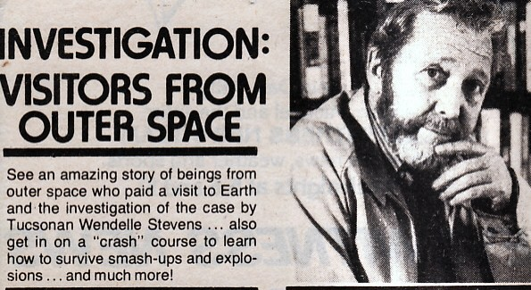
More and more people, probably many of you in this room are going to begin to have contact. It’s going to happen all over the world, it’s going to be picked up exponentially. Many of the races who have been here studying us, and I would suggest that you research the work of Colonel Wendell Stevens because he is the foremost authority on contactees around the world, his books are available. There have been many many races here studying us, they know us better than we know ourselves, and many of them are stepping forward and are going to be stepping forward to say okay we are going to participate in this process to help move us as along because they understand us. They’ve been here around us, amongst us, they’ve observed us, they know the challenges we have. Many of those specific races have been in exactly the same place as we are now, and they knew how to get through the hurdles. They knew how to get through the traps, or to avoid the traps that apparently we may be stumbling into here.

Again, I know many of you in this room, if not all of you have devoted an amazing amount of time into developing yourselves, into finding your balance, to finding your strength, to finding out who you are or what you are, and to find out exactly where you [are] so that you know where you stand. Bravo, you deserve every accolade there is! The next step for you, now that you’ve been there is to help create the world. What is it that we want the world to look like? It’s us, we have to do this, no one else is going to do this for us.

[It] has to be grassroots level. All it takes is conversation, discussion; you know, if you put out the intention, ‘I need to know about this information’ and you put it out and you keep putting out, even if it's just for 10 seconds a day, you will draw that information and knowledge to you. The right people will come to you. The opportunities will come to you. You have to trust that. I'm learning to trust that, because I’m a guy I still over analyze everything. But my wife is kicking my ass in that direction and making sure I get that (I love you for it).

This is all about us. We have drawn this entire experience to ourselves so we need to own it, and the faster we own it, the more empowered we will become about the process, the more it will make sense to us, the more intelligent we can discuss it and as with this process begins people around you --- well, you’ll find yourself in a position of leadership and you'll find yourself being the teachers.

There was a great line in Sterling Allan's presentation, quote where he said ‘If you're one step ahead of the world you’re genius, if you’re two steps ahead your crackpot’. It was a great line, so I borrowed it, we’ve all been crackpots! Soon we’re going to be geniuses but that's when the real work begins. The idea is to try to [get] everybody else up to speed. Do what you can. Just do what you can. Don’t over extend yourself to the point where you can't keep your self centered and balanced, you have to keep yourself centered. It's not necessary for you to save the world, or to want to save the world. If you become the example it will reflect and other people will get it around you. The tide is definitely changing, the frequency is changing, again I want to just, I want to put this out one more time. If you have you had two years left to live on earth, what would you do with your life? What would you do? Just think about that. What would you do differently? If you wouldn’t do anything Bravo, you’re there, but if you would do something differently what would you do? What would make you happy? My wife Audra, has a great saying and its ‘we’re all sitting on the G waiting for the O’.

Ladies and gentlemen you are my brothers and my sisters, I love you. I am honored by you, I want you to know that I have done the very best I could to represent us. I’ve had my stuff to deal with as well, I have my own challenges to deal with as well, but ultimately in the end I have absolute faith in us. The world is not going to end but it is going to change. It has to, and it's going to change for the better, but we need to be the driving force of that change. Humanity has to be the driving force of that change, not government. Do not ever, ever surrender your freedoms and liberties to government, it’s too self-serving and it doesn't create anything, but laws that restrict our freedoms. You know you can't possibly need any more examples of that.

***

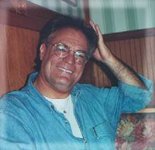
Alex Collier is a 'contactee' with a race of human looking extraterrestrials from the constellation of Andromeda. He first began to experience extraterrestrial contact during his childhood up to his mid-teens. After the experiences stopped over a period of several years, which included military service as a helicopter pilot in the U.S. Army, the contact experiences resumed in 1985. He met with two Andromedans who became his mentors and took him on board their space vehicles including a large extraterrestrial mother ship where he was exposed to the teachings of the Andromedans over a three month period. The Andromedans gave him information about cosmic spirituality, life in the universe, and Earth’s galactic history.
***

Join us at the University of Leeds Annual UK Conference

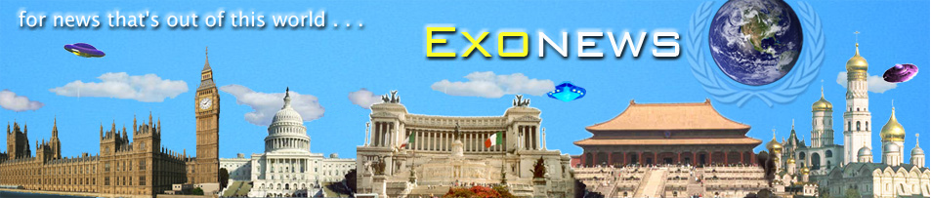
More info at: exonews.info
