

Introduction to Volume 3:2

From Secret Empire to Galactic Civilization

Our planet is undergoing a fundament transition. Secrets hitherto kept from the mass of humanity for millennia are suddenly coming into the open. This has led to the exposure of many practices and institutions that are not in integrity.

This issue of the Exopolitics Journal provides a compelling vision of humanity’s evolution into a fully developed member of Galactic Society. The three research articles discuss humanity’s historical evolution into a society that can successfully blend expanded consciousness with advanced technology. Those familiar with the evidence of advanced extraterrestrial life and technology, understand the need for expanding human consciousness in order to integrate these technologies in a harmonious way. Those interested in ways to harmoniously integrate human consciousness and advanced technology will be pleased to find much in the three articles that helps identify how this can be done.

Alfred Webre, J.D. who was responsible for an extraterrestrial communication study supported by the Carter administration, outlines his vision for a future where extraterrestrial communications take place with an article titled, “Exopolitics and a Positive Human Future.” Alluding to his earlier communication study, he points out that “exopolitics provides a path for minds to go where they had not ventured before.” He demonstrates how the “exopolitics model has provided an accelerating interface between human and advanced Extraterrestrial societies.” Webre goes on to point out that the “degree of conscious interaction and cooperation among human society and advanced, ethical Extraterrestrial civilizations will be a determining factor in a positive human future.” This is the first installment of a two part article by Alfred Webre.

The second article is by distinguished former South African civil servant, Douglas McClure. In “The Origins of Humankind – Quo Vadis - past surprises/future revelations,” he points out that “Darwin’s ‘missing link’ may have been found through information contained in a form of time capsule involving ancient Sumerian clay tablets outlining the origins of man.” McClure shows how the Hubble telescope images are leading a “sudden and dramatic expansion of the human consciousness round the world.” He concludes that this carries enormous ramifications with it for the further evolution of humanity.”

I authored the final article titled “Are ‘Celestials’ assisting Humanity in Relations with Extraterrestrial Life?” In it I refer to individual testimonies and historical records describing highly developed ethical beings, whom I call ‘celestials’, often witnessed in association with extraterrestrials. In contrast to extraterrestrials, celestials are not dependent on technologies for communication and travel. I describe the historical role played by ‘celestials’ in intervening in human and extraterrestrial affairs. I show how increased awareness of the historic presence of celestials can assist humanity in making the transition to a mature galactic culture, wherein open contact with extraterrestrial civilizations occurs.
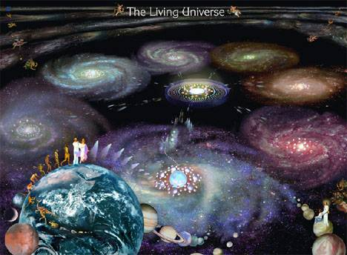
All three articles in this first issue of the third volume of the Exopolitics Journal form essential reading for those interested in humanity’s evolution into a galactic society.

I am also pleased to announce a number of important changes designed to help promote the Exopolitics Journal as a scholarly research tool for all interested in public policy questions concerning extraterrestrial life. First, the Journal was recently assigned an International Standard Serial Number (ISSN). This was assigned to all back issues, and now appears for each article. This helps give the Journal greater exposure in universities and research institutes since some academics require the ISSN number for research and citation purposes.
Second, the Exopolitics Journal decided to focus on 4000-6000 word research articles for future editions. Each article will in future need to be positively evaluated by at least two researchers before appearing the Journal.

Third, in order to assist the Journal’s transition to a peer review journal, more respected exopolitics researchers have been asked to join Editorial Advisory Board. I am pleased to announce Alfred Webre J.D.; Victor Viggiani, M.Ed. and Paola Harris, M.Ed., have agreed to join Thomas Hansen, Ph.D., Dr Rebecca Hardcastle, Manuel Lamiroy, Lic. Juris. and David Griffin, M.Sc., on the Journal’s Editorial Advisory Board. I thank my valued exopolitics colleagues for their past and future assistance in evaluating article submissions and helping the development of the Exopolitics Journal.

The January 2009 edition of the Exopolitics Journal is available at: http://exopoliticsjournal.com/

Michael E. Salla, Ph.D.
Chief Editor, Exopolitics Journal



