

Exopolitics: Discipline of Choice for Public Policy Issues Concerning Extraterrestrial Life

Michael E. Salla, M.A., Ph.D.

Introduction
The existence of extraterrestrial life has long been a subject of intense speculation and fierce public debate. Speculation has focused on the more than 200 billion solar systems known to exist in the Milky Way, and similar figures for other galaxies, that might harbor advanced extraterrestrial life. This is exemplified in estimates of extraterrestrial life in the galaxy provided by Project OZMA participants (forerunner to Search for Extraterrestrial Intelligence - SETI), who in a 1961 meeting agreed on the Drake equation. They came up with the initial figure of 10,000 technological civilizations scattered throughout the galaxy. Such estimates have allowed futurists and science fiction authors to speculate on what such life would be like, and how it may impact on human society at some future date. Scientific speculation has taken the form of estimating the possibilities of advanced extraterrestrial life evolving in our galaxy, and the levels of scientific advancement that these would have reached. The Russian Astronomer Nikolai Kardashev, for example, speculated that advanced extraterrestrial civilizations could be distinguished by the quantity of energy they used. This could occur at a planetary level (Type I), stellar level (Type II) or galactic level (Type III).

Public debate concerning extraterrestrial life has focused upon extensive visual sightings, radar trackings and photographs of Unidentified Flying Objects (UFOs) that appear to be under intelligent control. Many UFO sightings have been acknowledged by government officials as not explainable in terms of known aircraft or natural phenomena, and have even been reported to outperform the most advanced aircraft possessed by industrialized nations. For example, former Chairman of the Joint Chiefs of Staff in the U.S., General Nathan Twining, made the following declaration about the “flying disks” phenomenon in September 1947: “The phenomenon reported is something real and not visionary or fictitious.” Such comments by similar senior military or government officials have led to the extraterrestrial hypothesis that UFOs are extraterrestrial in origin, as a possible explanation. More recently, a growing number of former government, military and corporate officials have come forward to disclose direct experience of UFOs and extraterrestrial life, and of government suppression of corroborating data.

While speculation and debate continues around the subject of extraterrestrial life and its relation to UFO sightings, there has been growing controversy about how to approach the growing pool of data available in the public domain, primarily through the internet. The data comprises many thousands of accounts by both private individuals; and former corporate, military and government officials; who have made available personal testimonies, photos, videos and documentation concerning extraterrestrial life. National governments have also significantly contributed to the growing pool of open source data available. The U.S. government, for example, has made available many documents through Freedom of Information Act requests that are now available on the internet. Similarly, governments such as France and Britain in 2007 and 2008 placed thousands of UFO case files on the internet.

One approach to the public database has been to focus primarily on evidence concerning UFOs, and to subject this to rigorous scientific analyses to determine its credibility. Another more recent approach gaining popularity has been to focus on the public policy implications of evidence concerning extraterrestrial life. These respective approaches are generally known as ‘UFOlogy’ and ‘exopolitics’. The supporters of each approach advocate distinct methodologies for dealing with the data available in the public domain. In this paper, I contrast these two approaches to UFO-related data in terms of their suitability for comprehensively understanding the public policy implications of extraterrestrial life.

UFOlogy and Emphasizing Scientific Study of Physical Evidence
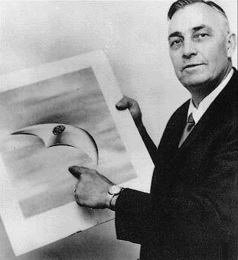
The field of UFOlogy is generally accepted to have started with sightings of what were initially called ‘flying saucers’ by Kenneth Arnold in June 1947. The frequency of flying saucer reports in the U.S. quickly led to a classified study by the U.S. Air Force with the initial assistance of the Federal Bureau of Investigation in 1948. Documents have emerged to confirm that the Air Force commissioned technical specialists at its Air Technical Division at Wright Patterson Air Force Base to conduct a detailed investigation. The resulting investigation of approximately 300 cases produced a highly classified study called ‘The Estimate of the Situation’ in September 1948, whose initial conclusion reportedly supported the extraterrestrial hypothesis. The Estimate and its remarkable conclusion was moved all the way up the Air Force hierarchy to the desk of the Chief of Staff, General Hoyt Vandenberg who, according to unconfirmed reports, rejected it and made clear that support for the extraterrestrial hypothesis was not an acceptable conclusion for reasons related to national security. According to Captain Edward Ruppelt, who in 1952 set up and was in charge of Project Blue Book, the official USAF investigation of the UFO phenomenon: “The general said it would cause a stampede....How could we convince the public the aliens weren’t hostile when we didn’t know ourselves? … the general ordered the secret analysis burned. But one copy was held out - Major Dewey Fournet and I saw it in 1952.”

If accurate, Ruppelt’s statement suggests that the extraterrestrial hypothesis was not a neutral scientific problem to be determined by technical specialists, but an issue of utmost national security concerns. Clearly, the public policy implications of extraterrestrial life, trumped any neutral scientific study of the phenomenon. It could not be assumed that the findings of any genuine investigation of UFOs would be released to the general public. The subsequent official U.S. Air Force study of UFOs, Project Blue Book, was dogged by criticisms by UFO researchers that important evidence was being overlooked. The most well-known critic was Major Donald Keyhoe who wrote a number of books concerning ‘flying saucers’. He eventually became the head of the National Investigative Committee for Aerial Phenomenon (NICAP) which was created in 1956 to initiate civilian investigations of UFO’s and to pressure the USAF to conduct more thorough investigations. Keyhoe and NICAP employed well-credentialed scientists, engineers and former officials to build impressive database confirming the reality of UFOs and the support this gave to the extraterrestrial hypothesis. Regardless of Keyhoe’s and NICAP’s efforts, USAF and official government attitudes were dismissive, and even recommended debunking of UFO reports on national security grounds.

The 1953 CIA-sponsored Robertson Panel delivered a report, the Durant Report, that recommended ridiculing the flying saucer phenomenon and the possibility of extraterrestrial life, for national security reasons. The Report stated:

The "debunking" aim would result in reduction in public interest in "flying saucers" which today evokes a strong psychological reaction. This education could be accomplished by mass media such as television, motion pictures, and popular articles.… Such a program should tend to reduce the current gullibility of the public and consequently their susceptibility to clever hostile propaganda.

Subsequent debunking by government and military officials culminated in Keyhoe and some UFO researchers concluding that a government conspiracy existed to cover up information. Keyhoe’s 1955 book, The Flying Saucer Conspiracy, detailed the extent to which the U.S. military was silencing personnel from revealing what they had seen and withholding corroborating physical evidence.

Other UFO researchers, in contrast, insisted that the government had merely “fouled up” its study of UFOs, and that no government conspiracy existed. The consensus between the two groups of UFO researchers was that more emphasis would be given to establishing the scientific merit of UFO evidence, to counter the debunking efforts of government officials and members of the public. Public policy implications of the data confirming the reality of UFOs and the likelihood of the extraterrestrial hypothesis would be put off to some future date when evidence would be sufficiently overwhelming to remove all possible doubt.

As a field of study, UFOlogy therefore concentrated on scientific analysis of physical data associated with UFOs, and minimized speculation on the origins of UFOs and the extraterrestrial hypothesis. This is best demonstrated in a famous definition by Dr Allen Hynek, who defined the scientific study of UFOs as follows:

We can define the UFO simply as the reported perception of an object or light seen in the sky or upon the land the appearance, trajectory, and general dynamic and luminescent behavior of which do not suggest a logical, conventional explanation and which is not only mystifying to the original percipients but remains unidentified after close scrutiny of all available evidence by persons who are technically capable of making a common sense identification, if one is possible.

Leading UFOlogists such as Dr Hynek were not receptive to the idea that government entities were systematically tampering with evidence and intimidating individuals into silence. Any government ‘cover-up’ was limited to maintaining silence on evidence confirming UFO’s, and not admitting to blunders in official studies of UFO’s. Thus the government ‘cover-up’ or ‘foul-up’, according to UFOlogists, could be overcome by more detailed scientific studies.

The view that a ‘hard’ cover-up existed in terms of systematic evidence tampering and intimidating witnesses by draconian security measures was dismissed. The idea of a ‘hard cover-up’ would seriously undermine the merit of the scientific method championed by UFOlogists for getting to the truth. Given that leading UFOlogists were scientists with backgrounds in engineering, astronomy, meteorology, physics, and/or image analysis, who were “technically capable of making a common sense identification”, the ‘hard cover-up’ idea was dismissed as unsubstantiated conspiracy theory. Consequently, neither the UFO data that pointed to the existence of extraterrestrial life, nor evidence of a high level government cover-up on national security grounds, would be discussed in terms of its public policy implications.
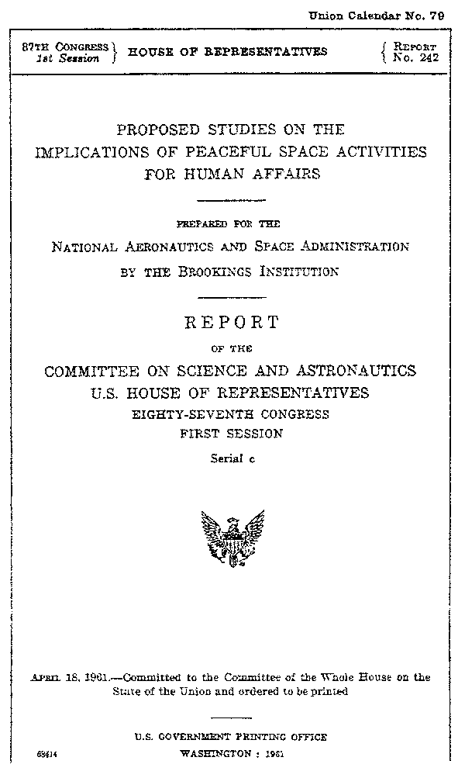
UFOlogy as a field of study was not receptive to analyses of the public policy implications of extraterrestrial life which was regarded as premature and too speculative. Instead, a number of ad hoc public policy measures were adopted in terms of briefings of government officials and the mass media of the need for serious scientific study of UFOs given the quality of evidence. This attitude has not appreciably changed over the sixty-year period of UFO investigations by official and private entities. It is best exemplified in documents such as “The Best Available Evidence” which was circulated in a confidential policy initiative by Laurence Rockefeller to brief the Clinton Administration of UFOs in the early 1990s. More recently, a Press Conference at the National Press Club in Washington DC chaired by former Arizona Governor Fife Symington, focused exclusively on expert witness sightings of UFOs. The extraterrestrial hypothesis was deliberately excluded from discussions by Symington and the organizers.

The Brookings Report and Public Policy Implications of Extraterrestrial Life
While UFOlogists avoided analysis of the public policy implications of extraterrestrial life, official documents would slowly emerge detailing such implications. Undoubtedly the most important document to publicly emerge is the 1961 Brookings Institute study commissioned by NASA on behalf of the U.S. Congress. Titled “Proposed Studies on the Implications of Peaceful Space Activities for Human Affairs,” the Brookings Report devoted several sections to discussing the public policy implications of extraterrestrial life. The Brookings Report delivered to the U.S. Congress in April 1961, described the potential impact of extraterrestrial life or ‘artifacts’ being found on nearby planetary bodies. The Report stated:

While face-to-face meetings with it [extraterrestrial life] will not occur within the next 20 years; artifacts left at some point in time by these life forms might possibly be discovered through our space activities on the moon, Mars, or Venus.

The Report described the unpredictability of societal reactions to the discovery of extraterrestrial artifacts:
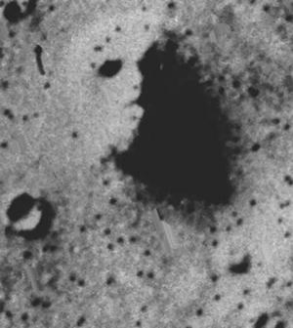Viking Photo: Face on Mars

Evidences of its [extraterrestrial] existence might also be found in artifacts left on the moon or other planets. The consequences for attitudes and values are unpredictable, but would vary profoundly in different cultures and between groups within complex societies; a crucial factor would be the nature of the communication between us and the other beings.

The Report also mentioned that devastating societal effects could also result from contact with more technologically advanced off world societies:

Anthropological files contain many examples of societies, sure of their place in the universe, which have disintegrated when they had to associate with previously unfamiliar societies espousing different ideas and different life ways; others that survived such an experience usually did so by paying the price of changes in values and attitudes and behavior.

The Brookings Report went on to raise the possibility of suppressing any announcement of extraterrestrial life or artifacts for national security reasons: “How might such information, under what circumstances, be presented or withheld from the public?” Significantly, the Brookings Report pointed out that “of all groups, scientists and engineers might be the most devastated by the discovery of relatively superior creatures, since these professions are most clearly associated with mastery of nature.”
The Brookings Report provides the first officially sanctioned analysis of the public policy implications of discovering extraterrestrial life and/or artifacts. The Report confirms the unpredictability of societal responses around the globe, and raises the possibility of societal collapse. The clear conclusion is that the discovery of extraterrestrial life and/or artifacts would be of the utmost national security concern. Furthermore, the Brookings Report alluded to the possible desirability of withholding from the public any discovery concerning extraterrestrial life and/or artifacts on national security grounds. It should be pointed out that the Brookings Report itself, while not a classified document, was mysteriously withheld from the general public until 1993 when it was discovered at a Federal Archive in Little Rock, Arkansas. The conclusions of the Brookings Report and its non-availability for over thirty years, helps confirm that an official effort was well underway to discourage discussion of the public policy implications of extraterrestrial life.

The Brookings Report together with the Durant Report make it possible to identify ten significant public policy questions concerning extraterrestrial life that are raised by these official documents:

- Is an official cover-up of extraterrestrial life justified on national security grounds?
- To what extent would official disclosure of extraterrestrial life destabilize global society?
- What segments of American and global society would be most affected by disclosure of extraterrestrial life?
- To what extent are the tools of psychological warfare such as debunking and discrediting of witnesses, to be used on the American and global public to dismiss the seriousness of data concerning UFOs and extraterrestrial life?
- To what extent is the mass media used to promote a cover-up of extraterrestrial life?
- What is the constitutional standing of classified executive orders concerning extraterrestrial life?
- To what extent does the public’s ‘right to know’ impact on official efforts to limit information on extraterrestrial life on a ‘need to know’ basis?
- To what extent would a cover-up of information on extraterrestrial life involve draconian national security measures?
- To what extent should scientific principles or technologies gained from extraterrestrial life be shared with the general public?
- Should public policy decisions concerning extraterrestrial life or technologies be decided in secretly appointed committees veiled from public scrutiny or made transparent in a highly visible public process?

These public policy questions and the issues they address arise directly out of officially sanctioned investigations, the Durant Report and the Brookings Report. The related public policy issues do not require acceptance of data confirming the reality of extraterrestrial life, only the possibility that extraterrestrial life exists.

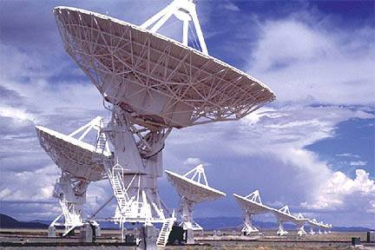
Consequently, there is an important need to systematically study such public policy issues using a range of disciplinary approaches incorporating both quantitative and qualitative methods on the publicly available evidence on extraterrestrial life and UFOs. This needs to be done in a way that satisfies two constituencies who strongly differ over the question of whether the minimum threshold of evidentiary support for the reality of extraterrestrial life has been attained. The first constituency comprises individuals and groups who do not accept that a minimum threshold of evidence has been reached to prove that extraterrestrial life exists beyond all reasonable doubt. Prominent examples include supporters of Search for Extraterrestrial Intelligence (SETI), who argue that the possibility of extraterrestrial life is sufficient to justify the investment of appreciable resources in seeking evidence through radio transmissions. Such individuals and groups largely accept the pioneering work of Frank Drake and his SETI colleagues in calculating the likelihood of extraterrestrial life existing in the Milky Way galaxy. However, many advocates of SETI openly challenge the evidence proposed by UFO researchers as having proved the existence of extraterrestrial life.

A second constituency is individuals and groups who argue that a minimum evidentiary threshold has been reached but that the general public and many scientists are not aware of this. This group believes that vigorous education programs are needed to inform the public of the available evidence, much of which has been ignored by the mass media, universities and public officials. More importantly, this second constituency argues that public policy analysis needs to proceed using the available evidence.

Exopolitics and Public Policy Concerning Extraterrestrial Life
Historically there have been a number of attempts to address key public policy issues concerning evidence of extraterrestrial life from the perspective of inadequate official investigations and governmental suppression of UFO data. These public policy issues have arisen in an ad hoc manner in the context of proposed or ongoing UFO investigations without any attempt to systematically address these issues. This has primarily resulted in attempts by UFO researchers to get national governments to initiate official investigations and to create the necessary governmental bodies to achieve this task. This is exemplified in the 1978 UN General Assembly Decision to set up a United Nations agency to investigate UFO reports and the possibility of extraterrestrial life. While lauded at the time as a great achievement by UFO researchers, to date the UN has not implemented this decision, nor made any effort to study the public policy issues associated with the evidence. Consequently, up until recently, there has been no attempt to systematically study public policy issues concerning extraterrestrial life. ‘Exopolitics’ has been proposed as a distinct disciplinary approach that attempts to provide such a systematic study.

The first reference to ‘exopolitics’ as a distinctive approach to studying public policy issues associated with extraterrestrial life appeared in a seminal 2000 paper by Alfred Webre where he wrote:

No mainstream politicians have defined extraterrestrial presence as a live political or public policy issue. No sizable number of citizens of any terrestrial nation are moved to call upon their local politicians or the political process to connect with the extraterrestrial presence, or study it, or even acknowledge it officially… Exopolitics is a fundamental organizing, mediating, social, and governmental process in our interplanetary and interdimensional space.

The need for systematic discussion of public policy issues concerning extraterrestrial life by establishing a new discipline called ‘exopolitics’ was more formally proposed in a January 2003 paper where I argued that evidence concerning extraterrestrial life would:

… lead to the birth of a new field of public policy, ‘exopolitics’, which can be defined as the policy debate over the choices governments and populations need to make in formulating and implementing legislative and policy responses to the presence of ETs in human affairs.”

More recently, a definition has been proposed for helping better formalize exopolitical study:

“Exopolitics is the study of the political actors, institutions and processes associated with extraterrestrial life.”

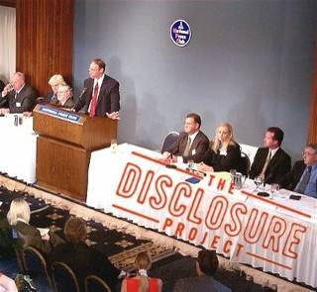
The advantage of this definition is that it makes it possible for exopolitical discussion of public policy issues without necessarily accepting that extraterrestrial life has been discovered and/or is covered up for national security reasons. This helps offset criticism that exopolitics makes a priori assumptions that extraterrestrial life exists which might be directed at alternative definitions of exopolitics. So, for example, the Brookings Report can be cited as a document making a number of exopolitical statements concerning public policy implications of extraterrestrial life, without accepting the reality of extraterrestrial life. Similarly, SETI researchers speculating about protocols for dealing with contact with extraterrestrial life are implicitly analyzing exopolitical themes.

Most supporters of exopolitics accept that the existence of extraterrestrial life has been abundantly demonstrated by a vast and ever-growing pool of evidence accumulated over the last sixty years provided by eyewitnesses, whistleblowers, scientists, ‘experiencers’ and leaked government documents. Consequently, most advocates of exopolitical analysis claim it is finally time to focus on public policy aspects of this accumulated evidence. This is exemplified in the case of Paul Hellyer, the former Defense Minister of Canada, who has spoken at a number of exopolitical events on what he describes as some of the “most profoundly important policy questions that must be addressed.”

Alternatively, it is possible, as already mentioned, for public policy aspects of extraterrestrial life to be analyzed without necessarily accepting the veracity of evidence supporting such life. Consequently, while exopolitical analysis often proceeds from accepting the persuasiveness of evidence establishing the reality of extraterrestrial life and/or artifacts, exopolitics does not require such an acceptance as a necessary condition. A sufficient condition for exopolitical study is acceptance that the possible existence of extraterrestrial life has significant public policy implications.

Most exopolitical analysts contrast their approach with UFOlogists who continue to advocate accumulating more evidence to provide a scientific argument for proving to determined skeptics that UFOs are real and that the extraterrestrial hypothesis a legitimate focus of scientific inquiry. Exopolitics analysts conclude that much of the skepticism concerning UFOs and extraterrestrial life crosses the conceptual boundary between objective criticism and debunking. This has led to claims that the debunking performed by critics of UFOlogy and exopolitics, is part of the debunking and ridiculing effort recommended by the Durant Report, and implicitly legitimated by the Brookings Report. In short, the discussion of public policy issues concerning extraterrestrial life is itself subjected to debunking as evidenced in the 30 years of secrecy surrounding the Brookings Report and its findings. This has prevented the development of the field of exopolitics for over five decades since UFO research began in 1947.

The attempt to raise public policy discussion of extraterrestrial life has led to much debate and controversy. Supporters of exopolitics have been subjected to sustained criticisms for proposing serious public policy discussion of the available evidence. Many ‘UFOlogists’ remain highly critical of exopolitics as an emerging disciplinary approach to public policy issues concerning extraterrestrial life. UFOlogists and other skeptics have difficulty grasping that exopolitics is the forerunner to a legitimate academic discipline that can be anticipated to be eventually established in every major university for the systematic study of such policy issues. Critics of exopolitics often tend to focus on some of the pioneers of exopolitical thought in terms of their methods and ideas, rather than identifying the merits of demarcating the conceptual boundaries for a scholarly approach to public policy issues concerning extraterrestrial life.

Exopolitics as the Discipline of Choice

The present historical situation is in some ways analogous to the 19th century where there was much debate on how to prepare individuals for studying public policy issues in relation to careers in international diplomacy, public office and/or as university professors. Gentlemen drawn from the Aristocratic class formed a unique pool of amateur scholars who emphasized classical studies as the best preparation for dealing with public policy issues. They recommended the historical works of Cicero, Josephus, Herodotus, Thucydides and other ancient authors; and requisite training in Latin, classical Greek or similar ancient languages. Amateur ‘gentlemen scholars’, as they have been described, prescribed ample leisure time for study of public policy issues and criticized those who required remuneration from their studies. Nevertheless, largely out of the History departments of many universities, the new discipline of Political Science began to emerge in the 1860s; and these were staffed by salaried professionals trained in the latest methods of political scholarship and pedagogy. Political science developed as an academic discipline since it fulfilled a functional need: the need was to systematically study public policy issues, and how individuals could be trained to professionally deal with these.

Political science is now the discipline of choice for those wanting to systematically study public policy issues and to be professionally trained to work with these in various careers. Similarly, exopolitics will be the discipline of choice for those desiring to study public policy issues associated with extraterrestrial life, since it also fulfills a functional need. The functional need is to understand how extraterrestrial life impacts on public policy issues, and to professionally train individuals to deal with these. Exopolitics will be first established in departments of political science as a legitimate sub-field, as is currently the case with ‘international politics’, ‘foreign policy’, ‘comparative politics’, ‘political economy’, etc., in many political science departments. The precursor to such academic studies is the Exopolitics Certification Program created with faculty drawn from the Exopolitics Institute. Eventually, exopolitics will emerge as a distinct department with an interdisciplinary focus spanning public policy issues relating not only to political science, but to exoscience, exoreligion, exodiplomacy, etc.

Debunkers, UFOlogists, SETI researchers and other critics of exopolitics are poor students of history not to have observed how academic disciplines and sub-fields develop to fulfill functional needs. Such individuals are remiss in not observing how exopolitics will fill the functional need for the systematic study of public policy issues concerning extraterrestrial life. The choice of the word 'exopolitics' to represent this nascent academic discipline has long-term strategic value due to the functional need it fills. Furthermore, exopolitics is the term of choice to deal with the public policy issues identified earlier, and others that arise from documents and evidence concerning extraterrestrial life and technologies.

Both UFOlogy and SETI will become redundant as fields of study since the functional needs each serves will quickly be settled once the existence of extraterrestrial life is accepted. The reality of UFOs will be moot once they have been publicly identified as ‘extraterrestrial’, ‘interdimensional’ or ‘extratemporal’ in origin. UFOs that are extraterrestrial origin will no longer form a unique conceptual category of unidentified flying objects, but will become identified as extraterrestrial vehicles (ETVs). Similarly, continued efforts to “search for extraterrestrial intelligence” will also become redundant. Discerning the existence of extraterrestrial life through radio communications will cease to have much of a functional need once such life has been confirmed.

Those devoted to UFOlogy and SETI are missing a great opportunity to contribute to establishing legitimate conceptual parameters for exopolitical study. Experts in both fields of study can assist in bringing clarity to the public policy implications of a phenomenon they are also interested in. Exopolitics is here to stay as the discipline of choice for understanding the public policy implications of extraterrestrial life. Exopolitics as a new branch of knowledge will revolutionize academic studies and the world as we know it.

About the Author: Michael E. Salla, PhD., is the author of Exopolitics: Political Implications of the Extraterrestrial Presence (Dandelion Books, 2004) He has held full time academic appointments at the Australian National University, and American University, Washington DC. He has a PhD in Government from the University of Queensland, Australia. He is the Founder of the Exopolitics Institute (www.exopoliticsinstitute.org ) and the popular internet website Exopolitics.Org; Chief Editor of the Exopolitics Journal, and Co-Organizer of the Earth Transformation: New Science, Consciousness and Cosmic Contact conferences in Kona, Hawaii.




ENDNOTES

Grateful thanks to Dana Tomasina for proof-reading the final version of this article.
See Frank Drake, “The Drake Equation: A Reappraisal,” in First Contact: The Search for Extraterrestrial Intelligence, eds. Ben Bova & Byron Preiss (Bryon Preiss, 1991) 115-17.
Kardashev, N. S. "Transmission of Information by Extraterrestrial Civilizations," Soviet Astronomy, 8:2 (1964) 217-21.
Letter From General N.F. Twining to Commanding General, Army Air Forces, 23 September 1947, Available online at: http://everything2.com/index.pl?node_id=679398
For comments by former military and government officials concerning UFO’s see Don Berliner with Marie Galbraith and Antonio Huneus, UFO Briefing Document: The Best Available Evidence (UFO Research Coalition, 1995) 153-208.
See Steven Greer, Disclosure: Military and Government Witnesses Reveal the Greatest Secrets in Modern History (Crossing Point Inc., 2001). Website: www.disclosureproject.com
France’s UFO files are available online at: http://www.cnes-geipan.fr . The UK’s Ministry of Defense UFO files are available online at: http://www.mod.uk/DefenceInternet/FreedomOfInformation/PublicationScheme/SearchPublicationScheme/UnidentifiedAerialPhenomenauapInTheUkAirDefenceRegion.htm
For detailed analysis of what occurred with the initial “Estimate of the Situation,” See Michael Swords, “Project Sign & Estimate of the Situation,” Journal of UFO Studies, 7. Available online at: http://www.ufoscience.org/history/swords.pdf
Donald Keyhoe, Aliens from Space (Signet Books, 1973) 14.
Donald Keyhoe’s first book was The Flying Saucers are Real (Fawcett Gold Medal, 1950).
Cited from online version of Robertson Panel at: http://www.cufon.org/cufon/robertdod.htm
Donald Keyhoe, The Flying Saucer Conspiracy (Henry Holt & Co. 1955).
Allen Hynek, The UFO Experience: A Scientific Inquiry (Henry Regnery Company, 1972), 10.
Allen Hynek, The UFO Experience, 10.
See Don Berliner, et al., UFO Briefing Document.
For media coverage of the November 12, 2007 National Press Club Conference on UFO’s go to: http://cficoverage.wordpress.com/
Brookings Report, 215. For an overview of the Brookings Report, go to: http://www.enterprisemission.com/brooking.html
Brookings Report, 215.
Brookings Report, 215.
Brookings Report, 215.
Brookings Report, 225.
See Richard Hoagland and Mike Bara, Dark Mission: The Secret History of NASA (Feral House, 2007) 81.
See Frank Drake, “The Drake Equation: A Reappraisal,” in First Contact, eds. Bova & Preiss, 115-17.
See Isaac Asimov, “Terrestrial Intelligence,” & Arthur C. Clarke, “Where Art They” in First Contact, eds., Bova and Preiss, 29 & 310.
See Donald Keyhoe, Aliens from Space.
For discussion of an evolution in approaches to public policy issues concerning extraterrestrial life, see Michael Salla, “The History of Exopolitics: Evolving Political Approaches to UFOs and the Extraterrestrial Hypothesis" Exopolitics Journal 1:1 (2005) 1-17. Available online at: http://exopoliticsjournal.com/Journal-vol-1-1.htm .
See UN General Assembly Decision 33/426, 1978 . Available online at: http://www.ufoevidence.org/documents/doc902.htm
First published in June 2000 and republished in the Exopolitics Journal 2:2 (2007): 142-50. http://exopoliticsjournal.com/vol-2/vol-2-2-Exp-Webre.htm
See, Michael Salla, “The Need for Exopolitics, Implications of Extraterrestrial Conspiracy Theories for Policy Makers and Global Peace,” www.Exopolitics.Org (January 2003): http://exopolitics.org/Study-Paper1.htm . Paper published as chapter one in Exopolitics: Political Implications of Extraterrestrial Life (Dandelion Books, 2004).
This is a revised version of a standard definition I proposed in 2005 in my paper, "The History of Exopolitics” Exopolitics Journal 1:1 (2005) 1-17.
See Michael Michaud, “A Unique Moment in Human History,” in First Contact, eds., Bova and Preiss, 243-61.
See Michael Salla, “Using Space Weapons Against ET Civilizations,” Nexus Magazine 14:2 (2006). Available online at: http://exopolitics.org/Study-Paper-10.htm .
See Michael Salla, Corso’s Critics "Colonel Philip Corso and his Critics: Crossing the Rubicon between Objective Criticism and Debunking" - Parts 1 & 2 Exopolitics Journal 1:2 & 1:3 available online at: http://exopoliticsjournal.com/Journal-vol-1-2.htm & http://exopoliticsjournal.com/Journal-vol-1-3.htm .
For example, see Kevin Randle, Exopolitics, available online at: http://kevinrandle.blogspot.com/2005/11/exopolitics.html
See Michael Parenti, “Patricians, Professionals and Political Science,” American Political Science Review, 100:4 2006) 499. Available online at: http://www.apsanet.org/imgtest/APSRNov06Parenti.pdf
See Michael Parenti, “Patricians, Professionals and Political Science,” American Political Science Review, 100:4 2006) 499. Available online at: http://www.apsanet.org/imgtest/APSRNov06Parenti.pdf
See: http://exopoliticsinstitute.org/certificates/

