

Extraterrestrial Guides: The Great White Brotherhood in the Andes & Lake Titicaca

by Luis Fernando Mostajo Maertens

Earth Transformation: New Science, Consciousness and Contact Conference,
May 17, 2008, Kailua-Kona, Hawaii

[Editorial Note. Luis Fernando’s conference presentation was spoken in Spanish, and was translated by Manuel Roberto. All attempts have been made to transcribe this presentation as accurately as possible. Transcribed by Gesan Lahman]

Abbreviations
LF = Luis Fernando (Mostajo Maertens)
MS = Michael Salla (Conference MC)

MS: We’re ready to launch into the presentation for this afternoon. This next presentation is about something that I hold very dear in my research on extraterrestrial life, which concerns the experiences of those that have had direct, face-to-face encounters with extraterrestrial beings. These people have a story to tell which is so profoundly transformative and, according to my research, is so disturbing to vested governmental and security interests that they have tried very hard, for over 60 years, to suppress this kind of information. So, it’s such a thrill to be able to hear from someone who comes forward and speaks with great authority from their own personal experience – someone whose voice hasn’t been muted, someone who has the dignity and the integrity to carry on despite whatever opposition he finds.

This person comes from Bolivia. He has had contact with extraterrestrials from the planets Venus, and Ganymede, which is one of the moons of Jupiter. And he has also had contact with the Inner Earth Beings – the Elders, who are those associated with the Great White Brotherhood. Luis Fernando Mostarjo has been having physical contact experiences since birth. In 1977, when he was 13, he began to speak about these experiences, and he continues to do so to this day. For over 30 years now he’s been speaking with great authority about his experiences. And for decades he’s been holding Contact Preparation Courses in the countries of South America – Argentina, Chile, Peru, Paraguay, El Salvador, and Central America – in Honduras, Costa Rica, in Mexico, in the US, and, of course, Bolivia. He’s published five books wherein he shares these experiences that he has had with extraterrestrials. I believe he has a few of the books at the back, so you can have a look at those…. There’s one translated into English. It’s definitely something worth having a look at. He has demonstrated, to detached observers, that his experiences are very real. He’s had people come from the TASS Agency to watch programmed UFO sightings. This is something that he has been able to succeed in manifesting, according to the communications he has had. So, I won’t take up any more of your time, Luis. I welcome you. Luis will be translated by Manuel Roberto, who is also going to be our performer tonight. Manuel is multi-talented, multi-tasking like many of our great volunteers here. So with that, welcome, Luis and Manuel.

Audience applaud.

LF: Good afternoon, everyone. Thank you, Angelika and Michael, for allowing me the opportunity to be able to be here with all of you, to tell you about my experiences of over 30 years of contact not only with ETs, but also with the teachers of internal meditation. My experiences started in 1975, with telepathic communications. Through these communications they asked me to get out of the city. These are beings who come from our solar system, from the second planet of our system. We call that planet Venus… The Morning Light. They claim, in their communications, that, not only now but for many, many thousands of years, they are forming a Great Plan of assisting and helping this planet. These beings that come from Venus are here – their influence is felt, especially here in North America, Central America, and South America. Especially during the first or original cultures of the Americas. They manifested themselves telepathically.

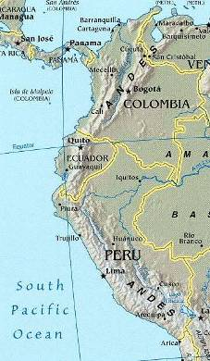
They are here now trying to establish a bridge of communication with, because, for them, it’s part of a program of assistance. It is a mission of contact because the evolved worlds that are in this galaxy, who form the Confederation of Planets, have seen, at this time, not only the changes of this Earth, but also of the whole galaxy. They claim that this planet as we know it is not finished evolving. It is still transforming itself. Within this transformation, it is up to us to take a part, a role, in this planet regarding these changes that are happening. They claim, firstly, that the whole universe is pure energy, and, secondly, that this energy is dynamically acting upon all stars in the galaxy, which are continually transferring information. The universe, as we see it at night, is constituting itself into the universal consciousness. Our sun is receiving this cosmic energy and it is sending back to our planet, determining the conditions of life and living for humanity.

For thousands of years this cosmic energy was concentrated in the mythical mountains of Tibet. But, after the Second World War, this energy, which is part of the cosmic energy of the planet – and it had a masculine-positive form – was transferred to the Americas. In its feminine aspect, or negative charge…. Negative doesn’t mean bad, but a quality that is represented. The feminine energy is concentrated in the Americas, all along the Andes and going all the way up to Mt Shasta. This energy has its center in Lake Titicaca because it’s the highest place, at 3800 meters above sea level, forming a great place for concentrating the energy. Later on we are going to see more about that. But I will to tell you this; the Great White Brotherhood has deposited there a wonderful instrument known as the Sun.
Now, the ET guides invited me, along with six other friends, to go to a place called the Animas at nine o’clock at night. They said they were going to come with their ships, confirming the telepathic communication that I had back in 1977. So, that date I went with my friends to this place, and what I saw changed my life. Five different objects appeared in front of my eyes. They started to send beams of light, as if they had powerful flashlights, that were illuminating great extensions of land, for about fifteen minutes. While that was happening, I received more telepathic communications from the ET guides who were claiming to start a new process of preparation, for us to be able to have physical contact with them – and not because they are better than we are, but because the fields of energy in which they move around are different than our fields of energy. They suggested that we need to start a different civilization for our physical structure, our thoughts, and to elevate our spiritual vibrations. They also suggested that we start a process of vegetarianism in order to elevate our vibration. Then they can come down and contact can be made.

They claim that around Lake Titicaca area they have supported the civilizations of two great solar cultures. One civilization is that of Tiahuanaco which, even today, very few people know about it, that is considered the most ancient in South America. But recently, excavation began and now it is about 10 percent excavated so far. I was telling them about the concentration of cosmic energy in this planet – the positive energy and the negative energy – that it is specifically concentrated in Tibet, in Lake Manasarovar; and also in Lake Titicaca, in South America.
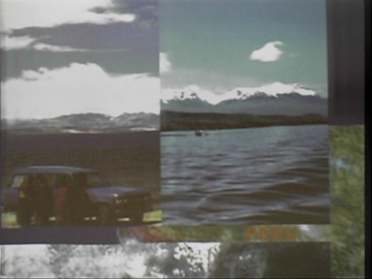
It is curious to see these two photographs [Indicating the video image on left]. But down there, there are Tibetan people. So if there weren’t these Tibetan people here, then we could say that it looks to be the same place. The mountains of the Himalayas are very similar to those of the Andes.

Within this area in Lake Titicaca, and part of the Andes, there is a triangle of energy where the extraterrestrial guides were assisting the development of the original South American cultures until the Golden Age of Tiahuanaco. It is known today as the Solar Civilization. The Tiahuanaco civilization has been debased by the many theories that have been evolved. Some theories sustain that the Tiahuanacans began and developed the Golden City of America – the famous Paititi. In the Amazon section of Bolivia we have found archeological ruins which today don’t have any explanation because they are very different.

These ancient people had a very advanced technology by which to control the weather for farming and irrigation. There were very, very large pools that were created, located farther away, but they were built in order to feed many people, through the preparation of the land. They were able to feed millions of people, not just thousands. Regarding the Tiahuanaco civilization, there are many speculations over the origin of the famous Paititi. In the last few years, Gene Allen the famous British archeologist …

Have you ever listened to this gentleman on the Discovery channel, British archeologist Gene Allen, who did a documentary about Atlantis in the Andes…. The satellite photographs have shown that there is a city underneath everything. With regard to all of these buildings, there are pools and canals of high technology that are very ancient, dating back thousands and thousands of years. Recently some archeologists have found, around the archeological ruins of Tiahuanaco, writing, dating from the pre-Sumerian period. This is obligating us to rewrite history.

With regard to Dr Michael Cremo’s lecture yesterday, he spoke about the archeological findings of some footprints, dating back millions of years ago. Recently, the Institute of Bolivian Archeology found a petrified footprint which, according to the carbon-14 analysis, was made during the Tertiary Age, about 15 million years ago. This footprint corresponds to a normal homo-sapien of about 5’12” and about 80lbs. It is important to know about these things because, certainly, something happened in the past indicating that there have been other civilizations much more developed than ours. But, they disappeared. They claim that the disappearance of previous civilizations was not only due to natural catastrophes, but also because of man himself.

That reason for the disappearance is the message that we need to take into account. It is what the ET guides are telling us about. They have been reminding us that we, too, are living our last opportunity toward evolving ourselves as a civilization. What we need to do now is discover precisely what happened in the past, learn the lesson from it, and plan for our future by understanding the past with regard to our present.

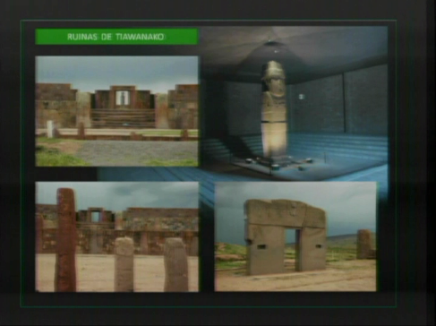
What you are looking at [image on left] is the remnant of what was the way of life in Atlantis, and the guides from Venus.

An astrologist has studied the Door Of The Sun, and he has determined that what is depicted, here [on the image], represents Venus. Venus has 292 days of rotation around the sun, and from that depiction on this Door Of The Sun, it is now known as the Calendar Of Venus.

It has been mentioned that not only the Tiahuanaco civilization was influenced on our planet by these off planet civilizations…. In the original cultures of North America, we know that the Apaches to this day are direct descendants of these guides. The information that they have is starting to be discovered, and it is also now being understood at this time. At this point, the ET guides have been contacting me and they are manifesting themselves to me. They have continuously invited me to different places where they manifest themselves, such as in the Andes, as well as in the Amazon. It is through these experiences of a contact program that I have become familiar with their presence.
Now, they claim that the greatest barrier for the human being is fear of the unknown. Consequently, they claim that what we must learn is to control our fears, our emotions, so that our contact with them can be possible. So, they invited me to many inhospitable places, sometimes by myself, sometimes with a group, so that I could conquer my own fears and emotions – something very, very difficult to do.

I remember thinking, If the guides are observing me, nothing wrong can happen. But then when you start walking around in the middle of the night, and you’re 3 meters down the road, and suddenly you start feeling like someone is touching your back, that’s when you get chicken-skin. Later, I realized that when you have this kind of experience a lot of emotions start coming up from inside you. So not only do you need to recognize them as they come up, you also need to overcome them. This is what constitutes the preparation of self-control. But in my case, this emotional preparation lasted more than a year. It lasted for 3 years. During this preparation process the guides gave me tools. They imparted to me a name which is known as the cosmic name. They claim that all the living beings in the universe have a unique key which is not duplicated to anyone else. It is your own unique cosmic name.

When you start working with your own key, a lot of memories start waking up from within your sub-consciousness. You start remembering who you are. You remember who you are and where you come from. You remember what is your present mission, and where you need to go in the future….During my experience when I was with the extraterrestrial guides, they asked me to extend my hands. When I did so, a ship started coming down. It was above me. It started sending me this energy which came down into my hands, in a physical form, like two pyramids. It was integrated inside of my body, a few centimeters above the thymus where there is the terminal of our radial nerves, and which allows the body to assimilate the energy. They explained to me that this experience and this tool is not only given to all the spiritual beings that are working for this change, but is also given to the planet for its transformation.

Since biblical times they have been giving these tools to other beings. If you remember in Genesis, when the people of Israel were leaving Egypt, the priests, in order to offer the host, did the ceremonies. They would put the two stones, known as the Urim and Thumim. Here in North America, the last record of this experience was with Joseph Smith, who also received two white stones in order to translate the golden plates. What the extraterrestrial guides are doing now, though, is giving us new tools that enable us to awaken our sixth sense – the sense of clairvoyance – so that we can see beyond our physical eyes, to see with our spiritual eye the life that exists in the next dimension. So, after three years, I became familiar with all of their ships. What I am telling you was witnessed by myself and by the group of people, my friends, who were with me.

Now, a ship … was in charge of opening a dimensional field known by them as the Door Of The Sender. These doors are a concentration of luminous energy that allows us to introduce ourselves to them by accelerating our vibration which dematerializes the molecules of the body so we can project ourselves to the place where they are waiting for us. This is not science fiction. Even today our own science is developing a machine of teleportation. It transports one particle here to another location there. This brings to mind the Philadelphia Project in the United States. Through this program experience, the ET guides from Venus were wondering if I would be able to speak the truth of what they were telling me.

They are aware that the human being, since birth, learns by imitation. So, when we come into contact with a different civilization which is much more evolved than ours – one that has gone beyond war, illness, famine, lack – then we can come to understand this higher concept of life, and we can share it with other people in the very places where we live. We can help people who will then help other people to understand this higher concept of life. They claim that some people believe that a great ship is going to come down out of the sky and magically change everything for us. No. It is the human being who must assume that responsibility of change. Right now is the time that we need to take full charge of our destiny.

After three years of preparation, I was in the middle of the Andes. They told me that at eight o’clock at night a ship was going to come to a valley called "Valle Potosi". This ship was going to monitor the materialization of the door through which I would be able to get in touch with them, and through which I would arrive at a city not located on this planet, Earth, but on Venus in a valley known to them as … the Valley Of Silence. This is a place where there are concentrated the academy of the spiritual science of this civilization.
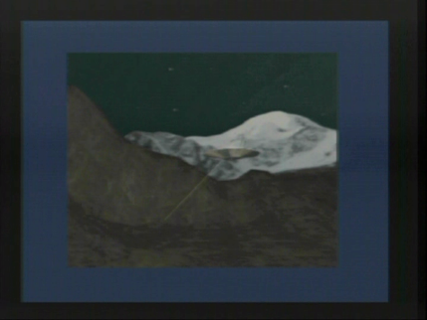
While I was in the Andes, when the ship was coming toward me, I wanted to leave but my curiosity keep me on.

An object similar to that one [on left] was between two hills. The ship was producing pulsations that were concentrating its energy like a half moon. It was a whitish color, and shining. Once the energy was materialized, they told me, “Come”. Immediately my heart started jumping. “Come,” they said again.

I started walking toward the energy coming from the ship. I began to go through the energy field and immediately I did not feel any weight. I had a sensation of vertigo, like when you are flying on an airplane, going through a turbulence, and there’s a lot of pressure in the head and chest. I wanted to leave, but I couldn’t because I was engulfed by the energy field that was pulling me forward, yet my feet were not touching the ground.

Immediately the starry night of the Andes began to transform itself into a magical valley. The sky had multi-colored forms. Immediately to my right, a being, with beautiful characteristics, said, “Don’t worry. You are here because the time has arrived for you to corroborate everything that I have told you before. My name is E’tel. During your time with us here we’re going to tell you about part of your mission, and the purpose of my presence with you.” Then he started to speak about what he was observing in the sky. It was the reaction of the clouds that surround Venus. It is known as the solar rain. That is what was producing the multi-colored sky. On this planet, Earth, there is something similar to that – the Aurora Borealis. He said that their life on Venus is subterranean. When a civilization is more evolved they don’t build above ground but mainly subterranean. And there is an explanation for that.
They believe that the ancient civilizations were trying to be as close as possible to the nucleus of the planet, to the telluric energy. That reminded me of the ancient civilizations who used to build their temples on top of a hill, or below the Earth, in order to connect the cosmic energy with the telluric energy. They said that they didn’t utilize angles, but circular and conic constructions. That reminded me of the teepees of native North Americans. They said that in their current civilization, they have less than five million people, and that they are mainly feminine. That reminded me of the Greek mythology of the muses.

The civilization from Venus is very similar to ours, but we would say ours is very similar to theirs. And there is a simple reason for that. There has been a hybrid interaction. They claim that they have had a different genetic insertion than our human insertion. The famous missing link would be the extraterrestrial genetics which those people inserted, four or five thousand years ago – cybernetic energy and other special energies. According to anthropological studies, in order to go from one state of evolution to another it takes hundreds of thousands of years, and in some cases even millions of years. So then, the question is, What happened in such a short span of time in human evolution that got us from the cave to taking trips to outer space? This new genetic insertion evolved our own species. In a very short amount of time we jumped another step.

Now, the people on Venus feed themselves the same way that we do, except that they eat only a vegetable and mineral diet. Their physical development is assisted by methods that determine the quantities of minerals and calories that one needs. Their bodies have done away with many of the organs that we still have. We still have them because we eat more than what we should. In order to maintain their species, they still have physical contact for procreation. But their union is more pleasurable because of their spiritual experience. They said that in order for us to wake up and keep advancing as a species we need to continue getting closer to ourselves and helping one another. There is an evolution chain in the universe. Some of them have reached a very high level of development socially. They are able to share that freely to people like ourselves.

Something that really touched me was how E’tel looks. He is a being of about 5’ 12”. They have clear eyes. Their skin is whitish. Their ears are bigger than ours. Their attire was fitted close to the skin. E’tel said that in order to find true spirituality, going to the top of the mountain to sit and meditate for hours is not required. To find true spirituality you only need to understand the laws of nature and how to live in harmony with nature. True spirituality is not far away. It is very close to us. One’s true transformation comes from that which allows us to change our attitude, to think positively, to feel positive, so that we then act positively.

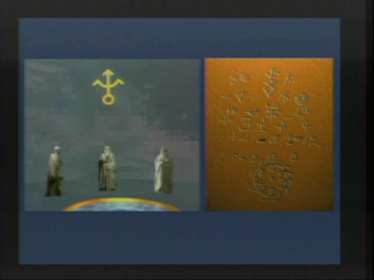
He took me to the presence of three elders – the wise people of Venus. They spoke lovingly to me through the universal language, which is not only telepathic, but is a series of ideograms, which is what they call a record [represented in image on right]. We know it as the Akashic Record. This is something that is in the Van Allen Radiation Belt around the Earth. It is continuously recording every thought of every one of us. In its physical form, there are seven shapes. That’s what the elders said.

Earth’s Akashic Records are protected by an internal government of the Earth. This internal government of the Earth is known as the Great White Brotherhood. And this Great White Brotherhood was formed at the end of the destruction of the ancient Atlantis civilization. Before the disappearance of their civilization, the elders of Atlantis protected their knowledge by placing it in trusted guardianships at the various colonies that they established in different locations inside the planet. It is at these places where the positive government of the Earth is residing. They are waiting lovingly for humanity to mature so that they can give us this knowledge and then the new humanity can be guided, like a road map, so that we don’t make the same mistakes again. That is how it was conveyed to me. So, near to where I used to live at Lake Titicaca, in another small lake known as Lago Winaymarka in the Almara language, there is one of these internal places. Part of my mission is to stay in touch with them because they are human beings, teachers who, for thousands of years, have understood the purpose of the Earth and of the creation of the cosmos.

Either way, since an image is worth more than a thousand words, I have made this recreation for you. This is close to what I saw and experienced with the guides of Venus [video simulation begins].
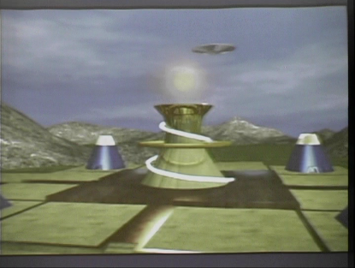
This is a way to concentrate the solar energy. This is how the inhabitants of Venus receive the solar energy and then send it out to other places [image on left]. There is vegetation in this valley, but they live subterraneously. But it is not like being in a dark cave. Within the cave itself it looks like a real sky is above you. They said that when human beings reach this kind of understanding then they will take the reigns in their own hands and will change the future positively, not only for themselves but more importantly for everyone else as well.

The elders said that human beings go through four different stages. The first stage is omnipotence. In the first 2 years of life you always get the highest attention. The second stage is dependence. We don’t do anything without consulting with our family members. The third stage is the age of rebellion. This is when human beings, in its adolescence period, start to cut all the emotional ties so as to identify themselves as individuals. Then we reach the fourth stage. There are very, very few that evolve in their lives to the fourth stage. The problems of the third stage of dependence are reflected in people’s daily lives. There are many people who get married so that they can have a husband or wife to depend on. There are people who require a political or a spiritual organization in order to follow a leader who tells them what to do.

The mature stage, the fourth stage, is where you have come to know what your own role in life is so that you don’t have to depend on a second or third person to tell you what you can or can’t do, what it is that you’re supposed to do with your life. When you arrive at that stage, when you know what you are to do and how to do it, that is what is known as the Awakening of the Consciousness. It is when you take into your own hands the reigns of your own destiny. That is when you start changing the future positively, not only for yourself but also for the wellbeing of others.

When you are the only one around who reaches that awakening, if there is no group of others, the elders said it is possible to start talking of changing at the personal level. Then you can start forming a system, like a pyramid, which we have been under for thousands of years. It is a horizontal system where you are recognizing what you have to share with others. But in order to become realized, it is more important to know what is lacking by finding in others the necessary substance for our own realization, then forming a common unity, in thought, in feeling, and in action. And that’s why we at this conference, trying to reach out to others, with feelings, with thoughts, and with actions, so we can vibrate like one, regardless of where each one of us is independently located.

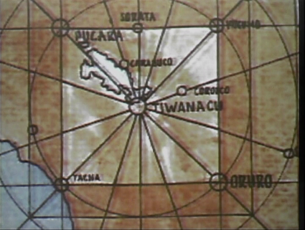
When I came back from my contact with the guides, I became aware of what they had told me – that near Lake Titicaca there is a retreat of the White Brotherhood.
The first thing that came to my hands was a map [on right]. This map was achieved with all the archeological findings around the Andes.
The archeologists have determined that there is a big net forming a square cross. This square cross, in the Aymara language, is known as a “Chakana.” It is going to show us that the people of this area have perfect knowledge of the geomagnetic movement of the Earth because their buildings were not haphazardly placed, but in special natural magnetic locations. The center of it is Tiahuanaco and the small lake.

So that you understand better what we are observing here [image below left], I started to investigate the symbolism of Andean cosmology. This is nothing new for the South Americans. This is a natural symbol in the original cultures. This is the Wiphala. This represents a composition of light through a prism, or The Seven Rays.

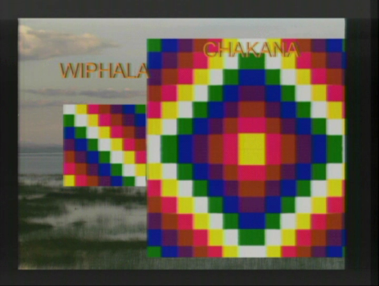
All the population inherits knowledge of the organization of the civilization from Venus and the civilization of the Confederation. According to them, the world is divided by four regions.... When the four regions unite as one, they form what is called the Chakana. The Chakana is the square cross.

This Chakana is the map of the pyramids that are all over Central and South America. In their pure essence, the unity of the Four Regions symbolizes the mathematical representation of the geomagnetic movement of the Earth. Current archeologists know that there is a large temple in Lake Titicaca. They have started sub-aquatic archeology. They have discovered ruins underneath Lake Titicaca which is projected to be from thousands of years ago. There was life all around this area.
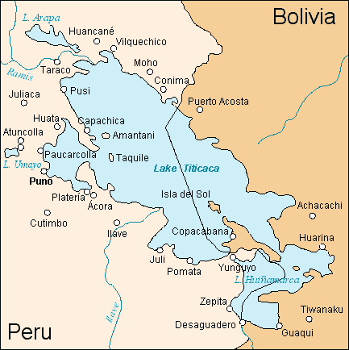
Lake Titicaca is divided into two sections. What you are seeing here is the main lake. This is the small lake, or, in Aymara, is Winaymarka. Winaymarka, in the Aymara language means, The Eternal City. It is amazing that geologists cannot explain why, at this point, there are two longitudinal cross sections, as if a great shovel has taken away a great portion of the Earth, creating this inundation on that side of the lake. Furthermore, that’s the evidence why all of this was realized.

One year after my contact and my interdimensional trip with the guides from Venus, contact happened to me again, but this time it was not in the countryside, but occurred in my own home. When I was about to go to sleep, one of the elders came to me in a holographic image. The first thing that I saw was the same as with the extraterrestrial guides – he had a light coming out of his eyes. He told me how the eyes are the mirror of the soul. Just then I realized that he was an elder, but with Nordic characteristics, from the north. He had a beard that was very fine. He had long, straight, white hair.

While I was observing his presence he told me, “I am Soromis. I love you, my son. The time has come to give you the key that will open the door of your consciousness.” When I heard that, I said, “Wow! Finally!” Immediately the elder said, “The key that can open the door of your consciousness is to love God above everything else, and to love everyone else as you love yourself.” That created a feeling like an earthquake within me. It was not a magnetic key. It was not an explanation of magnetics, or vibrations. Nothing strange that I didn’t already know. The elder told me, “True realization is not very far from you. It is very close to everyone if you are going towards your own light.”

At that moment I understood. You can understand this with your mind, but you can feel it with your heart. The elders are talking to your heart, not your mind. Their energy, their words and their thoughts have a certain level of understanding beyond what you are listening to. They are illuminating your understanding. I understood at this moment that if God is love then the only way to connect with that source of love is through action. And what is the action of love? It is to love. The action of love is translated in our lives through the action of service.

There is no advancement without service. The only way you can go forward is in understanding that we cannot give to others what we haven’t been able to find inside ourselves. That’s why the first job is one within yourself. But when you have found your own destiny, in the same way that the guides and the elders are sharing with us, then we have to share it with others in order to keep going forward. I understood that to love ourselves doesn’t mean to look at the mirror and say, “Wow, how beautiful I am! Now I can go and meet others.”

To love oneself is the need to feed oneself at every plane of your development – in the physical plane, the mental plane, and the spiritual plane. In sum, we become an integral being. I understood that true love is not what has been taught to us. It is not blind. True love is conscious and intelligent because it allows us to give what everyone requires. The elder was there not only to let me know of this, but also to invite me to integrate myself with the luminous circle of Lake Titicaca. Extending the invitation to me so that I could assist, and so that I would be able to understand this tool, which is known by them as the Solar Disk.

This experience was beyond the previous one I’d had, going beyond the Earth. I was able to know and integrate myself with these elders who are very, very old. They are the guardians of human history. Today they have opened the doors so that this wisdom and knowledge can reach humanity, until 2012. That’s what I experienced during my travels to the internal retreat of Lake Titicaca. These are the islands of the small lake. This is one of the passages to the internal retreat. This is the actual Paititi, the lost city, The Eternal City, which is beneath the lake, and is also very similar to what I have experienced on Venus.
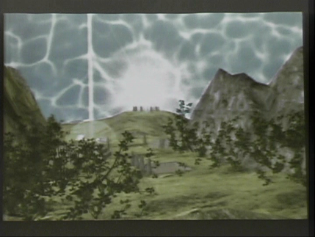
The elders are protecting the sun, which is known as the Solar Disk. What you are observing [image on left] is a tool which allows us to move through the forces of nature, and also through the most powerful force which is our own heart. This is an activating force of our own sun, of our own atomic structure.

The internal retreat is made of several small buildings. They are preserving an old civilization… It is the Eternal City that was protected and is still waiting for us to share this information that has been kept for millennia.

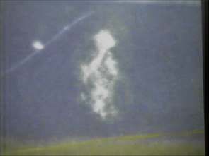
This photo [at right] is what one of the members of our group took as the image was materializing itself. It materialized automatically. It was the Master Solomis. You can see his face – eyes, nose, lips, beard. There is a veil that covers him. Are you seeing that? That’s Master Solomis. All through these experiences, the extraterrestrial guides, and Master Solomis, have been continuously accompanying us.

The guides of the Confederation said that the year 2005 was initiated to be seven definitive years in the historic process of humanity. They said that during these seven years we are going to start living the ultimate preparation. Why ”ultimate”? Because whatever we are going to live during this time has not been written, has not been lived. It has been prepared so that we can share the roots of the beginning of a new time and a new world.…

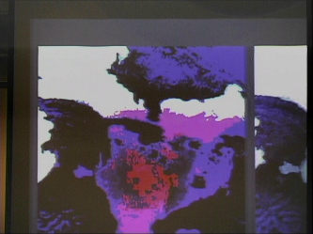
In the year 2005, NASA took these photos [on left]. You can see all this magnetic energy which is concentrated around this small lake and forming the Chakana. This has about 10 kilometers on each side, exactly the [size of the] internal retreat underneath Lake Titicaca.

What is happening at this time in the Andes and in Bolivia itself, you probably have seen it in the news, that in the past five or six years there have been five presidents. Whoo! Pull your hairs out! But it has an explanation. Studies at NASA have determined that the concentration of zero gravity is what creates altered states. The society that is around this field is unstable. The people who are in search for spiritual knowledge or change take a big step in the process of awakening. The concentration of energy here – which was activated during the 1950s – offers a great opportunity to reach that transformation.

In 2012 there is going to be a council or meeting around this marvelous energy and the elders. What we are waiting for, with this process of preparation, what we are expecting, is that in the years before 2012, all of us together can come together, can live together, by preparing ourselves internally which has everything to do with the conscious management of our internal energies which will bring about the reality of contact between the elders and us.

This is a different film [still shot on left]. This is one of the guides. In this case there were other people around me who were observing it too. So, this film has been analyzed and has been on the news. That’s on the Bolivian television. In the last few months and years, the presence of the ships and of the extraterrestrial guides have been ongoing.


That’s another sighting from a few months ago [still shot on right]. It was being filmed from an airplane. They filmed it on radar. The object accompanied the airplane flight. For about 10 minutes it was suspended, immobile. There are white and blue lights. After remaining stationary in the sky for about 10 minutes, it starts moving above the city.

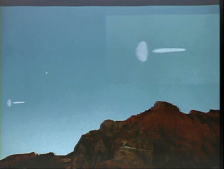
This is one of the photos [on left] that I like best because you can see the ship coming out. The energy that I saw in the first part of my trip, was exactly like that. This is like a dimensional door which is opening up at the same time that the ship is coming out …

This is not my only experience to the internal lake. A couple of years ago I had another experience, which is not part of [the topic of] this conference, but I am telling you this because in that experience, while I was in the Andes at 4,000 feet elevation, I was in contact with a group of elders, who told me many things concerning this time. I feel inside myself that it goes along with this process [Earth Transformation] that you are living in Hawaii.

Hawaii is the central point of Ring of Fire. As part of my work about six years ago, the elders told me to go to the active volcanoes of Costa Rica. When I went to Costa Rica I suddenly felt that I needed to go to Hawaii. My trip [here, with you,] is a confirmation that the Plan is moving beyond my own will. The Ring of Fire synchronizes perfectly with the sun. The sun projects the program of life through the Ring of Fire. This Telluric energy is what moves humanity. It is what we feel at this moment. It is what we are receiving and perceiving, consciously or unconsciously.

During this trip [to the U.S.] the elders told me to start two councils. The first one was already done last year with people who came from seventeen different countries, who had been contacted at Lake Titicaca, in order to finalize whatever is missing for the advent of the new world, the new time; and also to initiate, at the world level, the true preparation of internal life. You are all welcome, so that together, united, we can take the next step with everything, until 2012.

Through our communications we have participated in the discovery of archeological ruins. My experience of contact was one of the few experiences that has physical evidence of the authenticity of this communication of the invitation given to six journalists, amongst whom were two journalists from the Russian TASS [News Agency].
All of these contacts, if you look at the dates [showing video clips], the contacts have been ongoing after thirty years up through today.

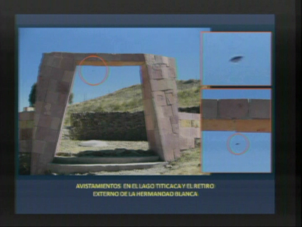
What you are seeing here [on left] is the door of a temple for the activation of solar energy. The elders have given me the command next to the shores of Lake Titicaca.

This photo is from last year… They [the ET ships] have been with me constantly….

Since last year we started to live in the activation of the solar energy. We are living the ultimate preparation, sharing the internal energies started by the elders, so that in the near future we can come back to the fountain where we all come from. Hopefully we can all come back to this so that all together we can say, Mission Accomplished.

Thank you, thank you, thank you. Aloha.

Luis Fernando Mostajo Maertens is considered one of the most important ET contacts of our times. He has experienced many physical encounters with his extraterrestrial guides since he was 13, in 1977. He began to share his experiences & knowledge by giving 'Contact Preparation Courses' and talks on the subject in many different countries such as Argentina, Chile, Peru, Paraguay, El Salvador, Honduras, Costa Rica, México, U.S.A. and Bolivia. He has published 5 books, in which he shares the nature of his ET contact experiences & the great awakening message he receives from them for these times. Luis has demonstrated that his experiences are real by inviting members of the press, some from the TASS Agency, to watch "programmed U.F.O. sightings." His main a website: http://www.winaymarka.org/. Luis Fernando will be leading a 7 day Initiation Retreat from October 18-24, 2008 in the Lake Titicaca area. For further information call 808 323 3400 or click banner.

***

