

An Andromedan Perspective on Galactic History, Part II

by Alex Collier

Global Wings Conference, August 2002
[Transcribed June, 2007 & January 2008]

[Editorial Note. This is the second installment of Alex Collier’s final lecture before his ‘retirement’ from the UFO lecture circuit in 2002. It has never been published before. It deals with information given to him by his ‘Andromedan’ extraterrestrial contacts concerning Galactic History. In preparing the second transcribed installment it was learned that 45 minutes of Alex’s lecture had mysteriously disappeared from the DVD recording, missing much vital information on the history of a number of extraterrestrial races. When the error was discovered by the Chief Editor on Jan 2, 2008, the missing 45 minutes was kindly transcribed by Teri Callaghan for this edition of the Exopolitics Journal. Given the importance of the material that went missing, it would not be inappropriate to speculate that one of the extraterrestrial races criticized in the missing 45 minutes did not want this material to get out. The missing material included all of what follows up to the next editorial note. All attempts have been made to transcribe this presentation as accurately as possible. Transcribed by Teri Callaghan]

Abbreviations
[AC - Alex Collier]
[Q - audience question]

[… Continued from Part 1, http://exopoliticsjournal.com/vol-2-2.htm]

Several thousand years later, actually a couple hundred years later, Orion established an Eden here from the Orion star system.

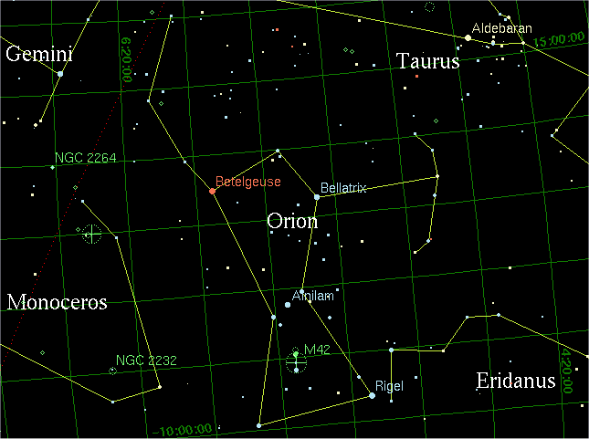
In Orion they come from Rigel and Betelgeuse, that’s these systems here [pointing to the Orion Constellation]. The star we call Rigel, the Orion’s name for this planet is “Cyclopisis”. In their tongue, it is called Cyclopisis. Whenever they go to a formal function of a galactic event where there are other star races there … the proper way that they introduce themselves, and this is what the Andromedans do and apparently it’s tradition and it was done and everyone, whether they are enemies or not have agreed to these specific introduction traditions so that there are no misunderstandings. So they have created traditions and everybody does it, no matter what, this is what they do.

You introduce yourself, you give them your full name, any rank or office, and the star system that you are from. So, “Alex Collier, father (I don’t have a rank or an office), Sol System, Terra 3.” That is how I would properly introduce myself, so whoever it is that I am introducing myself to, knows who I am and where I am from. If you are an extra-terrestrial, most of them are telepathic, therefore, they are giving the same information but as they are giving the information they are also flashing star maps because that is what is in their head. And the other races immediately acknowledge that because they get all that.

Orion established their first Eden in what is now called “Euromani” China. The date: 763,132 years ago. Shortly thereafter Capella, also part of Ursa Major, Ursa Minor, the Capellans established their first full operational Eden 741,237 years ago and theirs was established at the base of Mt. Yogan in southern Chile.

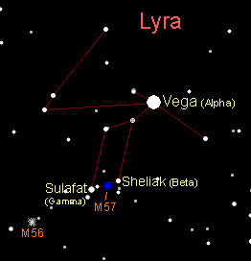
Next are the Vegans (no, this is not a plant-eating race) [Laughter] they are from Vega, they are also known to us as the Lyrans, who are literally our human ancestors. They established their first colony 701,655 years ago in North Africa, along what is now known today as the Libyan/Niger border. And I want you to know that on an archeological perspective, in Ethiopia there are absolute amazing things yet to be dug up there that have been left behind, that the cavemen did not build.

Next we have the Cassiopeians: 604,003 years ago. This is an entirely insectoid sentient race as Algeria North Africa.

Next is “Butese” [spelling uncertain]: Nibiru we know them today. They established their first Eden 585,133 years ago in Cairo, Egypt. Then Orion sent another team here 87,300 years ago which was established in Perth, Australia. The Earth was not in the position that it is laying in now. If you were to take the planet as it is today and literally lay in on its side this is where they were colonizing, but these are the locations that we know today.

Some of the colonies, after they had been here for some time, they packed up and they left, they got all the information they wanted. But the Earth is in constant flux. Many of these are hydrogen-based, hydrogen-breathing extra-terrestrial races. So when they go to their home planets, its dull compared to the very complex eco-systems that O₂, oxygen-breathers have and live with. They are extremely fascinated and according to Moraney what they were trying to do was to not only study the vegetation and life forms here in oxygen breathing eco-systems but they were also trying to genetically manipulate them so that they could take them home and make them hydrogen. That’s what a lot of this was about. This is where they became master geneticists, trying to convert O₂ life forms to hydrogen life forms. Because we are blessed, oxygen breathers are blessed with very complex, magnificent eco-systems.

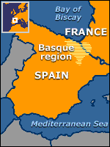
Lyrans came back 83,400 years ago. Has anyone ever been to Basque country? Their language, nobody knows where their language came from; it is an ancient Lyran tongue that has survived, it’s extra-terrestrial. If fact all of them are, but that one is still really close to the original tongue.

Orion came back again 73,414 years to Mt. Neblina on the border of Venezuela and Brazil.

71,933 BC: Lemuria is founded as a collective colony. Many of these races decided “Ok, let’s just pool our resources.” And they moved their Edens to a continent in the Pacific. Those star nations were: Lyrans, Sirius A, Pleiades: races from Teygeta and Merope specifically. Those two star systems [from Pleiades – point to star mount]. Well a lot of people are fascinated with the Pleaidians, well I’m not. But I’m going to be talking about them in a little bit. Ursa Minor and Butese [other two star systems], which is Nibiru (this is 71,933 BC) Lemuria is established as a collective colony, so now everybody is working together. It’s a good sign, however it didn’t last.

57,600 BC Atlantis is founded. Somewhere between the establishment of Lemuria and the establishment of Atlantis the Pleiadians get pissed off and they leave, a misunderstanding. They come back to the star system and Atlantis is founded. It is the Pleiadians again, the Nibiru, Alderbarans, Antariaens, the Hayades, a group from Sagitarius and the Andromendans make a guest appearance. With the exception of Nibiru, all of these are O₂s that establish Atlantis. Some of them of Nibiruan tribe are oxygen breathers because they come from Sirius. But those that come from Butese are hydrogen. They can still operate and function as long as they wear a helmet.

31,017 BC: Lemuria is destroyed in war.

27,603 BC: Atlantis is destroyed.

Q: So in previous time frames that you gave as “years ago” you meant BC?

Yes, it was in my notes, I apologize, I take full responsibility for that, I meant “BC”. I am not going to go into the whos and the whats and the hows and why they destroyed each other.

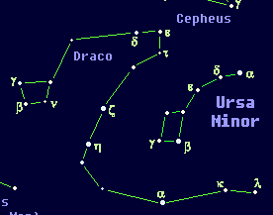
Let’s talk about the races. Let’s talk about the Ciakar, Alpha Draconis, the ancestral line of the reptilian races in our galaxy. The Ciakar themselves, according to legend, do not know exactly where their home system is either. That’s how big the Universe is or the galaxies are. According to the Andromedans there are a hundred billion galaxies known and mapped in the known Universe. If we can get a 7/11 franchise in each galaxy we would have it made, or a coffee shop, even better, legally addictive stimulants, let’s just do that. [Laughter] I am just going to give you some things about several of the races.

The Ciakar: an absolute amazing race, the oldest known reptilian race in our galaxy. They are, in fact, the only genetic line of their kind that is not extinct. When we talk about that, that’s extinct, they have found remnants of others that came after but were extinct. Most of the reptilian civilizations that we know today, in Butese, Orion, Capella are all genetic manipulated half breeds of the original Ciakar race. They stand 18-25 feet tall and can weigh up to 2,500 pounds. They are like Tyrannosaurus Rex. They are monsters. They have black leathery brown scale bellies, they have multiple abdomens, they have whiskers along their chin and jaw line. They have a mating claw and multiple tongues. I’m going to give you some very specific information.

They lay eggs and what is called a battle hormone is used to accelerate the birthing process. They are a duality. This is why ancestral females did not participate in war, because if they did, there wouldn’t be anybody there to help with the eggs. They also had to be there to secrete this hormone. I am only sharing with you what I know about them.
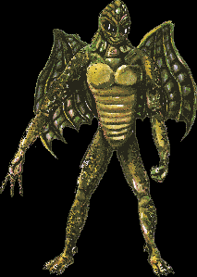
Stronger young females were expected to defeat and kill older and weaker leaders in ritual combat. The Ciakar race is ruled and managed by genetic lineage. Genetic lineage always follows the mother, because you always know who the mother is, you don’t always know who the father is. In that particular line the gals have all the say.

Ruled by the monarchy of a queen genetic lineage they are one of the most powerful races in the galaxy. They have some of the greatest military might that has ever been seen in the galaxy and most of the clan members are zealots and will do anything for the glory of their clans, of their lineage. They have been the chief enemy of all human races in this galaxy in past conflicts. Again, we are talking about hydrogen breathers vs. oxygen breathers. They have three spinal columns. One spine is located ventrally near the stomach; the other two are located dorsally on the left and on the right of the Ciakars body. Spinal columns join near the dorsal of the geometric center at the extreme posterior of the trunk to form a long and very powerful tail. Inside of the hands are claws of the Ciakar are jelly-like sacks that excrete the various hormones and substances when the Ciakar is aroused, either for sex or for battle. The primary purpose of these enzymes is to initiate encrusting of sperm. [Laughter] There is an amazing amount of life out there. They look at us and they think we are beasts as well, honestly.

Now, I am going to talk about the Lyrans. When I am talking about the Lyrans and the human race as a whole, I am talking about us and our ancestors and all the ancestors of the ancient Lyran genetic line. Before I even get to that I am just going to read the first sentence that I have on humans. The Human Race is unusual in having all of its member’s races derive from one genetic line. That is an amazing thing.

Now, let’s talk about the Lyrans and then we can talk about the humans some more. Their skin color is amber, blue and/or red. The color of the stars in their planetary systems is what caused their skin tint to change, depending on the frequency and the UV, ultraviolet scale of their stars. They are of mammalian descent. They are the only human race to have full empathy senses and full psionic abilities and have experienced “quantum probability control.” I’m still working on what that means [Laughter] you have to remember these are extraterrestrial races who know all this stuff. They are also considered today a retired race that has very little intercourse with other main civilizations. In the past, on Earth, they were known as Bodhisattva.


They have been known to monitor and provide guidance for some planetary systems. Some planetary systems today see them as their protectors and guides. They are worshiped in other words. What is interesting is that the Lyrans prefer to live on ringed worlds. They have a preference for it. On the Andromedan Council they are known as an elder race, which carries great prestige on the Council, because extra-terrestrial civilizations, ladies and gentlemen, really pay close attention to genetic lineage.

Now we are going to talk to the human race as a whole, how the Andromedans see the human race. The human race is unusual in having all of its member races derive from one genetic line. This accounts for the remarkable casual interactions of the great human civilizations, but for better or for worse, human galactic civilizations, even if they compose a single clan have diverse evolutionary histories. Each culture is very different in the way they have evolved. Not as a species, but as a culture. Misunderstandings and conflicts have occurred. Traditions exist to minimize the likelihood of misunderstandings and to lesson the negative consequences of any miscommunications that might occur. So they were sentient enough to know that they had to put things in place to try to minimize human vs. human war. In addition, the behavior of individuals does reflect on the species and the clan. This is an Andromedan human race sharing this with us that the actions of individuals of those races do reflect on the entire clan.

None are faulted for polite or proper behavior. Informality is always at risk of being misconstrued or miscommunicated. The traditions of human interaction were developed by the ancestors over the ages. When an elder race insists that a new civilization observe traditions; for example: The Andromedans come down they introduce themselves, they say “ok, boys, it’s time to go to the show.” The show being the Andromedan Council, we are being asked to be invited to the Andromedan Council. What they will do is they will teach us the tradition, the proper way of introducing yourself, of acting before all these civilizations because you will be misinterpreted if you walk in “Yo, man, whaz happenin’?” You will be completely misunderstood. [Laughter] It helps the young races build a culture that will function well in galactic civilization, as well as help guarantee that this young race will become a virtuous and productive member of the Galactic Commonwealth. That is exactly Moraney’s verbiage, I took it word for word – the Galactic Commonwealth.

It is important that all humans be as polite as possible. This helps both the young and the old cultures because many of the old cultures are socio-biologically dependent on ritual. They have become so conditioned that this is just the way you do it. They traditions are so deeply embedded that they are not going to change. We have that same situation here on our planet. And can be psychologically disturbed by informal and rude behavior. If the occasion calls for it apologize and then speak only when spoken to. Never touch a fellow elder race person unless you are specifically asked to.

That leads me to something I was taught when I was brought on board and I met other races. This is what the Andromendans do when they meet another race. And I was taught to teach this to everyone here which I’ve done, and I am going to do it again. When you have a contact and you are standing before an extra-terrestrial or extra-terrestrials you stand yourself square, you bow, never taking your eyes off of them and you say: “It is the manner and custom when entering my space that permission be asked”. You say it very clearly, because what you are doing is you are declaring your sovereignty and you are declaring your space. Alright, because we are not that well thought of, so it is important to do something like this. You have ten seconds to make a good first impression.

“It is the manner and custom when entering my space that permission be asked.”

We would have to say it verbally. They would probably respond telepathically.

Q: And if we didn’t say that?

There is always the possibility that your space would be violated. The Greys (Dows) would, absolutely. But nobody knows to do that. And besides they wouldn’t approach you that way, they always steal you out of bed because they are little frigging cowards. No, I don’t have any charge on that. [Laughter]

Most human galactic races have three languages and these difference markers are: formal, informal and differential. The differential apparently is what is used in a lot of politics, galactic politics. The formal is when you are addressing your own race, like state of the union; it is also when you are talking to elders. If I am a young Terran and I am addressing an elder of my race, I am to use the formal. The informal, is informal, “Yo blood, whaz happenin’?” [Laughter]. The informal marker is not used ever in public. Always ask if both parties are comfortable with the informal language. I would have to say, “Mike, do you mind if I talk trash?” And Mike would have to say “Sure, man, talk trash.” [Laughter] Then we are both agreed and I can talk trash. It’s probably a bad example……

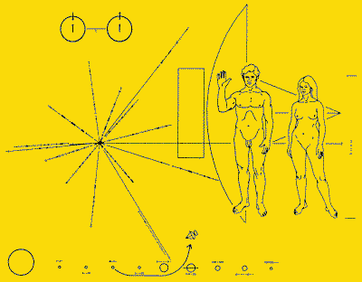
The formal marker is always used in public because you always want to regard your partner in conversation as worthy of respect. The prestige of a mature race is always subject to debate. The first measure of the general rule of prestige is number one the age of the race. The second index is the race’s lineage. It all comes back to genetics. The third index is the number and size of the race or the clan or the tribe. In standard introductions, always include identification by full name, species name, any relevant titles, and your home planetary system. Species name and planetary system, e.g., Sol, Terra 3: because our star is known as Sol. We are Terra which is third planet from the sun. If you were in Mars you would say “Sol, Terra 4.”

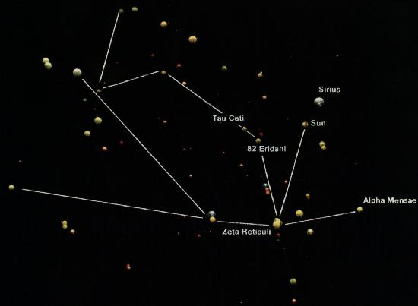
I am going to talk about the Greys, the Dows; D-O-W is how the Andromedans refer to them. The Dows are the Reticulums [from the constellation of Zeta Reticulum] . The Andromedan word for this particular race, when tweaked and converted into English is Dows, they are known as the Dows. They are a militant race known to be very hostile to humans. Humans have never been able to successfully negotiate with the Dows. I am sure that our military wished that they knew about this in the 50’s. They made agreements, they signed treaties, and the Dows have never kept one of them, but they are so technologically advanced that we are having a hell of a time getting rid of them…. They are known in the inner circles as a pain in the ass. (That’s informal). Most avoid them at all cost. They have little empathy, if any at all, for human races. And believe that unworthy species will one day be exterminated. They have participated in all “Wars of Enforcement.” I want you to hold that thought. We will come back to that.

The original ones are hydrogen. The little ones, who do most of the dirty work, are of course, just organic clones. They have been genetically bred to do the dirty work in O₂ atmospheres. They have participated in all the Wars of Enforcement declared by the reptilian alliances. Humans have also had Wars of Enforcement, and have been attributed with three accidental extinctions in the last ten thousand years. [Audience member asks, who?] The Dows.

Let me read it again. The Greys have participated in all Wars of Enforcement declared by the reptilian alliances and have been attributed with three accidental extinctions in the last ten thousand years. It doesn’t say who, so I am not going to say it was humans because I don’t know that. The fact that they exterminated a race is enough for me. They are under investigation for excessive genetic manipulations of at least two races, your Earth race being one of them.

[Editorial Note: Missing material ends here. It may not be inappropriate to speculate that some extraterrestrial group did not want you to read from the start of this transcript to this point]

… And something else he added as an after thought is that they do not experience childhood. That’s probably why they are all tweaked.

Wars of enforcement
In the human race a war of enforcement is where someone, whether it is a human race or a reptilian race or a hydrogen breather, or an oxygen breather or a methane breather or an ammonia breather. If they cross the line and do something so severe, they will literally go to war to enforce a punishment, to enforce something, a restriction, they will do that. What is going to be happening here in our solar system in the next couple of years is being classified as a war of enforcement.
It is not a police action; they are coming in to kick butt, because they have crossed the line. And we are not the only star system; there are 21 other star systems that are having the exact same problem that we are having.

They want all regressive presences off our planet and the moon, completely out of here, end of story; they want them out of here. If it is true that the moons of Mars are no longer in orbit around Mars and that they are in fact in orbit around Earth, then something major is about to happen.

Q: Aren’t people seeing them?

AC: Apparently they are, people are taking photographs, and people are seeing it. I, myself, have not, but I live too close to Denver and there are a lot of city lights. But there are people back east who say they are seeing them, and people in Europe who are seeing them. The solar eclipse in Turkey, several years ago, European reporters who were taking pictures, got pictures of these two objects. And when they were blown up they look exactly like Phobos and Deimos, following the moon.

They are both space craft, an old hollowed out planetoid converted with an ecosphere on the inside and propulsion on the outside. It’s an older model; you can find them on any good used spacecraft car lot. (Laughter). According to Moraney, and this was many years ago before their alleged re-entry into our atmosphere or gravitational field, Moraney had said that the last time that Phobos specifically, he didn’t mention Diemos, had entered the Earth’s atmosphere or gravitational field is when the great plague began.

There are all kinds of records of space craft flying though space at this time, William Bramley, The Gods of Eden, has it in his book. They talk about star ships flying through space dropping the spores. It’s a weeding out. I want to cover a couple of other things before I get to the other races.

Dolphins and Whales
In our galaxy they are honored as sentient animals. They are brilliant philosophers and poets. And we think they are just big, dumb fish, but apparently they are absolutely amazing, amazing mammals. They have the admiration of many of the old races for their beautiful songs and storytelling. They have legendary stories of the whale dream, which is the cetacean race memory. So they tell stories about their lineage, which they call “whale dream”. If the humans of earth make extinct these species, they will have no standing in the galaxy. (Star Trek). Some of these writers are clued in. I don’t know where they are getting this stuff, but they are totally dialed. And the same for dolphins. We don’t know their language; it’s an extremely sophisticated language, more sophisticated than the English language. It’s a trinary language, which is why we don’t understand it, because we are so one-dimensional in our language.

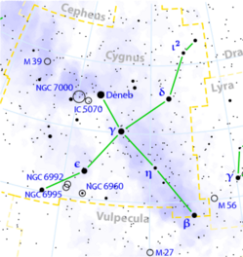
Whales and dolphins originated in Cygnus Alpha. Smaller star systems which orbit around the central suns of Deneb, Sidar, Denaia and Alderia are where they come from. The largest population of whale and dolphin life is right here. Within this collection of smaller stars are thousands of star systems. They wanted to migrate, they wanted to explore other worlds, they wanted to add to the whale dream. They were brought here millions of years ago and they are recording. My understanding is that when they birth the young they teach them the song and the song is the story of their lineage and the history that they have learned of the home world that they are on. That’s the song that they sing. They are singing the song of the lineage. It’s one right after the other; they teach them everything they know. It’s absolutely amazing….

To be continued…

***


Alex Collier is a 'contactee' with a race of human looking extraterrestrials from the constellation of Andromeda. He first began to experience extraterrestrial contact during his childhood up to his mid-teens. After the experiences stopped over a period of several years, which included military service as a helicopter pilot in the U.S. Army, the contact experiences resumed in 1985. He met with two Andromedans who became his mentors and took him on board their space vehicles including a large extraterrestrial mother ship where he was exposed to the teachings of the Andromedans over a three month period. The Andromedans gave him information about cosmic spirituality, life in the universe, and Earth’s galactic history.

[Note: Alex Collier will be a featured speaker at the upcoming Earth Transformation Conference.]
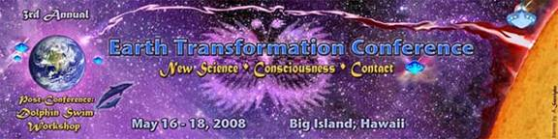
Website: www.EarthTransformation.com

