
Book Review: Rulers of the Earth: Secrets of the Sons of God, by Joe Lewels, Ph.D. (Galde Press Inc, 2007) ISBN 976-1-931942-37-9
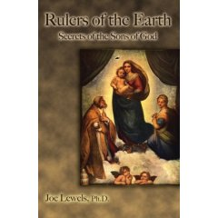
Rulers of the Earth is a moving personal attempt to clarify ancient biblical references to the “sons of God”, and relating these to the life and teachings of Jesus Christ. Dr Joe Lewels reveals his own personal odyssey from successful businessman and academic who once headed the Department of Journalism at the University of Texas at El Paso, to a researcher of the UFO abduction phenomenon. After discovering that “hypnosis was absolutely necessary” for recovering the suppressed memories of those experiencing the abduction phenomenon, Lewels discovered that past life information could also be regained detailing historical events (p. 19). A number of synchronistic events lead to him discovering that he and others involved in abduction research, have deeply personal connections to the biblical events surrounding the life and crucifixion of Jesus. More significant for Lewels, is his own personal association with a mysterious Jewish sect called the Essenes who have much information about the “sons of God”.
In 1947, the Dead Sea Scrolls were discovered from the Qumran caves describing in great detail the beliefs and teachings of the Esssene community. Lewels describes how translations were suppressed for over four decades by Catholic authorities that “had no interest in science at all, but only in protecting their church’s belief system” (p. 114). Most disturbing are references found in a number of the scrolls to “sons of God” who comprised both righteous and fallen ‘angels’ who are described in modern terms as extraterrestrials. ‘Fallen angels’ were generally known as ‘Nephilim’, ‘Watchers’ or ‘Archons’, while righteous angels were known as ‘Aeons’ or ‘Elohim’. The fallen angels or ‘Nephilim’ were banished to Earth and interbred with the Daughters of Eve as explained in the Book of Genesis (6:1-4): “The Nephilim were on the Earth in those days, and also afterwards, when the sons of God mated with the daughters of men and they bore children for them: these were the heroes of old, the men of reknown.” While the Book of Genesis contains references to the fallen angels as ‘Nephilim’, the Dead Sea Scrolls contain the original sources for this information. The Book of Enoch gives a highly detailed account of the activities of 200 fallen angels or ‘Nephilim’/’Watchers’ who were locked into a deep conflict with the ‘righteous angels’ or ‘Aeons’. The Nephilim proceeded to interbreed with humanity and created a race of giants that had much authority until the time of the Noah and the great flood. The Book of Enoch gives surprising validation to the theory of extraterrestrial visitation, and that this involved genetic intermixing with ancient humanity. According to Lewels, “the idea that the sons of God came to Earth and had sexual relations with human women, thereby creating a race of half man/half gods is too incredible for most modern Christians or Jews to even contemplate” (p. 130).
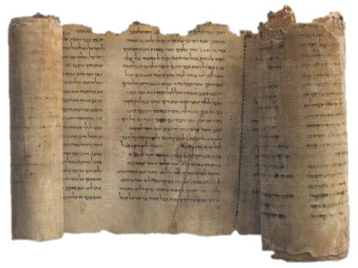
According to Lewels, the Dead Sea Scrolls reveal many parallels between the teachings of Jesus and the Essenes. The Essenes were led by a “Teacher of Righteousness” who taught by personal example and led an ascetic life that eschewed collaboration with the secular world of the Romans or their Jewish collaborators, the Pharisees. In Lewels’ view, Jesus was both a member of the Essene community and their Teacher of Righteousness. He nevertheless points out that there is controversy over whether Jesus was an Essene, let alone their Teacher of Righteousness. There is less controversy that John the Baptist was an Essene (p. 121). Furthermore, other key figures in the life of Jesus, his mother, father, aunt, were very likely, according to Lewels, part of the Essene community. This meant that while Jesus may not have been an active member of the Essene community, he was deeply familiar with their teachings and had been influenced by their ascetic lifestyle.
It is the discovery of the Gnostic Gospels at Nag Hammadi in 1945 that Lewels is able to penetrate deeper into layers of the mystery surrounding Jesus and the sons of God. As in the case of the Dead Sea Scrolls, the contents of the Nag Hammadi findings took decades to reach the general public. It was only in 1975 that an authoritative translation of their contents were published. Here Lewels reveals surprising information about Jesus teaching Gnostic beliefs over reincarnation, elevation of women to leadership roles, and developing a direct personal relationship with the transcendent God that pervades all existence. Most surprising is the belief that the God of the Old Testament, Yahweh/Jehovah, is in fact a Watcher or ‘Archon’ who keeps souls captive. Jesus gives assent to this Gnostic view in the following: “[The souls are delivered] to the powers, which are under the Archon. The souls will once more be cast into fetters and led about until they are saved from lack of perception, attain knowledge, and so will be perfected and saved…. It [the soul] no longer goes into another flesh [after it is perfected]” ( p. 169).
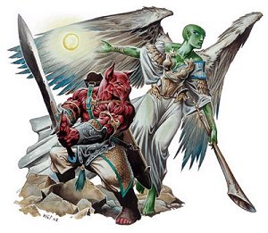
Lewels elaborates on the Gnostic belief system that human life on Earth is controlled by the “sons of God” or ‘Archons’ who were secret rulers entrapping human souls in endless material pursuits. The idea was that if humans spent their lifetime enmeshed in material pursuits, they would remain bonded to the material world through reincarnation. Understanding that Earthly life is a form of bondage to the ‘Archons’, Jesus in fact set out to reveal the truth. This formed the real reason for his opposition to both the secular and religious authorities of the day. However, the Gnostic teachings of Jesus were suppressed by the Orthodox Church who ruthlessly persecuted Gnostics and destroyed their texts. Apparently Mary Magdalene and her followers escaped to the Languedoc region of France which became a haven for Gnostic teachings. The Cathars of Languedoc flourished until the 13th century when they were finally destroyed by the Albigensian Crusade ordered by Catholic Church. Gnostic beliefs all but disappeared until the Nag Hammadi discovery in 1945.
Lewels backs his claims with sufficient citations and reputable sources to make even the most staunch conservative Christian rethink some of the core tenets of his/her belief system concerning the sons of God, and the true message taught by Jesus concerning these beings. Overall, Lewels builds a very compelling case that the “sons of God” described in biblical texts are really extraterrestrials that are divided between those trying to exploit humanity (Nephilim/Watchers/Archons) and those trying to assist humanity (righteous angels/Aeons/Elohim).
Lewels argues that the modern abduction phenomenon relates to biblical events concerning “sons of God” and genetic modification of humanity. He suggests that genetic modification by extraterrestrials is well evidenced in human history, and while this has traumatic elements, he implies this is acceptable due to its beneficial aspects. To illustrate, he cites one abduction case where the experiencer claims that Jesus or ‘Sananda’ approved of the genetic modifications occurring in the abduction phenomenon. In response to a question by Lewels as to why Jesus would ask her to submit to such an experience, the abductee replies: “He is teaching me about karma and how we all live many lives, and in each life we make promises. There is an agreement that we make before we incarnate into a body, and then we have to fulfill our contract if we are going to progress to a higher level” (p.220). This leads to my one caveat about Rulers of Earth.
Lewels merges the findings from his abduction research with the ancient biblical material wherein genetic modification associated with abductions are accepted as part of the historical intervention method used by the Watchers or extraterrestrials. For example, he cites the view that “we have been genetically manipulated by intelligent beings that apparently combined some of their own genetic material with that of apes hundreds of thousands of years ago. That genetic manipulation is still going on today” (pp. 53-54). This view is best illustrated in the work of Zecharia Sitchin concerning his translations of Sumerians cuneiform records of the ‘Anunnaki’ bio-engineering humanity from primitive hominoids.
Lewels makes the assumption that extraterrestrials responsible for genetic intervention in the modern era are linked with or the same as those performing genetic intervention in past. This linkage has some major problems. First, the extraterrestrials cited in Sitchin’s work and historical texts have little physical resemblance to the small ‘Grays’ with emaciated bodies and large physical heads in the modern abduction research. The former are described as physically powerful beings that sired a ruling class of demigods and giants that dominated humanity for centuries as Lewels describes:
Beginning with the ancient Sumerian kings, we find references to these demigods who ruled by divine birthright. The Pharaohs of Egypt, the Incan rulers of Peru, and the dynastic kings of China and Japan all had the same tradition: that long ago the gods interbred with humans to create special lineages of humans to serve as rulers of their nations (p. 132).
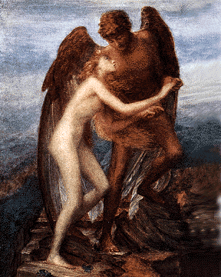
Second, the biblical texts describe the “sons of God” as mating with women. This is not part of the modern abduction phenomenon which describes genetic manipulation, not physical mating between extraterrestrials and abducted women. Most experiencers describe Grays as having neither sexual organs nor emotions, and are attempting to create some kind of hybrid race with some human emotions. While researchers such as Dr David Jacobs describe some of the hybrids as sexually active, the overwhelming majority of human extraterrestrial encounters described in abduction research involve invasive medical procedures and not the sexual procreation described in the biblical texts.
Third, the abduction phenomenon is relatively recent in the modern era dating from the 1960’s and 1970’s, and was preceded by a far less intrusive and non-traumatic set of human extraterrestrial encounters in the 1950’s and early 1960’s. The latter set of encounters is exemplified in the contactee stories of George Adamski, Howard Menger, Daniel Fry and countless others who were exposed to consciousness raising teachings by human looking extraterrestrials. None of these interventions involved genetic experiments. This suggests that an important aspect of the human extraterrestrial contact has little to do with genetic manipulation, and instead is focused on consciousness raising. In some cases, there are even reports of physical mating between the extraterrestrials and humans. This suggests more of a correlation between latter day contactee reports with biblical events concerning the sons of God, than the abduction phenomenon.
Lewels doesn’t mention contactee testimonies concerning fully conscious voluntary interactions with human looking extraterrestrials, nor analyze these in terms of the biblical accounts of the sons of God. He focuses instead on abduction reports which he has personally researched in clinical conditions using research tools such as hypnosis and correlates these with historical references to the sons of God. Focusing on one’s own empirical data in interpreting extraterrestrial encounters is an understandable research method. Nevertheless, it does lead to the criticism that the subsequent research findings are skewed towards a category of human extraterrestrial contacts that are not reflective of all that is currently happening or has historically happened with human extraterrestrial interaction. Undoubtedly there are many modern cases of human extraterrestrial encounters with non-human looking beings that have traumatic elements to them and involve genetic modification. At the same time, there are also cases of non-traumatic encounters with human looking extraterrestrials that are respectful, do not involve genetic modification, are oriented to consciousness raising, and in cases appear to have involved physical mating.
Any research into the human extraterrestrial encounter needs to take both sets of these encounter phenomena into account to reach a balanced perspective on what is currently occurring. This is especially the case since the modern abduction phenomenon involves extraterrestrial interactions that may not be related to the sons of God described in historical texts. This is my only caveat with Rulers of Earth insofar as the extraterrestrial phenomenon is presented through the filter of abductions involving genetic modifications. It is not clear that the modern abduction phenomenon correlates with historical texts describing the sons of God who appear to have been a physically more robust set of extraterrestrials than encountered in abduction research.
Despite my caveat, Rulers of the Earth gives an impressive analysis of historical evidence concerning extraterrestrials as “sons of God” that historically have interacted with humanity. Lewels persuasively argues that this phenomenon continues into the modern era. Rulers of Earth will be upsetting to more traditional practitioners of the Judeo-Christian faiths who may refuse to accept the implications of the radical findings at the Dead Sea Scrolls and Nag Hammadi. The idea that the ‘God’ of the Old Testament, Yahweh/Jehovah, is in fact an “intermediary god” or extraterrestrial intent on maintaining control over humanity and eliminating extraterrestrial rivals will be deeply upsetting to many. Lewels’ scholarship, numerous insights, and deeply personal experiences involving events concerning Jesus and his disciplines, will help soften the radical implications of his work that challenges the very core of Judeo-Christian beliefs.
This is a book that will help many open up to a set of disturbing truths about religion and humanity’s extraterrestrial origins. It will alert many to the possibility that humanity has to confront a historical situation where it is dominated by some extraterrestrials/’sons of God’ that control humanity in ways that minimize the human potential. In alerting us to the importance of understanding the true implications of the discoveries of historical texts at Qumran and Nag Hammadi, Joe Lewels provides invaluable insights into how humanity can move beyond the historic control dynamic with extraterrestrials and empower itself.
***

Reviewer: Michael E. Salla, PhD is the author of Exopolitics: Political Implications of the Extraterrestrial Presence (Dandelion Books, 2004) and founder of www.Exopolitics.Org. He is Founder of the Exopolitics Institute and Chief Editor of the Exopolitics Journal. Main website: www.exopolitics.org

***
Earth Transformation Conference DVD’s NOW Available!!!
Phone: 808 323 3400 www.EarthTransformation.com

