
Italy’s Disclosure of Human Looking Aliens
“The Timing is the Thing” & “Exclusive Interview with Maurizio Cavallo”

Paola Leopizzi Harris, M.Ed.

[Editorial Note: what follows is a groundbreaking commentary and interview by Paola Harris concerning new evidence in Italy of human looking extraterrestrials living among the Italian population. The interview was conducted in Novemeber 2006 and the commentary written in May 2007. The commentary and interview have been respectively numbered I. & II. and combined as a special feature article for the Exopolitics Journal]

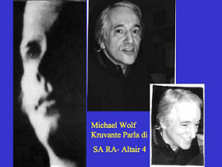
I. “The Timing is the Thing” … that tells us everything

I remember years ago in 1999, that Dr. Michael Wolf Kruvante told me that there was going to be a “slow” process release of information governed by a “special study group”. He may have been the first to print what he said were two alien photos on his book” Catchers of Heaven”. One is a blonde blue-eyed human looking alien called Sa Ra from Altair 4 [photo on right], the other a “baby” grey. He talks extensively about his role as interface with this human looking alien in a diplomatic capacity. These are the protocols of which I speak in my new book: Exopolitics: How Does One Speak To A Ball Of Light - Exopolitical challenges and protocols for future contact.

7-8ft tall extraterrestrial living near Pescara, Italy
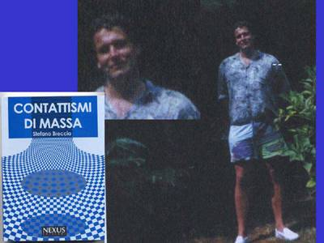
This year in Italy, two important books surfaced talking about aliens among us. The first book was written by Stefano Breccia. Italian engineer and computer graphics expert and telecommunications who is considered a very credible source. The book is called Contattismi di Massa (Nexus Edizioni) which literally means Mass Contacts. It deals with two opposing groups of Aliens situated near the Adriatic coast near Pescara who mingled among the residents and especially who communicated with several important political figures in 1956. Their liaison contactee was a a man called Bruno Sammaciccia, a credible figure who held four University degrees among them psychology and psychiatry and amazingly enough was nominated man of the year by UNESCO in 1982 for his cultural background. He was first contacted telepathically by these very tall (8 foot) humanoid aliens who had a base in the Adriatic sea. In the Chapter called “Amicizia” at the end of the book he talks about their habits, intentions and their interaction with humans among them ,such prestigious figures as a Brazilian Cardinal, a famous painter, a general of the carabinieri( Italian Military Police) but in particular, they contacted the much noted ( Italian Consul) Console Perego who had the sighting over St. Peter’s December 1st 1953 and who spoke about UFOS to many Italian Officials in the 50’s much like Adamski.

Contacted telepathically was also, journalist/photographer Bruno Ghibaudi who took the amazing photos of these distinct craft coming out of the water near Pescara on the Adriatic coast. The book includes many photos of this plus the dignitaries mentioned plus one photo of an 8 foot tall Alien who said he was part of a confederation from a “ blue” galaxy which means probably a blue nebula. One message given to Planet Earth was “ most extraterrestrial life was humanoid in Nature”! They look like us!
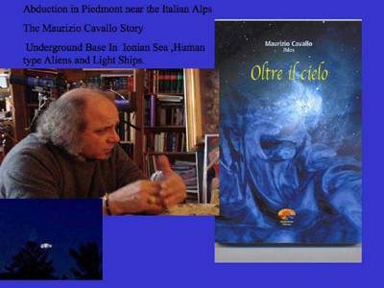
The second book that I researched is called Beyond Heaven or Oltre il Cielo by Maurizio Cavallo. This second book details the agony and the ecstasy of Maurizio’s contact with a group from Clarion from the star system of Aquila ( the Eagle). The problems with conflicting realities and dimensional travel which almost led him to insanity.

Cavallo’s contact happened in 1981 and in an effort to stabilize himself in this reality, he took many photographs, and many Polaroids of different aliens, of this what he also calls the “ confederation”! These Clarions asked him not to release them for 10 years to test his commitment to them. Most every photograph portrait has a name and is very particular. He explained to me that his Clarion Contacts absorb light when photographed so there are many flashes of light as in the picture of Suell.

I have been working on the Maurizio Cavallo story since October 2006 and find him very stable, logical, calm and credible. He simply lives his story. It is very difficult to evaluate this type of case that has films, photographs and artifacts. Although I visited him four times always staying in his town for days, I became very anxious to involve Jaime Maussan from Mexico in this particular case especially since he was doing the “Antonio Urzzi” case only 40 kilometers away. The Urzi footage of daylight UfOs matches that of Mauizio Cavallo and in one film, it seems like the same UfO. Antonio Urzi is in Milano, Cavallo lives one hour away near Torino and his contacts come about in Val D’Aosta as well as the French Alps. Jaime Maussan flew to Milano the 11th of May 2007 and he filmed interviews for two days. Both these contactees are summoned to film these craft plus they are sensitive to the presence of their extraterrestrial friends. They are chosen.
It is ironic to me that there is a special timing to all this. It seems about time that we realize that these people walk among us on Earth and they are concerned with our welfare to some extent. My job is simply to report the story and with Jaime Maussan to slowly analyze the case and report what they tell us. You decide! Maybe It is time!

***
II. Exclusive Interview with Maurizio Cavallo
Piedmonte, Italy, November 2006
Contact or abduction? Maurizio Cavallo's life enigma is part of this extraordinary interview….
Paola Harris: I'm only an investigator of those who claim they had experiences. My duty is to do a good job and to faithfully report what witnesses say, because only the correct information should reach people, with no distortions.
Maurizio Cavallo: I felt obliged to tell my experience after eleven years of silence to relate what happened to me and could happen also to other people. Something that brought an inner, complete transformation in me, in my life and in my family. But after I regreted doing it because, though I met many open minded people, beautiful and great personalities who wanted and wish to know the truth, I found also a lot of wickedness. I met with people who were selfishly driven by personal aims and they disgusted me. I have met also unstable people, really insane people. Two months ago I hosted here, after many telephone calls, a guy who presented himself as the chief commander of the extraterrestrial fleet and, to demonstrate he was a real alien, he showed me what he called a laser beam, but it was only a chinese pocket torch with some small lights on it. These things really upset me.
Paola Harris: How do you get rid of those kinds of visitors?
Maurizio Cavallo: It was my intention to invite him for lunch as I usually do with the people I meet for the first time, to treat them like friends, like people dear to me...but, when I realized what kind of person he was, despite all my best intentions, I had to invent an unexpected appointment. I hate to lie. I love to be frank. Also, if sometimes I sound a little rough, I like to be outspoken. I can't stand a world built of lies but, in some cases, you have to protect yourself. That man was a dangerous person.
Paola Harris: There are also people who wish to consider you a guru, how do you manage them in these situations?
Maurizio Cavallo: I cause them to dislike me. It means that, if they think I can give something to them, if they ask me to teach something to them - and I have always been very clear about it - I tell them that I am not a guru and I cannot teach them anything apart from my personal experience. If they will be able to learn something from my experience, I will be happy, but I cannot teach them anything because I am still learning. And when I say that they often have a negative reaction because they feel betrayed. They start to treat me like someone who doesn't want to give them what they consider a property of their own. From when my experience started in 1981 I have become a person who can be loved but can be hated as well.
Paola Harris: In 1981 you were married, you had children?
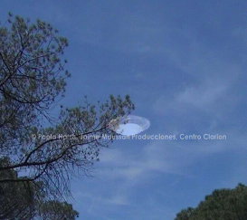
Maurizio Cavallo: Yes, I was married and I had two children, the girl was seven years old and the boy was four.
Paola Harris: Did everything happen all of a sudden?
Maurizio Cavallo: Yes. I had had some experiences like many people. I had seen strange lights in the sky but that night, the night of the abduction, it fell upon me all of a sudden. I did not expect anything like that and from that moment, everything has changed for me.
Paola Harris: I noticed you used the word "abduction". Do you call it an abduction or a contact?
Maurizio Cavallo: I call it abduction.
Paola Harris: Because it happened against your will?
Maurizio Cavallo: Yes, I did not want it, they obliged me. I was at home. The whole story is in my book, all the dramatic moments I had to live. I was at home and I felt...I started to feel physically sick, feverish and suddenly I heard an internal and imperious voice ordering me to go out, to go back to the hills of Monferrato where we had been the night before for a walk with some friends of mine. After dinner in a Pizzeria we had gone for a walk on those hills for ten miles, more or less, from Vercelli. We had left our cars and we had started to walk when we saw a globe of light, red like a fire, which descended behind some trees giving us the impression it was landing. We were all very excited and went in that direction to see what was happening. It was deep night and the ground was rocky and difficult so we gave up and went back home. As soon as I came home I started to feel sick. I felt warm, I felt cold, I felt feverish. At first I thought it was caused by poor digestion. I thought I had eaten something that had made me sick. I could not sleep and I started to hear that voice complelling me, and ordering me to take my car again and to go back to the hills. In that moment I started a titanic fight, an incredible fight. I tried to wake up my wife to tell her I was sick and I had to go out, but my wife went on sleeping as if she was under the effect of some drug. In my book I talk in detail of a particularly strange experience... It was like my house was entrapped in something... I don't know how to define it, it was also like being frozen. I don't know if that is the correct word.. I went to the bathroom to have a glass of water, the glass slipped from my hand and fell on the ground but it fell in slow motion, very, very slowly.
Paola Harris: Time had stopped?
Maurizio Cavallo: It was a Saturday night and the street was full of the noise of a holiday night, but in my house everything was silent. When the glass broke in pieces on the ground I heard no noise. Everything was crystallized. It was like time had slowed down. It is obvious it was an abduction because I did not want to go. The more I resisted that order, the more the pain in my head increased. I noticed that when I began to take the car and to go to the hills my pain lowered, but when, on the contrary, I thought I wanted to stay home, my pain increased, stronger than before. It was a form of constraint, this is the reason why I say it was an abduction. If they had asked me to go with them I had answered no.
Paola Harris: At that time it looked [like] a bad experience. And what now, in 2007?
Maurizio Cavallo: Today not. Also in my book I say that those who were my contollers, I call them abductors, those who imprisoned me, were the same ones who gave me my new freedom.
Paola Harris: They showed you a new truth.
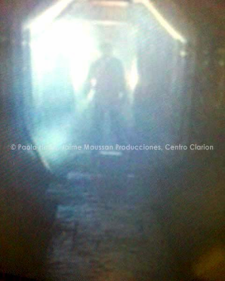
Maurizio Cavallo: They showed me that Cosmos is not what we believe, that life is not what we live, that everything we call reality is a pure illusion. They opened for me a window on Cosmos, they brought me to the edge of madness and they destroyed the Maurizio of the past. The old Maurizio existed no more, they had skinned him, lapidated him but they had permitted to new Maurizio to look beyond the borders of what we call reality. They gave me an immense gift, They gave me freedom.
Paola Harris: But you had to pay a high prize...
Maurizio Cavallo: A very high prize. See, when I understand that these people come to me waiting for something, treating me like a guru, I always say that I have no truth to give them. I only have my own truth and it belongs to me completely. I feel upset when I realize that this truth, so strong in my mind, can be manipulated ... Not everyone can understand.
Paola Harris: Of course, we are on planet Earth. We are human beings, a peculiar race. We are growing up but you are trying to bring us from elementary school straight to secondary school but we cannot jump that way It is a slow process. It happened to you, they made you able...
Maurizio Cavallo: Yes, but perhaps I had been trained for it before.
Paola Harris: That's exactly what I wanted to ask you.
Maurizio Cavallo: Yes, because I realized that nothing happens by chance, my mother had been abducted too.
Paola Harris: How did you know it?
Maurizio Cavallo: They showed me some images, something like recorded images. They showed me images in a sort of monolith, in a ruby-red pyramid used like a screen. I saw images of a girl walking in a graveyard, at first sight I could not recognize her and they told me: "It's obvious you can't recognize her, she is your mother when she was a girl; she knew the secrets of the stars too." This means that they have programmed us.
Paola Harris: Did your mother talk to you about it? Did she ever ask you something?
Maurizio Cavallo: My mother died when I was thirteen. I had a special relationship with her, very intense. We had no need to talk. She looked at me and I understood, I looked at her and she understood. I cannot remember any dialogue with my mother but we had a complete relationship. When she died I missed her very much and my pain was beareable. I could not feel the intense pain you feel in you mind and your body when you lose somebody, I was quiet because I knew nine months before she had to die.
Paola Harris: How did she die?
Maurizio Cavallo: She had had low blood pressure but the doctor had misunderstood her symptoms for high blood pressure symptoms and had prescribed some medicine to lower her blood pressure more. She had taken them faithfully and her heart gave out so she had to be hospitalized and her condition worsened quickly. When she entered the hospital, nine months before her death, I knew she was going to die. I was sure of it and I was waiting for that moment quietly. I was sure that, in any case, nothing could have parted her from me. At that time I was thirteen and I believed in God, the Catholic God and, of course I prayed for my mother. I prayed to God to let her live and to heal her. When my mother died I became very angry with God because I had previously believed that God listened to all our prays. From that moment I said: "You don't exist, you don't exist because you didn't listen to me."
As time passed and thanks to the experience I had in 1981 I started to think in a different way. I understood that a Divine Mind exists but it is completely different from the image we are used to. A Divine Mind exists but not all our prayers can be heard because there are programs and our life and death are only some roots of these programs. With my mother I have always had a perfect relationship. That night they showed me my mother when she was a girl.
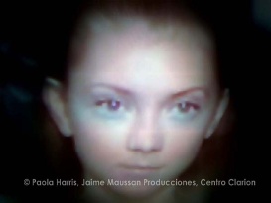
Paola Harris: Did they ever show your mother alive?
Maurizio Cavallo: Yes, I met her.
Paola Harris: I know they brought you to Clarion. Did you meet her on the Earth or on Clarion?
Maurizio Cavallo: I saw her at home. One night they told me I would be having a pleasant visit. At first I thought I was dreaming because I was in my bed and I was sleeping but after I realized I was awake. I saw my mother not with the appearance that I remembered. She was physically different. I knew she was my mother but she did not look like her.
Paola Harris: How did she look?
Maurizio Cavallo: She looked much younger. We did not talk to each other but she made a gesture that was her typical gesture, a wave of her hand that my mother used only with me. She smiled at me and that's all.
Paola Harris: Was it like a dream?
Maurizio Cavallo: No, at first time I thought I was dreaming because I was in my bed, but after I realized I was not because I left the bed to go towards her but she moved her hand to stop me, she smiled at me and made that gesture so typical. When we were babies and went to bed she made that gesture to say good night. In that moment I felt I had to go back to bed and I had to sleep again. I am sure it was not a dream.
Paola Harris: Inhabitants of Clarion are made of flesh and blood? Did you ever meet them in the streets?
Maurizio Cavallo: I have met them at the supermarket.
Paola Harris: Were they doing the shopping?
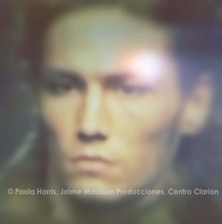
Maurizio Cavallo: No, we had a meeting there ... People don't have to believe in what I say, they only have to think about what I am relating and ask themselves if there could be something true in it. If their conscience gives them the feeling that all this could be real, they could start to interrogate themselves till the big question: "ARE WE ALONE?" My photographs are not proof also because I do no spread them. I have photos of UFO, of aliens. This is a photo of Suell (on right), I talk about him in my book.
Paola Harris: He could well walk among us!
Maurizio Cavallo: He walks among us. I met him in a big city I cannot mention. He gave me a little black card emitting some impulses that told me to do or not to do certain things. At a certain moment I felt I had to take a train to go to a town where I had to meet some of them. While I was travelling I asked myself: "But why do I have to take a train while, in other occasions, they just abducted me?" Perhaps it was a trial, something I could not understand. When I arrived to that town I plainly met the same person I had already met on a magnetic ship, a UFO.
Paola Harris: Which was the place of the appointment?
Maurizio Cavallo: I knew I had to go to a bar and wait for them. Hours did pass. Time was passing by, nobody was arriving and I begun to be anxious. I begun to think I had invented all that thing...after a long, long time, Suell arrived, happy as a child, asking me: " Hello, were you waiting for a long time?" Everything is in my book.
Paola Harris: Is he normal? Did he speak in a normal way?
Maurizio Cavallo: Yes, he has a house and works on Earth.
Paola Harris: How can you recognize them?
Maurizio Cavallo: You “can” recognize them.
Paola Harris: You can recognize them!
Maurizio Cavallo: He asked me if I had noticed something strange in the girl working at the supermarket cashier's desk. I had noticed nothing unusual but soon I thought a little and said: "Yes, she had something strange! A strange earring looking like a world into another world. When I had seen her she had not caught my attention; but, after they asked me, I remembered her. Some of them work and live here on Earth.
Paola Harris: Why?
Maurizio Cavallo: Because they must help us a little in our evolution, they don't have to condition us, they only must have an influence.
Paola Harris: Do they have a completely alien DNA or half alien and half human?
Maurizio Cavallo: Some of them are totally alien and came here when they were already adults. They apparently are thirty or forty years old. They just arrive so they don't have problems to get documents ... and their DNA is completly alien, if we want to define them. Then we have those who are born here; they have an alien DNA but take a human body with a human DNA, so we can call these ones hybrids.
Paola Harris: Do you think that the Government knows about it?
Maurizio Cavallo: Not all the men in the Government, only a few.
Paola Harris: The women look like movie stars.
Maurizio Cavallo: They are gorgeous. You must note one thing. These are Polaroid photos made without developing process and there is always an abnormal light absorption because they absorb atomic light. During one of my last contacts, in a base under the sea near Genova ... (Cavallo shows a photograph, N.d.R.) ... This is a photo where you can see those who in the Bible were called "Cherubs", they are astral beings.
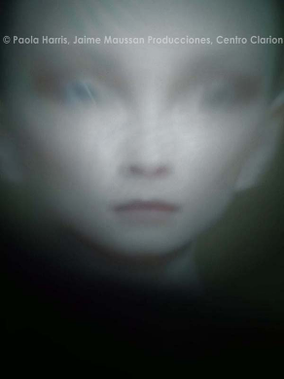
Paola Harris: You are incredible! You succeed in making these photos ...
Maurizio Cavallo: Not at all ... Look at this photo, you need much light ... there is a spaceship and you can see some figures. One of these figures is a Grey, one of the tall ones, at least they call them so. This is another Grey but of hybrid race, half human and half alien.
Paola Harris: Where did you take this photo?
Maurizio Cavallo: In the base.
Paola Harris: How did they bring you?
Maurizio Cavallo: Physically, last year.
Paola Harris: How did it happen?
Maurizio Cavallo: By now there is a symbiosis. I start feeling very nervous and troubled, I am very anxious and let my intuition to drive me. When these feelings are very strong I go to certain places. When I arrive in one of these places I meet a physical being part of the alien world who drives me to the base.
Paola Harris: How did they bring you to that base?
Maurizio Cavallo: In a very normal boat. We left the harbour, we went to a certain point in the sea and then the water around started to whirl. I was scared, of course, because it looked. like a hurricane, then we and our boat started to go down. While I was going down, all around me I could see a crystal wall, water was liquid no more, it was solid. Water walls were solid like a tunnel and we went down till a point where those walls opened like rays. We were in the middle of a wheel whose rays were the corridors of the base they have under the sea.
Paola Harris: Which is their race?
Maurizio Cavallo: They are Clarions working together with another race.
Paola Harris: I can imagine that you are not a tourist for them, they have an agenda . They want you to disclose in a soft way such a complex scenario and to disclose this unbelievable reality?
Maurizio Cavallo: Very probable, but perhaps the primary fact is they are instructing me. This is what I think, but I can also be wrong. They are instructing me so everything I see, everything I live and everything that will bring in a soft way this reality to other people, is mainly directed to my self. You see, Paola, we think we can choose and it's terrible when we understand that all we have done was not our choice. If I could go back to my past I could not have lived in a different way. I have always had different hobbies. I did not like sports like football, I liked to go fishing, I liked my work and my family. I've always believed, since my childhood, that the other worlds were inhabited. I have always believed that there are other intelligences on other planets ... anyway I led a normal life until I was hurled into this unbelievable new reality.... By the way, they walk in a strange way, they glide ... It's an extraordinary effect.
Paola Harris: Do they walk in this strange way also on the road?
Maurizio Cavallo: No, on the road they look like normal people. But you can recognize them from some signs: they are very kind, they radiate a healing energy also when they are not speaking. When they talk their voice may sound a little metallic and low. Sometimes it happens because there is a sort of simultaneous interface from their language to ours, but perhaps their vocal chords give this lower tone to their voices. They have big ears and strange, penetrating eyes, very penetrating. But more than all you can feel this energy, this kindness, their energy. They emanate an energy so strong you can feel uneasy.
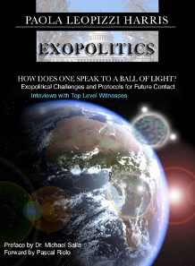
Paola Harris: In my second book I wrote a lot on how we must act not to be scared from alien races, first of all we must accept all the differences existing between races here on Earth. You have been very lucky. This happened to you in 1981. Now, let's try to understand, has this been only a contact or have you got some prophecy about our future? Can we give a hope to people?
Maurizio Cavallo: Yes, the only hope is that our conscience, human conscience must reach another level, a higher level.
Paola Harris: We don't have much time.
Maurizio Cavallo: We have no more time and so our duty is enormous. We must achieve a dynamic change. It is more a dynamic change than that simply of consciousness.And there is time to change our dynamism because they are two different things. Consciousness needs a very long time of assimilation. Everything that happened to me belongs to a program which started a long, long time ago. When they showed me images of a girl I could not recognize because I was not yet born and I recognized she was my mother, they said she too had been touched from the Lords of the stars, and I started to understand that everything was part of a program. Many of us on this planet are unconscious parts of this program, also people who say they never saw anything. We only see a mechanical reality but I can see a magical reality. I don't use the word "magic" in a negative sense because our universe is, in effect, a magical creation and all the dimensions and the same creation that we think have physical parameters, don't have any. Matter is illusion and is only the crystallization of our thought. We only see what we learned to believe is reality. When the humankind will be able to look through this otherwindow and will look at reality with new eyes, perceiving the real universe we live in, we will go insane or we will evolve. There are no alternatives.
Paola Harris: Perhaps the two things together...
Maurizio Cavallo: I have passed the two of them. I don't think I'm a superior man but I have seen things that nobody else has seen. These things taught me to be more humble and every time I think about what happened to me and what could still happen I feel so little and I ask myself: "Why me?"
***
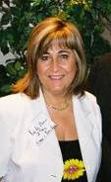
About the Author/Interviewer: Paola Harris, M.Ed. is an Italo-American photojournalist and investigative reporter in the field of extraterrestrial related phenomena research. She has studied extraterrestrial related phenomena since 1979 and is on personal terms with many of the leading researchers in the field. She has written for Nexus, UFO Magazine, Notizario UFO and Dossier Alieni, among others publications. Her books are entitled, Exopolitics: How Does One Speak To A Ball Of Light - Exopolitical challenges and protocols for future contact (AuthorHouse, 2007) and Connecting the Dots: making sense of the UFO Phenomena (Granite Press, 2004). Paola also teaches courses in the Exopolitics Institute Certification Program. Her main website is: http://paolaharris.com .

