

An Andromedan Perspective on Galactic History

by Alex Collier

Global Wings Conference, August 2002 [Transcribed June, 2007].

[Editorial Note. This was Alex Collier’s final lecture before his ‘retirement’ from the UFO lecture circuit in 2002. It has never been published before. It deals with information given to him by his ‘Andromedan’ extraterrestrial contacts concerning Galactic History. The information is vital for understanding the historical intervention by extraterrestrials. Investigations conducted by the Chief Editor of the Exopolitics Journal point to the crediblility of Alex Collier as someone who has physically interacted with extraterrestrials. Many thanks to Alex Collier for permission to transcribe and publish his presentation. All attempts have been made to transcribe this presentation as accurately as possible. Transcribed by Teri Callaghan – June 2007]

Abbreviations
[AC - Alex Collier]
[Q - audience question]

Introduction
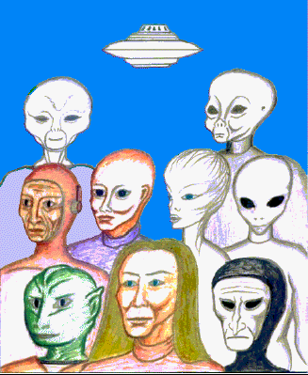
My name is Alex Collier, I want to thank you very much for coming, this is going to be a very special treat for me. I love these small, intimate settings here, these living room types of things. I am very comfortable and when I am in my element I like to talk, and I am definitely in the mood for a talk fest. The information that I shared this morning, I am going to go over it again, briefly, because I went through it so quickly and some of you weren’t there. Essentially what we are going to be talking about is the 22 [extraterrestrial] races. The book that will be ready this spring is going to be called “Defending Sacred Ground II, ET 22”. I have been wanting to do this book for ten years and now it’s time to do it. The reason it’s time is that there is so much going on in our solar system that we all need a score card. I hope to be able to share the knowledge that has been shared with me as to who these beings are and how they relate specifically to earth, to us.

In a nut shell, we are a composite of a lot of different races, 22 to be exact. It is a physiological fact that there are 22 different body types on the planet. And that is the result of the extraterrestrial races. I cannot share everything that I have in two hours, because I am sharing the stage tonight with Mike Russ. But I will be around and available, and the information will be put on the website. You will have it as soon as it is done, and proofed and edited. There will be a bound book version of that, but by then you will already have the information. If it is something that you want to purchase at that point to give to friends, it will be available. It will be for free, none the less.

I’m not going to go into how it all started for me, for thirteen years I have been telling that story and I refuse to tell that story any more. If you want to know, you can go to the website, http://www.bibliotecapleyades.net/esp_andromedacom.htm#menu , all the information is there, including Book One, which you can download for free.

Now, earth history, we are taught a very, very shallow version of earth history. We are also taught that we evolved from a single cell, that essentially we were an accident. All of us are just an accident. Something happened, something really weird but yet something miraculous happened to a couple of chimpanzees and ta-da here we are! It should be so simple. In fact, I like the real version much better than the concocted version.

What I am going to start with is some of the earth timelines of history and I am going to blow through specific periods and just move it through to prove a point. This will be much more specific in the book. Earth formation, we will start with the Precambrian time, 4.5 billion years ago to 554 million years ago.

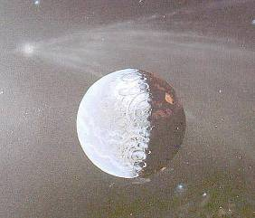
Earth taught history.
The earth is forming, along with other planets in the solar system. Earth is being born, life is awakening. The first tectonic plates are beginning to move. Fungus, plants, animals and organisms are developing and the atmosphere is becoming enriched with oxygen.

Andromedan taught history.
An ancient race, known as the Founders, who the Andromedans and the Pleiadians believe are an ancient race called the Paa Tal, is on an engineering program whereby environments of planets and terra-forming is being done. They are doing this to make these planets and star solar systems suitable and habitable for organisms and for life, rendering ecosystems that are filled with hydrogen, oxygen, methane, and ammonia. Ecosystems, some being oxygen, some being methane, some being ammonia, and some being hydrogen. These are all gases for the introduction and colonization of micro-organisms, manites and all types of life forms. Self replicating machinery and the bombardment by comets and planetoids to change the rotation and the chemistry of the planets. We will get to the self-replicating machinery here in a little bit.

The practice and engineering of removing moons to alter a planet’s rotation and moving planets closer and further from their sun’s to either decrease or increase radiation received by the planets. Now I want you to know that that specific engineering fete of moving planets closer and further away from the sun, moving moons, adding moons is a practice that is absolutely in full swing today throughout the galaxy and in other galaxies. It is solar system building. This happens a lot. There are races, even the Andromedans, that are capable of creating a solar system.

All projects, it appears, were designed to enter many star systems and many planetary bodies habitable for organic life. Small machines have been discovered that were built so long ago that no one really knows for sure who built them. They cannot be replicated and no one knows exactly how they were built.

I will give you an example of the Andromedans. The Andromedans are approximately 43 to 45 hundred years more advanced than we are technologically. That’s in our years. A year for us equals 365 days. This is one rotation around our sun. The Andromedans count years in a completely different way. In fact almost all the extraterrestrials do. In their concept of age, what they consider a year is when every cell in their body has been fully duplicated, replicated. Now if we did that one year would be equal to seven years in our body. It takes approximately 34 years for their bodies in our time to replicate every cell in their body. So it is hard to give you exact dates of when they say something happened to put it into our timeline of years. In reality, if I say it was 4 thousand years ago, it’s a lot longer than that. But they have had a very hard time explaining to me in our earth time, because they don’t deal with the concept of time. They just don’t. I’m giving you these numbers in earth years just to give you an idea of how vast our history is.

Amazingly these machines still work. The machines do not have a name in the English language. They don’t even have a symbol that we could comprehend. It has been explained to me that it is an anti-matter machine. It creates matter. It creates molecules which then creates atoms, which then creates physicality. And these are actual machines. They are like computers where you can program it for what you want; and this machine will literally bring it forth and manifest it, and there it is, physically there. If each one of us had one of these machines, it would be like winning the lottery every day. Mike likes to do VWs. He could make himself a new VW as soon as the new models came out, as soon as he knew what he wanted. I could create a babysitter so that my wife and I could go out. Apparently there are seven of these actually working and seven different races have one. These are archeological finds, discoveries, these atom making machines, for lack of a better word. There is one here on the planet.

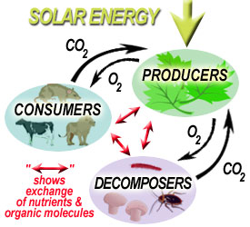
They also discovered advanced building complexes, very large machinery and complete terra forming ecosystems. Earthlike organic life is much less common than hydrogen gas ecosystems in our galaxy because we are limited, oxygen (O₂) ecosystems, are limited to the geological presence of water. For O₂ life forms, which everything is on this planet, there has to be water. The most precious thing that we have is our ecosystem, our biosphere. The second most precious thing we have is of course the water. When we get to Nibiru, our entire planet used to be fresh water. The oceans were salinated. And it was the Nibiru from the star system of Bootes that did that because they wanted to control the water. They salted the sea. At the time that they did this there was only 4% fresh water, and they had total control over it. It took 36 years to completely salinate the oceans. And it also gave time for all the life forms in the water to adapt very slowly. But we couldn’t drink the water after that.

This is all in our years, that is the only way I will present this to you; otherwise it will get too confusing. Hydrogen ecosystems are much more abundant as is methane because they are not complicated ecosystems. O₂ ecosystems are very complex, the most complex in the galaxy. Archeological evidence, records and legends point to the Founders, the Paa Tal, as the creators and caretakers of this galaxy. This disappearance and/or extinction of the Founders appears to be deliberate. And what that means is, how it’s been explained to me, we all know what disappearance means. To the Andromedans, when they refer to extinction, if there is no physical record of them on third density, they are extinct on third density. That doesn’t mean that they are gone. It could be that they ascended or evolved to a higher frequency or they dropped down to a higher frequency to create third density and when they were done they left. But they are extinct on third density.

In sharing this particular information that I will be sharing in the next year it is important to try to stretch yourselves to think holographically here. There are so many implications to this information and it is difficult to try to express that because the English language is so limiting, to try to give you a concept of how this was all done.

When the Paa Tal apparently left according to the archeological record, other life forms, sentient life forms, reptilian, human, plasmic, methane life forms all began to appear; and do appear in our galaxy in full form. Now just think about that, they appear in full form. That means that they came from someplace else or they were brought from someplace else. There was no millions and millions of years of evolution into this. And this is the same problem that our archeologists have on planet earth. They keep espousing evolution, but there is just no proof of evolution in the geological, archeological record.

There just isn’t. Things appear fully formed. It’s amazing stuff. Now are the Paa Tal archangels, are the Paa Tal the gods? Nobody know what they are which is why they just refer to them as the Founders, because they don’t know. They don’t know. The Andromedans do say that there is a “creation”, “creator”. They, in their traditions, say that it does not carry a dominant male frequency. In their opinion, it carries a dominant female frequency. In their opinion, and I tell you they are real men, the creator is a goddess. It does exist. So we blew through that.

The Paleozoic Era, 554 million years ago to 245 million years ago: a dramatic explosion of diverse, multi-celled animals. They put that because suddenly everything is there, it’s in the geological record. They don’t know how it got there, where it came from, but its there, so they just say “Well, it just exploded, there it is!” All these different things show up out of nowhere. Species appear with all living animals and species appear within a few million years. Again, there is no evolutionary process here. They just begin to see them in the archeological record, and each existing on different parts of our modern continents.

Now at the time that this was happening, the North and South Pole were different. The planet was literally lying on its side. It had already had a pole shift, one of its many pole shifts. This is where the physical north and south pole rotate usually following a magnetic pole shift, if it is done on its own. If it doesn’t do it on its own that is because a planetoid or an asteroid has hit the planet, made it roll and then what happens is, the magnetic poles will either correct it over time and make the planet rotate back, or the magnetic poles will follow. I do not understand the mechanics of that.

The west coast of North America ran east and west along the equator. Africa was the South Pole. Suddenly, during this period 245 million years ago, 90% of all marine and animal life becomes extinct: animal life, not plant and fauna, marine and animal life. You would think that if something dramatic happened that everything would be affected.

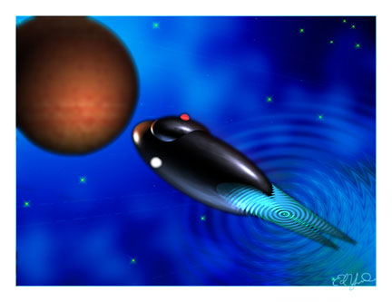
But that is not what happened. It was mammal and animal life. The same period, 544 million to 245 million: the ET history, the Andromedan ET history. Races in the solar system began to develop space travel. Most are only able to travel within their own star systems. Some, however, are able to travel outside of their respective systems and have begun contact and discovery of other cultures. The start of trade within Star Systems begins. Trade routes are established and negotiated. The sharing of technology has begun and the development of new systems of space travel has also begun because now the space colonies, the different races that have been established here that came in fully formed have figured out how to get off their own planets and now they are talking to other people getting different perspectives and the are sharing ideas and sharing opinions.

I’ve not touched on this and I won’t touch on it in this lecture, but there were also a lot of misunderstandings that went on here, especially between the hydrogen cultures and the O₂ cultures. And I will explain why there were some misunderstandings later on when we get into this.

Treaties were forged between star systems and races. One particular race of sentient beings which was much more advanced in space travel, set out to explore the galaxy, that is the Alpha Draconian, the Ciakar. They were the very first, according to the Andromedans, to actually get off planet. And they were at the time the most advanced.

They are an incredible race... They just have some incredibly ridiculous prejudices and biases. But that doesn’t take anything away from the fact that as a culture they have done some incredible things and a lot of other races have learned from them as well. Their space craft, at the time, were hollowed out moons and planetoids which they refurbished, built out, created their own internal ecosystems and fitted with propulsion. Some of that using fuel, which is not oil like we have here, but it was some kind of a gel that was mined in their star system. And they created kinetic energy engines; it’s a type of electricity in my understanding.

The Mesozoic Era which is 245 million years ago to 65 million years ago: Earth history: ‘Mesozoic’ means middle animals. It is the time in which the world’s fauna changed drastically. It didn’t change before, but now suddenly it does. And great change in terrestrial vegetation. The dinosaurs evolved, well, they show up out of nowhere, and evolve in the Triassic and then Jurassic Eras, only then to become extinct. Another planet hitting asteroid hits the Earth in the Atlantic Ocean off the coast of what is now known as Columbia. Now, were they deliberate? No one seems to know if they were or not. But what is interesting is that every time the planet gets hits with an asteroid or there is a pole shift, there is a radical change in the Earth or its ecosystem and what happens is it becomes more and more friendly for human life. 244 million years ago we just could not live on this planet. There were just too many things out there that would have hurt us.

Extraterrestrial History.
245 million years ago to 65 million years ago: Many planetary civilizations have full space travel. Interplanetary trade is extremely [well] established; the need for natural resources increases and causes the exploration of the galaxy by advanced sentient beings. Space travel has been in progress and trade for over 17 million earth years at this point; 17 million years. Look at what we have accomplished in 4 thousand years. And we know we have been held back and we also know that there is technology that has been hidden from us.
The most well established star races are the Ciakar of Alpha Draconis or Draco, the Orion star civilizations and the Lyra Vega star system. Colonization is in full swing. Many planetary alliances set up rules of colonization and are reaching further and further out into the galaxy. So here 245 million years ago our star brothers, our ancestors, because they are, because we are the sum total of 22 of these races, our ancestors already had space travel… They were setting up rules of colonization amongst themselves. It is just amazing to me.

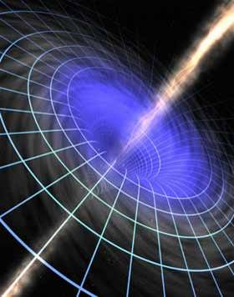
The discovery of space highways; what our scientists theorize to exist as wormholes. There are space highways. The discovery of these is made during this period. To date, 17 have been discovered in our galaxy alone, 17 wormholes. And for those who don’t know what we are talking about, this is our galaxy [points to star chart], the little dots are the stars, and what you have are tunnels that go to different parts of the galaxy. Just to give you a little example, … our scientists theorize that if you can tap into one you are on the other side of the galaxy in no time, in a blink. Like the movie “Stargate”.

Several of these connect to other galaxies. And we all have to assume that at least one of these connecting tunnels would be to the Andromedan Galaxy, which would be over here. So you have a hole, you have a hole here, now you have a way to get here, incredibly fast. So it is not a situation where you get into your rocket and by the time you reach you destination everyone is dead of old age, because the galaxy is huge and it is expanding all the time. But as the galaxy expanded many of these tubes of focused time, that’s the Andromedan perspective of what a wormhole is: tubes of focused time. I cannot explain it to you any more than that. I do have some notes that are still stored away in a storage unit in another state where they have had to be put for safety and I have not gotten them yet. In fact there are three boxes of notes, let’s not even go there.

Some of these tubes have snapped, in other words, as the galaxy expanded, there were breakages in these wormholes, or space highways. No galactic races to the present time, and this is as of 11 months ago Earth time, knew how they were built or who built them and they can’t be repaired, because we don’t know how they were built. Nobody knows how they were built. There is an assumption by many that the Founders created them. Which is how they were able to do all of the terra-forming and eco-building in the galaxy in preparation for life to be introduced here. There is an assumption that that’s who built it. The truth is we don’t really know for sure. It could have been built by somebody from before them, we don’t know. According to the Andromedans, third density, as we know it, is 21 billion years old. The Universe that we know of, which includes all of the dimensions, is 21 trillion years old in Earth years, which is a staggering number.

According to the Andromedans only two of the wormholes have not snapped in our galaxy. So out of the 17, two are still fully operational. As trade increased, the spread of life forms also takes place. The experimentation of transplanting life forms and vegetation is in full swing. Now let’s go back to the dates.

245 million to 65 million years ago.
Our extraterrestrial ancestors are now transplanting the vegetation and life forms from other systems to other star systems. The transplanting of life forms is only with life that has potential. Now what their actual definition of what that potential is, I can’t tell you because I don’t know. But according to Moraney this potential can only develop in complex ecologies. And by far the most complex ecology or ecosystem in the galaxy is O₂, oxygen based, which is what we are. Truly complex ecosystems only occur in a relatively small number of planets in the galaxy. Now that might be several billion planets, but when you take into account how many suns and how many actual star systems we have, it is in fact, a small amount even though to us we would say “My God, there’s two hundred billion earths out there?” That’s a staggering number to us. But in the big scope of things it is actually a very small amount, because the hydrogen ecosystems by far out weigh all the others.

It follows that a complex, planet wide ecosystem is the next most valuable thing in the Universe to consciousness. Species, however, come and go. But a truly rich biosphere will endure as long as it is not compromised. Dinosaurs, birds, fruit trees are brought to our solar system and transplanted on the three ecosystems in our solar system. They are: Earth, Mars and Uranus.

All developed extraterrestrial races have already impressed on their civilizations that conservation of bio-spheres was and is simply a necessity. This is 245 million to 65 million years ago. They were already teaching their children about conservation of the ecosystem. The Cainozoic Era: 65 million years ago to present. We are going to get through this and then we are going to get really down into some fun stuff.

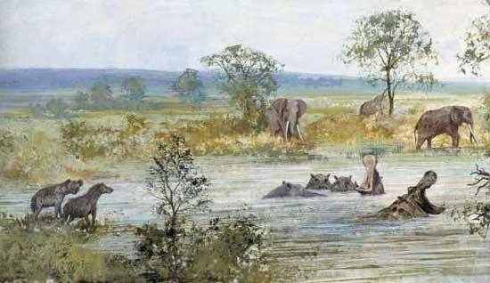
Earth Taught History
Sometimes called the age of mammals, because the largest land animals and mammals show up at this time. It is also called the age of flowering plants, the age of insects, the age of fish and the age of birds.

Andromedan Taught History
Our solar system is being visited more and more. Three very complex ecosystems exist here already, we’ve already covered that. The first full time self-contained bio-sphere, called an “Eden”, and I’m going to use that word, because that’s what the Orion’s called it, that’s what the Nibiru called it, and that’s what the Pleiadians called it. An E-Den, which is like a garden. It’s a fully transplantable bio-sphere, having everything they need to exist somewhere else.

We do not really appreciate how smart our ancestors are, because they don’t always travel in very large space craft. But what they have learned to do is travel light and make sure that whatever it is they need they have or they can grow. Now, virtually every mother ship has an internal ecosphere. We see the scout craft. We see the four, the five, the hundred mile craft. The hundred mile craft may have some kind of an ecosphere inside of it because it has a crew and that crew needs to eat, so they will create a park-like setting and ecosphere inside those space craft. Most of the craft that have hit the Earth are just little scout ships. If a hundred mile mother ship hit the Earth, we would have a pole shift and everybody would know about it. But the very large ships, I will give you the example of the Andromedan mothership.

They are complete spheres and on the inside they are complete worlds unto themselves. In the center of these crafts, and they may have as many as three, they will have ecosystems, park-like, as big as 21 miles long. The one that I saw was 21 miles from one end to the other. It [the mothership] was 900 miles and for me to literally see every inch of that ship would take 25 years, that’s how big it was. It had everything. In these parks you could not even tell you were in a space craft, you would think that you were in a park, Agora Hills California, Rocky Mountain National Park, Central Park (although I wouldn’t necessarily want to hang out there) but without the crime. And they are complete unto themselves everything is grown aboard the craft. So, when they come here and they send a team down to the surface of a planet and they say “Ok, we are setting up an Eden, because we’re going to leave a team of you here to research the plant life, the geology of the planet, the minerals, what it has.” What they do is they literally drop … as many as 12 type cylindrical antennas. They plant these antennas down into the ground, at least a mile, into the ground. And when they flip these things on, they connect. And when they connect they create a dome, a frequency dome. And then all they do is they unload the plants, the fruit trees, everything they need, and this biosphere is exactly to match their physiology. It doesn’t have too much oxygen, it doesn’t have too much carbon, it’s exactly what they need. It can even be hydrogen because then, once they leave they just wear a space suit and they can go out and do their work. But when they come back from doing their work, they come back to their bio-sphere and it’s like living on the home planet. This is what I am talking about; this is what an Eden is. This is what Richard Hoagland has been talking about all those years, with the dome structures; this is what these things are these things were for, exactly. It’s good stuff, it gives me the chills!

The very first one was founded in what is now North America, along what is now known as the New Mexico-Arizona border. And it was founded by and established by the Ciakar, which are [a] hydrogen based life form, so they had to have something like this. Hydrogen is a gas; it is not something we can use. Our physiology would not allow us to breathe it and live in an environment like that. But hydrogen beings tend to be very large, a little bit slower in movement, their body frequency, the rhythms of their bio-system tend to be much slower than O₂, and the one thing about hydrogen based life forms is that they cannot go faster than the speed of light in space travel. O₂ have been known to go four times the speed of light. That’s been a real problem for the hydrogen based beings. In lectures years ago, I talked about how prejudice is an extraterrestrial perspective. All the prejudices we have, we’ve learned. We’ve formed some of our own, but the initial “not liking any of your own race” was taught to us by these guys millions and millions of years ago.

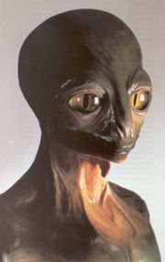
This first Eden was created 899,701 earth years ago by the Ciakar in New Mexico/Arizona border. The reptilians still fancy the desert. This bio sphere was first inhabited by…the reptilians civilization is a caste system. It is a monarchy, but it is also a caste system and you will find that it is stunningly similar to those in England where you have royalty. You have the officer class, which is your dukes, your earls. Then you have your peasants who do all the dirty work, who literally do all the work. It is exactly like that. According to Moraney, this first bio sphere was built by the officer class of reptilian beings and they were the first to stay here. It was not actual royalty.

[Editorial Note. January 4, 2008. What originally followed at this point was another transcribed page and a half of Alex Collier’s 2002 Lecture. It was subsequently learned that 45 minutes of Alex’s lecture had mysteriously dissappeared from the DVD recording, missing much vital information on the history of a number of extraterrestrial races. When the error was discovered by the Chief Editor on Jan 2, 2008, the missing 45 minutes was kindly transcribed by Teri Callahan for the next edition of the Exopolitics Journal. Given the importance of the material that went missing, it would not be inappropriate to speculate that one of the extraterrestrial races criticized in the missing 45 minuties did not want this material to get out. To read the missing material, please visit part two of this lecture at: http://exopoliticsjournal.com/vol-2-3.htm ]

***

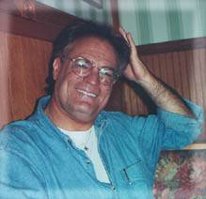
Alex Collier is a 'contactee' with a race of human looking extraterrestrials from the constellation of Andromeda. He first began to experience extraterrestrial contact during his childhood up to his mid-teens. After the experiences stopped over a period of several years, which included military service as a helicopter pilot in the U.S. Army, the contact experiences resumed in 1985. He met with two Andromedans who became his mentors and took him on board their space vehicles including a large extraterrestrial mother ship where he was exposed to the teachings of the Andromedans over a three month period. The Andromedans gave him information about cosmic spirituality, life in the universe, and Earth’s galactic history.

***
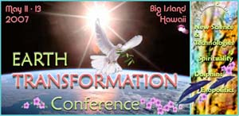
Earth Transformation Conference DVD’s NOW Available!!!
Phone: 808 323 3400 www.EarthTransformation.com

