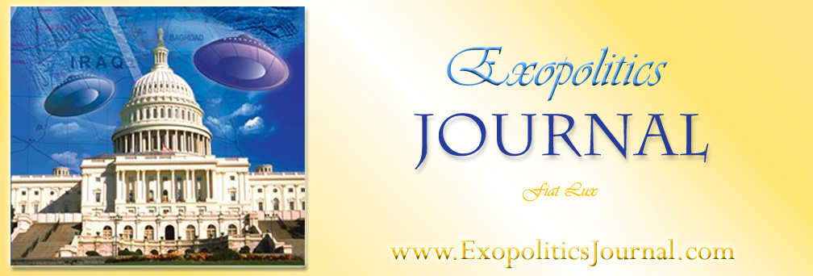

Book Review: Paola Harris, Exopolitics: How do you speak to a Ball of light? Exopolitical Challenges and Protocols for Future Contact (Author House, 2007) ISBN: 978-1-4259-0940-0
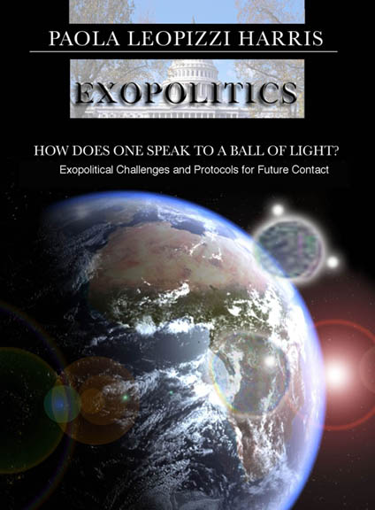
Exopolitics is a revolutionary new approach to evidence concerning an extraterrestrial presence that is kept secret by a shadowy group of covert quasi-governmental organizations in the United States and other major countries. Exopolitics differs from more traditional approaches in UFOlogy that focus on finding sufficient empirical evidence to “indubitably prove” the UFO phenomenon to be real. In contrast, exopolitics focuses on the implications of the available evidence confirming the presence of extraterrestrial visitors to our planet. Exopolitics focuses on key policy questions such as: “are extraterrestrials friends or foes?” “should space weapons should be targeted towards extraterrestrial visitors?” and “what diplomatic protocols should be used for establishing contact with extraterrestrials?” Finally, exopolitics focuses on identifying the key political players, institutions and processes influencing the available evidence of visitation by extraterrestrial civilizations.

The exopolitical challenge requires going beyond the simplistic demand for “indubitable” empirical evidence, and requires analysis both of how evidence is collected and analyzed, and its implications. This typically leads to the realization that evidence is systematically distorted, removed or fabricated by shadowy quasi-governmental organizations intent on maintaining the ‘Cosmic Watergate’. Exopolitics therefore requires an open mind and systematic attempt to investigate the best available evidence that extraterrestrials are visiting our planet, that quasi-government organizations are keeping this secret, and that the available evidence has important implications for all life on this planet. This book by Paola Harris, a veteran UFO investigative journalist, both defines the exopolitical challenges before us, and outlines some strategies for meeting these challenges.

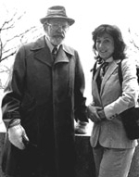
Paola began her UFO research under the expert guidance of Dr Allen Hynek who began advising her in the 1970’s on the importance of thoroughly investigating UFO evidence. Working under Dr Hynek, Paola began personally investigating key UFO cases by traveling to interview witnesses and see at first hand any available evidence. She has since compiled an impressive database of witnesses and evidence confirming the reality of the UFO phenomenon, and of a high level cover-up up by quasi-governmental organizations. Her research confirms that these shadowy organizations, in the United States, use as their authority, executive orders passed by a number of presidents in order to co-opt the resources and personnel of various governmental, military and corporate entities.

In her first book, Connecting the Dots (2005), Paola provided an impressive compilation of interviews with whistleblowers and veteran UFO researchers detailing how the UFO cover-up is organized, and how suppression of the evidence occurs. Her book helped open up some of the key challenges confronting the emerging field of exopolitics. In this book, Paola explicitly addresses a number of exopolitical challenges. As her book title suggests, these include establishing reliable forms of communication with advanced non-terrestrial life forms, establishing protocols for extraterrestrial contact, and finally understanding the covert quasi-governmental cover up.

Paola’s is the latest in a series of published books that explicitly examine exopolitics, and help define exopolitics as a new field of scholarly study. My own book, Exopolitics: Political Implications of the Extraterrestrial Presence (Dandelion Books, 2004), describes the evolution of the global management system for extraterrestrial affairs; outlines how exopolitics impacts upon conventional international politics; and gives an exopolitical analysis of the Iraq war. This was followed by Alfred Webre’s, Exopolitics: Politics, Government, and Law in the Universe (Filament Books, 2005) that examines how a quarantine has been imposed upon the Earth due to historically violent human policies, and what this suggests about political processes existing in “universe society”.

In the first section of her new book, ‘essays’, Paola outlines the emerging field of exopolitics and how it differs from more traditional UFO approaches. She advocates the need to break free of the myopic focus on finding indubitable empirical evidence and documentation, and instead begin examining the implications of the available evidence made by a number of credible witnesses and whistleblowers, that extraterrestrial visitation is very real. Paola correctly identifies that traditional UFO approaches are often a thinly veiled form of debunking that systematically casts aside valuable testimonies from whistleblowers and witnesses courageously revealing the truth about extraterrestrial visitation.


Having worked directly with key whistleblowers such as the late Lt Col Philip Corso she know all too well the difficulty of substantiating the testimonies of those revealing the deep secrets hidden by quasi-governmental organizations behind the Cosmic Watergate. Her essays section correctly lays out the need to study the implications of whistleblower testimonies, and the folly in thinly veiled debunking efforts that will doom traditional UFOlogy to irrelevancy as the population awakens to the truth of the extraterrestrial presence.

In the subsequent section of her book, “unconventional wisdom from unconventional people” she interviews some of the key people contributing to the exopolitical awakening. Most significant are the revelations from Dr Steven Greer, former Astronaut Dr Edgar Mitchell, and the Honorable Paul Hellyer, who all provide unique perspectives into the exopolitical challenges before us. Dr Greer discusses how quasi-governmental organizations have usurped constitutional principles in maintaining the Cosmic Watergate. Dr Mitchell reveals his own experiences based on conversations with reliable ‘insiders’ that extraterrestrials are visiting Earth, and government suppression of this information is very real. A former Canadian Defense Minister, Paul Hellyer, discusses the policy issues raised by US efforts to weaponize space and the possible targeting of extraterrestrial visitors.

The next section of Paola’s book contains a number of interviews of individuals who point out the main exopolitical challenge before us in terms of developing the right protocols for extraterrestrial contact. The Charles Hall interview describes the need for developing the right protocols for interacting with extraterrestrial visitors. Hall warns that misunderstanding these protocols can have harmful consequences as he directly experienced himself. This substantiates the need to carefully assess the development and use of advanced weaponry that might be used against extraterrestrial visitors. Another interview involves (Dr) Dan Burisch who describes the compartmentalized security processes used for managing human extraterrestrial contacts, and for restricting this information. The interview with Philip Corso outlines the challenges for establishing a new world based on human extraterrestrial contact.

Paola finally examines in her last section of the book, some of the protocols that might be used for establishing contact with extraterrestrial civilizations. These protocols correctly point to one of the central challenges of exopolitics, how do we communicate and act when in contact with advanced non-terrestrial life forms? Each set of protocols point to a set of procedures that either have been used, or can be used when extraterrestrial contact occurs in order to minimize undesirable actions and misunderstandings.

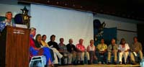
Some protocols for encouraging peaceful extraterrestrial contact were agreed upon at the Extraterrestrial Civilizations and World Peace conference in Hawaii in June, 2006. The Hawaii Declaration on Peaceful Relations with Extraterrestrial Civilizations was adopted by consensus at the conference which comprised seventeen speakers and a total audience of almost 150. Speakers included the Honorable Paul Hellyer, Ambassador John MacDonald, Paola, Alfred Webre, Philip Corso, Jr., and I. The Declaration outlines seven key principles for promoting peaceful relations with extraterrestrial civilizations. It therefore represents an important citizen diplomacy initiative for establishing the protocols for contact with extraterrestrial civilizations. The Declaration is included as an appendix and is available online at: www.etworldpeace.com .

Paola’s book is a valuable tool for all these seeking to understand how to establish formal protocols for communicating and contacting extraterrestrial civilizations. Her book makes a significant contribution to the field of exopolitics by correctly identifying the implications of the testimony provided by a number of credible witnesses and whistleblowers concerning the extraterrestrial presence. Exopolitics is an emerging field that promises to awaken many to the implications of an extraterrestrial presence that has yet to be officially acknowledged to the general public, elected political officials or the mass media. Paola Harris’ book makes a great contribution to awakening many to the implications of the extraterrestrial presence. I strongly recommend it as valuable tool for both established researchers and those just beginning their journey in understanding the exopolitical challenges confronting humanity.

***

Reviewer, Michael Salla, Ph.D
Extracted from Preface to Paola Harris, Exopolitics: How Does One Speak to a Ball of Light



http://www.earthtransformation.com

