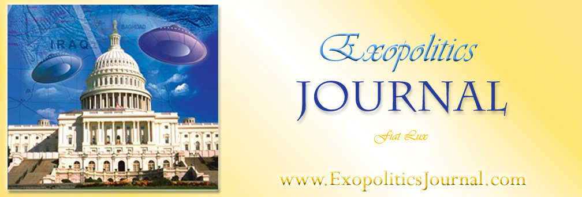
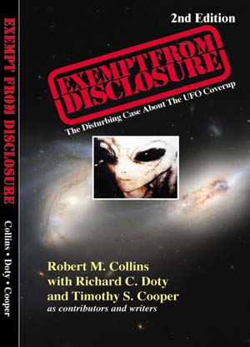
Book Review - Exempt From Disclosure: The Disturbing Case About the UFO Coverup, 2nd Ed., by Robert M. Collins with Richard C. Doty and Timothy S. Cooper as contributing writers (Peregrine Communications, 2006) ISBN 0-9766426-3-8.
Exempt from Disclosure is a helpful attempt to describe the entire history of the UFO phenomenon from the mid 1940’s to the present based on the revelations of a number of individuals earlier associated with an informal study group known as the ‘Aviary’. The Aviary was a group of former and serving officials, scientists, military personnel and television producers from a number of military services and corporations that began meeting in 1986 to discuss the UFO phenomenon. The Aviary attempted to piece together the most credible available information on the UFO phenomenon into a coherent pattern. The main author and the two contributing writers of Exempt from Disclosure were all members of the Aviary, and draw upon their experiences and knowledge gained through their own direct experiences and hearing the stories of others involved in classified projects. The UFO history described by Collins et al., is intended to be a primer for all those wishing to piece together the highly classified activities of senior officials and military services associated with UFOs.
In reading Exempt from Disclosure, one embarks on the journey of understanding the UFO phenomenon from the perspective of an informal study group that had access to various levels of classified information in compartmented programs, and were willing to share this among themselves to piece together the larger UFO puzzle. In particular, Exempt from Disclosure represents the research efforts of the main author, Robert Collins, a retired Air Force Intelligence Officer with the Foreign Technology Division at Wright Patterson Air Force Base, to piece together the secret history of the UFO phenomenon in a coherent and systematic manner.
This second edition of Exempt from Disclosure improves upon the first edition which did not have an index and had a number of typographical errors. Furthermore, it has a number of additions and deletions that reflects the ongoing dialogue between the main author, Robert Collins and contributing writers such as Richard Doty. The first edition provided an astonishing amount of information on a number of key personnel and their relations to UFOs. Collins provided information on the roles played by Allen Dulles, James Jesus Angleton, Richard Helms, in controlling information on UFOs and their knowledge. Each is studied in successive chapters and an earlier review by Dr Robert Wood (see Exopolitics Journal 1:3 [156-59]) describes the importance of much of the information on these key intelligence officials that has never before been released to the general public.
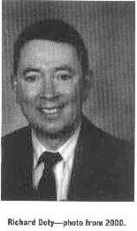
A key feature of this release is the military intelligence backgrounds of the author/writers and the Aviary more generally. Of most significance is the chapter by Richard Doty who served as a Special Agent for the Air Force Office of Special Investigations responsible for UFO investigations (1978-1988). Doty describes his access to classified information during this period, and provides direct testimonial evidence of classified projects involving UFOs. While the first three chapters provide much factual and documentary information on Dulles, Angleton and Helms, it is Doty’s chapter and subsequent revelations that provides primary first hand information. This gives his chapter and subsequent contributions in Exempt from Disclosure most significance for the overall persuasiveness of the book.
Doty was the co-author of the first edition but appears in the second edition as a contributing writer. This appears to have occurred as a result of Doty aiming to distance himself somewhat with his revelations and the classified documents in the first edition, and his later public statements that raised some controversy. Most prominent among these was an extraordinary story in the first edition where he described being physically present at an interview with an EBE. Doty later backtracked and claimed to have seen the interview by videoconference in another room (pp. 143-44). Collins points out that Doty’s new position is incongruent with the story described in the book. According to Collins, Doty regreted having disclosed his experience thereby accounting for his later backtracking and the inconsistency.
Another area of controversy is where Doty claims that he completed a law degree and passed the bar exam in New Mexico (p. 91). This became subject to some heated internet debate when it was discovered he had not passed the New Mexico Bar exam. Later Collins argued that he mistakenly inferred that Doty had passed the New Mexico Bar, but that Doty had indeed passed a law degree. To date there has been no substantiation of Doty having achieved a law degree or any degree for that matter. Furthermore, he did not correct what was in the first edition where he spoke in the first person about his education background. This suggests that Doty dissembled in relating his educational qualifications to Collins. Nevertheless, Doty’s professional qualifications as a former Special Agent for and New Mexico State Trooper can be verified. Such inconsistencies do not augur well for Doty’s reliability as a witness and indeed casts some uncertainty over Doty’s claims in Exempt from Disclosure. Given his important role in the book as the subject of one chapter and later contributions, it’s worth reflecting on Doty’s reliability as a source of UFO information.
Doty’s began his service as a Special Agent for the Air Force Office of Special Investigations in 1978 and played a role in officially sanctioned deception programs. Most well known were his efforts to mislead UFO researchers Paul Bennewitz and Linda Moulton Howe in their respective efforts to research the UFO phenomenon. In such deception programs, Doty attempted to befriend or beguile the researcher and sow misinformation. The goal was to steer the researchers away from sensitive UFO information and ultimately discredit them or render them ineffective. This respectively happened in the cases of Bennewitz and Howe, and likely occurred with other unnamed researchers. In Exempt from Disclosure, Doty apparently comes clean and is disclosing his own direct experiences starting in 1968 when he entered U.S. military service and trained for Air Force security police. Doty’s revelations about his initial assignment at Indian Springs where he witnessed a hangar filled with UFOs, and subsequent experiences with EBEs and UFO information is startling. The key question is: “how close is Doty sticking to the truth.”
As a contributing writer, Doty appears to be performing the inconsistent functions of disclosing personal experiences involving highly classified information concerning UFOs, while raising issues over his credibility as a witness with his subsequent public backtracking and dissembling.
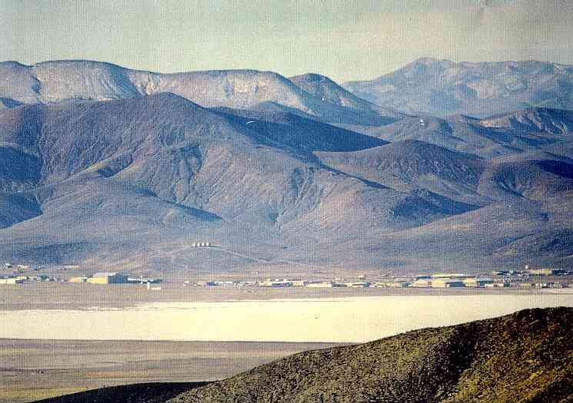
Area 51 – Groom Lake, Nevada
The most significant change from the first edition is Collins clear shift away from using material concerning (Dr) Dan Burisch. In the first edition, Collins and Doty (as co-author) used information from Burisch in terms of him being employed at a classified project at S-4 situated near Area 51 involving a captive EBE called J-Rod in a ‘clean sphere’. Indeed, Burisch’s colleague Marcia McDowell provided information in the form of detailed drawings of S-4 and the location of the ‘clean sphere’ that were used in the first edition (pp. 188-89). McDowell also provided information on the mysterious Men In Black that confronted her when she began disclosing information concerning Dan Burisch (pp. 118-20). In the second edition, all this information is removed. The reason becomes apparent in the testimony of former Defense Intelligence Agency agents, Gene Lakes and Paul McGovern who claim to have worked at S-4 and had access to classified UFO information, and never discovered a captive EBE or a clean sphere (182-84). In particular Lakes, claims to have been chief of Security at Area 51 with access to personnel records. While he could verify that Lazar worked at Area 51, he never saw any record of Burisch at S-4, and concludes along with McGovern that Burisch’s story is bogus. Based on Lakes’ and McGovern’s testimonies, and lack of corroboration of a ‘clean sphere’ at S-4, Collins decided to remove the Burisch material.
Significantly, both Lakes and McGovern first emerged into the public realm as a result of disclosures by a number of anonymous sources at the DIA claiming to have information an alien exchange program. Known subsequently as Serpo Project or Project Crystal Knight these former DIA employees described the details of a project involving up to 12 personnel that traveled to planet Serpo in the constellation of Zeta Reticulum as guests of the EBEs. Collin’s includes information on Project Serpo in the final section of his book. The Serpo information becomes significant because Doty described the planet Sieu in Zeta Reticulum as the home world of the EBE he witnessed in the interview (143-44). So Doty provides some confirmation for the project Serpo material and in the process confirms that Gene Lakes indeed worked for DIA at Area 51 and S-4. So Lakes offers important corroboration for Project Serpo and in the process debunks the Dan Burisch case along with McGovern, also a former DIA official. These former DIA officials are who they claim to be based largely on Doty’s testimony and his reliability as a source.
In conclusion, Exempt from Disclosure represents the efforts of the main author to piece together and make sense of many strands of testimony offered to him by a number of individuals starting from the informal networking of the Aviary study group over nearly 20 years since 1986. The book’s detailed diagrams of the physiology of EBEs; reflections on Majestic 12 control group; the physical layout of S-4; and the intelligence backgrounds of Allen Dulles, James Jesus Angleton and Richard Helms are all very revealing in relation to UFO information. Collins is a competent researcher working systematically with material that has much validity and importance for the study of UFOs. Unfortunately, the prominence of Richard Doty in the first and second edition, and the inconsistencies raised over his experiences and educational background, introduces an element of uncertainty in the overall accuracy of the material in Exempt from Disclosure. While that detracts from the ultimate plausibility of the book, it does not diminish the book’s importance in terms of systematically presenting information gained over two decades of research by some of the key individuals associated with the intelligence community and the Aviary ‘study group’. There is much in Exempt from Disclosure that will help researchers understand some of the key intelligence players in the classified history of UFOs, and paints a coherent picture of UFO related activities and entities that still remain an enigma to most. This is a book that should be added to the library of any serious researcher of the UFO/exopolitical phenomenon.
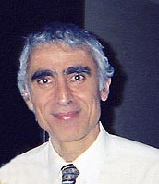
***
Reviewer: Michael E. Salla, PhD. Chief Editor, Exopolitics Journal. Main website: www.exopolitics.org

