

Interview with Dr. Edgar Mitchell, Apollo 14 Astronaut

Roswell July 5th 2004

By Paola Leopizzi Harris, M.Ed.

“I think I’ve reached the point that I‘m convinced enough of the reality of the ET presence and I’m not going to deny it and shun away from it” (Edgar Mitchell)

[Acronyms: P.H. - Paola Harris; Edgar Mitchell, E.M.]

[P.H.] It is a pleasure to see you here in Roswell. I think that you said that you grew up in this area. I think you said that you lived here when you were about 3 to 13 years old?

[E.M.] I lived here from when I was 5 until I went off to College. We had a family business in the valley. It was between Roswell and Artesia.

[P.H.] Friends talked you into coming to speak here at the UFO museum.

[E.M.] I resisted for a long time.

[P.H.] Did you resist because it was connected with the UFO phenomenon?

[E.M.] No. I think I’ve reached the point that I‘m convinced enough of the reality of the ET presence and I’m not going to deny it and shy away from it. I don’t get into it in detail. That is not my area.

[P.H.] I know that your area is more the metaphysical.

[E.M.] Well I think it is an interaction there. Particularly since there does seem to be a non local communication or mental tie here with some of these functions, whether they are real or not, I don’t know.…

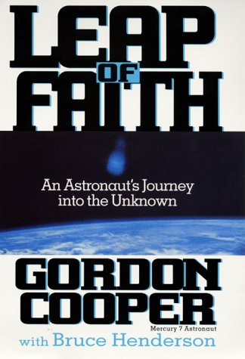
[P.H.] Can I ask you why is it do they pick you of all the astronauts? In the media you have been selected as one who represents the astronauts’ testimony as to this UFO reality although you mentioned you never saw one in space. Gordon Cooper talks a lot more about it in his book Leap of Faith. So why you? Is it by talking about the metaphysical, they have attached you to the weirdness [factor]?

[E.M.] I think it was the personal connection since I had personal contacts in this area. I think it is my credibility as a scientist. I am very very incredulous about what I see. I can’t throw caveats in. I don’t make blanket statements. I tell my sources that disclaim my experience as having first hand experience. But I trust my sources that have first hand experience. I am very clear about all of these things and I am very clear about where our lack of knowledge is. What is the frontier? What are the unknowns? What are the parameters that we don’t understand and I think this gives me a lot of credibility.

[P.H.] What advice would you give those serious researchers that want an answer and let’s say dream of harmony with Cosmic cultures… What advice would you give them?

[E.M.] We are dealing with a difficult process here. The main problem that we, as an earth civilization, have not come to understand ourselves, see ourselves in a cosmic sense at all. We are still very provincial. We fight over religion. In my opinion, Fundamentalist Christians are just as bad as fundamentalist Islam; and at the very core, neither religion is like that. In the inner core of both of them, these religions talk about qualities like love and brotherhood.

[P.H.] You are saying that there are more similarities than differences.

[E.M.] Of course. It’s the cultural differences. It is not an intrinsic difference. It is like I said in my talk last night: “the transcendent experience is common to every culture in the world” and the transcendent experience is brotherly love, nature, harmony, the unity and cultures in trying to define it, try to define an external deity as opposed to the process.

[P.H.] It is easier that way because you don’t have any responsibility. I guess a proverb could be: “You can blame it on the devil or God. It is a lack of taking responsibility for who we are.”

[E.M.] Well, that’s right and our ignorance, and it is based on the egos we have… Transcendence gets you beyond ego. If you go beyond ego, you see all of this in a more decent perspective and you can start to put all pieces together. We haven’t done that yet. Not as a civilization.

[P.H.] That is why you think that contact is not likely until we get there. Right? Humanity as a species is not there. You mention in your talk yesterday, if they ask where you are from, you don’t say from Earth, you say from LA.

[E.M.] Yes. That’s true

[P.H.] So do you think there has to be a one world kind of political situation?

[E.M.] Of course that is what got to happen.

[P.H.] People have some commonality. Right?
[E.M.] In due course, that’s what got to happen. If we survive that long. We might wipe ourselves out before that I don’t think it is a forgone conclusion that we are going to survive. That is where the philosophic, the whole notion of determinism and what the future is like. We are creating the future. It is not determined. If we get our act together and solve out current problems, we could have a sustainable abundant future. If we don’t, we could wipe ourselves out. We are on the verge of doing it with our current politics. It is regressive going back the other way…

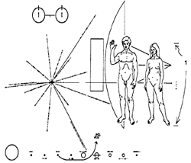
[P.H.] I need to ask you a personal question. Would you have liked to have had Contact with a cosmic culture?

[E.M.] Yes. Of Course.

[P.H.] This is very ironic because you are the chief astronaut spokesman for the ET presence and have never had contact. Like me who has been this work for over 30 years now, and [I] have never seen a UFO.

[E.M.] Yes. I would. I would like to speak from first hand experience instead of second hand experience.

[P.H.] Has it been lonely for you to have this vision and not many people to share it with because the vision you have is kind of a “completion” vision, a kind of overall picture vision, and it is true that you are spending three quarters of your time trying to explain it to people.

[E.M.] I would not put it in those terms because I spend ninety percent of my time trying to explain it to myself.

[P.H.] But you know that is truth for you for you. You are outspoken about that.

[E.M.] Well, I‘d like to discover “truth” when I can latch on to something that I think is true… Our Knowledge base is incomplete and all we do is keep adding to our knowledge base. I think it laughable frankly that physics community comes up for a theory for everything. There isn’t one theory for everything. There is not one explanation. We may eventually have several theories that can tie things together nicely but there is not a single theory of everything.

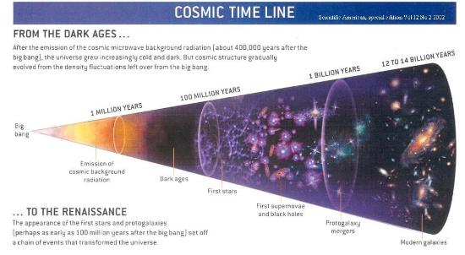
[P.H.] Like the Big Bang being the main theory of creation and what about super string theory and others…

[E.M.] Well, the Big Bang has gone away but as far as Super String, [that] is suspicious for me. It all starts out with the notion of Big Bang which starts out, if it were true, starts out with incredibly high temperatures. So they think we need to get these high temperatures, these high temperatures for this broken symmetry, all this broken symmetry reunited, and we do not have enough energy in the whole galaxy to get to those temperatures, to prove their point. To me, that is the single flaw in Super String theory. Now there are a lot of good points but if it could hold together any better than the Big Bang theory, I don’t know. I’m not a physicist.

[P.H.] You are not going in that direction. You are more into the awareness and what you can accomplish as a human. Is that right?

[E.M.] Yes. And I also think we are moving into a direction of quantum cosmology as opposed to starting with “a big bang “and trying to make quantum physics fit into it.

[P.H.] Quantum Cosmology. That’s a new term.

[E.M.] That originates from Quantum processes. That is, the quantum fluctuations within an o-point field can start the process that builds the process, that builds into matter, an irreversible process. We have some evidence that suggests that. You don’t have a Big Bang but we have a lot of little pops! A continuous set of little pops!
[P.H.] That is a good metaphor. In your talk, one of the things you talked about is that the “intent” creates action. The intent creates your reality which makes us who we are. If that is true, then that makes us powerful on the planet that has always been undermined by great powers trying to put down the masses. So is the idea that “intent” creates, and you can create realities, and you can also create events.

[E.M.] We are creating. I don’t create yours and you don’t create mine but we each create “ours”!

[P.H.] In the past we have always given up our power to the power structures. So would you agree that it is very likely unpopular to the individual people and that that doesn’t come out…?

[E.M.] You have to tie it with transcendence because when you transcend the transcendent states, you get past the ego structure, and at that point you don’t need laws you have “morality”! You have inborn natural ethics because it is built on love.

[P.H.] That seems to be the secret word...

[E.M.] Yes. that is why the ancient traditions, even Christianity, say God is love. There is a symmetry here. The fundamental step where you get into this transcendent state is this feeling of ebullience, love and caring and unity.

[P.H.] And you do not need laws.

[E.M.] That is the law! You learn to live in that. It is hard to live in that too when you are in this world that is why the great mystics go into the mountains tops; to get away from the world. So they don’t have to deal with it but it doesn’t help the world that much.
***
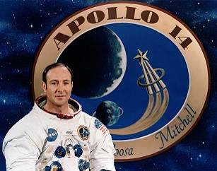
Edgar Dean Mitchell, Sc.D. was the sixth man to walk on the Moon. He did this with Alan Shepard as part of the Apollo 14 mission on February 9, 1971. The mission was NASA's third manned Moon landing. He has a Doctor of Science degree in Aeronautics and Astronautics at MIT. He also has two Bachelor of Science degrees, one from the U.S. Naval Postgraduate School and one from Carnegie Mellon University. He was awarded honorary doctorates from the New Mexico State University, the University of Akron, Carnegie Mellon University and Embry-Riddle Aeronautical University. He began training at NASA in 1966 and served in the US Navy between 1953 and 1972.

