
Extraterrestrial Angels?
Wayne Johnson

If you ask the average “Man-in-the-street” what he thinks of UFOs and aliens, he will likely offer images of spacecraft and ETs from the movies or sci-fi novels, for he has no other reference frame to draw from, unless he was abducted. Right or wrong, a public image of extraterrestrials does exist. Likewise, if I asked readers what they think of angels and demons, I would again get images from movies, TV, and books, or maybe someone’s near-death experience. Since both categories are labeled as supernatural and very uncommon encounters, it’s likely the public image of angels is equally off-the-mark as it is for ETs, aliens, and UFOs.

I have an exercise for those who are sincere in their quest for the TRUTH, which we all know, IS OUT THERE. Take a piece of paper and divide into two long columns. In column A, write all the attributes and qualities that are popular about ETs, aliens, martians, Starmen, or whatever else you call them. Yes, you can draw from your experience at the movie theaters, and if you are a Trekkie, this will be a simple task. Now, in column B, you are to write all known facts and qualities about angels and demons, and I recommend you use a good theology textbook and Bible to get your information. This may be very difficult for some readers, but a worthy and enlightening exercise.

If you wish, talk to some conservative Biblical scholars or pastors who accept a literal, grammatical, and historical approach to the book. What you want is the facts from the text, not liberal opinions and/or slanted denominational theology. Warning—we all know that those who pursue a clearer understanding of ETs are looked on with great suspicion, and likewise, those who desire to explore supernatural topics in the Bible. Don’t be surprised if people question your motives, your intelligence, and your sanity. I’ve been told to see a psychiatrist more than once, so be careful who you talk with.


Once complete, your two-column list will reveal some interesting similarities between the two supernatural categories above. Please don’t jump ahead, for I am not saying these groups are completely one in the same. This article is merely an introduction into a very complex topic, and I’m hoping the readers of Exopolitics Journal will have the proper open mind and objective criticism to sort nonsense from the truth. If you search Google for information on ETs and aliens, you’ll find a wide range of fantasy and speculation, mixed with large pieces of truth throughout. Likewise, if you search for information about angels or Biblical aliens, you will find a similar range of hits—some from the wacky fringe and some from the bull’s eye. The vast majority of UFO-nuts are not born-again Christians, and vice versa, but there is room in the middle, and it’s a fascinating place to live since both groups share so much in common—and offer so much to explore.

Ok, so you don’t have time for this exercise above? Then, I will give you a sample of what you will learn. God has apparently chosen to keep much angelic information a secret, but what has been revealed in the Bible is apparently good for us to know, and very compelling stuff. The obvious facts are that angels have been around since the beginning of recorded human history. They can appear and disappear at will; they have superhuman knowledge, abilities, and power. They can disguise themselves as humans, wear appropriate clothing, talk in appropriate languages, eat with us and interact with humans to the point that no one can tell the difference (doesn’t this sound familiar?) They are messengers and watchers from above; they have specific assignments on Earth, and can even transport people from here to there. They apparently live in a parallel dimension around the Earth, and fly back and forth around the globe, fighting with demonic entities for control of portions of terra firma or for the souls of men and women. This is basic stuff—but there’s much more….

The book of Genesis introduces many things, much of which is ridiculed as mythology and simplistic thoughts from simple people, thousands of years ago. But if one adheres to Biblical inspiration, the stories tell a beautiful plot of the conquest of Planet Earth, once the exclusive domain of Satan and his friends, but now a galactic theater of redemption in its ultimate form. Redemption is a great word, for it describes a legal contract or buy-back if you will, and the theology gets very rich as an appointed Messiah (Jesus) enters center stage as the legal purchaser or Redeemer of the Planet. Sorry, I used the J-word, but please hang on. Important to this discussion is the counter plot hatched in Genesis to undo the plans of this Messiah, who must be born of a woman. One key element of this drama is in Genesis 6, where we see a deliberate attempt to spoil the bloodlines of humanity (and therefore the Messiah) with the introduction of alien DNA.

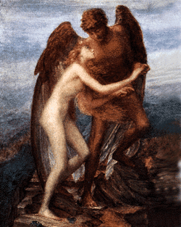
This is never a Sunday school lesson for children, but it’s sufficiently important to be reprinted millions and millions of times over thousands of years, so maybe we should listen to what the Bible says. It is recorded that angels (bad ones of course) came to Earth and mated with human females to deliberately produce a hybrid offspring of giants that were half-human, half-angel. Surely, you have heard of Goliath. The reality of this action is undeniable from this text and others, and may explain much of Greek and Roman mythology from our human past. This rape account in Genesis is predicted to happen again in our future, therefore, this topic has far reaching implications for the subject of Biblical prophecy and our current discussion of aliens, Exopolitics, and everything that deals with contacts or relationships with ETs. The reality and significance of this Biblical event in Genesis should not be ignored, for it sheds much light on the possible nature and identity of alien life forms, and is worthy material to consider.

There is much that the Bible does NOT tell us; therefore, alien life forms and habitable planets other than Earth are certainly possible. If we accept the Genesis story as true, that angels took human wives, then it is possible that fallen angels may have attempted the same genetic experimentation on other planets with other species. The product of such behavior could be so benign as to walk and talk like one of us, or be much scarier than anything you’ve seen in the movies. Any individual alien seen on Earth could be an innocent galactic adventurer, or hybrid demonic/alien creature, or an imposter disguised as one of these groups, or one of the above disguised as human, or something more hideous than we can imagine. The result of all this wild speculation has one clear conclusion—not one of us can say anything definitive about any specific alien or extraterrestrial group we may encounter now or in the future. We simply don’t have enough objective information.

Remember this—modern day ETs and aliens, as well as angels and demons, share one very important trait—they are all vastly superior to humans—with advanced intellect and logic in every conceivable science and philosophy, therefore all humans are inherently vulnerable to their influence and their logical summaries of who they are, why they are here, what they want, and especially how “they can help us”. For centuries our actions and behaviors have been observed and studied like ants under the glass in an ant farm—scurrying about and oblivious to the eyes of greater intellects analyzing and recording our every action. In this scenario, it is not the ant’s welfare that is important, but rather the power, control, and agenda the ant-masters possess.
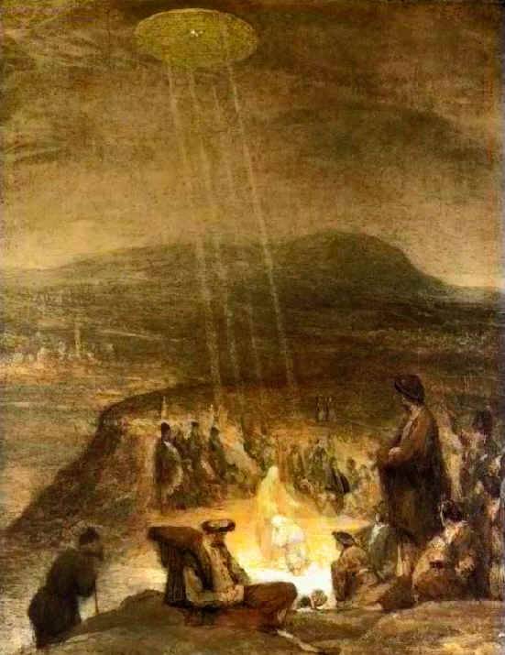

Many stories exist of alien contact in dream states and other out-of-body experiences, very similar to recorded encounters with angelic messengers in the Bible. This should be alarming to Exopolitics advocates, since we have virtually no understanding, much less control, over the subconscious areas of our humanity. Telepathy is another area which aliens have apparently mastered, yet a controversial subject that humans know very little about. Does any human really have sufficient experience, perception, discernment, or wisdom to distinguish a good alien from a bad alien, to determine a lie from the truth? We seem to have great difficulty evaluating the integrity and intent of our own kindred politicians and statesmen, much, much less so for any alien figure. Republicans and Democrats are constantly bashing each other on national TV, yet both claim the definitive answer to everything. Are we really that sophisticated? Are we really a highly advanced culture of intellectuals? How can any single human being claim sufficient ability to objectively evaluate an alien culture, or speak for humanity in the presence of an advanced alien race? Is anyone adequately prepared to enter an arena of communication with alien life forms, all vastly superior to us? Can we ever really trust them? Aren’t we all, like Captain Picard in a losing conversation with the wily Q, forever at the disadvantage, forever hopelessly vulnerable?

I doubt the devil wears red tights and carries a barbed pitchfork, as we see in Gary Larson cartoons (I love them). Somehow, I prefer to think laughter is a human exclusive, but if aliens ever laugh, it is likely at our human ignorance—and our arrogance—about extraterrestrial things, and how gullible we are to alien suggestion about who, what, why, and how. Modern intellects seem to worship science as having the absolute answer to everything, but today, scientists in many fields soon find themselves looking for things invisible, answers in other times and dimensions, thought experiments, mind control, and other speculations that could easily be labeled supernatural. The more we discover of the universe, the bigger it gets—the opposite is true inside the atom, and it seems there is no end in sight. Prudent scientists should admit they have a long, long way to go in our quest for scientific knowledge—why, we have yet to crack the secrets of gravity and time!

Before the Big Bang the universe was full of spacetime, but no one really understands what that is. Dark matter seems to be everywhere, but remains a huge mystery as well. I could go on and on with speculations and theories that are educated guesses about the universe. Even Einstein’s speed limit of light is being questioned by some who are exploring FTL propulsion. There is so much we don’t know.

For thousands of years, people thought the stars came out only at night—now every grade school kid knows they are planets and galaxies, and that they are there all the time. Alien cultures / angels have been there too, whether we see them or not. It’s easy to put angels and demons into a boring box called religion, then move on to more exciting things in science, research, and disclosure politics. Angels are “spiritual” creatures, after all, so we easily assume they don’t have physical form, assume they don’t live in a world with laws of physics, cause and effect, challenge, danger, intrigue, bravery, faith, or victory. The Man-in-the-street assumes angels are fairytale creatures, and laughs at anything that is labeled, “faith”. Yet, he entertains the concept of aliens from other planets by faith; he believes in theoretical physics by faith; he accepts that he is a product of random mutation by faith; he may even read this journal by faith, believing the words of others.

There are hundreds of references to angels in the Bible, written over a period of thousands of years. There are hundreds of references to places that could be defined, “parallel dimensions”, and numerable supernatural references of this and that, written on every page. And don’t forget the incredible subject of prophecy, God’s own fingerprint of authenticity as the only author who knows the beginning from the end. Add these facts to your two-column list you made at the beginning of this article, and you might be tempted to read the book for yourself. There is much to learn from the Bible—it is still a bestseller, and modern explorers of TRUTH should consider what it might have to say about aliens, UFOs and the like. As one who has read it many times, I will speak as one tiny ant to another—Yes, the TRUTH is out there, but so is the LIE——please get your facts right——be very, very careful.
***

About the Author: Wayne Johnson is a professional photographer who lives in North Liberty, Iowa. He has a background in science and medicine, and has worked for many years as an incident scene investigator and technical writer. He is self-taught in photography, woodworking, a dedicated D-I-Yourselfer, and a creative writer. As a professing Christian, he has a special passion for Biblical prophecy—past, present, and future—and how it may dovetail with current movements in exopolitics. As an avid rollerblader, Wayne’s personal motto is, “I’m too old to start acting my age.” Wayne can be reached through his company website, www.mainstreetstudio.com

