
Let’s change that Prime directive! The Agony and the Ecstasy of Ufology

By Paola Leopizzi Harris, M.Ed.

In these days, when the fate of the planet is hanging by a thread in the Middle East and thousands of innocent civilians find themselves caught in the ideological political struggles of the major powers on the planet, “someone” is watching. We who have been following the phenomena since the 1947 Roswell crash during the testing of the atomic bomb at white Sands Proving ground knew someone was watching then as someone is watching now. Those who were in the Pacific campaign during the Second World War knew someone was watching then especially close to the Island of Titinian. While the French were doing nuclear testing off the Hao reef from 1966-1969, they knew they were also being watched. Witness testimony from geo-physicist Guy Andronik tells us he saw two different flyovers of UFOs then and he was present when they scrambled a plane to follow the intruders. All this says that they must be the watchers who have a prime directive: Non interference with a primitive species during their evolutionary period.

Looking at this scenario, I believe we have come to a crossroads not only of aggression and war but also of a certain insensitivity to the evidence of Extraterrestrial visitations. Audiences still listen to speakers at conferences but then go home, have a few beers and switch on the game. Recently a close girl friend of mine put it aptly when she said: “I do not want to know if there are UFOs, Paola. I have enough to worry about!” This reminded me of a very discouraging statement made by aeronautics heir John Lear whose father developed the Lear jet. In a recent interview, he commented on the disclosure efforts of serious researchers in this way.
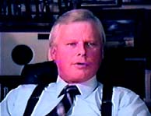
T'was a noble effort by noble people. Unfortunately they had not the slightest idea of the ramifications of what they were trying to disclose. In their naive innocence, they assumed they were disclosing the existence of flying saucers from outer space. What they failed to realize is that not everybody is ready for that information. Probably 99 and 99/100% are not. That information would not help them in their daily lives. It would not help them raise their children. It would not help them pay their taxes. It would not provide them with more income. It would not provide them with a new God. As a matter of fact it might destroy their faith in their old God. Those for disclosure only want one thing: they want to prove THEY KNOW THE TRUTH ABOUT FLYING SAUCERS. So do a lot of other people. Get over it. It’s an ego trip. Let go. It’s not time and won't be time for several generations. Relax, disclosure is none of your business. Have a sip Courvoisier XO and a Cohiba Esplendido and talk about it amongst your friends but don't try to go on Larry King and bang the U.S. Government over the head with a flying saucer. They don't know what’s going on either. Have a heart.”

He is absolutely correct! This is the pathetic state of affairs on planet Earth in 2006. So some researchers may say “why bother?

To add to this negative picture, I heard a famous radio host recently comment about Buzz Aldrin’s denial of his sighting of UFOs during the Apollo 11 moon mission saying: “Again we do not have a shred of "real evidence” after all this time that proves the existence of UFOS. May I remind him that just because someone of the caliber of Buzz Aldrin denies it, does not mean other astronauts do. To add insult to injury, Buzz Aldrin, in that same radio interview, used the old "speed of light argument" to explain why ET cannot come here. With discoveries in cutting edge quantum mechanics, we know now that no one in their right mind accepts this argument any more. This statement sets us back eons.

Is it true that we are no further along in acquiring proof after Buzz Aldrin cautiously denied he saw UFOs on the moon? Of course no one wants to explain the several film canisters which are actually missing from the NASA moon footage in the National archives. Only Richard Hoagland does. On his website www.enterprisemission.com , Richard Hoagland is addressing this mystery showing real Apollo 11 moon mission photographs. Thank God, in 2006, Richard Hoagland, Steven Greer, Ryan Wood, Bill Hamilton are still plugging away, even after the negative Lear statement. But is it worth all this effort and money that we researchers put into disclosure, when the result is total apathy? Maybe it is a problem in United States. I can only talk about what I witnessed this year.


On July 22rd 2006, MUFON researcher Alejandro Rojas passionately orchestrated a “Colorado Briefing” on the grounds of the State Capital in Denver Colorado. Inside the beautiful Greek amphitheater, David Sereda, documentary maker from California spoke of his Film “Dan Akroyd- Unplugged”, Leo Sprinkle Senior Professor and Abduction Researcher from the University of Wyoming spoke about current abduction research, and Ryan Wood spoke about his new Majic Eyes Only book. Wood explained that there were at least 60 crashes after Roswell documented in his book. Denver policeman, Ken Storch spoke about Dr. J. Allen Hynek, the Lonnie Zamora case and of his very own sighting of a UFO over Colorado.

Lastly, I spoke about the signing of the ET Citizen Diplomacy effort, Hawaii Declaration, by Ex- minister of Defense Paul Hellyer and US Ambassador John McDonald (see cover of Area 51 July Issue!). A formidable cast of credible speakers briefed the Colorado Public on the Capital grounds. But, maybe John Lear is right. No one really cares. I must admit that there was little media attention with approximately 30 people seated in the hot sun, while perhaps the rest at home prefer “not to worry about UFOS”. We may refer to that as “ the agony” of the many disclosure efforts. But still overhead“ someone is watching”!

On the other hand there is ecstasy in this work. Disclosure goes on in the highest level. Jesse Marcel Jr. was just of 11 years old when he saw and handled the Roswell debris He says his dad woke his family up at 3:00 am in the morning, and spread some of the debris out on the kitchen floor to show it to them. Ironically, in a recent interview, Jesse Marcel Jr. told me he is currently in the military and has just returned from Iraq. Does he care about disclosure?

Recently when I asked Jesse Marcel Jr. (who will be a special guest at our Rome Roswell Conference in Rome in April, 2007) why he cares to speak and why he just wrote his account of Roswell in a new book called Roswell: It Really Happened. He said: “I’d like people to know we are not alone in the Universe. These beings may have survived their nuclear conflicts but I am not sure we will.”
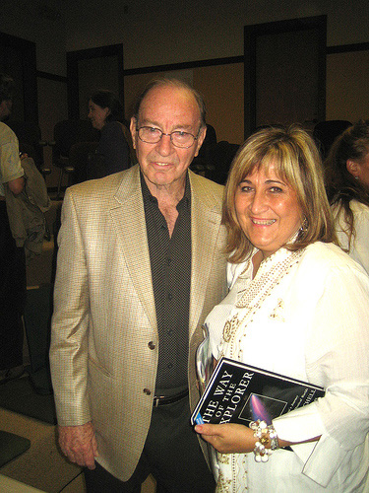
The other side of the same coin has Edgar Mitchell’s testimony. It was a pleasure but no surprise when I heard Edgar Mitchell, in San Francisco on June 7th 2006 at the Institute of Noetic Sciences’ lecture, answer in this way when asked if he believed in UFOS.
“I have never had doubts that of the millions of planets and galaxies out there, that there is life. Yes! I believe in UFOs but I had no personal first hand experiences except that I have been briefed by people “in- the-know”, high level superiors, and old timers who had these particular jobs in Intelligence. They were there especially during the Roswell event and others since then and they had no doubt in their minds because they were there first hand. In addition to that, I had an opportunity to go to the Pentagon with these questions and went to a man in high level position of intelligence and I told him what I thought; what I heard. He did not know but he said if that is true “ I should Know!” I will investigate”.

Mitchell continued: “people know I am on the Board of NIDS ( National Institute of Discovery Science) and seen that there are events that are very strange and could be ET related. Certainly we know that the Soviets have had these encounters and had their Air Force chase them down, unsuccessfully of course. Also the French put out the COMETA Report where high level officers told of their experience and asked their government to take it seriously. Two years ago Belgium made their knowledge official and then there are still the reports out of Mexico. So the answer is “yes”! There is a cover-up.”

Mitchell added: “You want to know why it has been covered up. That story is not too hard to explain . It goes to the mid 40’s, the Roswell incident was 1947. At that time President Truman was taking over from Roosevelt. The Army Air Corps became the US Air Force. The OSS has been disbanded and CIA came on board instead. It was not quite sure that anybody knew “who was on first”. When the Roswell incident took place, a number of people whom I know including Werner Van Braun, were called there to investigate this. A committee of high level people was set up by Truman. It was a committee called the Military Joint Intelligence Committee and there were 12 individuals so the abbreviation MAJIC was the name of this organization and although the name has changed over and over again, that committee still exists. That is one of the things my contact confirmed. There was a Executive National Security law that was passed and unthinkingly it was given such power over years that they are accountable to no one. Even presidents at this point, can’t adequately have access Other Presidents have tried but as far as I know Eisenhower and perhaps Kennedy was the last one to have full access.”

There was an applause for one of those ecstatic moments where someone of the caliber of Edgar Mitchell Apollo 14^{t} Astronaut who, like Aldrin, also walked on the moon had the courage to address the UFO question publicly and ask for a certain openness. Likewise, ex minister of Defense, Paul Hellyer in Canada told me that we needed to know the “whole picture” before countries allocated huge amounts of money “to shoot aliens out of the skies.” He used the word “aliens”! We need to be grateful for these small steps in disclosure .They keep us going.

Often, I am asked why I work in this field for information and disclosure? I must admit, often discouraged, I do think of the John Lear “who cares response,” but then I remember Dr. J Allen Hynek, Colonel Philip Corso and Dr. Michael Wolf Kruvant who are no longer with us. They believed the following:
- It is a matter of National Security and we need to know who we are dealing with before we shoot! It is a political or rather an exo-political concern especially to finance a “Space War”, perhaps the next war Werner Van Braun warned about”
- If we are visited by different races, they could have a relationship to as a human Species. Were we inseminated from the Stars as most indigenous people believe?
- If these visitations are of ancient origins, we may need to rewrite our true history and update our archives. That is essential for future generations.

These are three powerful arguments for continuing UFO research but this brings back to the precarious state of this planet currently at war. Besides having to worry about UFOs, after viewing Al Gore’s powerful film, “An Inconvenient Truth, I realize we have ten years before complete environmental destruction.

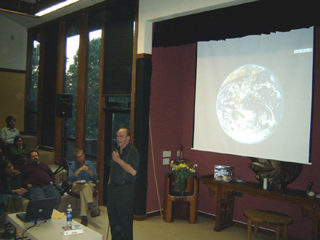
In San Francisco, Edgar Mitchell who also saw the film summed it up by saying this:
“The reality of this and the ET Issue is that we have not been able to move government at any level in our country so other countries will move on it. I frankly believe we have far more serious issues right now than the ET presence. If these creatures are benign and there are conflicting stories, they may try to help us out. But it seems they are trying to take a “hands off, wait and see what happens attitude” to us!. Our major problem is sustainability, ( survival) and the consumption ethic. All of these facets are about to be featured in brand new ways and Al Gore’s environmental global warning is the beginning of it. I’m hoping that we will get all these issues that are hidden and important to our way of life opened out.”

So do I Dr. Mitchell, or we will need to change the “Prime Directive” and ask for help from the Stars!
***
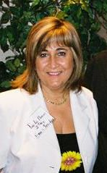
About the Author: Paola Harris, M.Ed. is an Italo-American photojournalist and investigative reporter in the field of extraterrestrial related phenomena research. She has studied extraterrestrial related phenomena since 1979 and is on personal terms with many of the leading researchers in the field. She has written for Nexus, UFO Magazine, Notizario UFO and Dossier Alieni, among others publications. Her book is entitled, Connecting the Dots: making sense of the UFO Phenomena (Granite Press). Her main website is: www.paolaharris.it .

