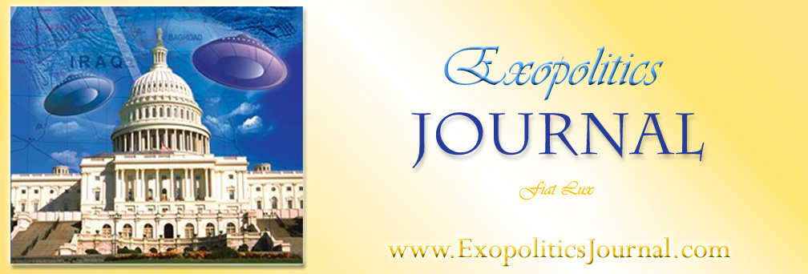

Colonel Philip Corso and his Critics: Crossing the Rubicon between Objective Criticism and Debunking – Part 2

Michael E. Salla, PhD

Continued from Part 1 (http://www.exopoliticsinstitute.org/Journal-vol-1-2-Salla.pdf)
…
6. Did Philip Corso Witness an EBE while Stationed at Fort Riley, Kansas?
Col Corso claimed that while on duty at Fort Riley Kansas, on July 6, 1947 he saw an Extraterrrestrial Biological Entity (EBE) being shipped from Roswell, New Mexico to what is now Wright Patterson Air Force Base in Dayton, Ohio. In The Day After Roswell he described how he was informed about a mysterious shipment from Fort Bliss containing remains “from some accident out in New Mexico”, Corso wrote:

Whatever they’d crated this way, it was a coffin, but not like any coffin I’d seen before. The contents, enclosed in a thick glass container, were submerged in a thick light blue liquid … the object was floating, actually suspended, and not sitting on the bottom with a fluid over top, and it was soft and shiny as the underbelly of a fish. At first I thought it was a dead child they were shipping somewhere. But this was no child. It was a four-foot human-shaped figure with arms … thin legs and feet, and an oversized incandescent light bulb-shaped head that looked like it was floating over a balloon gondola for a chin.

Corso’s military records give credibility to his EBE story. He was stationed at Fort Riley Kansas from 21 April 1947 - 12 May 1950; with the rank of Major. Events he described as the alleged duty officer on the night the EBE body arrived at Fort Riley en route to Wright Patterson AFB; are corroborated, in part, by his military record.

Corso’s story has been challenged by critics such as Stanton Friedman. Friedman has questioned whether something as important as an EBE would have been shipped overland from Roswell Army Air Force Base to Dayton, Ohio. Friedman writes:

I personally don't understand why the body would have been sent by truck (without a 24-hour guard) rather than plane, and why it came from Ft. Bliss which is Southwest of Roswell though it was HQ for the rocket scientists at White Sands Missile Range. Corso spoke of Rte. 40 being the only major EW highway in 1947. But Ft. Riley is West of Manhattan, Kansas, and well North of Highway 40, and not on the most direct route to Wright Field.”

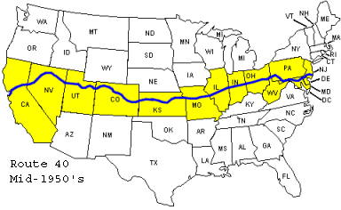
Friedman is mistaken about Ft Riley’s accessibility to Route 40, and misleading with his statement that Fort Riley is not the most direct route to Wright Patterson Air Field. As historic maps demonstrate, Route 40 was indeed the main thoroughfare for travel between the East and West coast – from Atlantic City to San Francisco. Second, Ft Riley is actually situated very close to Route 40 and is described as part of the historic Smokey Hill trail followed by U.S. Route 40: “From Fort Riley, Kansas to Denver, the Smoky Hill/Butterfield Trail was a route for both military and commercial efforts.” Fort Riley is situated close to Junction City, which is exactly where US Route 40 has historically passed. For the majority of the State of Kansas (from Oakley Kansas, through Junction City and onward, to Kansas City, Route 40 coincides with Interstate 70; exactly where Fort Riley is situated, as indicated on current maps below.

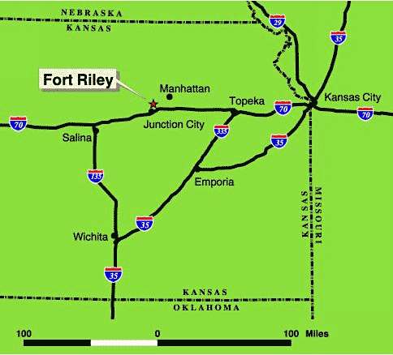 | 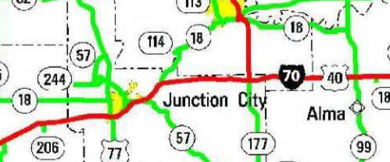  Image Sources (left to right):  http://www.riley.army.mil/OurPost/Maps.asp  http://www.cityofatchison.com/nationalhighwaysystem9d.jpg

Consequently, Friedman’s argument that Fort Riley lies “well North of Highway 40” is a gross error. Furthermore, Fort Riley was used as the key military staging post for maneuvers between the East and West coast, as corroborated by a report that President Eisenhower, when serving as a Captain in the pre-WWII era “found his command bogged down in spring mud near Ft. Riley, Kansas, while on a coast-to-coast maneuver.” So Fort Riley was indeed on the most direct route between the East and West coast, though not on the most direct route from Fort Bliss.

Friedman asks why the convoy came from Fort Bliss which is southwest of Roswell, rather than having proceeded directly north to Route 40 and onwards to Fort Riley and Wright Patterson AFB, the more direct route. While he acknowledges that Fort Bliss was the HQ of German scientists working at White Sands Missile base, he fails to identify the obvious answer for why the UFO artifacts were transported there. The German Scientists, experts in advanced aviation technologies and working on the stockpile of former Nazi V2 rockets at White Sands, were called upon to identify the artifacts from the New Mexico crashes at Roswell/Corona and ‘Plains of St Augustine’. Their knowledge of advanced Nazi aviation systems would have been vital in determining the origins of the Roswell crash material. This is suggested in a leaked Majestic Document: “The inability of the German scientists from Fort Bliss and White Sands Proving Ground to make a positive identification of a secret German V weapon out of these discs.” Friedman is correct however that the more direct route from Fort Bliss could have included another route, at least part of the way, such as Route 66 which was at the time another major East-West corridor.

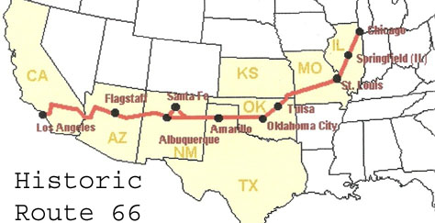
If the convoy did come from Fort Bliss as Corso suggests, why didn’t it take the most direct route north to US 66, then East to St Louis Missouri, then on to US 40 for the remainder of the trip to the Wright Patterson? One answer might be that Fort Riley was a major military staging post for East-West travel as demonstrated by Eisenhower’s pre-WWII military maneuvers. Another is that Route 66 may have not been suitable for such a sensitive military cargo. Fort Riley undoubtedly offered a number of benefits as a major military staging post and would have been a logical choice for the long road trip from Fort Bliss to Wright Patterson.

Friedman has also questioned Corso on the dates of the alleged incident Fort Riley and wrote:

I asked how he knew the Kansas date was July 6 ... Was it notes, a diary? He was evasive... For me the simplest explanation is that the … background descriptions came from Crash at Corona .... The bodies from the Plains might have been picked up by July 6, but wouldn't they far more likely have gone to one of the nearby military bases, and either been studied there or flown out?

The date provided by Corso is consistent with what is known about the flying saucer crash that allegedly was scattered over two sites: Roswell/Corona and the Plains of St Augustine. According to various sources, both sites were independently discovered on July 3. While only vehicle debris was found on the farm of Mac Brazel, four EBE bodies were allegedly found at the second crash site at St Augustin. This is partly confirmed by the Eisenhower Briefing Document that refers to two crash sites and states that “four small human-like beings had apparently ejected from the craft at some point before it exploded.” Friedman posits that the bodies from the Plains of Augustin could have been picked up by July 6 as Corso claims, but suggests that it would have been more reasonable to have them studied at the nearby military base and/or flown out. As mentioned earlier, Fort Bliss was a logical choice given that it was the HQ for German scientists and others working on the White Sands rocket program. As for why the bodies weren’t flown from Fort Bliss rather than trucked overland, safety concerns might have dictated that a land route was preferable to air travel. The crash of a truck would lead to minimal damage to an EBE whereas an air crash may have led to the complete destruction of this valuable cargo. Indeed, it may have been decided to sent the EBEs by both air and road since Corso claims to have seen only one body.

Overall, in his criticism of Corso’s story concerning the dead EBE Friedman is mistaken and misleading in a number of ways. First, he makes a basic mistake concerning the proximity of Fort Riley to Route 40. Second, he is misleading in terms of Route 40 being the most direct route to Wright Patterson Air Field. Third, he overlooks a very plausible explanation for why retrieved artifacts from Roswell/Corona and Plains of St Augustine were taken to Fort Bliss. Finally, overlooks why Fort Riley was a logical choice as stopping off point for a road convoy starting from Fort Bliss and traveling to Wright Patterson Air Field. Consequently, Friedman’s claim that Corso “almost certainly” concocted the Fort Riley incident, has no merit. Friedman has again strayed from objective criticism into the debunking of Corso’s claims.

7. Did Corso Confront the CIA while serving at the Foreign Technology Desk?
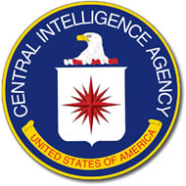
In his detailed ‘expose’ released on the internet in August 1998, Brad Sparks points to a number of inconsistencies in Corso’s book and concludes that these “prove Corso to be a rank literary hoaxer.” One of the most important inconsistencies, in Spark’s view, is Corso’s description of an alleged confrontation with the former head of the CIA’s covert operations Frank Wisner some time after Corso began working under General Trudeau at the Pentagon, in May 1961. In his book, Corso described the incident where he walked into Wisner’s office and demanded that he put an end CIA agents following Corso. This had also, according to Corso, occurred earlier while he served in the Eisenhower administration:

I told Wiesner [sic] to his face that yesterday was the last day I would walk around Washington without a handgun. And I put my .45 automatic on his desk. I said if I saw his tail on me tomorrow, they’d find him in the Potomac the next day with two bloody holes for eyes…Wiesner said, “You won’t do that, Colonel.” But I reminded him very pointedly that I knew where all his bodies were buried, the people he’d gotten killed through his own ineptitude … I’d tell his story to everyone I knew in Congress. Wiesner backed down.

Sparks writes:

Problem is that Frank G. Wisner (not "Wiesner") had been hospitalized and replaced as top CIA covert operator nearly three years earlier in August 1958…. Worse still, Wisner’s office was not even in the U.S. in 1961 but was in London. Wisner had been sent overseas to take the less demanding post of CIA Chief of Station in London on August 6, 1959, but was recalled from London in the spring of 1962 and resigned from the CIA entirely in August 1962.

It is very likely that in the communication between Corso and his co-writer, William Birnes, the precise date of the alleged confrontation encounter in Spring 1962, was mistakenly implied to be mid-1961 when Wisner was based in London. It is conceivable that it would have taken some time for Corso to realize he was being followed after taking up his new position at the Foreign Technology Desk, and to determine the person responsible for him being followed. Wisner knew Corso from the time of the latter’s service in the Eisenhower administration, where they were antagonists. It is very likely either that Wisner played a role in what was occurring with Corso, or possible that Corso mistakenly assumed this to be the case. The important point is that Wisner was stationed in Washington DC at the same time as Corso was at the Foreign Technology desk. This makes it possible that the meeting actually occurred in Spring/Summer 1962, and not during mid 1961, as implied in the book.

Sparks also points out that Corso’s claim that Wisner committed suicide in London in 1963, was incorrect and that Wisner actually took his own life at his family farm in Maryland in October, 1965. Spark’s concludes: “these are not minor errors of abstract historical facts. These are stories of Corso's own alleged personal experiences involving supposed major episodes in his career and in world history.” The major problem with Spark’s criticism is that the circumstances of Wisner’s death were abstract facts that Corso was attempting to recall after more than 30 years. As for his alleged confrontation, Corso quite likely got the dates wrong, but that doesn’t preclude the circumstances and dialogue at the confrontation that he described.

Spark’s ignores the historical facts supporting Corso’s testimony. Wisner was a former antagonist at the CIA who headed the CIA’s covert programs, while Corso was simultaneously worked with Army Military Intelligence (G2) under Lt General Arthur Trudeau. This was the time of a major confrontation between Allen Dulles (CIA Director) and Trudeau where the latter was relieved from his command. The details of this conflict are still to be fully disclosed but there is no doubt that Trudeau still enjoyed the support of the US Army that ‘promoted’ him in 1958 to his new position as head of Army Research and Development. Corso subsequently served under Trudeau in a sensitive position with the Foreign Technology Desk, which the CIA would have had interest in monitoring. Finally, from Spring 1962 until August 1962, both Wisner and Corso were in Washington DC at the same time, a fact Spark ignores.

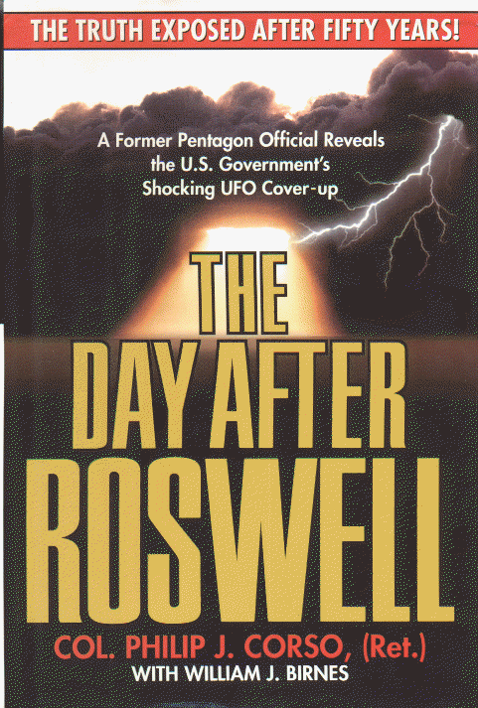
In conclusion, Spark’s critique of Corso is mainly focused on historical details that the latter gets wrong in his book. This may be entirely due to the way in which Corso communicated with his co-writer, William Birnes, or insufficient details in his personal notes or his recollections. At the time of collaborating with Birnes in writing of The Day After Roswell, Corso was approximately 80 years of age and his health was deteriorating. He certainly would have been tested to get all the details right in his recollection and communications with Birnes, given the decades that had elapsed since his experiences. Sparks inclusion of the Wisner story as an example of Corso being a “rank literary hoaxer” is further evidence of Sparks unwillingness to consider alternative explanations for inconsistencies in Corso’s claims. In not considering the alternative explanation that Corso got some dates and details wrong in his recollections due to poor health and/or sketchy notes, Sparks is once again crossing the Rubicon from objective criticism into debunking.
8. Was Corso Head of the White Sand’s Missile Firing Range?
Corso has been accused by Major Randle of embellishing his military record in a number of ways one of which concerns Corso’s service at White Sands Missile Range. Randle says the following about Corso’s testimony at a press conference in 1997:

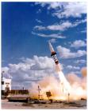
I watched him at the Roswell press conference where he claimed that he had been the Commander at the White Sands Missile Range. Not that he had been a Commander (of a Battalion) but the Commander. I have watched the tape dozens of times, and he clearly claims that he was "The Commander". The website of the White Sands Missile Range lists all the commanding officers and Corso is not among them. Again, this is not a mistake that can be blamed on Birnes.

In his original notes Corso described himself as being “in command of the Army’s Missile Firing Range at Red Canyon, New Mexico, part of the White Sands Proving Grounds.” In his book, he claims that he gained his command as a result of a promise made by President Eisenhower:

Ike had once promised me a command of my own when I returned from Korea and was posted to the White House. And in 1957 the opportunity came up, a juicy assignment at a high-security base with the coveted green tabs and all the trappings: train and command an antiaircraft battalion to use the army’s most secret new surface-to-air missile.

In both his book and original notes Corso clearly is claiming that he was the commander of a battalion based at White Sands Missile Range. His military record confirms that in June 1957 he began a new position as Battalion Commander at White Sands Proving Ground. His military record supports the claims Corso made in his book and original notes.

In his criticism of Corso, Randle refers to the 1997 Roswell interview where Corso referred to himself as “the Commander” rather than “a Commander” at White Sands Missile Range. Randle goes on to conclude that Corso was deliberately embellishing his military record. Randle doesn’t provide any transcript of what Corso precisely said and neither does he provide the full context for the latter’s comments. While Randle claims to have repeatedly listened to the interview, he doesn’t provide the context of Corso’s discussion where he may have been referring to himself as “the Commander” of the missile battalion at White Sands, rather than “the Commander of White Sands”. If the former, then Randle is at fault for not correctly identifying Corso’s intention in making the comment and the correct context for Corso’s comments. If Corso did refer to himself as “the Commander” at White Sands then he may have simply made a mistake in correctly identifying his former position, rather than trying to deliberately embellish his record. In 1997, Corso was 82 and his health was quickly deteriorating. His detailed recollection of events and positions would have been questionable in an interview. Yet in his book and original notes, there is no ambiguity here; Corso correctly identified himself as the Battalion Commander at White Sands, rather than the Commander of White Sands.

In making his claim that Corso was embellishing his military record, based on an interview, rather than the more precise original notes and book that described his position, Randle is going too far in his criticism. In the worst case scenario, Corso may have simply made a mistake in the interview and Randle is correct to point out the inconsistency. Yet this possible mistake is something Randle has not proved and merely asserted from his recollection. More importantly, Randle is claiming that Corso was deliberately embellishing his military record. Randle needs to come up with more instances where Corso is repeating such an error, rather than in one isolated interview. Consequently, Randle’s claim that Corso deliberately embellished his military record is not an objective criticism, but a form of debunking.

9. Was Corso ‘Unreliable’ as claimed by the FBI?
An FBI report on Col Corso contained particularly ungenerous depictions of him as "shifty-eyed", a “rat”, and “a parasite”. These depictions stemmed from his involvement in rumors that Lee Harvey Oswald was a paid informant of the FBI, and for his earlier efforts in seeking to identify Fabian Socialists in various government agencies. Even Corso’s former boss, Lt General Trudeau who headed the Army’s Military Intelligence (G-2) during the 1950’s, received disparaging comments in the FBI Report for his and Corso’s role in seeking to identify Fabian Socialists while at G-2 and at Army Research and Development. In 1955, Trudeau and Corso had compiled a list of alleged Fabian Socialists and passed this list on to different government agencies. This led to a serious confrontation between G-2 and the CIA that culminated in Trudeau’s eventual replacement at G-2. Relevant passages from the FBI Report demonstrate the remarkable hostility towards both Corso and Trudeu on the part of both the FBI and the CIA in 1965:

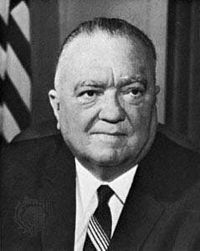
From your interview with Corso on 2-10-64, you got the definite impression that he was a rather shifty-eyed individual who fancied himself a great intelligence expert…. Trudeau has a fetish about security and intelligence work and cannot keep his fingers out of that area … The Director [J. Edgar Hoover – on right] noted: “Corso is a rat” … [the] CIA characterized Corso as a parasite who has never produced any intelligence through his own efforts, but who has profited from information developed by hundreds of dedicated Government agents and investigators.

Finally, in rejecting Corso’s efforts in investigating the relationship between the FBI and Oswald, the FBI dismissively referred to the “tremendous amount of work his gossip had caused the FBI.”

The above criticisms are remarkable given Trudeau’s military intelligence experience as the former chief of G-2, and Corso’s role in some of the most sensitive committees in the Eisenhower Administration involved in covert operations and counter-intelligence. Clearly, Corso and Trudeau had created powerful enemies in various government agencies for their efforts in identifying ‘Fabian Socialists and ‘communist sympathizers’. As part of a routine security check, the FBI passed on this damaging information to the Immigration and Nationalities sub-committee of the House of Representatives in 1965 that was considering employing Corso. The Report effectively stymied his application. Some parts of the classified report were even leaked by the FBI to a reporter who wrote a story on Corso being blackballed by the FBI.

The background of the FBI’s damming report was due not only to Corso’s work with Trudeau in forwarding a list of alleged Fabian Socialists in 1955, but also his accusation that Lee Harvey Oswald was a paid FBI informant. Corso had been told by a CIA informer, later identified as Frank Hand, that Oswald had FBI connections. Corso refused to divulge his CIA source. This led to strained relations with the FBI who demanded to know who was spreading such rumors. The FBI was furious that Corso would not reveal his sources. On behalf of Senator Richard B. Russell, a senate member of the Warren Commission, Corso was investigating the effectiveness of the Warren Commission’s own inquiry into the Kennedy assassination. Corso and Russell were seeking to discover evidence of a possible Cuban/Communist role in the assassination. The FBI strenuously denied any connection with Oswald and struggled to end rumors suggesting otherwise. Indeed, the final report of the Warren Commission explicitly discussed Oswald’s being an FBI agent/informant but concluded insufficient evidence existed to support this. Since the FBI were acutely aware of Corso’s belief that the FBI had Oswald on its payroll, it had a direct interest in portraying Corso in a negative light, and to prevent his appointment to any Congressional committee.

The FBI assigned J. Edgar Hoover’s aide, Cartha DeRoach, who performed special assignments for Hoover, to the Corso case. This was evidence that Corso was a significant player in the Warren Commission investigation and that the FBI took him very seriously. Consequently, the FBI report on Corso needs to be seen as the FBI’s effort to tarnish an individual they believed directly threatened the reputation of the FBI. In seizing upon the FBI criticism of Corso as ‘unreliable’ Sparks, Randle and other critics suggest that this ‘impartial’ criticism casts doubt on his later UFO testimony and supports their view that Corso ‘lied’. This ignores the context for the FBI’s damning report on Corso, and ignores the direct interest the FBI had in discrediting Corso due to his investigation of the FBI-Oswald connection and his earlier work at G-2.

In a detailed response to accusations that Corso had lied and the FBI report was evidence of this, Alfred Lehmberg demonstrates that Corso certainly made mistakes in his testimony but this did not amount to lying. In not revealing the FBI’s interest in discrediting Corso, Corso’s critics perpetuated the character assassination unleashed by the FBI. Corso had an impact on the Warren Commission investigation into the Kennedy Assassination and directly threatened the reputation of the FBI. Once again, in not considering the alternative explanation that the FBI report was slanted to discredit Corso, his credits have crossed the Rubicon from objective criticism into debunking.

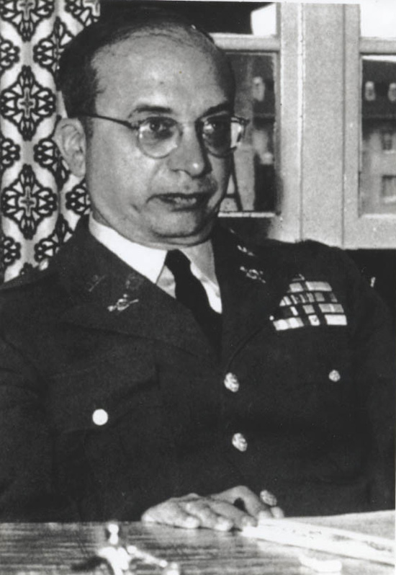
10. Was Col Corso Promoted to Full Colonel Upon his retirement?
In the Day After Roswell, Corso claims that he “was a lieutenant colonel in the army heading up the Foreign Technology desk.” His military record verifies that he did have this rank while heading up the Foreign Technology desk, and that this was his final rank upon leaving active service. Corso was a US Army Reserve Officer who had been on active service for 21 years until his retirement in 1963. The Second World War had led to the greatest expansion of the US Army in history and many Reserve officers such as Corso continued to serve on extended active duty after the Second World War. There were differences in the promotion process for Reserve officers as compared to Regular Army officers, making it more difficult for the former to rise through the ranks. In an effort to assist Reserve officers, Congress had passed the Reserve Officer Promotion Act in 1954. According to Major David Cannon: “career Reserve officers on extended active duty did not receive equal consideration for promotion as regular officers. So to make amends, Congress passed the Reserve Officer Promotion Act, which allowed these officers to receive a final promotion to the next rank on the day of their retirement.” Under the Promotion Act, Corso was eligible and apparently received a promotion upon his retirement, to redress the lack of promotion opportunities he enjoyed while on extended active service. Since this promotion was not part of Corso’s active service as recorded on his DA 66, the record of the promotion is likely to have been documented elsewhere, according to Maj General David Bockel (ret.) who is currently the Deputy Executive Director of the Reserve Officers Association.

The main critic of Col Corso’s claim that he was promoted upon retirement is Major Randle. Given Randle’s military background and current appointment in the Iowa National Guard, his criticism has carried much weight. This is what he claims with regard to Corso’s alleged promotion to full Colonel:

First, when asked why the cover of his book said "Colonel" rather than "Lieutenant-Colonel", Corso replied that he had been promoted to Colonel in the Reserve so the title was appropriate. I won't mention here that publishers often make assumptions and the mistake could have been blamed on them. Instead, Corso chose to lie about it. His record clearly indicates that the highest rank he held was Lieutenant-Colonel. (And I won't even comment about how he was a Major in 1945 and retired in the early 1960s as only a lieutenant colonel).

Now there are two points to be raised here. First, Randle claims that Corso lied since his DA 66 doesn’t mention the promotion. Second, Randle makes a disparaging comment over the fact that while Corso had achieved the rank of Major in 1945 (the actual date was 1947), he retired in 1963 only one rank higher. On the surface, this appears to be a rather pedestrian military career and casts doubts on some of Corso’s claims to have been in charge of very sensitive military projects. The problem with Randle’s criticism is that he fails to mention the more difficult promotion opportunities for Reserve officers on extended active service. More to the point, he fails to mention the existence of the Reserve Officer Promotions Act; and how under this Act Corso would have been automatically promoted upon retirement, but this would not necessarily have been recorded on his DA 66, as confirmed by Maj General Bockel. Rather than the absence of any record of Corso’s alleged promotion to full Colonel on his DA 66 conclusively showing that Corso lied; the absence instead shows how Randle fails to consider alternative explanations. Randle jumps to damming conclusions regarding Corso’s claims that reflect Randle’s own prejudices. So once again, the failure to consider alternative explanations is evidence that Randle has crossed the Rubicon from objective criticism into debunking.

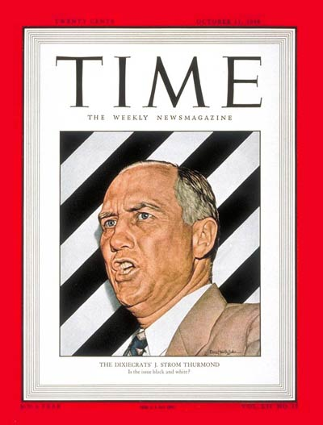
11. Did Col Corso deceive Senator Strom Thurmond?
In the original hardcover version of The Day After Roswell, a preface by Strom Thurmond appeared. Subsequently, the preface was withdrawn allegedly due to the Senator Thurmond not having been aware that it would appear in a book about UFOs and Roswell. A number of Corso’s critics have seized upon this incident as evidence that Corso is unethical. For example Randle argued back in May 2001:

“Senator Thurmond was angry about the introduction because Corso had pulled the old bait and switch on him. Thurmond demanded the introduction be pulled because the book wasn't the one Corso had said that he was going to write. What does that say about the integrity of the man?

Similarly, Stanton Friedman wrote in 1997: “Certainly there are some ethical questions about the use of an introduction by Senator Strom Thurmond, now in his 90s, written earlier for a memoirs book that had definitely been planned by Corso.”

Corso’s critics have repeated this criticism that since Thurmond wasn’t aware that Corso was going to use his preface for a book on Roswell and UFOs, that Corso lacked integrity. However this criticism was refuted by the reprinting of a release signed by Strom Thurmond in the October 2001 edition of UFO Magazine. Here is how French UFO researcher Gildas Bourdais declared the significance of the release and the earlier criticisms that Corso had deceived Thurmond:

The UFO magazine article by Don Ecker shows the reproduction of the release signed by Senator Strom Thurmond, giving to Lieutenant Colonel Corso the "irrevocable right and permission to use and to publish the material described below, in any and all editions of the book presently entitled Roswell Book...” So, this authorization, dated 2-7-97, clearly referred to Roswell, although it was not the final title, 'The Day After Roswell'. He knew that Corso was writing on Roswell!

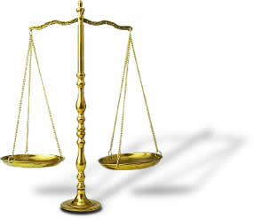
The fact that Thurmond had signed a release explicitly mentioning Corso’s book on Roswell refutes the criticism that Corso “had pulled the old bait and switch” on Thurmond as Randle contends. Despite Thurmond’s release having become public knowledge in October 2001, Randle nevertheless continued to claim that Corso had deceived Thurmond and therefore lacked integrity. For example, Randle wrote in December 2005, “Corso pulled a bait and switch on the foreword, which is not very ethical.” In the case of Friedman, he never replied to Bourdais public notice of UFO Magazine’s reprinting of Thurmond’s signed release, and never retracted his criticism that Corso had “ethical questions” over the preface episode.

The above demonstrates Randle’s lack of integrity in continuing to essentially ‘defame’ Corso by repeating a criticism that had been conclusively shown to be baseless. Similarly, an ethical response from Friedman would have been to acknowledge his own error in raising “ethical questions” over Corso, but to date this has not occurred. So we have outstanding criticisms by Randle and Friedman against Corso on the basis of an allegation that was shown to be baseless. This demonstrates the unethical lengths to which veteran UFO researchers have gone in attempting to debunk Corso. This conclusively demonstrates the clear prejudices of Randle and Friedman when it comes to critiquing Corso, their lack of objectivity and efforts to ignore evidence that is contrary to their stated views that Corso willfully misled or lied in his testimony.

Conclusions
In bringing this paper to an end it is worth recalling what I originally described as ‘objective criticism’ based on the work of Dr Haiash:

… one who practices the method of suspended judgment, engages in rational and dispassionate reasoning as exemplified by the scientific method, shows willingness to consider alternative explanations without prejudice based on prior beliefs, and who seeks out evidence and carefully scrutinizes its validity.
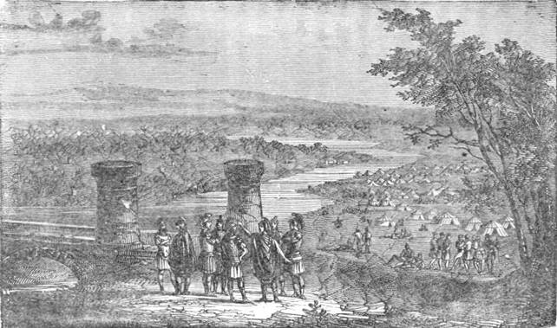
It is this willingness to “consider alternative explanations without prejudice” that helps identify the conceptual Rubicon between ‘objective criticism’ and ‘debunking’. My analysis of Col Corso’s critics shows that they routinely dismiss alternative explanations for a number of inconsistencies in Col Corso’s claims, and for mistakes he made. In analyzing numerous claims made by Corso and subjecting these to detailed critique, they ignore the common sense view that mistakes and inconsistencies can easily be explained by the advanced age and deteriorating health of Corso in the twelve month period from the publication of his book in July 1997 to his death in July 1998, at the age of 83. While Corso predictably focused on communicating the substance of his experiences and information, the details would have become increasingly blurred as poor health set in. While it is desirable to have details correct when discussing the extraordinary events Corso disclosed, it’s important to keep in mind that Corso was recalling events that occurred more than three decades earlier. It is very likely he made mistakes in recalling details when recounting incidents and positions in his book and interviews. This is especially the case given the level of sensitive classified information he was revealing and the obvious concern not to reveal anything that might negatively impact on U.S. national security.

In this analysis of Col Corso’s critics what emerges is a pattern whereby they consistently focus on any inconsistence or mistakes made by Corso in his books and interviews, and suggest that these make Corso unreliable as a witness. In dismissing alternative explanations for why Corso may have made mistakes such as the correct position titles for his appointments as a ‘staff member’ and not a ‘member’ of the NSC system under Eisenhower; as a ‘battalion commander’ and not “the Commander” at the White Sands Missile Range; Corso’s critics are not displaying objective criticism but are engaging in debunking. Furthermore, in making erroneous statements in discussing possible routes taken by an army convey traveling from New Mexico to Wright Patterson AFB, why Fort Bliss was a logical choice for the Roswell/Corona/St Augustine wreckage, and why overland travel was a sensible security precaution, critics such as Friedman display a lack of objectivity. Brad Sparks’ overheated rhetoric over Corso’s mistakes in recalling the correct details concerning his meeting and the demise of a former CIA antagonist in 1961-62, displays Sparks’s lack of objectivity. The references by Randle, Sparks and others to a critical FBI report of Corso, ignore Corso’s role in investigating a link between the FBI and Lee Harvey Oswald on behalf of one of the Warren Commission’s members, and how this directly threatened the FBI’s reputation. The final episode concerning Corso’s alleged deception of Thurmond has been shown to be baseless. Yet Randle continues to regurgitate this criticism as though it were valid, and Friedman has not publicly withdrawn his comments that the Thurmond issue raised ‘ethical questions’ about Corso.
In arguing that Maj Kevin Randle, Stanton Friedman and Brad Sparks have routinely crossed the Rubicon from objective criticism into debunking in their criticisms of Corso, I have cited Dr Haiash’s prescription that science works by assessing a range of alternative explanations for any phenomenon under scientific investigation. This is no less the case for social science phenomenon such as the extraordinary claims of whistleblower testimony, and possible inconsistencies and mistakes in these claims. In routinely ignoring alternative explanations for the inconsistencies and mistakes made by Corso; Randle, Friedman and Sparks have engaged in what appears to be the deliberate debunking of a very important whistleblower. In debunking Corso, each to varying degrees, have displayed a remarkable degree of prejudice concerning the usefulness of Corso’s testimony. This prejudice has led to them concluding that Corso is a literary hoaxer, a liar and/or a fraud.

The above three critics of Lt Col Philip Corso has willfully hampered an objective examination of Corso’s substantive views concerning his role in disseminating UFOs information by deliberately focusing on minor details, inconsistencies or mistakes in his testimony. Furthermore, these veteran UFO researchers with collectively over 100 years of UFO field work experience, have deliberately ignored evidence that supported Corso’s claims as exemplified in Thurmond preface issue. Each of these researchers deserves to be censored for their willful debunking of Philip Corso, and for the great harm they have done to his reputation, and to setting back UFO research for years by ignoring the important testimony offered by Corso. While seeking to cast doubt on Corso’s integrity, what these critics have instead achieved is casting doubt on their own integrity as objective researchers of the UFO phenomenon.

Corso’s credentials have been well documented. All UFO researchers would concede he is a vitally important whistleblower, without necessarily accepting all his claims. Nevertheless, given the available documentation substantiating many of Corso’s claims in terms of his career positions and responsibilities, there is good reason to suppose that much of his testimony concerning extraterrestrial technology and EBEs is based on real events. While there are certainly inconsistencies and mistakes in Corso’s testimony, these largely concern details that have little to do with the substance of his claims that he was in charge of a covert Pentagon project to seed civilian industries with extraterrestrial technologies, and that he witnessed an EBE from the 1947 Roswell crash. Corso’s documented background inspires confidence in the credibility of his testimony. In attempting to debunk Corso in an effort to discredit his testimony, Corso’s critics deserve to be admonished for distracting UFO researchers from the task of identifying the truth in Col Corso’s remarkable testimony. What remains to be done is a truly objective and impartial analysis of Corso’s testimony, and its implications concerning a high level governmental cover up of UFO and EBE information. I look forward to collaborating with other researchers in this monumental task.

****

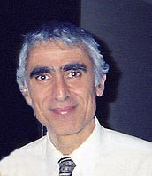
About the Author: Michael E. Salla, PhD., is the author of Exopolitics: Political Implications of the Extraterrestrial Presence (Dandelion Books, 2004) and founder of the popular website: Exopolitics.Org. He has held full time academic appointments at the Australian National University, and American University, Washington DC. He has a PhD in Government from the University of Queensland, Australia. During his professional academic career, he was best known for organizing a series of citizen diplomacy initiatives for the East Timor conflict funded by U.S. Institute of Peace and the Ford Foundation. He is the Founder of the Exopolitics Institute (www.exopoliticsinstitute.org ); Chief Editor of the Exopolitics Journal and Convenor of the “Extraterrestrial Civilizations and World Peace Conference.”

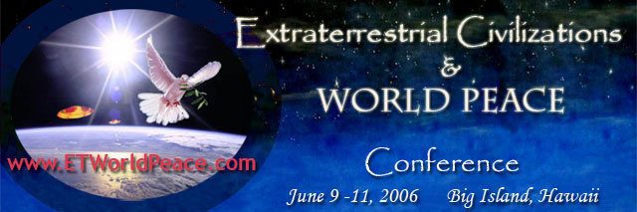

Endnotes ? Corso, The Day After Roswell, 34
Stanton Friedman, “A Review of Col. Philip J. Corso's Book: "The Day After Roswell" (1997): http://www.v-j-enterprises.com/sfcorso.html
http://www.route40.net/index.shtml
Cited online at: http://www.route40.net/history/index.shtml
See http://www.route40.net/history/40n-40s.shtml .
US 40 joins I-70 across Kansas as described depicted here: http://www.cityofatchison.com/nationalhighwaysystem9d.jpg
Cited online at: http://www.route66.com/66History.html
“Air Accident Report on “Flying Disc” aircraft near the White Sands Proving Ground, New Mexico,” The Majestic Documents, ed., Robert and Ryan Wood, 25. Available online at: http://209.132.68.98/pdf/airaccidentreport.pdf
Kevin Randle & Donald Schmidt, UFO Crash at Roswell (Avon Books, 1991) 28-32.
“Eisenhower Briefing Document,” The Majestic Documents, ed., Robert and Ryan Wood, 129. Available online at: http://209.132.68.98/pdf/eisenhower_briefing.pdf .
Sparks, “Colonel Philip Corso and William Birnes' Bestselling Book Exposed as a Hoax!” http://www.virtuallystrange.net/ufo/updates/1998/aug/m11-001.shtml
The Day After Roswell, 94.
Cited online at: http://www.virtuallystrange.net/ufo/updates/1998/aug/m11-001.shtml
http://www.virtuallystrange.net/ufo/updates/2001/may/m14-024.shtml
“L’Alba di una Nuova Era,” 39.
The Day After Roswell, 38.
FBI records on Col Philip Corso, http://foia.fbi.gov/foiaindex/pjcorso.htm
See M.A. Jones memo to Mr DeLoach, November 2, 1965, http://foia.fbi.gov/foiaindex/pjcorso.htm
See M.A. Jones memo to Mr DeLoach, November 2, 1965, http://foia.fbi.gov/foiaindex/pjcorso.htm
For discussion about Frank Hand and the FBI files on Corso see: http://www.virtuallystrange.net/ufo/updates/2001/may/m06-018.shtml
See Warren Commission Report available at: http://www.archives.gov/research/jfk/warren-commission-report/appendix-12.html#usgov
See Alfred Lehmberg, “Corso’s FBI Files Revisited” http://www.virtuallystrange.net/ufo/updates/2001/may/m06-018.shtml
Corso, Day After Roswell, 1
http://www.dcmilitary.com/airforce/beam/6_09/commentary/5388-1.html
Initially described in a phone conversation with the author on December 13, 2005, and confirmed in a private email on March 31, 2005. Gen Bockel can be reached at: dbockel@roa.org ; ph: (202) 646-7705.
http://www.virtuallystrange.net/ufo/updates/2001/may/m14-024.shtml
http://www.virtuallystrange.net/ufo/updates/2001/may/m19-024.shtml
“My Take on Corso,” http://www.v-j-enterprises.com/sfcorso.html
http://www.virtuallystrange.net/ufo/updates/2001/oct/m31-002.shtml
http://www.virtuallystrange.net/ufo/updates/2005/dec/m24-010.shtml
Cited online at: http://www.ufoskeptic.org/

