

Paola Harris Interviews Paul Hellyer
February 24th, 2006

Toronto, Canada

Harris: I wanted to interview the Honorable Paul Hellyer who has come out with a speech using terms that are so unpopular in Politics. So I think we will start by asking him: “When did you get interested in the whole entire UFO field? When were you curious about what was in the skies? Was it when you were working as Defense Minister. Was that a curiosity? Was it when you were young? When was it?”

Hellyer: Not really. It is very recent. When I was Minister of National Defense, I had reports crossing my desk about sightings. They just indicated as to whether there was some natural explanation or whether there wasn’t and I was far too busy at the time to worry about it very much because I was the Minister who united the Armed Forces, the Royal Canadian army, The Royal Canadian Navy and the Royal Canadian Air Force into a single armed force. This was really unprecedented in the Western World. Robert McNamara who was the U.S Secretary of Defense at the time said this is what all the ministers wanted to do but didn’t have the guts to do. It was war really to accomplish this.

Harris: This was McNamara under Kennedy in the 60’s?

Hellyer: That was the 1960’s so I was just too busy to be curious about UFOs and other things. It was only, I suppose in very recent times, when some friends have started sending me things. Frankly I was too busy to read them or I thought I was, so I kept putting them off and I put them on the shelf for future reference. I must admit that it was only after I took Colonel Corso’s book [The Day After Roswell] to my little lodge in Miskoka a year ago and sat down and read it that it really tweaked my interest because I knew right away it was real. I said: “ hey, this is something I want to find out about because this is important and there are a lot of policy issues that I’m going to have to think about.

Harris: This book, who gave it to you?

Hellyer: I guess it was "Pierre Juneau. Pierre has been sending me quite a bit of stuff. He is very judicious. He knows that I am overloaded and you looked at my desk earlier so you know that it is true.

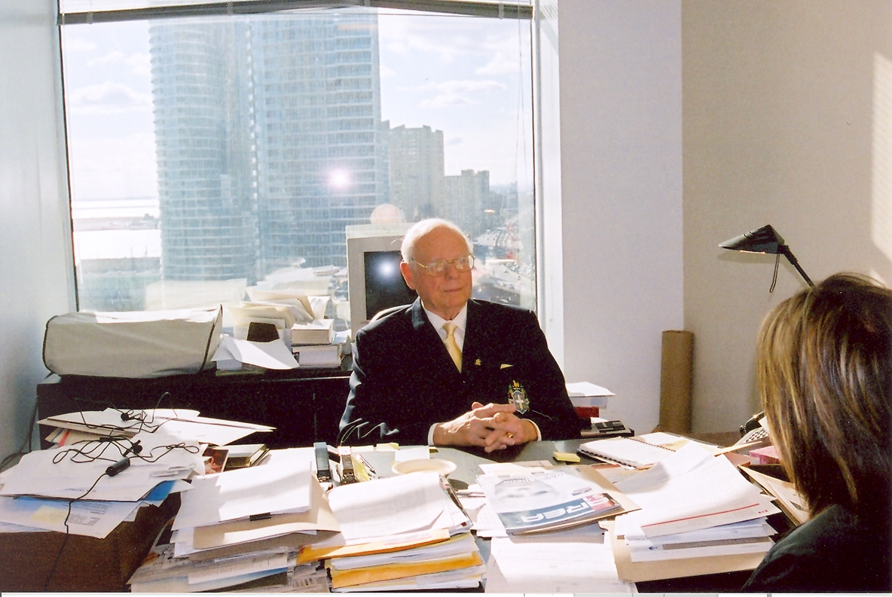
Harris: But you are an activist in many many areas.

Hellyer: That is true. Yes, I’m just going night and day. People ask me what I am do now that I’m retired and the only difference is that I only work six days a week now and it is more or less true. But I read the Corso book and I knew that it was authentic. I asked myself “ you know, would anyone be capable of making that fiction? I only read a few books a year and the Corso book was so convincing that I could not make up my mind 100% until right at the end whether it was fact or fiction. I said Is there any possibility that this book could be fiction ? And the answer that I concluded is “no, that it couldn’t be because there were too many times, too many names, too many places and there are too many references that I would know about as the former minister of National Defense that I would recognize as being legitimate. All of a sudden I became deeply interested and deeply concerned.
Harris: And I also know because it was part of a story that was written about you that you called a four star general in the United States to confirm….

Hellyer: I am not at liberty to say who it was or how many stars he had. When I was reading the book, my nephew asked what I was reading and I told him and so he was, like a large proportion of the population, a skeptic and did not mind admitting it. So he went away as he had been visiting for a few days. Then a couple of weeks later he called me. He said I had been talking to my friend the retired General and told him about the book; he [the General] said, quote: “every word is true and more”! And he said “now I want to get my hands on that book.”

Harris: Well, the book was a best seller and it did come out programmed at the 50th anniversary of the Roswell crash. We have groups who believe that Roswell didn’t even happen where Colonel Corso, in the book and in the Dawn of a New Age, which are his original notes [published in Italy], talks about seeing a body in Fort Riley Kansas in 1947. So it is not just his work at the Pentagon but it is the fact that he did also saw an alien body which is very important.. So you are telling me that this changed the way you thought about a lot of things and you were curious and you also considered it serious. Did you consider it serious because it is a matter of National Security or did you consider it serious because, as a human being, it changed the way you looked at the world?

Hellyer. It made me very curious and concerned because I understand policy issues when they stare me in the face. So I said there are all kinds of policy issues here. First of General Twining, General Nathan Twining designated these people as “enemy aliens”. So my first question is, “are they still designated enemy aliens,” because if they are, then the United States Armed Forces are preparing to kill them. Then I asked myself if they start taking on a superior technology, what is going to happen? Are they just going to take it or are they going to retaliate? What are the consequences of such a thing for the United States and for the world. It is just absolutely tremendously important. And of course other policy considerations are; well, that if this technology is so absolutely wonderful, it has the makings of saving our planet from environmental destruction. We could get away from burning fossil fuels, and save the Ozone layer and stop the Ice Caps from melting and raising the water levels world wide, and stop disrupting the weather pattern that are upsetting a lot of people. I think upsetting them a lot more than they are willing to admit and so this is reason two which is tremendously important. And the third one of course is that it certainly reinforces that the officials are not telling the truth about Roswell. I know that. I heard some of them on Television not too long ago and the party line was still that it was still a weather balloon and I heard dozens of others say they were sworn to secrecy. So I said “wait a minute! Give me a break! You are wearing people to secrecy because of weather balloon crashes?

Harris: It is not logical.

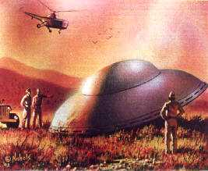
Hellyer: Well, it is not credible! So when we are taking about these things, they can accuse the people who say that the crash was real of not being credible but I would say that the people who would say it was a weather balloon are by no means credible. So I say to myself that this cover-up, because I am convinced that there has been a systematic cover-up, thorough and very successful cover-up for half a century or more. The whole cover-up lends credence to Lewis Lapham, the editor of Harper's magazine’s theory of the two governments. I suspect you are familiar with that?

Harris: The shadow government and the real government?

Hellyer: The permanent and the provisional, or permanent and the provisional. He says that the permanent United States Government is the Fortune five hundred list and the top legal firms of Washington that do their legal work and the top PR companies that do their public relations or their propaganda if you want to be a little more vulgar about it, and the top civil servants, both military and civil. They run the United States and every few years, and let me paraphrase a little bit with the license I have as a former politician. They have a charade called an election and the permanent government picks the actors to go on stage and read the scripts written by the programmed government. They try to pick actors that won’t improvise too much and who will do as they are told in effect and then they give them the money to get elected and nobody else need apply because it has become such an expensive business especially in the United states where they raise these huge astronomical amounts of money to get elected. Anyone who doesn’t have the backing of the establishment just isn’t in the race. They call it Democracy but this is just nonsense. It confirms for me that we have a real problem in countries that we call Democracies where we are basically the pawns of the people who consider themselves to be the proprietors of the orders of our society and it does not often matter who we elect, they are not going to change anything of significance. These are fundamental policy questions that intrigue me, not just intrigue me but which I think have to be resolved first not only for the benefit of the United States but for all mankind because we tag along with the United states because whatever they do we are involved in.

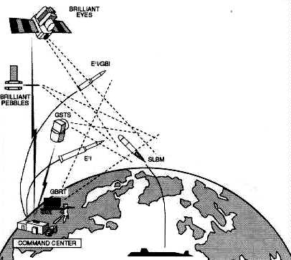
I guess it is just in today’s paper, our new minister of national defense under the new minority government under Steven Harper has said that they are going to reopen the question of the anti missile defense. Right away my antennae goes up. We are going become part this business of building a system designed to take the “alien intruders” on for size. Do we want to be part of that? Do we want to be part of it without knowing what we are doing which is obviously the case. Does our Prime Minister…is he in the loop? Absolutely not! I’m sure he is not! Is our Minister of defense who is a Brigadier General in the loop? Well I’m sure he is not. He’s just going along with the conventional wisdom that we have to build a system that protect us from rogue missiles “from heaven knows where”, the party line, the cover stories and I say “you know this is not good enough.” We got to have some facts and figures; and some real hard information before we start spending money and time, and diverting resources from far more important things to be part of a project that probably is not good for us.

Harris: So you are FOR disclosure. Do you realize if it seems like your saying that you are for disclosure. If you are for disclosure, do you realize it is like pulling the rug out from under a lot of institutions that are well established, including the financial, the religious and the political institutions and that is the excuse a lot of people have been using for keeping the secret still a secret? How would you deal with that?
Hellyer: I believe in seeking the truth, In the “Good book” it says the Truth will set you free. I don’t think there is any other approach. I don’t think you can live a lie. I am a religious person and I am not the least bit concerned about disclosure. And I’m absolutely determined that we find out what the truth is and I think that it is just natural and inevitable that there are other species elsewhere in the galaxy or galaxies that are more advanced technologically that we are and probably more advanced spiritually as well and we should cooperate with them and learn from them and work together to make a better world. We should start with making our world better and then we could cooperate to make a better galaxy or galaxies. These are the kinds of projects and policies we should be adopting and not trying to spend hundreds and millions of dollars when we have millions of people on our own planet dying of starvation and ill health. I put on the scale of Justice a project costing a few hundred million dollars that happens to fit the temperament of the military industrial complex as against saving a few hundred million lives who otherwise are people who otherwise don’t have a chance. We are just not helping when we have the capacity and resources to help them and to give them a more abundant life.

Harris: Well, this is also entering into a [new] philosophy. As a ufologist, I feel that we have plenty of sightings.We have been recording them forever. We have thousands and thousands.This is a phenomena that from South America to Europe to Asia, we have enough proof that there are sightings of these anomalous objects. Now we are into the philosophy of “what do we do with the truth”? What are the policy issues? This goes into a brand new area that Dr. Michael Salla and Alfred Webre are interested in called “ exopolitics”. Would you agree that even in the future we need to get together, even in a grass roots level since the politicians are not doing it, to develop some policies concerning contact?

Hellyer: Well, I’m sure we have to do something. I applaud them for their efforts. We have to do something positive by way of cooperation and Alfred Webre suggested a ten year period of contact and cooperation. I think that would be marvelous and heaven only knows where it will lead. But I think it would be far far more positive than spending the next ten years trying to build the military system capable of starting an intergalactic war

Harris: Which we might not win.
Hellyer: Well of course not. But that is a possibility that some military people would never take into account. They saw we will just keep working until we win. I understand the military mind.

Harris: It is also that war makes “ money”. We are dealing with a complex that lives on this money making situation.

Hellyer: It only makes money for certain people but it puts the rest of us in debt. Under our very peculiar monetary system which you may or may not know is one of my particular lifetime interests.


Harris: Yes! I see you have written other books on economics. I did not know you are so prolific in this area. Books like surviving the Global Financial Crisis and Agenda-Plan for Action. You have written several books about the monetary system.

Hellyer: This is such a peculiar system that we expend the money to win a war But the way we do it is by going further into debt and consequently every time we have another war, the people have the additional debt burden put on them while few people who own the munitions factories are the beneficiaries but the beneficiaries of the munitions factories are not the ones that do the fighting. They are the ones who have luxury continuing during the wartime period. It is the ordinary people that do the fighting and lose their sons and fathers and uncles and brothers, then have to carry debt afterwards instead of having the freedom to regroup their lives and make them better. There are some humongous policy issues involved. They are so big that I find it difficult to find words to describe them

Harris: Now on a grass roots level, if you were to give us advice, what would it be? We are using a lot of what you say in our Area 51 magazine [based in Rome, Italy] because you have been courageous enough to ask President bush reconsider a base on the moon and so forth. But on a grass roots level, those people who realize that what you saying is wise and, what you are saying is really the truth. On a grass roots level, what advice would you give us all to do some changing to look to a better future? But you are speaking on the political level because you are speaking as someone who has a particular position but what would you advise on a “ grass roots” level? But we the people, what would you suggest we do?

Hellyer: I think the people should inform themselves of the information available. There is a lot of Information. You were saying that Disclosure Project drew little press.

Harris: Steven Greer’s disclosure project had the qualifications of a very well orchestrated “ media” event dealing with the truth about UFOs.

Hellyer: We need to use the internet globally to spread the word and use that vehicle for the grass roots people to demand of their politicians, some action. In Canada, recently a group friends are asking the Senate defense committee to hold an inquiry and to interview some of the people present that Greer had and some others you know and to talk to them. I think in Canada they will get some press.

Harris: Do you think that Canada will receive outside pressure not to do that?

Hellyer: They may but if they buckle under, it will be just one more disappointing aspect of our being concerned with what the white elephant tells us to do. But if we did it here, it could provide some pressure. The communications goes from South to North. It is not unusual that they go North to South. Some listen to the Canadian broadcasting Cooperation and so forth and if they got enough good publicity here some of it could leak south of the border and they could encourage to do something. I think that they should demand of members of congress: “what are you doing with our money?” What projects? What secret projects are there and what are the consequences militarily? And encourage more Americans to demand that members of Congress to do something and otherwise of these project undertaken. And do you consider these people enemy aliens and if so why? Prove it to us and show us the evidence! I think the only thing we can do is to keep putting pressure on politicians and say: “hey, you are elected to look after our interests not to do what intelligence organizations tell you to do.” They are not elected by anybody. They are not accountable to anybody. They are just a bunch of people who think they, sort of , own the world and have their own little club and they lie to each other. And once you get in the habit, it spills over in what you are likely to tell the public. We have a very great responsibility to try to put pressure on the politicians to say the time has come . Full disclosure. We want to know and then we can decide whether we want to embark in a project to save the planet in cooperation with others or let you continue on the road to make bigger and better hydrogen bombs to blow up bunkers; to do a lot of things which is ultimately result in a virtually uninhabitable planet or relatively uninhabitable, and that seems to be the choice.

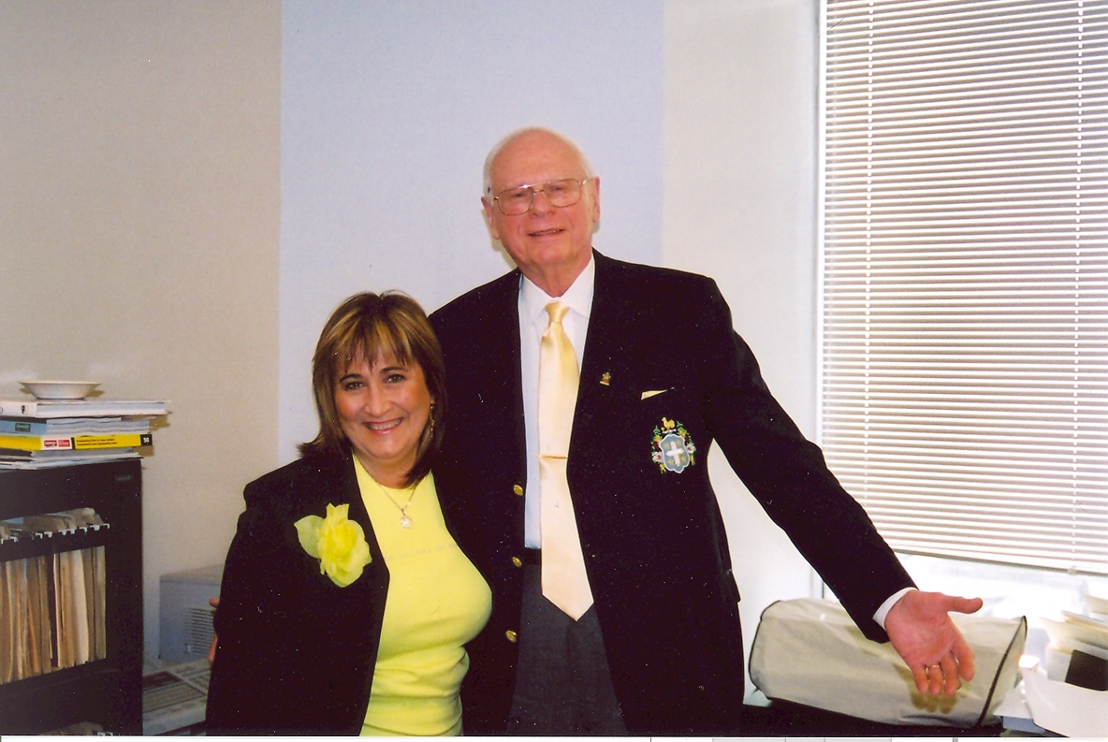
Harris: Ok. To wrap this interview that you had mentioned that you are writing another book and that you are going to dedicate a chapter to this subject. We need more of that. Can you just give us an inkling of what that chapter will say or will reflect?

Hellyer: Just basically the things that I’ve been saying to you. Starting with evidence of people who have a lot of experience in this area. I’m not going to give a lot of examples because you can’t put much in one chapter and I do not want the book to be too long, I’d like some people to read it. To maybe get eight or ten people of the most credible people who have person knowledge and to talk to them myself so I can quote them verbatim and to say these are credible witnesses and I believe them to be telling the truth. I do not believe that a lot of other people are telling the truth and the time has come for full disclosure. In my own words give the reasons why the time has come for full disclosure. I will develop some political aspects of this in other parts of the book where I’ll be taking about policy, including momentary policy. So there will a few threads tying this together.

Harris: Well it is all connected. It has a “futuristic” aspect to it, a philosophy of exopolitics; of how to deal with this reality. In other words, “let’s have a say in the way this goes in the future”! I think that’s why we are so elated that you can forth because it gives people “hope”. We have to give people hope that we can design a future. Also I wanted to ask you when will this book come out so we can look forward to it?

Hellyer: I think it will take the best of two years to write. I want to research it properly and I want to make it as authentic as I’m capable of making it. I have no deadline but at the same time I want to get started as soon as possible, and get on with it. I kind of hope this out before the next [US] Presidential election. It is not important in a sense but in a sense I may have some advice for the electorate for the kinds of the kinds of alternatives that they should look at for party policy in both the United States and Canada and it will be my final effort I think so I want to make it a good one and I’ll try to tie together the lose ends as part of a whole.

Harris: You mentioned the United States and Canada but I wanted to add that we are in Europe are following you very closely because whatever happens here is reflected on the other side of the ocean and I think what you have done for us is make us one global community as far as understanding that this matter affects everybody.

Hellyer: It is a global community and everyone is affected and the monetary system is universal. I don’t restrict it to North America . But these things we are talking about are universal. The fact that we have starving people in one part of the world and rich people in the other who are over eating is universal. This is not restricted to any geographical area although I will concentrate on the one I know best. We can have a world of peace if we have men and women of good will. What is missing at the moment are men and women of good will. We are more interested in killing each other then helping each other so if somehow we can turn that around and reset our priorities to change the direction off our lives and expenditures to emancipate mankind and” other kind”, Start The thought will be let’s start to look forward to a positive future, not a utopia, but something positive. And it is possible, we have the means! We have the technology, everything we need except the political will to do it. That is what is lacking. General Eisenhower warned us about this. I guess he knew about the UFO question at the time when he said it, “beware of the military industrial complex.” And he probably concluded that some of the information from the ETs was getting intro the wrong hands and that somehow we had to reestablish public control over what was going on.

Harris: Well, you have given you some hope and in Europe, most of us are one hundred behind you and we will be waiting for this book. We need to develop a philosophy of Exopolitics on a grass roots level. Having someone of your caliber speak helps validate an exopolitical view. It will help not only us but the whole entire planet. Thank you.

Hellyer. Let’s hope we can work together and do something.

***
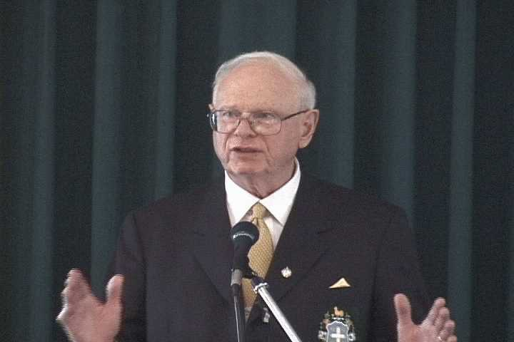
The Honorable Paul Hellyer is a former Canadian Minister for National Defense (1963-1967) in the Cabinet of Lester Pearson and Senior Minister in the cabinet of Pierre Trudeau (1968-1969). Though interested in UFOs he did not give much thought to UFO's having serious policy implications. His position dramatically changed after reading Philip Corso's The Day After Roswell. He contacted a retired United States Air Force General and spoke to him directly to verify Corso's claims. The unnamed General simply said: "every word is true and more". Finally convinced that the UFO phenomenon was real he decided to come forward and speak at the September 2005 Exopolitics Toronto about some of the "most profoundly important policy questions that must be addressed."

***

[Note: Both the Hon Paul Hellyer and Paola Harris will be speaking at the following conference]


