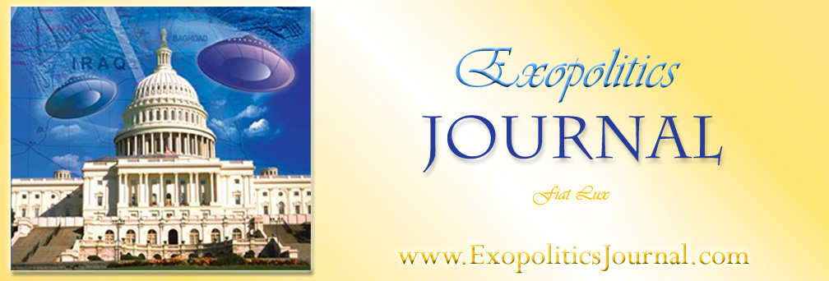
Colonel Philip Corso and his Critics: Crossing the Rubicon between Objective Criticism and Debunking – Part 1

Michael E. Salla, Ph.D

In 1997, Col Philip Corso’s book, The Day After Roswell, appeared and quickly rose into the New York Time’s best seller list with his revelations concerning his role in a classified program to seed extraterrestrial technologies into the private sector. Col Corso had a distinguished career as a Military Intelligence officer, serving in senior positions during the Second World War, the Korean war, and under the Eisenhower administration. It was during his assignment as ‘Special Assistant’ to Lt General Arthur Trudeau, who headed Army Research and Development, that Corso became head of the newly established Foreign Technology Desk. During this assignment from 1961 to 1963, Corso claims to have regularly passed on to various corporations, key ‘foreign technologies’ that were in fact, extraterrestrial in origin. This led to breakthroughs in developing the integrated circuit, night vision technology, fiber optics, super tenacity fibers, lasers and other cutting edge technologies. Corso’s book details a remarkable case; a former senior military official emerging as a whistleblower to reveal information about classified projects involving extraterrestrial vehicles (ETVs) or extraterrestrial biological entities (EBEs).

Since the publication of his book, there has been much controversy between those believing Col Corso was blowing the whistle on classified U.S. Army activities involving seeding extraterrestrial technologies into private industry, and those believing Corso distorted his distinguished military service in order to assume a historical role far beyond his actual achievements. Those most critical of Col Corso believe that he was prone to embellishing his service record. Most criticism has centered around a number of public statements Corso made that appear to be inconsistent with what can be verified in public documentation.
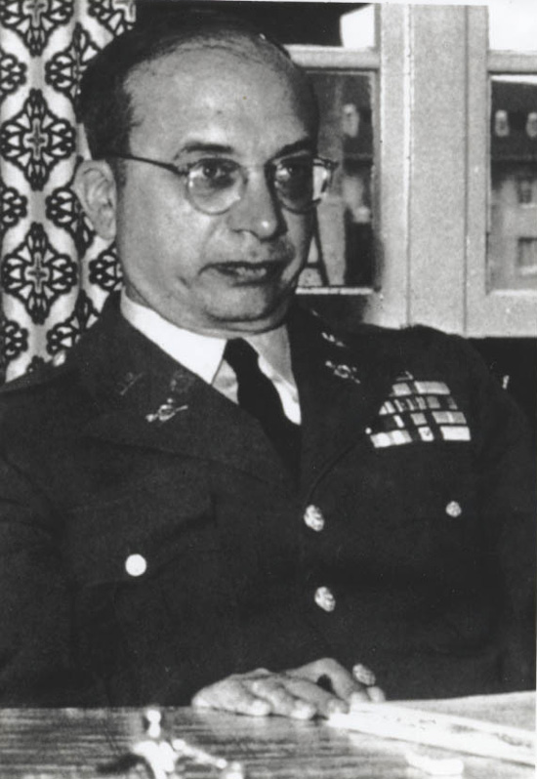
The most significant of Corso’s claims that have been subjected to intense criticism are that: 1. he served as a staff member of President Eisenhower’s National Security Council; 2. he was head of the Foreign Technology Desk at the Army Research and Development for two years; 3. he disseminated extraterrestrial technologies to private industry; and 4. he witnessed an extraterrestrial biological entity (EBE) being shipped overland from Roswell Army Air Force Base to Wright-Patterson Air Force base. Further criticisms include Corso’s claim to having been associated with a covert control group created to oversee the UFO phenomenon, MJ-12; to have served as commander of White Sands Missile range; to have concocted an alleged confrontation with the CIA’s director of covert operations; and to have been promoted to full Colonel upon retirement.

I will discuss each of these criticisms in order to assess their: validity; damage to Corso’s credibility as a whistleblower; discrepancies with available documentation; and impact on his central claim of having been part of a highly classified effort by the U.S. Army to seed civilian industries with extraterrestrial technologies. Corso’s credibility as a distinguished military officer coming forward to reveal his role in such a classified program shortly before his death, is at the center of the debate of whether his claims are valid or not.

Col Corso’s claims placed a number of veteran researchers of the UFO phenomenon in the uncomfortable position of dismissing the testimony of a highly decorated officer. Documentation does put him in places and positions where the events he claims to have witnessed could have occurred as he described. Nevertheless, there have been some inconsistencies found in what Col Corso claimed and what can be documented. This has lead to intense debate between those who consider these inconsistencies to be minor, and those believing the inconsistencies to be sufficiently significant to warrant dismissing Corso’s credibility and testimony entirely.

Some of Corso’s critics have gone as far as publicly dismissing Col Corso as a fraud and ‘literary hoaxer’. Corso’s strongest critics include veteran UFO researchers such Stanton Friedman, Dr Kevin Randle and Brad Sparks who collectively have expressed their skepticism. Many of the criticisms made against Corso cross the Rubicon dividing objective criticism and outright debunking. This invites speculation of the motivations of Corso’s critics who undertake such a concerted debunking effort against a highly decorated military whistleblower whose revelations do much to clarify the UFO phenomenon.

Files on Col Corso gained through FOIA include his service record and a declassified FBI report. To assist my evaluation I use statements from an Italian version of Col Philip Corso’s original notes that were published in Italy as L’Alba di una Nuova Era [Dawn of a New Age]. These notes have not been published in English. They comprise Corso’s raw beliefs on a number of UFO issues prior to his collaboration with co-writer William Birnes in The Day After Roswell. I examine each of the most significant criticisms raised against Col Corso’s credibility as a whistleblower, and assess whether Corso’s critics cross the line between objective criticism and debunking. First I will describe the difference between objective criticism and debunking to establish some guideline for determining when Corso’s critics cross the Rubicon and become debunkers.

1. Objective Criticism versus Debunking
The UFO phenomenon has led to numerous claims by many individuals concerning various aspects of this complex phenomenon. Analyzing these claims requires an objective approach to the evidence not overly influenced by the investigators own prior beliefs. I attempt to distinguish between critics committed to an objective investigation of the evidence, and critics who use their criticisms to promote prior beliefs. Dr Bernard Haiasch defines skepticism, what I will consider here to be ‘objective criticism’, as

one who practices the method of suspended judgment, engages in rational and dispassionate reasoning as exemplified by the scientific method, shows willingness to consider alternative explanations without prejudice based on prior beliefs, and who seeks out evidence and carefully scrutinizes its validity.

This definitition contrasts with ‘debunking’ which is driven by an investigator’s prejudice based on prior beliefs, and disingenuous efforts to manipulate evidence to promote a particular conclusion. It is worth pointing out that debunking was officially sanctioned by the Robertson Panel as a means of discrediting a great number of claims concerning UFOs. In January 1953, a group of scientists chaired by Dr Howard P. Robertson and covertly funded by the CIA, recommended that UFO sightings be debunked due to the potential for manipulation of this information by ‘foreign powers’ in a way that would undermine U.S. national security. The panel recommended an “educational program” to deter the general public from taking interest and demanding serious investigation of UFO sightings:
Dr Howard P. Robertson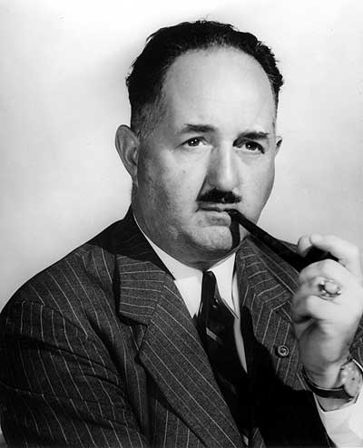

The "debunking" aim would result in reduction in public interest in "flying saucers" which today evokes a strong psychological reaction. This education could be accomplished by mass media such as television, motion pictures, and popular articles.… Such a program should tend to reduce the current gullibility of the public and consequently their susceptibility to clever hostile propaganda.

Consequently, a CIA sanctioned policy of debunking UFO reports had begun. This needs to be considered when examining the critics of UFO related claims or witnesses.

Objective criticism can be most easily distinguished from debunking in three ways when it comes to whistleblower testimonies. First, the objective critic is willing “to consider alternative explanations” if any inconsistencies are found in what the whistleblower claims and what can be objectively verified. In contrast, a debunker will automatically reject alternative explanations and will dismiss UFO related claims if any inconsistencies are found. Second, the objective critic will scrutinize inconsistencies and seek to judge how significant these are in relation to the claims made by the whistleblower. In contrast, a debunker will highlight such inconsistencies, overplaying their significance in relation to the integrity and reliability of the whistleblower. Third, the objective critic will evaluate the pros and cons for a whistleblower’s testimony and reach a balanced assessment. In contrast, a debunker will focus on the cons and argue for dismissing the testimony of the whistleblower, regardless of the pros.

2. Was Col Corso a (staff) member of the National Security Council?
In the biographical description found in The Day after Roswell, Corso claimed that the served on “Dwight D. Eisenhower’s National Security Council as a lieutenant colonel”. Elsewhere in his book, Col Corso states that he was “on the NSC staff”; and claims that in his fifth year he personally asked President Eisenhower to be released as a staff member of the National Security Council (NSC) so he take up his own military command in New Mexico. In his notes, he claims that from 1953-57 he was, “a member of the National Security Council Staff.” According to Col Corso, Lt General Trudeau had sent him to serve in the NSC under President Eisenhower. In his book he says that he “was working in some of the most secret areas of military intelligence, reviewing heavily classified information on behalf of General Trudeau.”

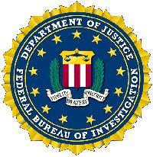
There have been two major criticisms of Corso’s claims regarding his service with the NSC. One, by Stanton Friedman and Dr Randle criticize Corso for claiming to have served on the NSC itself, rather than as a liaison officer on an NSC committee. The second criticism by Brad Sparks claims that neither the Psychological Strategy Board (PSB) or the Operations Coordinating Board (OCB) both of which Corso served on, were part of the NSC. These critics all conclude that Corso embellished his precise role with the NSC and that his entire testimony therefore becomes unreliable. I deal with each of these criticisms in turn.

Corso’s military record confirms that from 1953 to 1956, he was given intelligence staff assignments on both the Psychological Strategy Board (PSB) and the Operations Coordinating Board (OCB). This is consistent with an FBI Report that states that Corso was “assigned to the Operations Coordinating Board (OCB), National Security Council.” It can therefore be confirmed that Corso was assigned as an intelligence staff member to at least two committees that performed important psychological warfare functions within the Eisenhower administration. Two of these committees, the PSB and OCB almost certainly dealt with managing the public response to UFO information. Friedman’s criticism of Corso stems from a sworn affidavit made by Col Corso two months before his death in July 1998. In the affidavit Corso claimed that he “was a member of President Eisenhower’s National Security Council.”

Friedman conducted research at the Eisenhower Library into Col Corso’s claim of having being a ‘member of the NSC’. Friedman says that the archivist never found any evidence that Col Corso served as a member of the NSC or attended any NSC meetings. This led him to dismiss Corso’s claim of serving on the NSC. This is what Friedman wrote to the author on the UFO Updates forum:

You want to believe that Corso was on the National Security Council. If you do any checking … you will find that the NSC's membership is determined by Statute. He had none of the positions that would have permitted him to be named a member. Do you have any reason to claim that the Eisenhower Library was lying when they said he was not a member and did not attend any meetings? A referral letter about him makes clear he was a liaison man... not a member.

The problem in settling this issue is exactly what part of the NSC did Corso claim to be a member of? What is the cabinet level committee chaired by the President generally known as the NSC, or one of the various interagency committees formally and/or functionally associated with the NSC and generally described as comprising the NSC system? At the apex of the NSC are cabinet level officials and heads of various departments and agencies meeting regularly to discuss national security issues. During the Eisenhower administration, the NSC comprised the following:

… five statutory members: the President, Vice President, Secretaries of State and Defense, and Director of the Office of Defense Mobilization. Depending on the subject under discussion, as many as a score of other senior Cabinet members and advisers, including the Secretary of the Treasury, the Chairman of the JCS, and the Director of Central Intelligence, attended and participated.”

Col Corso never claimed, in his book or notes, to have been a member of the NSC as described above, but that he had been on the NSC staff. This suggests that the Affidavit, signed only two months before his death at 83 years of age, containing the reference to him having been a member of the NSC, can be attributed to human error. The aged and ill Corso failed to insert the qualifying word ‘staff’ before the phrase “member of President Eisenhower’s National Security Council.”

Concerning what part of the NSC precisely Corso served on, we learn of the OCB association with the NSC in the following description of how the NSC discussed its agenda and implemented its decisions during Corso’s service:

President Eisenhower created the Operations Coordinating Board (OCB) to follow up on all NSC decisions. The OCB met regularly on Wednesday afternoons at the Department of State, and was composed of the Under Secretary of State for Political Affairs, Deputy Secretary of Defense, the Directors of CIA, USIA, and ICA, and the Special Assistants to the President for National Security Affairs and Security Operations Coordination. The OCB was the coordinating and implementing arm of the NSC for all aspects of the implementation of national security policy. NSC action papers were assigned to a team from the OCB for follow-up. More than 40 interagency working groups were established with experts for various countries and subjects. This 24-person staff of the OCB supported these working groups in which officials from various agencies met each other for the first time.

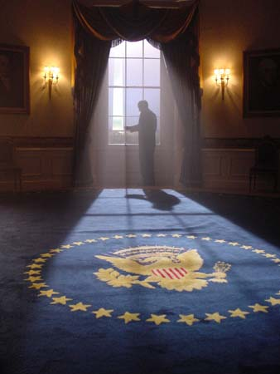
In addition to the ‘Operations Coordinating Board’ being responsible for implementing NSC decisions it was also mandated to report to the NSC as stipulated in the executive order creating it. The role of the OCB is described in official history of the NSC which states of the OCB: “Established as an independent agency by EO 10483, September 2, 1953, to report to the NSC on the development, by appropriate Executive branch agencies, of operational plans for national security policies of international import.” While formally independent, the OCB and the PSB were functionally part of the NSC system, since it was required for them both to report to the NSC and implement NSC decisions.

Consequently, it can be concluded that Corso served in a support staff capacity to the NSC rather than having been a member of the NSC proper. NSC was the ultimate government entity to which the Operations Coordination Board had to report and implement decisions received from. This view that the OCB was functionally part of the NSC was confirmed by the FBI report so it is true that Corso served on the staff of the NSC. The origin of Corso’s sworn statement that he had been a member of the NSC related to his membership in one of the subordinate committees – the OCB and its predecessor the PSB.

Friedman has taken Corso quite literally to mean that he served on the NSC when it’s clear from the context of his book, notes and interviews, Corso was only referring to his membership in the Operations Coordinating Board and other committees attached to the NSC. This has led to Friedman concluding that Corso was making misleading statements of serving both as a member of the NSC and attending NSC meetings involving the President and other Cabinet level officials. This explains why the Eisenhower Library archivist could find no evidence of Corso having been a member of the NSC or having attended NSC meetings, Friedman was looking at the wrong committee in terms of Corso’s membership and attendance. Clearly, Corso attended meetings of the NSC Operations Coordination Board and PSB, so Friedman’s contention that he could not find records confirming Corso’s attendance at NSC meetings is misleading. Corso clearly attended the PSB and OCB meetings during his four year assignment to the Eisenhower administration and the NSC.

A similar misunderstanding of Corso’s role in the NSC is stated by Kevin Randle in the following:

… the Eisenhower Library lacked the records to substantiate Corso's claim, not because those records were incomplete, but because they never existed in the first place. Here is another significant discrepancy that you choose to ignore by saying maybe, possibly, perhaps, but have no evidence to even begin a simple investigation, other than the word of a man who has been caught several times making false claims.

Dr Randle is also reaching a mistaken conclusion about Corso’s veracity as a whistleblower based on his focus on a statement made in Corso’s affidavit and taken out of context to infer something negative about Corso’s background. Corso had earlier cleared such a possible confusion in his book and during subsequent interviews. Dr Randle failed to examine the precise role Col Corso played in the NSC and the various committees he attended, and how the NSC is a multi-tiered institution. Col Corso was clearly assigned to the military staff of both the PSB and OCB which were part of the NSC system developed in the Eisenhower administration.

Another criticism is made by Brad Sparks who claims that the OCB did not become formally part of the NSC until 1957 as a result of Executive Order 10700 that incorporated the OCB into the NSC. Sparks claims that Corso was embellishing his military service by claiming that he had served in the more prestigious NSC as opposed to the less prestigious OCB. Sparks writes:

Corso served as a staff member of an "independent agency," something called the OCB from Feb 24, 1954, to Oct. 20, 1956, according to his records, ‘not’ as a staff member of the NSC…. The OCB (Operations Coordinating Board and its predecessor the Psychological Strategy Board) was not a part of the NSC …

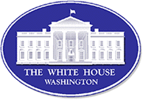
Sparks criticism is incorrect in a number of ways. First, the OCB was functionally part of the NSC from its inception due to its reporting to and implementing NSC decisions. The OCB’s formal incorporation into the NSC in 1957 was done for organizational reasons, and did not change its chief function as an interagency committee that was part of the NSC system. Second, an FBI record refers to Corso having served on the OCB NSC, thereby confirming that it was widely understand that the OCB was part of the NSC from its inception. Third, Corso’s sworn testimony to Congressional "Hearings Before The Select Committee On POW/MIA Affairs," in 1992, listed Corso as: "Lt. Col. Phillip [sic] Corso (USA, Retired) National Security Council Staff, Eisenhower administration." Fourth, Robert Cutler wrote an official history for the CIA about his experience while
serving as Eisenhower's Special Assistant for National Security Affairs. Cutler served on the Psychological Strategy Board, the NSC Planning Board and the Operations Coordinating Board from the years 1951-58. Cutler described the role of the OCB in implementing policies approved by the NSC as follows:

Finally, the President approves, modifies, or rejects the Council's recommendations, transmits those policies which he approves to the departments and agencies responsible for planning their execution, as a rule – where international affairs are concerned – [he] requests the NSC Operations Coordinating Board to assist these departments and agencies in coordinating their respective planning for action under the approved policies.

A significant flaw in Sparks’ argument is that he is not consistent in his criticisms. His more recent criticism against Corso is a reversal of his previous position that the PSB was part of the NSC and that Corso had been appointed to the NSC when serving in the Eisenhower administration. In his definitive ‘expose’ of Corso’s book, written in August 1998, Sparks wrote: “The PSB was a division of the National Security Council (NSC), not the CIA, and it didn't exist in 1947. The PSB was created on April 4, 1951. Corso should have known this from his tour of duty at the NSC in the early 50's.”

The documentary and historical evidence supports Corso’s contention that he served as a staff member of the NSC while assigned to the OCB and PSB. Furthermore, Sparks’ criticisms of Corso fail to be consistent. Sparks has been the most dismissive of all Corso’s critics when it comes to Corso’s credentials and background. This suggests to this author that he is motivated to disparage Corso regardless of the documentary evidence supporting Corso’s claims. In the case of Friedman and Dr Randle, both try to disparage Corso by emphasizing his alleged claim in his Affidavit of having served on the NSC itself. They ignore Corso’s repeated statements, made earlier, to having been a staffer assigned to the NSC. They put great emphasis on what is obviously an oversight on Corso’s part that can be attributed to his deteriorating health. They ignore previous interviews and writing which consistently claim that Corso had served on the NSC staff. This suggests both Friedman and Randle are intentionally posturing to disparage the significance of Corso’s testimony by over emphasizing inconsistencies in his testimony. The failure of Randle, Sparks and Friedman to consider alternative explanations for inconsistencies in Corso’s testimony; their overblown emphasis on the significance of the inconsistencies; and their lack of effort to reach a balanced conclusion over the pros and cons of Corso’s testimony, suggests they have crossed the Rubicon from objective criticism into debunking.

- Did Col Corso officially work with Majestic-12?
According to Kevin Randle, Corso had made some public statements of having been officially associated with the secretive Majestic 12 (MJ-12) Group created to manage the UFO phenomenon. Dr Randle concludes that the absence of documentary support for such claim suggests that Corso was prone to embellishing his service background, therefore his testimony is unreliable. Randle dismissively writes: “I find the references to his personal involvement in MJ-12 to be the smoking gun about the credibility of the book.”


Documentary evidence for a possible official relationship between Corso and MJ-12 is found in his official military records. Col Corso’s records point out that he served on the Psychological Strategy Board (PSB) in 1953; and also on its successor the Operations Coordinating Board (OCB) from 1953-56. During Corso’s service, these committees were both physically located at the Department of State, and headed by the Deputy Secretary of State. Corso describes his role in the PSB/OCB and the UFO information he had access to as follows:

During my military career at one time or another, I counted nine clearances above “Top Secret,” granted to me. These included cryptographic, satellite, code and intercept, special operational clearances and the “Eyes Only” category of special White House (NSC) matters. They made available to me all matters within the government which included “UFO” information. My colleagues of the NSC staff did not know of my special clearances. Only C.D. Jackson, my superior, and the President’s special assistant and President Eisenhower knew of the clearances.

Corso is here claiming that while serving as a staff member of Eisenhower’s NSC, he was given access to ‘UFO’ information. Claims attributed to Corso by Dr Randle that Corso served with Majestic-12 may be explained from the precise role played by the OCB. The OCB was the successor to the Psychological Strategy Board (PSB) that had been initially created by Gordon Gray, a former Secretary of the Army, in 1951. According to Stanton Friedman, Gray was a member of the original Majestic 12 Group mentioned in the Eisenhower Briefing Document. Given the high level of security attached to all MJ-12 activities, it can be assumed that the PSB had been created to perform certain functions for the secretive MJ-12 Group. A still to be confirmed ‘Majestic’ document, allegedly leaked by government insiders, declares that the Psychological Strategy Board was created by MJ-12 to develop policies on the UFO phenomenon.
Gordon Gray (right) being administered the oath as the first Director of the new Psychological Strategy Board while President Harry S. Truman (center) witnesses the event.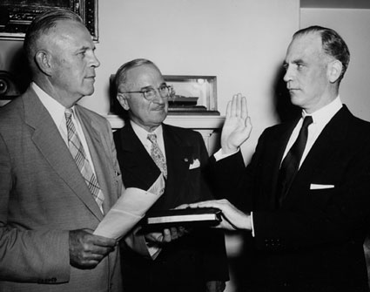

The PSB was created “under the NSC to coordinate government-wide psychological warfare strategy.” Both the PSB and the OCB were based on developing psychological warfare strategies. Given the role recommended by the 1953 Robertson Panel to debunk UFO sightings and Gordon Gray’s original role in setting up the PSB, it can be concluded that one of the functions of the OCB was to develop appropriate psychological warfare strategies to deal with the public response to the UFO phenomenon. Corso was most likely referring to his service on the PSB/OCB as the basis for his later claims to have been formally associated with MJ-12. Corso’s background as a military intelligence officer would have equipped him well to serve on a committee (PSB/OCB) performing psychological warfare functions authorized by MJ-12 to manipulate the public response to the UFO phenomenon. The criticism against Corso that he embellished his service record in claiming to have been associated with MJ-12 is therefore not supported by the documentary evidence. The lack of effort of Randle to find a plausible explanation for Corso’s claim regarding being professionally associated with MJ-12 suggests that once again he has crossed the Rubicon from objective criticism into debunking.

4. Did Col Corso head the Foreign Technology desk at Army Research & Development for two years?
Another criticism of Col Corso is Dr Randle’s and Stanton Friedman’s contention that Corso served only ninety days as head of Foreign Technology desk under Lt General Trudeau, and that he was embellishing his service record by claiming that he “for two incredible years” was “heading up the Foreign Technology desk in the Army Research and Development. Col Corso’s military record confirms that he served as Chief of the Foreign Technology Division from 18 April 1962 to 18 July 1962. Prior to this period he was assigned as a Staff Officer in the Plans Division from May 5 to June 25, 1961, and then as staff officer in the Foreign Technology Division from 26 June 1961 to April 1962. Furthermore, from 18 July, 1962 to his retirement on 1 March, 1963, he was once again assigned as a Staff Officer in the Plans Division of Army R & D. It is this entire period of serving in Army R & D that Corso describes as the “two incredible years” of heading the Foreign Technology Desk.
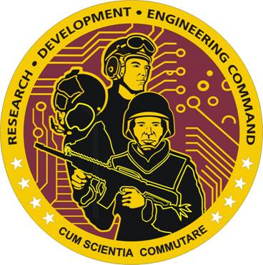
In Corso’s notes, he declares that upon his return from Germany in 1960 where he was Inspector General for the U.S. Seventh Army, he became “Special Assistant to the Chief of Army Research and Development, Lt Gen. Arthur G. Trudeau”. He claimed that in “Army R& D, I had the title of Chief of Foreign Technology Division…. I was always the team chief and made all decisions.” Corso’s claim is supported by his close relationship with Trudeau and his former senior positions as battalion commander at White Sands Missile Range and Inspector General of the 7th Army.

Independent corroboration that Corso served as head of the FTD despite his military record confirming this only for a three month period was established by Col John Alexander in his own private research of Corso’s background. Col Alexander discovered in his research that Col Corso had another officer nominally above him in the organizational hierarchy, but Corso was known to be effectively in charge of the Foreign Technology desk created under General Trudeau. This was confirmed to Col Alexander by senior military officials aware of Corso’s work with Gen Trudeau. The FTD was a very small unit possibly comprising just Corso himself. Col Alexander discovered that the FTD was created when Corso started at Army Research and Development, and the office was abolished when he retired, along with Gen Trudeau. This confirms Corso’s claim that the FTD was created for him by General Trudeau after his arrival at the Pentagon and required Corso’s various security clearances. This supports Corso’s testimony that he was in charge of the Foreign Technology desk over a two year period 1961-63, and not solely the ninety days confirmed in his military record. The great emphasis placed in this discrepancy between what Corso claimed and what his record establishes, once again shows how Corso’s critics fail to identify plausible explanations for this inconsistency. A number of plausible explanations exist for this discrepancy without undermining Corso’s central claim of heading the FTD. Consequently, the overblown emphasis on this inconsistency between Corso’s claims and his records, once again reveal that critics such as Dr Randle and Friedman cross the Rubicon between objective criticism and debunking.

5. Did Col Corso Play a role in disseminating extraterrestrial technologies into private industry?
There has been much criticism of Corso’s claims of seeding extraterrestrial technologies into civilian industries. The civilian technologies spawned by this covert seeding program include: Fiber Optics, Image Intensifiers, Super Tenacity Fibers, Lasers, Integrated Circuits, and Irradiated Food. Critics such as Stanton Friedman argue that:

Corso seems to be taking credit for the single handed introduction of a whole host of new technologies into American industry. All this is supposedly derived from the filing cabinet of Roswell wreckage over which he was given control by General Trudeau…. He is definitely NOT a scientist, but the implication is that in less than 3 years he could change the world's technology… Not very likely in my opinion.

Similarly, Brad Sparks is very critical of Corso’s claims regarding his seeding extraterrestrial technologies and concludes: “there really is no need to go into the rest of his confabulations about his heroic role in getting U.S. industry to "reverse engineer" microchips, fiber optics, lasers, Kevlar, etc., from his make-believe Roswell spacecraft.”

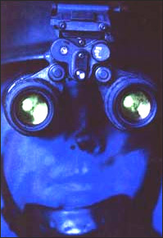
It needs to be pointed out that Corso consistently laid credit for the covert program to seed civilian industries with extraterrestrial technologies to his superior, Lt General Arthur Trudeau. Corso wrote that from the period 1947-58 that “military R & D was greatly disorganized” and that it was under his superior, Lt General Arthur Trudeau, that the “Golden Age of R & D (1958-1963 ) blossomed. Due to competing government agencies, Corso claimed that “R & D data, stemming from areas ‘out of this world’ had to be carefully hidden and the information kept among a select few.” As a former intelligence officer who served with Gen Trudeau, former head of the Army’s Military Intelligence (G-2), Corso was entrusted with extraterrestrial technologies to seed into civilian industries. He likely performed this covert function with the same single minded focus that exemplified his highly distinguished military career. Nevertheless, Corso consistently laid the chief credit for the covert extraterrestrial technology seeding program with Gen Trudeau, and not himself. Nevertheless, he is assailed by critics for exemplifying hubris. For example, Brad Sparks claims in his ‘expose’: “Corso just can't resist putting himself at the center stage of great events of history, courted by the big names such as Robert Kennedy and his "old friend" J. Edgar Hoover (Corso's "other book" is called "I Walked With Giants"), and he is ever the powerful hero.”

Corso’s critics have attempted to lay the charge of hubris on Corso without appreciating the implications of the unique circumstances that had placed in such a sensitive role. As the trusted personal assistant to the head of the Army R & D program, Corso was in the precise position to play his part in a covert program that could have had an enormous effect on human society. That is a statement of fact supported by documentation, rather than hubris which is based on the conjecture of critics. Consequently, the ad hominem attacks on Corso’s reflections on the significance of his historical role in a secret Army program to seed civilian industries with extraterrestrial technologies are at best a distraction. At worst, such ad hominem attacks are more evidence of Corso’s critics crossing the Rubicon between objective criticism and debunking .

[To be continued in Part 2.]

***

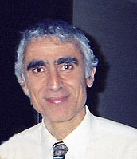
About the Author: Michael E. Salla, PhD., is the author of Exopolitics: Political Implications of the Extraterrestrial Presence (Dandelion Books, 2004) and founder of the popular website: Exopolitics.Org. He has held full time academic appointments at the Australian National University, and American University, Washington DC. He has a PhD in Government from the University of Queensland, Australia. During his professional academic career, he was best known for organizing a series of citizen diplomacy initiatives for the East Timor conflict funded by U.S. Institute of Peace and the Ford Foundation. He is the Founder of the Exopolitics Institute (www.exopoliticsinstitute.org ); Chief Editor of the Exopolitics Journal and Convenor of the “Extraterrestrial Civilizations and World Peace Conference.”

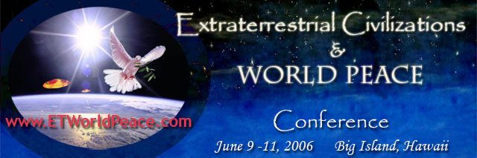

Endnotes ? See Stanton Friedman, http://www.virtuallystrange.net/ufo/updates/2005/may/m19-006.shtml;; Dr Kevin Randle, http://www.virtuallystrange.net/ufo/updates/2005/may/m18-006.shtml ; and Brad Sparks; http://www.virtuallystrange.net/ufo/updates/2005/aug/m04-007.shtml
See http://www.cufon.org/cufon/corso_da66.htm * I thank Paola Harris and Jan Aldrich for forwarding FOIA information available on Dr Phillip Corso which assisted me greatly in assessing the validity of Corso’s testimony and criticisms made against him.
Philip Corso, L’Alba di una Nuova Era: I Segreti Alieni Nascosti dal Pentagono, tr. Maurizio Baiata (Pendragon, 2003). I thank Paola Harris for generously giving me a copy of Maurizio Baiata’s Italian version of Corso’s original notes.
Cited online at: http://www.ufoskeptic.org/
Cited from online version of Robertson Panel at: http://www.cufon.org/cufon/robertdod.htm
The Day After Roswell, 62.
The Day After Roswell, 38.
L’Alba Di Una Nuova Era, 127.
The Day After Roswell, 2.
See: http://foia.fbi.gov/corso_philip_j/corso_philip_j_part01.pdf
See: http://www.ufocom.org/UfocomS/CorsoAffidavit.htm
See: http://www.virtuallystrange.net/ufo/updates/2005/may/m12-001.shtml
See: http://www.fas.org/irp/offdocs/NSChistory.htm#Eisenhower
Cited online at: http://www.fas.org/irp/offdocs/NSChistory.htm#Eisenhower
Cited online at: http://www.archives.gov/research/guide-fed-records/groups/273.html
Cited online at: http://www.virtuallystrange.net/ufo/updates/2005/may/m16-001.shtml
Cited online at: http://groups.yahoo.com/group/exopolitics/message/220
Cited online at: http://www.cia.gov/csi/kent_csi/docs/v03i4a05p_0003.htm
Cited online at: http://www.virtuallystrange.net/ufo/updates/1998/aug/m11-001.shtml
See: http://www.virtuallystrange.net/ufo/updates/1997/jan/m17-016.shtml & http://www.virtuallystrange.net/ufo/updates/1997/feb/m25-007.shtml
See: http://www.virtuallystrange.net/ufo/updates/1997/jan/m17-016.shtml
L’Alba Di Una Nuova Era, 31.
See Stanton Friedman, Top Secret/Majic (2005) 56-85.
“Majestic Twelve Project: 1st Annual Report,” The Majestic Documents, ed., Robert Woods, 110
Cited in Foreign Relations of the United States, 1964-1968, vol. XII, Western Europe, pp. XXXI-XXXV, April 16, 2001. Available online at: http://www.fas.org/sgp/advisory/state/covert.html
The Day After Roswell, 1. For Randle’s criticism go to: http://www.virtuallystrange.net/ufo/updates/2005/dec/m13-004.shtml . For Friedman’s criticism go to: http://www.geocities.com/Area51/Lair/7676/stanlog.htm
L’Alba Di Una Nuova Era, 29.
L’Alba Di Una Nuova Era, 31.
Private email from Col Alexander on May 20, 2005.
L’Alba Di Una Nuova Era, 44.
Cited online at: http://www.v-j-enterprises.com/sfcorso.html
Cited online at: http://www.virtuallystrange.net/ufo/updates/1998/aug/m11-001.shtml
L’Alba Di Una Nuova Era, 15.
L’Alba Di Una Nuova Era, 16.
Cited online at: http://www.virtuallystrange.net/ufo/updates/1998/aug/m11-001.shtml

