
Book Review - Exempt From Disclosure: The Disturbing Case About the UFO Coverup, by Robert M. Collins & Richard C. Doty with Tim Cooper as a contributing writer (Peregrine Communications, 2005) ISBN 0-9766426-0-3.

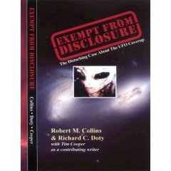
The book title itself describes the status of classified information on UFOs. The record is unambiguous, powerful, and almost unarguable that there are many aspects of the UFO or flying saucer reports that have been classified over the years, and this is the first book that provides enough detail to convince many that we have had a deeply covert involvement with the UFO topic from the beginning.
The two main authors, Robert M. Collins and Richard C. Doty, supported in part with documents provided by Tim Cooper, have painted what impresses this reviewer as an approximately accurate history of the handling of this topic inside the deepest confines of counterintelligence.
Collins, a retired Air Force Intelligence Officer with the Foreign Technology Division, and Doty, a retired counterintelligence Air Force Office of Special Investigations agent, have put their knowledge together to create an impressively coherent history of the internal and external relationships surrounding the UFO topic in the United States. They identify specific people with seeming accuracy as to their involvement, and begin the story of their interaction in the fall of 1986. Your reviewer had met nearly all of the players of that era, except that I still have yet to meet Robert Collins face to face---he is a friendly voice on the phone to me so far. I saw Richard Doty once at a restaurant at 3 AM in a restaurant stop on Interstate 80 in New Mexico once after a fruitless hunt for some ETs that should have come out to greet a small group of researchers in a remote area of New Mexico, but never came. However, I saw the “Doty” on his badge. Tim Cooper, the recipient of some of the classified documents, had been working with me to authenticate some of them…successfully.
The book begins with an appropriate chronology of the involvement with other interested (and usually “cleared”) people, followed by the description of who has been involved with MJ-12 (the UFO management program) from the beginning, supported by photographs of those participating, many of whom are identified. More recent individuals that impressed this reviewer involved in MJ-12 as of 1986 included Senator Claiborne Pell, and Dr. Carl Sagan. Tim Cooper contributed direct quotes from his own father, an Air Force MSgt, who has high credibility supported by a certificate of commendation from General Le May for his “contribution to the Air Force UFO Program.”
The second section of the book focuses on four very important people in counterintelligence: James Jesus Angleton was involved with both UFOs and interacting with JFK in his last few days. Allen W. Dulles was involved with both UFOs and the ZR/RIFLE for assassinations. Richard Helms, the former OSS officer who rose to power in the CIA, apparently had intimate contact with the captured EBEs (Extraterrestrial Biological Entities). Richard Doty, book co-author tells his own personal story of his interaction with aliens, deception techniques for the public, physiology and anatomy, disclosure arguments, alien views on weapons, and what really happened during the famous Cash-Landrum encounter and the Monzano incident. In some ways the more or less first hand revelations of Doty are more exciting than the coherent career descriptions of the first three personalities of Angleton, Dulles and Helms because most of Doty’s information has never been revealed. The final chapter of the section is devoted to the Men in Black, with specific and surprisingly detailed descriptions of their involvement and affiliation with various arms of the Government.
The four chapters of the third section focus on underground installations, with detailed maps of what is where at Wright-Patterson and Los Alamos respectively in the first two. The third chapter looks at the reverse engineering issues arising from specific recovered craft and artifacts as performed primarily underground at Los Alamos. This includes some relatively recently “leaked” top secret information about an “Extraterrestrial Energy Device” and some description of extraterrestrial propulsion technology. The fourth chapter provides details of what goes on in the desert – the famous “Area 51”.
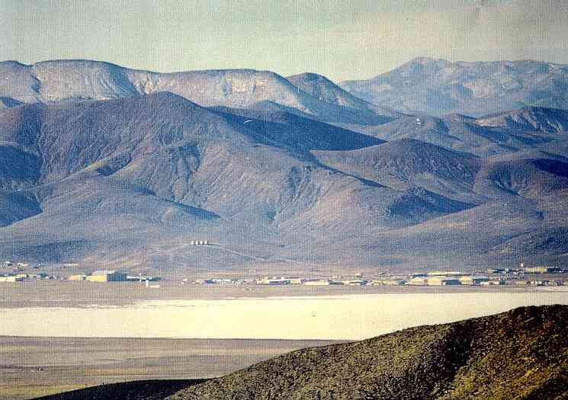
Area 51 – Groom Lake, Nevada
All the chapters in the book include (sometimes) random snapshots of known historical events interspersed with information unknown to even most UFO researchers.
The positive attributes of the book are:
- The book is a “must read” for those media types who have no clue about the detailed sophistication of our security system’s ability to keep things from the public.
- Frequent use of photographs, sketches and copies of drawings give the book a feeling of accuracy and authenticity.
- The specifics of the interactions with the EBEs are certainly new to most ufologists, although they have appeared in fiction before. This is a non-fiction book.
- The personal biographies of Angleton, Dulles and Helms as linked to UFOs and MJ-12 seem quite credible.
- The references and footnotes, while not extensive, include url addresses for verification of detail.
- The attempts to describe the alien technology in understandable language are a plus.
- The cover and title are attractive.
The negative attributes of the book are:
- Occasional embarrassing typos like “fool” instead of “foo” fighters in the Introduction and a few others elsewhere.
- Sometimes the documents are very hard to read.
- The references and footnotes sometimes felt as if they should have been incorporated into the text.
- Some of the photos and figures are distorted with a careless ratio of height to width different from the original.
- There is no index, an easy-to-do important addition in this age of technology.
In spite of the negatives noted above, this is a book everyone who has a curiosity about how our Government has been dealing with the UFO issue must read, because there is a very high probability in my opinion that a major fraction of the reported history, although often unproven, is exactly correct.

Reviewer: Dr. Robert M. Wood. Retired aerospace manager with McDonald Douglas and current UFO document researcher. Main website: www.majesticdocuments.com
***



