

“Ambassadors to the Universe Program: Protocols for Contact &
The Death of the 4th Estate”

Exclusive Interview with Dr Steven Greer – Crestone, Colorado - July 4, 2005

By Paola Harris

Paola: Steven, what is the focus of your career at the present time?

Dr Greer: My main focus is still the CSETI encounters that we are doing now like this one at Crestone, Colorado. But there are different levels of this. We have people who train people like Dr. Loder and his people. There are others that get a group together and take them out in smaller groups, and have done 20 or 30 of these expeditions. They know what they are doing. The big trainings like this of 20 or 30 people I do. The main ones are Mt Shasta, Crestone and Joshua Tree Wilderness area in California.

The core basis of our focus is the fact that humans are going to have to learn to contact these non-human beings in a peaceful way and right now there is no initiative in the world that are doing this but ours. There are a few in Latin America that sort of have the same concept. Unfortunately the political structures have not dealt with the issue and the covert programs are military and hardly diplomatic. I mean they are actually increasingly hostile. so what we are doing is a citizen’s diplomacy effort and we have laid down protocols that are interrelated with very spiritually based and we believe that we are spiritually conscious beings and there is that one mind of the cosmos that shines in every being. This is the fundamental basis for helping to make contact and. because extraterrestrial technologies interface with thought and interface with what some people call the etheric or astral level of things, we have found that we can put together protocols that involve electromagnetic things like lasers and BP signals using this concept of sort of the center of the universe of mind. and in that center begin to see in sort of a remote sensing where the ETs are and connect with them mentally. We have had amazing contact, sightings and even things have come right to the field and what have you all over the world. So the concept is an very adapt one because it integrates the mind, the physical.

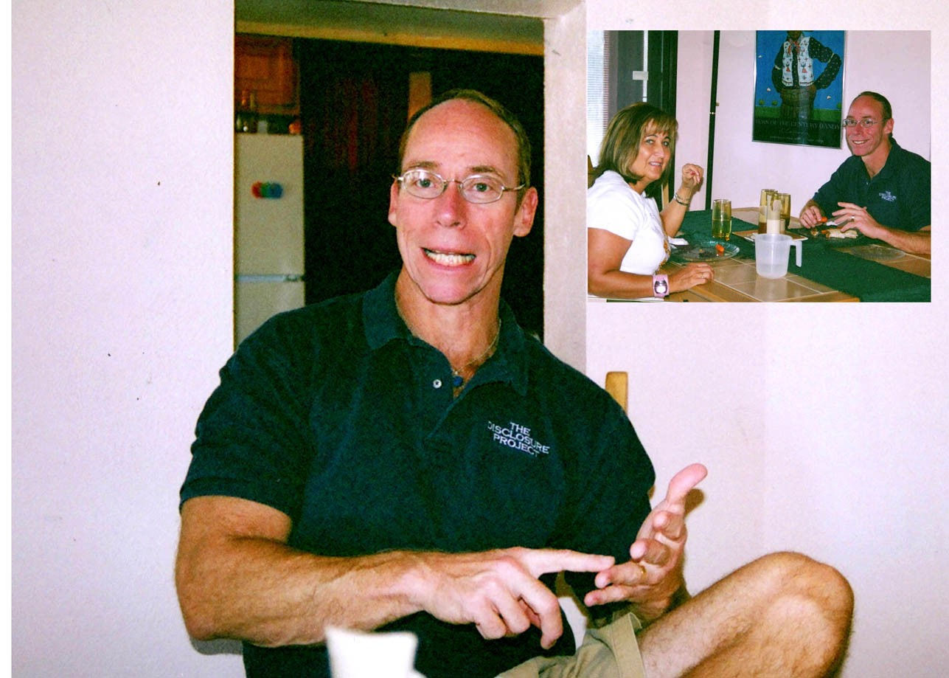
Paola: This is a very spiritual place here in Crestone. It has an incredible energy. there are many religions represented in this valley. I saw a Zen center and an ashram, and a center of Carmelite nuns.

Dr. Greer. There is a beautiful white stupa with the gold on top authorized by the Dalai Llama

Paola: Yes I saw that.

Dr. Greer: Yes. Ambassador Jim George from Canada was involved and was asked to build the stupa here and he did it. and he is an advisor to our group and has spoken to Canadian officials about the energy problem and alternative energies. I just spoke in Montreal and there were over a thousand people there. I also spoke at the University of Toronto.

Paola: So Is the focus of your ET communication training a type of Universal Cosmic Consciousness?

Dr. Greer: Yes. You see the fundamental basis of being an ambassador to non-humans life forms, as I see it, is the understanding what it is, what’s the Nexus where we all have some point in common. Well it is not going to be that we are human with those who are non-human. So it is that we are conscious. And so, I remember Monsignor Balducci saying “we are all children of God” but there is this light of Conscious Mind , this one spirit within us all. And there is One Spirit shinning through all of us so by relating to that which ,I feel is very important. I train people to do is take people to higher states of consciousness. I am taking people who are ready for that to a cosmic consciousness development retreat in Palm Springs in November. We will use meditation techniques and the contact techniques to be able to center and experience Cosmic mind and then remotely view, using Cosmic Mind. We don’t use the military system. It is very primitive. If we understand that the mind is omni-present and the Mind, and the Mind where you and I are awake right now, is a singularity; we can settle into that “non-local” or expanded reality, you can see everywhere. People come on these retreats who have spent big bucks trying remote viewing and get these breakthroughs in three or four days because I am teaching them to stop and be still, and center; and then use some specific techniques that I have learned to be able to remotely sense places and distant different objects. This training is very riguous. And I think that people have to understand that the fundamental reason why that is important is that if you don’t connect or relate to that aspect of Universal Mind, then how are you going to relate to non-human people? It doesn’t make any sense.Think about it .They are not going to have the same emotional quality; they are not going to have the same mental aptitude; they are not going to have the same font of knowledge ; they are not going to be biologically the same. So where are you connected? It is in this “ conscious mind” which is the spirit!

So in this kind of world, you not only have a diplomatic foundation for communication, but you also have a functional paradigm because their technology, it has been recorded at least in the 40’s and 50’s if not longer, they have devices that are electronic that interface with thought. They are not communicating with stellar systems in using microwave systems. They are using a sub-electromagnetic signal that interfaces with what the mystics used to call astral or thought energy and it is scientific reproducible. We have covert programs in the United States that develop these systems as well.

Paola: Edgar Mitchell used “thought transfer” from the moon and it worked!

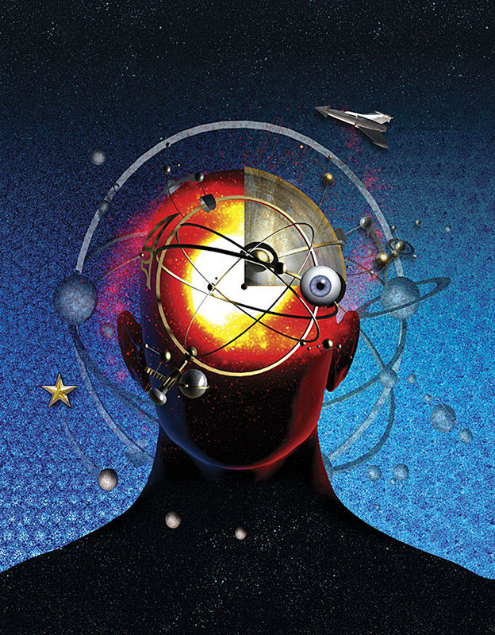
Dr. Greer. Right it does work. He and I talked about this. Every human being is a quantum hologram of the whole universe. In other words, I love this Sufi saying: “think yourself a puny form when within yourself the Universe is folded.” It is a rhetorical question. You are not a small thing. Within each person the entirety of the cosmic universe is unfolded literally. And opening to that you can not only communicate with these extraterrestrial life forms but you can also begin to relate to a universal aspect of yourself. So you don’t have to react to xenophobically when you encounter the diversity of extraterrestrial life.

Paola: Right. We already have trouble with diversity here on Earth.

Dr. Greer: My God, we are blowing people apart. We are spending a trillion dollars a year in military spending. So if we are going to be talking about a serious effort to become ambassadors to these other civilizations that are obviously involved with earth and obviously concerned with what we are doing, then those ambassadors in my mind, have to be knowledgeable about the universal component of conscious. So I find that as the fundamental foundation of being an interplanetary ambassador so that is how I train people. That is the basis of what we are doing. A lot of people say that is very far out but it is actually simple, Because if you don’t have something that you are anchored to that is deeper than the human, animal, intellectual emotional state, then you are not going to relate, First of all you can barely relate to another human from another culture. Look how different an Italian is to a Japanese? You are talking about different star systems and people, and so to be able to transcend that level of diversity, and the diversity is fine if you are able to keep that perspective. But what happens is you get overwhelmed by the diversity or that becomes a cause of conflict which is what human beings normally do. You know someone looks different, thinks differently. If they are gay, they are straight; they are black, they are white; they are Arab, they are Iraqi; they are Suni, they are Shite; they are Protestant, they are Catholic; whatever it is we find that for a reason to blow each other apart. Well, we cannot export that kind of thinking to the next stage of human development which is the cosmic moment. This is a cosmic moment. And the death throws of what is happening on Earth today is that the diversity is becoming a cause for conflict. It is really a spiritual problem as I see it. Now, I am not a religious person at all, but I am a spiritual person.

Paola: But you are optimistic? Right? You could get real pessimistic if you look at the reality of this. You are developing an alternative.

Dr. Greer: Very optimistic. The whole thing is I think that we have to create a world that is commiserate with the challenges of our time and we have failed to do that . In other words, we are 100 or 150 years into this chapter of human history and yet we have refused to make the fundamental changes spiritually, socially, politically, geopolitically and technologically that would support a civilization commensurate with this time. For instance, we know that there have been technologies that could have elimminated world poverty and pollution that could have been here for 75 years. They went deep black in the 50’s. The reality is that the human situation has been in a sense, retarded from an evolutionary development point of view for at least 50 to 100 years and this is why we see so much imbalance today. I’m optimistic that will be brought back. But it is going to take courage, good leadership, some sacrifice which we had to face in our group. It is going to take some thinking in how we are going to create a civilization that is commensurate with the challenges of the time. There are many power dynamics working in this dysfunctional world that need to be fixed.

Paola: You articulate that really well Steven. You are one of the only people who has it together. I mean you synthesize this problem well. I mean people have little pieces of it. They are talking about Zero energy here. They do not look at the spiritual, they don’t even talk about ET communication. Forget that! You synthesized the whole entire planetary situation and offered a possible solutiuon in the CSETI Ambassador Program of Consciousness. You said you were working on three things. What are they?

Dr Greer: CSETI, the Ambassadors to the Universe program, the other is Disclosure Project. We are still doing the Disclosure Project because we have a website with ten million people on it. People don’t realize that the Disclosure Project video has been seen by more people than who see CNN every night. I am still meeting with members of Congress. Within the last year, I’m trying to say “look this information exists and it is not only related to UFOs and extraterrestrials and but also to alternative energies and propulsion systems that would solve most of our problems. And so Disclosure still has to go on and we have a Disclosure Representatives Program..We also have dozens of people all over the world who host Disclosure project screenings….and meetings. So that is still going on.
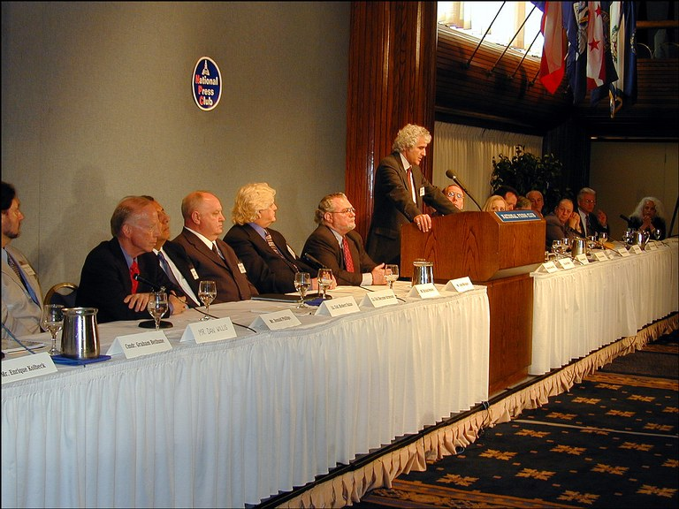
We would love to do Disclosure II. Many have yet to understand that after we did the Disclosure Project event in 2001, we doubled the number of military assets in terms of the number of witnesses because they came out of the closet. As a matter of fact, a retired Air Force general who has knowledge of these covert programs is one of them. The problem is that we do not have the funding to do it. We have got to find a source of institutional support and funding to be able to do the next level of it, or it’s impossible to carry forward. There is no funding for anything serious and this is the whole tragedy of the whole UFO movement. It has become a carnival and caricature of itself, yet we are dealing with incredibly important things and my understanding is that the intelligence community which really does run the UFO subculture, wants to keep it that way. Now what I’d like to do in the next year or two is do another level of disclosure where we would bring in some of the new top secret witnesses we have, and government officials including a former Clinton administration official. Also in technology where we can bring in scientists who can testify to the existence of new energy and propulsion systems, and how they have been systematically acquired and suppressed by large transnational corporate interests

Most people post 9-11 really don’t care if there are UFO and ETs out there. The majority of Americans believe UFOs are real anyway. They just don’t know what to make of it You’ve got to connect it to something meaningful. The fact is that it is meaningful because there are enormous implications to the secrecy, and the secrecy is not because of the extraterrestrial component. The secrecy is because of the technology that would make obsolete all the oil and gas and coal power in the world

Paola: I am asking if it is possible that disclosure can come from the United States? Maybe Canada. Did you even dream of doing Disclosure II in Canada?

Dr Greer: Now I am going to say something here people hate to hear. You can not do this without the dominant Power, the only super power in the world. We have projects, in Norway and Canada. The dominant power is the American Transnational Corporate Machine. What I tell people is that geography is irrelevant!

Paola: But the Media could open it up there!

Dr Greer: I think that what most people don’t realize is the issue that we are dealing with has no geographical boundaries and hasn’t had for decades.

Paola: We still need the media support, don’t we?

Dr Greer: Of course. It would have the seed funding we asked for. We could have had another level of the Disclosure Project in Washington, D.C., then move the whole thing to Canada, and to Rome and Switzerland and these places. There was the Chinese news media that took it seriously. You cannot ignore 110 military top secret witnesses who are cosmonauts, brigadier generals and so on. You can not ignore these people! The other problem is that the major media is corrupt and is the most corrupt institution in the world.

Paola: How does this affect disclosure?

Dr Greer: If you were to ask me what is the largest problem with getting disclosure out and getting these technologies out to the world, it is not the White House, it is not the Congress, it is not the UN, it isn’t the parliament; it is the Media which in democracies was supposed to be the “fourth estate” which means, one of the “watch dogs” of checks and balances to the other three branches of government: the judiciary, the executive and the legislative. That is where the fourth estate concept came from. I have a man who was on the board of AOL Time Warner and CBS who told me in 1992, he told me basically” the Fourth Estate is Dead!” We have no Fourth Estate. I had a Washington Post reporter frankly tell me that nothing important will ever be published in the major media. Look at our website where I talk about the Peter Jennings special and you will see a link to a CIA document that was sent to me recently this year that was dated 1991 during the first Bush presidency. It clearly describes on page 6, if I remember correctly, that there are assets that the intelligence community has at every major news media in the world; to kill, change or alter stories that they want to have done. The problem is the corruption of the news media, and the lack of a truly free press at large. Now the minor media is irrelevant. The major media is corporate and they are shills for the shadowy transnational para-govermental entity. Again the problem with that is that we are living in a pseudo democracy where the people cannot get the information. I have said seriously recently that Gorge Soreas and others need to come forth and put a billion or two into a “new” media empire.
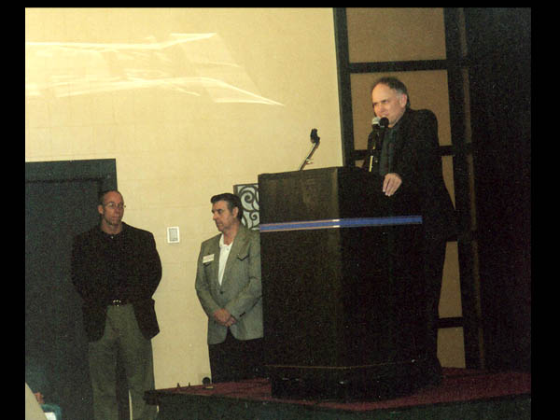
I said this should be called the Disclosure Network News. DNN instead of CNN and basically say: “Ok. We need to be able to have the assets to pour this information into the public to educate them to what is really going on Corporate America, or Corporate Italy or Corporate Japan”. Why is this secrecy going on? Who is sitting on the technologies and what is the truth? It is not going to happen. [Image: Dr Greer being introduced at 2004 X-Conference]. The major media right now is horizontally and vertically integrated with corporate interests that do not want this information out. One of the fundamental problems is the notion that we are living in a democracy without a free press, but a press that is corrupted by these secretive interests. It is very difficult for the masses to know what is really happening for that reason. It makes a mockery out of our democracy. It is interesting that I’m talking about this on July 4th. I think that what everyone has to understand is that we have to get some seriously committed people financially, professionally and with talent in the media to say: “look we really have to do some serious exposes.” For instance, this AOL executive told me that some of the secret UFO Documents he gave to Mike Wallace of “60 Minutes” TV show. Mike Wallace who is one of the most famous investigative reporters in the world, wanted to do a special on them, but all at once they pulled the plug on it.

During the Disclosure Project event, the executive producer of ABC news, who was the final call guy on “Prime Time Live” and 20/20, told me he wanted to do an hour special involving these top secret witnesses. A few weeks later I called him about it and I asked: “What are you doing about the special; and he said: “ well they won’t let me do it”! I asked “who are they? He said: “Dr. Greer you know who they are!” I have seen this up close and personal with the world’s media, not just with the U.S media. I have seen it with the BBC and I have seen it in England and other countries. So the inability, for even people who are in high places within the news media to be not able to be allowed by their corporate masters to tell the truth, is appalling. So since we do not have a truly free media, the Fourth Estate has been essentially assassinated.. You have a mockery of democracy because that is a “checks and balances” system that is no longer there.

***
About the Interviewer
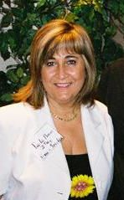
Paola Harris, MEd. is an Italo-American photojournalist and investigative reporter in the field of extraterrestrial related phenomena research. She has studied extraterrestrial related phenomena since 1979 and is on personal terms with many of the leading researchers in the field. She has been a speaker on many radio shows and conferences in Italy, San Marino, Belgium and Germany, and has appeared many times on Italian TV. She has written for Nexus, UFO Magazine, Notizario UFO and Dossier Alieni, among others publications. Her book is entitled, Connecting the Dots: making sense of the UFO Phenomena (Granite Press). Her principal website is: www.paolaharris.it

