

The History of Exopolitics: Evolving Political Approaches to UFOs & the Extraterrestrial Hypothesis

By Michael E. Salla, Ph.D

Exopolitics is a term increasingly used by many UFO researchers and activists as a consequence of the number of websites, books and conferences that have taken this distinctive approach to the UFO phenomenon and the extraterrestrial hypothesis (ETH) that UFOs are interplanetary in origin. By September 25, 2005 there have been three international conferences convened on exopolitics; two books written about exopolitics; and the establishment of a non-government organization dedicated to exopolitics. This article is aimed at clarifying the concept of exopolitics and explaining its history in terms of the some early pioneers who began to focus on the political aspects of the UFO phenomenon and the ETH. This has culminated in the term ‘exopolitics’ coming into widespread use. This will help identify some of the leading ideas in the exopolitics field and the challenges ahead as exopolitics is increasingly used with multiple meanings and different evidentiary sources.

I begin by defining exopolitics, its foundations and pioneers in the field, as a distinct political approach to the UFO phenomenon and the ETH. A clear definition enables one to identify who among the early UFO researchers first began pursuing exopolitical issues. I propose the following to be used as a standard definition for exopolitics:

“Exopolitics is the study of the key political actors, institutions and processes associated with the UFO phenomenon and the extraterrestrial hypothesis.”

This makes it possible to distinguish between the term ‘exopolitics’ and the concept of exopolitics. While the term ‘exopolitics’ is relatively new, being coined in 2000, and coming into widespread usage in 2003/2004; the concept of exopolitics has been implicit in terms such as the “Flying Saucer Conspiracy”, “UFO Cover Up”, “Cosmic Watergate”, etc., that have been a standard part of UFO literature for over five decades .

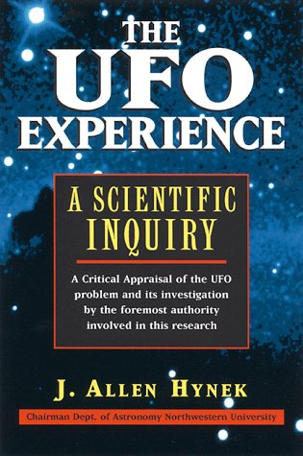
Exopolitics is distinct to UFO research which is focused on the empirical analysis of UFOs and avoids inquiries into the ETH until sufficient empirical evidence on UFO sightings has been amassed to indubitably substantiate the ETH. Dr Allen Hynek defined the scientific study of UFOs as follows:

We can define the UFO simply as the reported perception of an object or light seen in the sky or upon the land the appearance, trajectory, and general dynamic and luminescent behavior of which do not suggest a logical, conventional explanation and which is not only mystifying to the original percipients but remains unidentified after close scrutiny of all available evidence by person who are technically capable of making a common sense identification, if one is possible.

The ETH was first officially proposed as the most valid explanation for UFO/Flying Saucer sightings by a classified study initiated by the U.S. Air Force in 1948. The classified study of approximately 300 cases produced an ‘Estimate of the Situation’ in September 1948, whose conclusion supported the ETH. The study and its remarkable conclusion was moved all the way up the Air Force hierarchy to the desk of the Chief of Staff, General Hoyt Vandenberg who rejected it and made clear that acceptance of the ETH was not an acceptable conclusion for reasons related to national security concerns. The rejection of the initial Estimate of the Situation and the subsequent destruction of the initial report found its way to private UFO investigators such as Major Donald Keyhoe who concluded that it was evidence of a cover up perpetuated at the highest level of the U.S. military and government. Keyhoe was confidentially told the following by Capt Edward Ruppelt about Gen Vandenberg’s decision to reject the original Estimate of the Situation: “The general said it would cause a stampede....How could we convince the public the aliens weren’t hostile when we didn’t know ourselves? … the general ordered the secret analysis burned. But one copy was held out - Major Dewey Fournet and I saw it in 1952.”

Keyhoe’s subsequent writings and investigation of how the ETH was being deliberately undermined by military and national security agencies mark the birth of exopolitics as a distinctive approach to the UFO phenomenon. Keyhoe’s approach was an exopolitical analysis of the key agencies and individuals behind the UFO cover-up is a seminal source of exopolitical thought. I will describe exopolitics in terms of four phases that independently continue to the present day.

Exopolitics – Phase 1 (1948-): The Flying Saucer Conspiracy
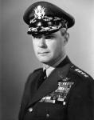
The foundations of exopolitics lies in a number of researchers that began seriously exploring evidence of a high level conspiracy by various government agencies and military departments to hide the truth about UFOs and the ETH. These researchers and their books emerged in the early 1950’s as it became clear that military departments and national security agencies were not genuine in their efforts to seriously investigate UFO sightings and evidence supporting the ETH. This accelerated as news about Vandenberg’s 1948 rejection of the original Estimate of the Situation was leaked.

A critical event in this process was the January 1953 Robertson Panel where a group of scientists chaired by Dr H. P. Robertson and covertly funded by the CIA, recommended that UFO sightings be debunked due to the potential for these events to be manipulated by ‘foreign powers’ in a way that would undermine U.S. national security. The panel recommended an “educational program” to deter the general public from demanding a serious investigation of UFO sightings:

The "debunking" aim would result in reduction in public interest in "flying saucers" which today evokes a strong psychological reaction. This education could be accomplished by mass media such as television, motion pictures, and popular articles.… Such a program should tend to reduce the current gullibility of the public and consequently their susceptibility to clever hostile propaganda.

The Robertson panel was followed in March 1954 by the secret passage of Joint Army Navy Air Force Policy (JANAP) 146 that made it an offense for military servicemen or airline pilots to disclose information about UFO sightings that had been reported and were subject to an official ‘investigation’. Another critical document was the Brookings Report that was prepared by the Brookings Institute for a NASA committee. The Report described the devastating societal effects that would emerge from contact with more technologically advanced off world societies and the political advantages of covering up such information in the event contact is made:

Anthropological files contain many examples of societies, sure of their place in the universe, which have disintegrated when they had to associate with previously unfamiliar societies espousing different ideas and different life ways; others that survived such an experience usually did so by paying the price of changes in values and attitudes and behavior.

It is the political cover up of UFO related information verifying the ETH that has led to the notion of a ‘flying saucer’ or UFO conspiracy. Authors and books commenting on the UFO conspiracy come from two complementary but distinct sources: researchers and ‘experiencers’. Each takes a distinctive approach to exopolitics based on the ways in which information is gained and evaluated. The first approach focuses on political processes surrounding the study of UFOs and the ETH in what will later be described as the conventional way of defining exopolitics. The second approch comprises the political processes used by extraterrestrial civilizations themselves which will be described later as the non-conventional way of defining exopolitics.

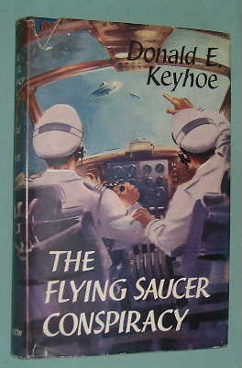
The first approach is based on the systematic study of the best evidence available from UFO cases in order to formulate conclusions about the reality of the phenomenon, and the existence of a UFO cover up. This approach involves seminal UFO researchers such as Donald Keyhoe who wrote a number of books identifying a political cover up of the evidence substantiating the existence of the UFO phenomenon as real, and of evidence supporting the ETH. Keyhoe was an especially significant researcher, since he began as a skeptic. As a consequence of his field investigations became convinced of the reality of the UFO phenomenon and the ETH. Keyhoe did not use the term ‘exopolitics’ but choose instead to use the term ‘flying saucer conspiracy’ to highlight the hidden political and national security processes at work, keeping from the general public the truth of the ETH. Keyhoe’s most important books displaying his implicit promotion of the exopolitics concept were The Flying Saucer Conspiracy (1955); Flying Saucers Top Secret (1960); and Aliens From Space (1973). In these books, Keyhoe meticulously outlines how the various military departments and national security agencies are involved in a conspiracy at the highest level to systematically cover up evidence supporting UFO sightings and the ETH.

Keyhoe used a wide range of sources for his conclusions. Using the friendships and networks from his military days, he was able to secure information ‘leaked’ to him by military officials concerning UFO sightings. He also was able to access a great amount of data gained from field researchers who investigated sightings from civilians, military and the aviation industry. Keyhoe also headed the National Investigating Committee for Aerial Phenomena (NICAP) in 1959 and meticulously based his exopolitical or “UFO conspiracy” ideas on the solid empirical evidence that had been discovered, but was systematically discredited, debunked or ignored by military departments, national security agencies and government institutions.

Keyhoe focused on various ways in which the truth about the UFO reports, especially of the giant UFO’s (or ‘motherships’) reported in 1953/54 might have led relevant US authorities to conclude that disclosure would cause widespread panic and loss of confidence in US military authorities. This Keyhoe believes may be the real reason for the cover up. In his final book, Aliens From Space, Keyhoe firmly identifies the CIA and U.S. Air Force as the two key institutions behind the cover up and responsible for discrediting UFO researchers and witnesses, and for sabotaging initiatives with Congress to have the UFO phenomenon seriously studied. In particular, Keyhoe described events surrounding efforts by the National Investigations Committee for Aerial Phenomenon (NICAP) to initiate congressional hearings in 1961. NICAP compiled the best UFO sightings in a confidential report to Congressional representatives for a planned hearing in the Science and Astronautics Committee in the House of Representatives. The planned congressional hearing was aborted after the shock resignation of Admiral Hillenkoetter, former Director of the CIA, from the Board of Governors of NICAP in early 1962. The confidential NICAP report was eventually published as The UFO Evidence, documenting 700 cases supporting the reality of the UFO phenomenon. Keyhoe was convinced that Hillenkoetter’s resignation was caused by high level government intervention to prevent the House committee hearing going ahead.

Keyhoe’s ideas of a UFO conspiracy became more widespread among UFO researchers after the publication of the Condon Report in 1969, widely dismissed by UFO investigators as a whitewash designed to permit the USAF to drop serious investigations of UFO sightings. Termination of Project Blue Book on the grounds that UFO sightings had no scientific value or national security concerns was for many, evidence that a government conspiracy did exist. Its role was to down play the significance of the UFO phenomenon by dismissing or discrediting evidence as recommended in the 1953 Robertson Panel.

The ideas of a national security cover-up and ‘conspiracy’ at the highest level of government were subsequently taken up by a number of authors who objectively analyzed UFO sightings and leaked statements reports. Timothy Good’s Above Top Secret: The Worldwide UFO Cover Up (1987) stands out as one of the most influential and well written exposes of how the UFO phenomenon has been systematically covered up in major countries to hide the truth about the ETH. Another significant book on the UFO ‘cover up’ is Richard Dolan’s, UFO’s and the National Security State (2000). Dolan’s book offers a detailed analysis of how the UFO phenomenon had been systematically covered up in the U.S. at the highest level by military and national security agencies. Good’s and Dolan’s analyses offer insight into the key agencies and departments responsible for covering up evidence supporting the reality of UFOs and the ETH.

The second approach to the UFO conspiracy are individuals who claim to have had directly experienced contact with extraterrestrials and who offer startling evidence for the ETH in terms of their extraordinary experiences. These ‘experiencers’ or ‘contactees’ claim that a systematic government/military effort exists to discredit these ‘contactees’ and corroborating witnesses, and to debunk the evidence confirming the ETH. There have been a great number of alleged ‘contactees’ who were very prominent in the 1950s and 1960s but fell into disfavor as a result vigorous debunking of the evidence and discrediting of witnesses by the general media, USAF and UFO researchers.


Some of these early contactees such as George Adamski, Daniel Fry, Howard Menger, and George Van Tassel described how government and military agencies kept this information from getting into the public realm. Much of the evidence for the veracity of these contactee reports continues to be strongly contested, but some researchers find the evidence to be persuasive. For example, veteran UFO researcher, Bill Hamilton, examined the cases of a number of “California contactees” and argued that there was much merit in these cases which conventional researchers chose to ignore. These early contactees related much information about the politics, philosophy, economics and law practices of extraterrestrial civilizations among themselves, and with developing worlds such as earth. The contactees’ experiences suggested that government agencies were not willing for information allegedly gained directly from extraterrestrial civilizations to get into the public arena.

More recently contactees such as Billy Meier, Sixto Paz Wells and Carlos Diaz, have supplied much evidence to substantiate their extraterrestrial contacts. Extensive photographs and independent witness sightings have been offered to substantiate these claims, and a number of investigators have concluded favorably over the authenticity of the contactee’s claims. Nevertheless, controversy continues over the authenticity of these cases, and evidence supplied by contactees substantiating the ETH and a government conspiracy to cover up the evidence. These contactees’ reports allegedly give an idea of the political processes used by extraterrestrials themselves in their relations with one another and with Earth. If their experiences are genuine, it can be concluded that a conspiracy to cover up the political processes used by extraterrestrials allegedly monitoring and interacting with the Earth does exist.

Exopolitics: Phase 2 (1974-): FOIA, Leaked Documents and Cosmic Watergate
Exopolitical research went through another stage of development with the passage of the Freedom of Information Act by the U.S. Congress in 1974 (revised from the original 1966 version) that focused on documentary evidence of UFOs, and an associated political process to cover this up. The passage of FOIA led to emergence of organizations such as the Citizens Against UFO Secrecy (CAUS) with the goal of using the legal process to extract documentary evidence relevant to UFO sightings and the UFO cover-up. Formed in the late 1970s by Peter Gersten, together with W.T. Zechel and Brad Sparks, CAUS achieved most public prominence for launching lawsuits against the National Security Agency (NSA) and the Central Intelligence Agency (CIA). These lawsuits resulted in a limited number of documents being released proving conclusively that UFOs are an issue raising deep national security concerns for these two agencies. On the whole, CAUS and other individuals engaged in FOIA research found government agencies and military departments very evasive and unhelpful in responding to legitimate FOIA requests. Lawrence Fawcett’s and Barry Greenwood’s book, Clear Intent, discusses in detail much of the FOIA activity of CAUS, its lawsuits, and its success in exoposing the political process for covering up evidence concerning UFOs and the ETH (1984).

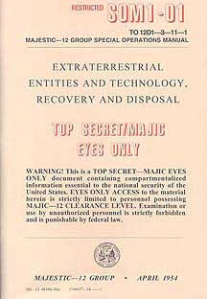
Another significant book that discusses how UFO evidence is covered up by key government and military institutions is Clifford Stone’s, UFOs are Real (1997). Stone examines key documents gained through FOIA requests that demonstrate the existence of various classified programs and incidents that deal with the UFO phenomenon, and the agencies and military departments involved. He persuasively demonstrates that government agencies will lie to investigators over UFO information.

One of the most astonishing exopolitical developments was the leaking of a number of documents known as the Majestic Documents that were initially sent to Jaime Shandera in 1984 and publicly announced in 1987 by William Moore. These documents emerged from the efforts of UFO researchers such as Shandera, Moore and Tim Cooper to liaise with ‘insiders’ in order to get information for a possible documentary. Dr Robert Wood achieved considerably success in demonstrating that these documents are authentic and/or replicas of historic documents. Another researcher, Stanton Friedman, examined the leaked “Majestic Documents” and proposed the existence of a “Cosmic Watergate” created to maintain secrecy over evidence supporting the ETH. Friedman, through detailed historical scholarship, provides compelling authentication for a number of Majestic Documents. He concludes in favor of the authenticity of documents describing the creation of the Majestic 12 Group for controlling evidence related to extraterrestrial affairs; the “Eisenhower Briefing Document” describing the history of crashed extraterrestrial vehicles (ETVs) and captured extraterrestrial biological entities (EBEs); and the “Special Operations Manual” that outlines recovery procedures for ETVs and EBEs.

Collectively, the Majestic Documents describe key actors, institutions and processes associated with an extraterrestrial presence known to exist since at least 1947. The leaked Majestic Documents offer surprising evidence of a comprehensive government cover up of UFOs and the ETH. In conclusion, research through FOIA and leaked government documents constituent an important stream of exopolitical research into the government cover up of evidence supporting the ETH.

Exopolitics: Phase 3 (1992) Political Activism and the UFO Cover Up
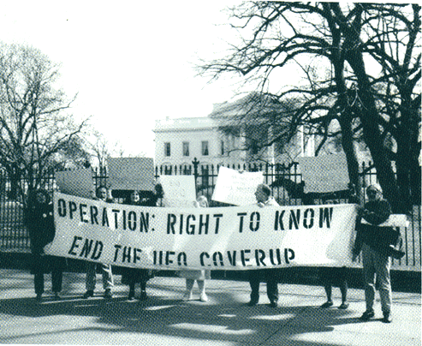
Operation Right to Know (ORTK) was active from 1992-1995 in organizing demonstrations for the right of the general public to learn the truth about UFOs and for full public disclosure to occur. Sponsored by Ed Komarek and Mike Jamieson, ORTK organized the first UFO protest in Washington D.C. in June 1992. ORTK 'shocked' the traditional UFO community by employing political activism rather than the more traditional scientific study of the UFO phenomenon. It organized 10 demonstrations in the U.S. and Britain before disbanding in 1995. ORTK was a significant expression of political activism aimed against the political cover-up the UFO phenomenon. It has laid the foundation for subsequent efforts to mobilize broad mass based action for ending the “Cosmic Watergate”.
At the same time ORTK became active, another more clandestine effort was underway to promote UFO disclosure. This was orchestrated by Laurence Rockefeller in 1993 and comprised a confidential effort to have President Clinton briefed on UFO issues so he could take the initiative for full public disclosure. Rockefeller’s initiative involved contacting Clinton’s science advisor, Dr Jack Gibbons, and sending him the most persuasive evidence for the reality of the UFO phenomenon. Rockefeller later organized an informal round table meeting of a number of prominent UFO researchers including Dr. Scott Jones, Dr. John Mack, Dr. Bruce Maccabee, Dr. Leo Sprinkle, Linda Moulton Howe, and Dr. Steven Greer who convened to share information with staffers from Dr Gibbon’s office. The clandestine initiative began to collapse after Dr Gibbon became opposed to it and warned President Clinton about cooperating with the Rockefeller initiative. After a briefing by Laurence Rockefeller, allegedly to both President Clinton and Hillary Clinton in August 1995, the initiative collapsed due to concerns that pursuing a pro-disclosure policy would present insurmountable political problems for President Clinton. The best available UFO evidence submitted to Dr Gibbons and to President Clinton in the form of case studies was eventually distributed to members of Congress and other legislative bodies, and finally published as The Best Available Evidence.

An independent and complementary initiative for political disclosure began with Dr Steven Greer. In contrast to the Rockefeller initiative and to the earlier briefing report prepared by NICAP in 1961-64 that relied on the best case sightings of UFO’s for initiating legislative investigations, Greer focused instead on whistleblower testimonies. Greer had begun systematically interviewing a number of ‘whistleblowers’ who claimed to have participated in classified projects involving extraterrestrial technologies and/or extraterrestrial biological entities (EBEs). Aside from cooperating with the Rockefeller initiative to brief Dr Gibbons and President Clinton about UFOs, Greer began a more public effort to brief senior Clinton officials such as CIA Director James Woolsey, based on Greer’s ‘deep throat’ sources. Greer built an impressive database of testimonies by whistleblowers who outlined how military authorities and national security agencies were systematically covering up evidence confirming both the reality of the UFO phenomenon and the ETH.

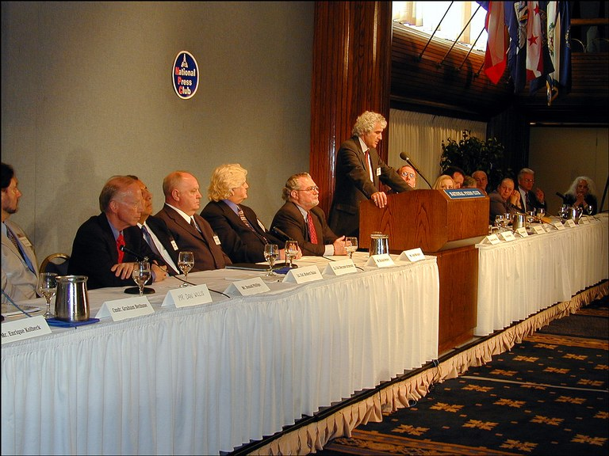
Greer’s database eventually led to the beginning of the Disclosure Project, with a Press Conference in May 2001 featuring prominent officials from a range of military, government and corporate entities who disclosing their knowledge of UFOs & the extraterrestrial presence. Greer’s Disclosure Project combined both witnesses and whistleblowers who had seen UFO’s and/or played a role in the control of this information. This replicated the work of UFO researchers such as Donald Keyhoe. Greer’s Project also featured individuals who claimed to have participated in classified projects such as UFO crash retrievals and reverse engineering ETVs.

Greer’s Disclosure Project was unique in political activism to end UFO secrecy. It highlighted the role of whistleblowers who had participated in classified projects involving reverse engineering of ETVs and EBEs. His focus on whistleblowers of highly classified projects involving EBEs or ETVs, led to him being criticized by many UFO researchers attacking the lack of documentation substantiating the extraordinary claims made by such whistleblowers. Nevertheless, the credentials, integrity and consistency of many of these controversial whistleblowers convinced many that there exists a highly classified world where projects involving EBEs and ETVs were ongoing, and hidden from the public in a Cosmic Watergate.

Another expression of political activism aimed against UFO secrecy was the candidature of Stephen Bassett in the 2002 Congressional elections. Bassett ran for a House seat in Maryland and attempted to raise the UFO secrecy issue into the political mainstream. While Bassett was not the first to run on an explicit UFO platform in Congressional elections or an electoral campaign, he was the first candidate to make it onto the November ballot in Congressional elections after openly promoting the UFO subject. Bassett ran on the slogan of shifting UFO debate “from lights in the sky” to “lies on the ground.” Bassett like many UFO researchers/activists before him, was convinced by the extensive data of a political cover up. He was destined to play an important role in the promotion of Exopolitics as a distinct approach to UFO data.

In conclusion, those engaging in various forms of political activism to end the UFO cover up were implicitly promoting an exopolitical approach to the UFO and ETH data. While the term ‘exopolitics’ had not yet come into use, the above individuals all implicitly understood the concept of exopolitics as a political process associated with a cover up evidence concerning UFOs and the ETH.

Exopolitics Phase 4: – Exopolitics Emerges as a Distinct Approach to UFO Evidence
Exopolitics as a distinct approach to UFO data grew out of all three phases described above; political analysis and activity focused on processes covering up evidence substantiating the reality of UFOs and the ETH. The term exopolitics had not yet come into general usage. It was only in the years 2003-2004 that the ‘exopolitics’ term began to enjoy widespread coverage as a result of the literary and activist projects of three individuals: Alfred Webre, Stephen Bassett and this author.

Those explicitly supporting exopolitics as a distinct disciplinary approach to the ETH, contrast it to the empirical study of UFO sightings focusing on improved investigative techniques and analysis of the best available evidence substantiating the reality of the UFO phenomenon and the ETH. While UFO studies has been dominated by physical scientists with an affinity for quantitative analysis of empirical UFO data, exopolitical researchers tend to have social science backgrounds where qualitative analysis of the UFO data and the ETH occurs more often. It is therefore no surprise that those explicitly supporting the ‘exopolitics’ term have social science backgrounds.

As mentioned earlier, there are two ways of defining exopolitics as a distinct approach to data on UFOs and the ETH. The first, more conventional approach, concentrates on the political processes from the perspective of ‘Earth based’ or ‘geo-politics’. This approach reflects what occurred in the first three phases of the historical development of exopolitics as I discussed earlier. I will refer to definitions of exopolitics in terms of geo-political processes as the “conventional exopolitics approach”. The second way of defining exopolitics involves examination of political processes among extraterrestrial civilizations themselves and how this relates to human affairs. I will henceforth refer to this non-Earth based politics as the “non-conventional exopolitics approach”.

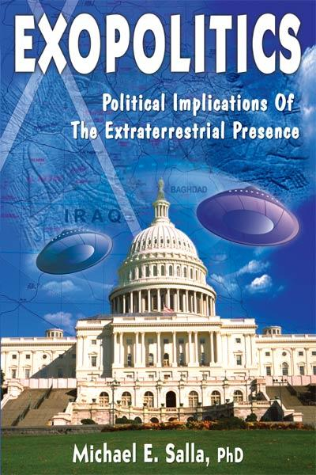
This author was the first to explicitly define exopolitics in terms of conventional political processes associated with the ETH in global politics with a set of online study papers beginning in January 2003. These culminated in the first published book on Exopolitics, Exopolitics: Political Implications of the Extraterrestrial Presence (2004). This book defines exopolitics as the “policy debate over the choices governments and populations need to make in formulating and implementing legislative and policy responses to the presence of ETs in human affairs.” In my book, I argue that extensive data concerning the ETH should be ranked in terms of degrees of persuasiveness, and the strongest data analyzed in terms of its exopolitical implications. The book further offers an exopolitical analysis based on key political actors, institutions and processes that explicitly deal with the ETH.

My book offers an overview of different sources of evidence; the political institutions and processes created to globally manage informatioon on UFOs and the ETH; and analysis of conventional international politics from the perspective of the ETH. My reliance on whistleblower and other evidentiary sources such as the Majestic Documents led to much controversy with conventional UFO researchers who widely dismiss the credibility of whistleblower testimonies concerning classified projects involving ETVs and EBEs. Furthermore, there continues to be debate over the authenticity of the Majestic Documents and their use for understanding how data on UFOs and the ETH is systematically removed or discredited. My subsequent debates with many veteran UFO researchers demonstrates that there is a clear dividing line between those, such as the author, who believe that “Cosmic Watergate” involves systematic manipulation and removal of documentation and evidence substantiating whistleblower testimonies; and those demanding documentation and hard evidence to substantiate whistleblower testimonies. This ongoing debate involves different disciplinary approaches to the extensive data on UFOs and the ETH.

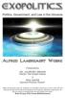
The takes me to the second or “non-conventional” way of defining exopolitics. The first person to coin and use the term ‘exopolitics’ was Alfred Webre who in 2000 wrote an e-book or ‘online treatise’ that was 22,000 words in length and could be freely downloaded from the internet. His e-book was titled “Exopolitics: Towards a Decade of Contact.”. Webre subsequently expanded his e-book and had it published in 2005 as: Exopolitics: Politics, Government, and Law in the Universe. Webre had been employed in 1977 as a futurist at the Stanford Research Institute (SRI). His project to establish communications protocols with extraterrestrials, sponsored by President Carter’s White House, was abruptly cancelled by SRI due to Pentagon pressure.

In his online e-book,
Webre defined Exopolitics as: “the study of political process and governance in interstellar society”.

His definition of exopolitics was based on his research findings on the existence of a ‘universe society’ of extraterrestrial races highly organized in a universal federation. Their adopted policy of non-interference with regard to humanity had placed Earth under a ‘quarantine’ due to humannity’s propensity for using destructive weapons in resolving geo-political problems. Webre’s approach to exopolitics mirrored the information released by early ‘contactees’ such Adamski, Menger and Van Tassel describing the politics, law and economic systems of visiting extraterrestrial races. Webre did not use these contactee reports in developing his analysis. Instead, he used a means of reasoning described in his e-book as the “intuitive method of knowledge”:

A more appropriate approach to Universe society is the intuitive method of knowledge. This intuitive approach to our Universe is not what the contemporary human scientific establishment wants you to pursue. Since time immemorial, our human culture has used intuition to survive. Our User’s Guide uses the inductive, intuitive method to build a working model of what the Universe is really like.

In his recently published book on Exopolitics (2005), Webre elaborates further on his “intuitive method” of pyschic information gained through methods such as “scientific remote viewing” and ‘channelled’ information such as the Urantia Book.

Webre has been a major source of (exo)political activism to prevent the weaponization of space. Webre’s exopolitics approach continues to remain controversial due to the lack of strong evidentiary support for his main thesis of a flourishing interstellar society with organized political processes, and for the novelty of his “intuitive method of knowledge”. Nevertheless, his thesis promises to be very significant in the future as the ETH is more widely accepted; and the political processes used by extraterrestrial civilizations receive greater scrutiny. Greater use of “intuitive methods” of information gathering and communication, the extraterrestrial approach, will also be more utilized in future.


Another pioneer explicitly supporting the exopolitics term is Stephen Bassett who organized a series of “Exopolitics Expos” in the Washington DC metropolitan area in April 2004 and 2005. Bassett’s Exopolitics Expos were the first UFO conferences that were explicitly focused on the exopolitical implications of the UFO cover-up and the ETH. Basset emphasized at the conference his earlier Congressional campaign slogan: “it is not about lights in the sky, it is about lies on the ground." Bassett assembled a line up of distinguished speakers from UFO research as well as pioneers in exopolitics research providing a unique opportunity for the general public to witness the emergence of exopolitics as a distinct approach to the UFO phenomenon and the ETH.

In addition to Webre, Bassett and the author who gave the ‘exopolitics’ term its initial impetus, there are a growing number of UFO researchers, organizers and activists supporting exopolitics research. These include veteran UFO researcher Paola Harris who investigated and supported the credibility of key whistleblowers such as Col Philip Corso, Sgt Clifford Stone and Michael Wolf. Harris has explicitly come out in support of the exopolitics term. Similarly, Ed Komarek, one of the original sponsors of Operation Right to Know, explicitly supports the exopolitics term with a series of articles on his exopolitics blogsite. There have also been more conferences explicitly promoting exopolitics. These include Dr Roberto Pinotti, a long time Italian UFO researcher, who is the organizer of the First Annual Symposium on Exobiology and Exopolitics at the University of Calabria, Italy in October, 2005. And also the Exopolitics Toronto Symposium organized by Victor Viggiani and Mike Bird on September 25, 2005, that featured a former Minister of Defense for Canada, Paul Hellyer. Hellyer confirmed the authenicity of Col Corso’s testimony on UFOs and the ETH, and referred to government management of this information as the “most successful cover up in the history of the world.” The author with the assistance of other exopolitics pioneers has launched an Exopolitics Institute for political study and activism in extraterrestrial affairs. Finally, this ariticle itself is published in the inaugural edition of the Exopolitics Journal.

Exopolitics is a term that will continue to gather support as the cover up of evidence substantiating the ETH becomes more difficult to maintain with a global population becoming ever more informed. As exopolitics evolves there will be three main challenges. First will be the debate over how to best to define exopolitics. One approach will be the author’s definition in terms of ‘conventional’ or ‘geo’-political processes concerning UFOs and the ETH. The second approach will be Webre’s definition which focuses on political processes associated with non-Earth based civilizations.

A second challenge will be to understand how the ‘conventional’ exopolitics approach has been implicit in the pioneering UFO research of seminal UFO investigators such as Donald Keyhoe. This will be important as many contemporary UFO researchers attempt to marginalize exopolitics as ‘fringe UFO research’ with no historical roots.

The third challenge will be in evaluating and ranking the diverse range of sources used in exopolitics research, often based on social science criteria, rather than more limited sources used in UFO research substantiated by physical science criteria. I sincerely hope that my effort to outline the historical roots of exopolitical thought will demonstrate the rich history of this newly identified science of exopolitics.

***
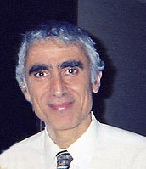
About the Author: Michael E. Salla, PhD., is the author of Exopolitics: Political Implications of the Extraterrestrial Presence (Dandelion Books, 2004) and founder of the popular website: Exopolitics.Org. He has held full time academic appointments at the Australian National University, and American University, Washington DC. He has a PhD in Government from the University of Queensland and an MA in Philosophy from the University of Melbourne, Australia. During his professional academic career, he was best known for organizing a series of citizen diplomacy initiatives for the East Timor conflict that received large financial grants from the United States Institute of Peace and the Ford Foundation. He is currently a resident of Hawaii. He is the Founder of the Exopolitics Institute (www.exopoliticsinstitute.org ) and Founding Editor of the Exopolitics Journal.

Endnotes ? Stephen Basset organized the 2004 and 2005 Exopolitics Annual Expos in the Washington DC area; and an Exopolitics Symposium was organized at the University of Toronto on Sept 25, 2005. The two books are Michael Salla, Exopolitics: Political Implications of the Extraterrestrial Presence (2004); and Alfred Webre, Exopolitics: Government, Politics and Law in the Universe (2005). The “Exopolitics Institute” was launched on July 4, 2005 (www.exopoliticsinstitute.org ).
Allen Hynek, The UFO Experience (1972), p. 10.
See Michael Swords, “Project Sign & Estimate of the Situation,” http://www.ufoscience.org/history/swords.pdf
Donald Keyhoe, Aliens from Space (1973) 14.
Cited from online version of Robertson Panel at: http://www.cufon.org/cufon/robertdod.htm
See: http://www.cufon.org/cufon/janp146c.htm
For an overview of the Brookings Report, go to: http://www.enterprisemission.com/brooking.html .
See the Flying Saucer Conspiracy (1953).
See Keyhoe, Aliens from Space, 76-86.
NICAP, The UFO Evidence (1964), ed. Richard Hall.
See “The Condon Report: A Whitewash,” http://mimufon.org/1960%20articles/CondonRptWhitewash.htm
William Hamilton, “California Contactees”, http://www.geocities.com/Area51/Shadowlands/6583/et031.html
See for example, Gary Kinder: Light Years: An Investigation into the Extraterrestrial Experiences of Eduard Meier (1987)
For Congressional Guide to FOIA, go to: http://www.fas.org/sgp/foia/citizen.html
See website for more details: http://www.caus.org/
Website with documents is: www.majesticdocuments.com
See Robert Collins and Richard Doty, Exempt from Disclosure (Peregrine Publications, 2005).
Top Secret/Majic (1996).
See online report at: http://www.presidentialufo.com/washington_demonstration.htm
For more info go to: http://www.destinationspace.net/ufo/editorial/ORTK.asp
For discussion of the Rockefeller initiative, see: http://www.presidentialufo.com/part1.htm
Don Berliner, UFO Briefing Document: The Best Available Evidence (2000).
For more information, go to: www.disclosureproject.com
Exopolitics (2004) p. 2. Also available online at: http://www.exopolitics.org/Study-Paper1.htm
Go to: http://www.exopolitics.org/Exo-Comment-32.htm
Archived copy available at: http://web.archive.org/web/20010129030900/www.universebooks.com/exoone.html
See Institute for Cooperation in Space, http://www.peaceinspace.com/home.shtml
Visit: http://www.paolaharris.it/final_exopolitics.htm
Visit: http://exopolitics.blogspot.com
Visit: http://www.exopoliticstoronto.com
Cited in Michael Salla, http://www.exopolitics.org/Exo-Comment-38.htm
Visit: www.exopoliticsinstitute.org

