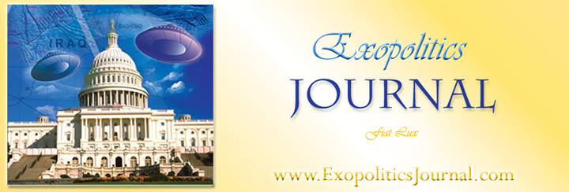

Book Review of Top Secret/Majic: Operation Majestic-12 and the United States Government’s UFO Cover-up (Marlowe and Co. 2005 [1997]) ISBN: 1-56924-741-2

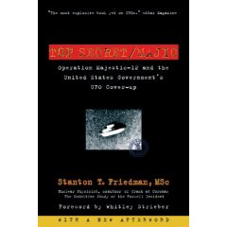
In his new edition of Top Secret/Majic, Stanton Friedman offers a spirited defense of his theses that a number of the Majestic Documents leaked into the public arena since 1984 are authentic; that an extraterrestrial vehicle crashed near Roswell, New Mexico, in July 1947; and that a government cover up of UFOs and the extraterrestrial hypothesis (ETH). He provides a detailed analysis of the logic for choosing the twelve/thirteen members of the first ‘Majestic-12 Group’ created to oversee the UFO phenomenon. He responds to criticisms such as that of Dr Kevin Randle as to why the twelve were not the best choices (41-51); and why Dr Donald Menzel was very possibly part of this elite control group (26-40). Using detailed archival research and documentary analysis, Friedman is able to determine the career movements and activities of key personnel mentioned in the Majestic documents. For example, he determined that on September 24, 1947, Dr Vannevar Bush and James Forrestal did meet with President Truman and that the famous Truman Memo establishing the creation of the Majestic 12 Group phenomenon was likely the result of this meeting (68).

Furthermore, Friedman determines that President-Elect Eisenhower did attend a briefing at the Pentagon on November 18, 1952, and that Admiral Roscoe Hillenkoetter was in New York at the time and therefore easily able to travel to Washington to brief Eisenhower as mentioned in the Eisenhower Briefing Document (EBD) (67,77). Friedman is also able to persuasively argue that the Cutler Twining Memo referring to the MJ-12 Special Studies Project helps prove the existence of the MJ-12 Group and is genuine (102). He argues that the Special Operations Manual detailing recovery procedures for crashed extraterrestrial vehicles passes a prima facie analysis for authenticity; he is prepared to do a more rigorous analysis to conclusively demonstrate its authenticity (166). He proposes that the leaked documents are strong evidence of a government ‘cover up’ or ‘Cosmic Watergate’ where an officially sanctioned campaign of deception is used to hide the truth about the UFO phenomenon (23, 209). In his concluding chapter, Friedman offers some speculations concerning motivation for Cosmic Watergate, as well as possible motivations of the visiting extraterrestrials.

In this new edition of the book, Friedman includes an afterword wherein he replies to criticisms of those questioning the authenticity of the Majestic Documents. He displays an impressive talent for extensive archival research for support of his arguments and refutation of criticism. It is easy to be impressed with the detailed analysis Friedman provides concerning his thesis that some of the Majestic Documents are genuine, and that this is documentary evidence of a Cosmic Watergate. Nevertheless, Friedman does point out that not all the Majestic Documents pass the standards he establishes for authentication. As a scholarly analysis of key Majestic Documents, Friedman’s work is exemplary. His detailed archival research and knowledge of numerous standards used in documentation of classified information, sets an impressive standard that critics will continue to find difficult to refute.

Rather than continue to extol Friedman’s detailed scholarship and investigative abilities, I wish to make one recommendation for a future edition of the book; and I will discuss three questions left unanswered by Friedman. I recommend the addition of a table summarizing Friedman’s research on the Majestic Documents. It would help the reader quickly determine which Majestic Documents he accepts as authentic, which he judges as frauds, and which require further authentication. A brief explanation for each categorization could be also included.

I now discuss three questions that Friedman leaves unanswered in his analysis of the Majestic documents: “how extensive is the network of covert projects created to deal with crashed ETVs and recovered EBEs?”; “how is this network of projects or ‘Cosmic Watergate’ funded?”, and “what security procedures are in place for Cosmic Watergate?” ‘Cosmic Watergate’ is a term he mentions on several occasions in the book. The Majestic Documents are cited as documentary evidence that such a systematic cover up does exist, and is covertly supported at the highest level of government and the national security system. Having provided impressive evidence of a Cosmic Watergate, Friedman fails to describe how Cosmic Watergate is funded and what security procedures are in place. In this regard, Friedman fails to fully exploit the fruit of his scholarship concerning the Majestic Documents.

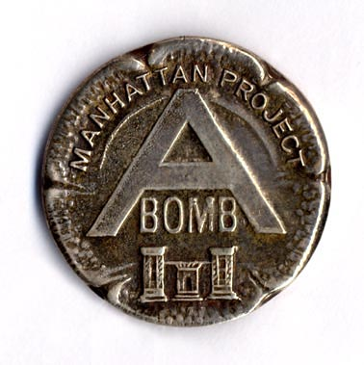
The Eisenhowr Briefing Document, for example, succinctly describes the history of crashed flying saucers and capture of EBEs up to 1952, efforts to understand the propulsion and navigation systems of these craft, and communications systems used by the EBEs. Friedman does not, however, discuss the logical corollary of a ‘second Manhattan Project’ based on an extensive network of classified programs, dealing specifically with replicating the ETV/EBE technologies and communications systems. Friedman doesn’t suggest how these projects might proceed without Congressional oversight.

More significantly, Friedman does not explore the funding aspect of this second Manhattan Project for exploiting extraterrestrial technologies and communication systems. Funding such projects without Congressional oversight would be critical for the security of such projects, ensuring sufficient funds for tasks at the apex of national security priorities. Friedman needed to identify, for example, the 1949 CIA Act, and how this permits the CIA to appropriate funds “without regard to the provisions of law and regulations relating to the expenditure of Government funds” [50 USC 403j (b)]; and how this is the most logical official means for legally funding a second Manhattan Project. Clearly, this ‘unique’ funding feature granted the CIA in comparison to other government agencies and military departments, makes it the logical choice for funding an extensive network of projects without Congressional oversight. Friedman chose to ignore the Cosmic Watergate funding mechanism.

Another aspect of Cosmic Watergate maintainence is operational security. For a network of classified projects created without Congressional Oversight, what security provisions would be in place for employees? The Eisenhower Briefing Document explains that the “Majestic-12 Group remains of the unanimous opinion that imposition of the strictest security precautions should continue.” This suggests extensive use of security procedures such as compartmentalization backed by the severest penalties for unauthorized disclosures, to maintain Cosmic Watergate.

More significantly, the Special Operations Manual details how witnesses of recovered crafts will be dealt with. It describes official denial, deceptive statements, and discrediting and intimidation of witnesses. If this is the standard used for witnesses of crashed UFO’s, it can be safely inferred that similar security procedures exist for employees in the network of projects involved in Manhattan Two. Basically, Cosmic Watergate is maintained by ensuring the “strictest security precautions” by official denial, deception, intimidation and discrediting of witnesses/employees. The discrediting process would undoubtedly involve tampering with available documentation substantiating testimonies of those making “unauthorized disclosures”. This helps explain why the ever growing number of whistleblowers willing to describe their roles in classified projects involving EBEs/ETVs, often have great difficultly substantiating their claims through documentation. Despite the transparent integrity, consistency and credentials of such witnesses, they are often discredited through absence, alteration or destruction of supporting documentation.
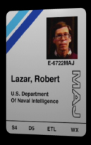
The above situation applies in the case of Bob Lazar who had great difficulty in documenting his claims of having worked on recovered ETVs at the secure facility S-4, and handled quantities of the rare element 115. Friedman dismisses Lazar’s testimony based on the lack of supporting documentation. Yet he overlooks the corroborating testimony of those proving that Lazar did in fact work previously at a prestigious nuclear facility at Los Alamos and had the kind of engineering background that would make it feasible for him to be recruited for such a covert project.

Discrediting former/current employees in classified ETV/EBE related projects is undoubtedly a key feature of Cosmic Watergate, yet Friedman ignores discussing the logical implications of a witness discreditation process described in the SOM-01 Majestic Document, and how it would be used against whistleblowers. It is through an appropriate examination of whistleblower testimonies revealing their participation in classified projects that Cosmic Watergate is most likely to be fully understood in depth and scope.

Stan Friedman’s book provides impressive substantiation for a number of Majestic Documents and the existence of a Cosmic Watergate. It is a must read for anyone wanting to understand the significance of these leaked documents. Responding to critics seeking to cast doubt on the authenticity of the Majestic documents has understandably been a major concern for Friedman. He has spent much time answering critics such as Dr Randle and Philip Klass. Despite the continued need to respond to such critics, I recommend that in future editions Friedman discuss the implications of the Majestic Documents in terms of the scope of the network of covert ETV/EBE related projects that make up the Cosmic Watergate. He should also discuss how Cosmic Watergate is funded. Finally, he must examine how government security procedures might impact upon supporting documentation for the claims of whistleblowers coming forward to disclose what is occurring in Cosmic Watergate.

Michael E. Salla, PhD
Chief Editor, Exopolitics Journal

