

The Science of the Extraterrestrials: 2005, the Year of Explanations*

By Eric Julien**

The conjunction of the release of "War of the Worlds" and of the centenary of Einstein's special relativity theory gives us the opportunity to wonder about beliefs in the matter of UFOs. This is also the opportunity to present The Science of the Extraterrestrials. Well more than a book, it proposes a new paradigm: Absolute Relativity!

Envisaging the existence of extraterrestrials in our environment is described as imaginary and impracticable. Two limits have been maintained to convince us of it. The first is that of the dream whose portrayal the film industry has as a goal. Thus, we unconsciously associate a fiction with the total absence of reality. If it is part of cinema, it does not exist. Thus the screen indeed acts as a screen. The second is that of the speed of the light. Nothing can go faster than light. Thus it would be impossible to come from a star to visit Earth. End of demonstration. It is time to move on.

Yet, admitting to the existence of extraterrestrial intelligences would not pose problems for the scientific community! In fact, every astronomer knows perfectly well that interstellar gases harbor molecules forming the materials of life. In the abundance of galaxies, among the myriad stars, life itself thus is inevitably developed. Closer to us, Mars was an immense reservoir of water, seat of probable life. The holders of the Darwinian thesis of evolution, a conservative theory as controversial to say the least for its missing links as, conversely, for its total absence of mutations, even are the first to admit that evolution leads sooner or later to intelligence by adaptation to the environment. This does not fail to make Ufologists smile. In fact, what comes after the stage of human intelligence? How will humanity need to adapt in the centuries ahead? Are ETs, like us, limited by the speed of light?

The Science of the Extraterrestrials, now available (as of July 2005) in French bookstores, confirms this limit. But then what are UFOs? Illusions? A myth? Hoaxes? Misunderstandings? Human technologies? True UFOs are extraterrestrial ships. But they are not spatial! First because the universe itself is extraterrestrial! But also because it is extratemporal! The hourglass image explains what the density of time means; it is the foundation of the extratemporality of the extraterrestrials.


The second is an arbitrary convention on which the equations are supported.

True UFOs are extraterrestrial ships. But they are not spatial!



In reality, the sand flows at different speeds. The density of time is increased when space diminishes.

The density of time is a major concept: to any given density of time there corresponds a given quantity of simultaneous physical information. In a higher density the amount of simultaneous information is greater. The greater the increase, the less "solid" the matter is, as the changes in the state considered keep growing ... until it becomes physically invisible to us, apparently being too rapid from our point of view as observers.

The work, greatly lightened by numerous illustrations, demonstrates this thesis and explains point by point the extensive spectrum of the oddities reported by hundreds of thousands of witnesses, by those who have dared to speak. Not one of these mysteries will fail to find a solution in Absolute Relativity. We are alone and lost in space, as it is not in space that it is necessary to seek the ET pilots of UFOs!

The speed of light thus remains a limit. But of what? Let us return to the year 1905. Einstein used the work of numerous scientists, among them Lorentz and Poincaré, to describe and compare the behavior of what are customarily called Galilean referentials, that is to say, reference points of space and time. Notably, he reached the conclusion that space and time are indissociable, that the speed of light c is unsurpassable and constant in the void. Time amounts then to a flow of instants going from the past toward the future. In this view, an effect can not precede a cause. The limit of the speed of light thus becomes that of the causality that can not be inverted.

The Science of the Extraterrestrials is founded on an intimate knowledge of the nature of time. This last is fundamentally cyclical and fractal (identically reproducing an object to a different scale). Now, a cycle is a process by which a point of origin is also the point of arrival. Causality is lacking there. All of human science, all our equations need causality to explain the world. Explaining comes back to describing a relationship between two situations. But can it be that a relationship may structurally escape us? Take the Big Bang. The universe is in accelerated expansion, we are told. So be it. But if it really is expanding, why do we study the microscopic universe? A painful question, in truth ...

In this universe, quantum mechanics does not apply the concept of causality in a strict fashion! It uses probabilities. Not only is the structure of matter immaterial because undulatory (one observes the materiality only on our spatial scale); in addition, the scientists "explain" the universe with an absence of law: that is, chance! How is chance causal? It is veritable nonsense. A mundane heresy. It is remarkable to note that the same probabilities serve, on the one hand, the cause of the determinism of equations (solid proofs) stemming from the statistical mechanics of the infinitely small, and conversely the cause of chance (absence of proof), for example refuting the results of parapsychological tests (telepathy, precognition, and so on). The same conceptual instrument for two opposing logics? The scientific opportunism of the "rationalists" often borders on intellectual dishonesty.

In the end, is "rationality" anything but persistent belief? Just a sectarian and irrational prejudice? Just the opinion, the point of view of an observer? Before one speaks of proof, it is important to evoke its definition. Now, the history of the sciences proves that it evolves with time! Then, proof of chance or chance of proof? Is it not our point of view as observer that needs to change, as it is on this last that the proof depends? Before judging, one still has to be capable of it! Naturally many are persuaded of it ... as they judge! But the clear-headed know that an opinion is but an opinion, though it may be rendered by one of the "notables." This is why NOTHING can replace personal experience. As NOTHING renders it absolute. The only universal way thus is the sharing of experience. This is what renders the interaction of ETs with humans inevitable. The question of why being resolved, it remains to know how.

The general principle of quantum mechanics is to vary physical sizes by small packets, as though counting the grains of sand on the beach. A wave is first of all a deformation traversing a medium, that is to say space flowing in time. Absolute Relativity suggests that time is transported by the waves, and not that the waves, universal phenomenon if it is one, propagate themselves "with" time. Hang on: though admitted by common sense, today nothing explains the propagation of the waves! Now, Absolute Relativity describes why and how phenomena exist only according to the space-time fractal to which they belong or that they traverse.

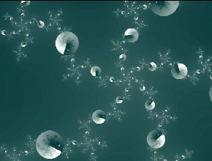

Fractals are natural or mathematical objects that reproduce themselves to different scales. (image of Philippe of Courcy)

What is a fractal? Imagine a rocky coast like that of Bretagne. The general form reproduces itself but to ever smaller scales. For us human beings, the coastline will represent a certain distance. For the ant that will need to follow the meanders of the merest pebble, the distance to travel will be much longer, an intangible length for us.

Like space, time reproduces itself, but the cycles are ever shorter down to an imperceptible limit. Time will become stroboscopic (alternations of perceived time). Thus there will exist phenomena that will be impossible for us to perceive. Now, reality seems just the character of what appears to us to have a certain duration. This reality thus is quite relative! Extraterrestrials seek not to reach the speed of light but to reduce it to the maximum. This would have the relative effect of showing us lightning-fast accelerations. Paradoxical, is it not?

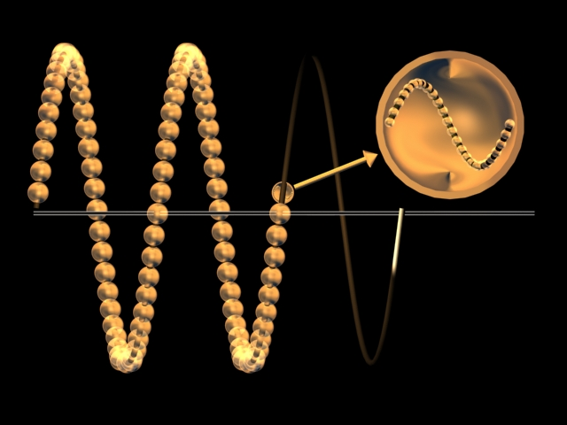

Waves are spires of time. In zooming on a quantum of time one notices another series of chronons, and so it goes.

Nothing explains the quantum character of matter ... apart from cyclical time!

The work overcomes some of this gratuitous evidence. You will certainly regain more of these charming contradictions. Here you are, help yourself: nothing explains the quantum character of matter ... apart from cyclical time! You know, this time that defies causality. In fact, this is the only variable that can be logically finite, thus quantified. Besides, ask a scientist what is between two quantum states. Most often, the response will be a big silence. This silence is all the more surprising as cyclical time (spin) is just what characterizes electrons and protons, principal constituents of matter! But what is the relationship between travel by extraterrestrials in "space" and the infinitely small?

Extraterrestrial ships have the ability to pass from macroscopic laws to microscopic laws by causing variation in the flow of time, that is to say, the number of grains of cyclical time. With every scale of space is literally associated a quantity of cyclical time. Ships, blindly called spaceships, travel not in space but between superimposed space-time entities of different scales. The universe is a layered cake of which global comprehension would be impossible: each layer has its own sense of perception! The physical world has its five senses. The psychological world has its own. And thus the spiritual world has ... its blindnesses!

The fundamental law of Absolute Relativity replaces the secular special relativity. It can be summarized in a sentence that any five-year-old child can remember: "The more time there is, the less space there is, and conversely." Thus, the speed of light is the limit between two space-time entities separated by their scale according to a specific number of magnifications, as it happens seven according to J.P. Garnier-Malet, Doctor in Physics (http://www.garnier-malet.com). For his part, Laurent Nottale (http://wwwusr.obspm.fr/~nottale/), another Doctor in Physics, has studied the relativity of scale for twenty years. There are numerous scholars of time, such as Tifft, Letho, Shikhobalov, and Venik. Does one need to insist on the experimental demonstration of temporal density in a rotating mechanism carried out by Kozyrev in the 1950s? Does one need to remind the neuropsychiatrists, enthusiasts of materialistic explanations, that our physical body does not evolve at the same speed as that which ... constitutes it? Read this question again, nice and calmly. If it is not enough, repeat the operation. Above all, do not hesitate. Your life risks being profoundly changed by it, as ...

Can anyone say where and when consciousness is located? Does one need to repeat that special relativity itself affirms these discrepancies of perception of space and time, depending on speed? Then what is "the imagination," if it is not a particular state of our consciousness to emit and receive information at a relativist speed? Can there be reception, though it be described as imaginative through ignorance, elsewhere than in space and time, supports of every perception? We are but at the beginnings, as the power of necessary abstraction is so great that even the most experienced physicists could lose their Latin in it. Yet a simple diagram permits representation of intervals of time of Absolute Relativity, intervals at the heart of which smaller chronons (quanta of time) multiply.

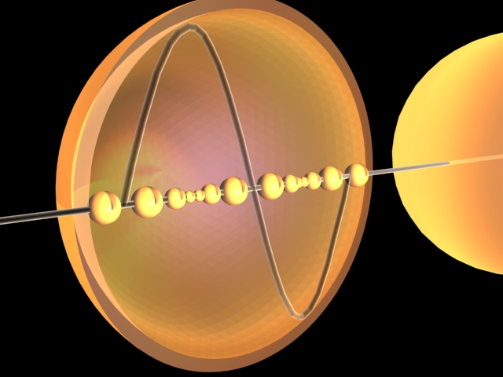

Linear time is a series of chronons of variable size. The larger ones conceal the smaller ones. This is why linear time, which flows, comes from the absence of perceived cyclical time.

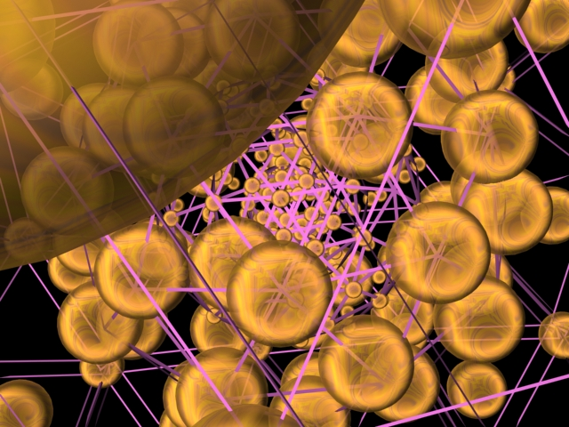
Imagine beings, ET or not, that live in intervals of temporal non-existence from our point of view. Naturally they will be dematerialized as waves are! But then the universe will hold them in a handkerchief.

A particular viewpoint permits a better visualization of the superimposition of quantum time. The flow of time comes from the intervals of temporal non-existence (mauve lines) in the concentric spheres of the universe.
It is enough for the extraterrestrials to diminish the flow of time in order to appear perfectly material to us in our expanded world. They succeed in this thanks to the conjugation of two forms of temporal pumping amply explained in the work, notably by using rotors and turning electromagnetic fields. The great difficulty consists of grasping what is produced at the interior of a system making the temporal flow vary. In fact, the state of matter depends directly on it! We perceive only the differences of density of time in the manifestations of nature, as we "see" it from the exterior, from a specific spatio-temporal scale.

The "space" agencies, unless they are unbaptized, are the least well placed to address extratemporal phenomena. In fact, these Ufological "anomalies" are not aerospatial but transmaterial. The state known as "matter" is a particular case of a vast whole. There is no "rigid substance" outside our spatial--and temporal--scale. How can one claim to study UAP (Unidentified Aerospatial Phenomena) while overlooking the essential, namely, this psychological part of the manifestations of which the casuistic is extraordinarily richer and yet neglected?

Every grain of time constitutes a data point, a state. Thus, time has a density. The more important it is, the more information there is and the more troubling the intensity of the phenomena will be.

The more time there is, the less space there is, and conversely.

High temporal densities are the seat of the psyche, of which the ETs have made themselves masters. They incarnate themselves at will following a genetic mutation synonymous with mastery of the information packets in the sense of universal entropy, which then becomes neguentropic (information structured in the image of the structure of the DNA molecule). Besides, this is what distinguishes us from the animals. This is also what differentiates, generally speaking, the living from the inert. The same qualitative discrepancy exists between the immaterial living and the material living. Extrasensory perceptions, emotions or thoughts are issues of the highest densities of time, access to which depends on the very complex structure of the neuronal network, a veritable spatio-temporal elevator. This is also the case with dreams, apparently brief, in which are produced quantities of events that our memory can not retrieve in physical time, hence their fleeting and incoherent character from our point of view on waking (weaker temporal density). Thus, the discrepancy between material and spiritual is but the result of a difference of flow of time. The question thus is not whether to believe it, or even to understand it, but to be capable of "rising" or not! In the past, humanity was stricken by geocentrism, believing itself the center of the world. Could it be that at this start of a millennium humanity remains fixed in chronocentrism, asserting an arbitrary unit of time in the equations?

Diversity and strangeness characterize UFO and paranormal phenomena. It renders them apparently insoluble. But on the basis of a unique concept transmitted by ETs to the author, which constitutes a decisive step in the matter of exopolitics (ET/human diplomatic relations), The Science of the Extraterrestrials presents numerous clear explanations such as those which follow, abstracted from the work.

Besides, this new paradigm does not content itself with providing a solution to the paranormal. It also explains the missing mass of the universe, the cosmological anomalies, the structure of the atom, and other quantum paradoxes, backed up by equations. Once the nature of time is assimilated, it is easy to understand the effects of one of its three dimensions, density.

An ET nave is surrounded by concentric strata of flattened temporal bubbles. These bubbles are, of course, invisible in reality. They are comparable to waves of which we perceive only the effects.

The discrepancy between material and spiritual is but the result of a difference of flow of time.
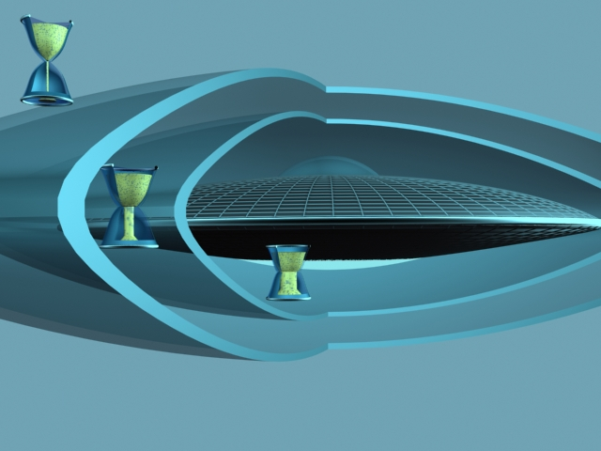
The figure below displays different hourglasses that, for simplicity, we will not retain in most of the illustrations. Many of them show cross sections that are intentionally simplistic in order to capture the general principle.

A ship is surrounded by different layers of temporal flows.

Let us linger over the means of observation and perception, whether they are natural or technical. UFOs are silent as the sound wave emitted by the craft, bathed in conditions of high density of time, is progressively slowed, thus expanded in moving away from the emitter.

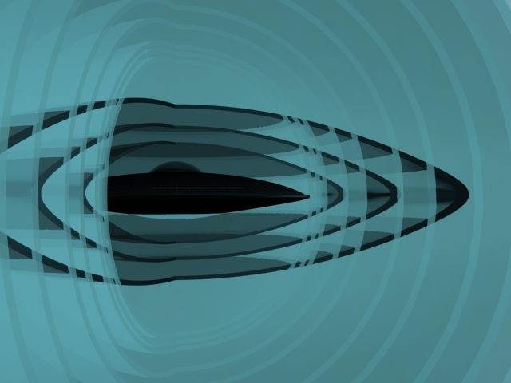

The frequency of the sound waves diminishes as they move away from the UFO, as a consequence of temporal variation. Generally speaking, the possible sound from an UFO is always at the limits of the audible: low or high frequencies.

It becomes an infrasound once it has left the temporal bubbles. This explains their "auditory" perception by the only animals endowed with specific organs. Then they manifest nervousness or fear, not understanding where this "noise" comes from.

The supersonic bang is absent for ETs as the air is progressively slowed as far as the fuselage. Time passes more slowly in successive temporal bubbles. The sound barrier simply does not exist. Besides, an ET ship is not "flying" properly speaking. It does not enter the frame of the aerodynamic laws of flight (force of sustenance). This is why an UFO is an unidentified object ...

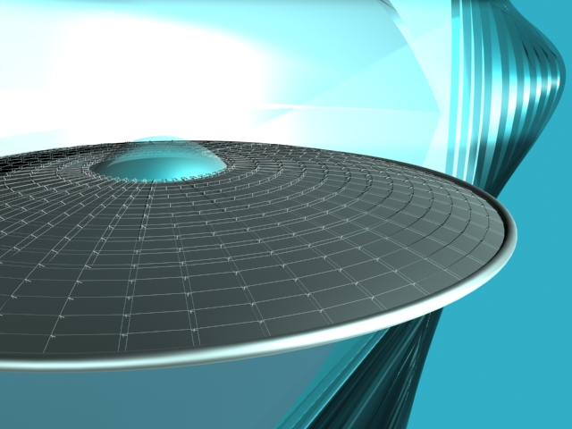

There is no boundary layer on which the shock wave could be born.

In "visual" perception, the discrepancies are understandable as well. The temporal fields around the UFO respect Absolute Relativity: "the more time there is, the less space there is, and conversely." Thus, depending on the intensity and influence of these fields, the perception of a single object will vary between witnesses. A ship will be more or less luminous, more or less large, more or less material. Hence the divergent reports of witnesses. If the abductees (the "taken") are surprised at the enormous interior dimensions, it is no less readily explained: the size of UFOs is relative to the temporal referential. They are small outside the field, large within.

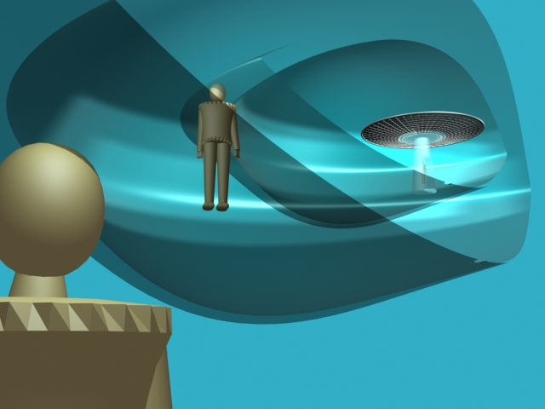

The perception of distances, sizes, and shapes depends on the situation of every one of the witnesses and on the instantaneous temporal density of the UFO.

The technical means of observation are of the same stripe. Photographs of UFOs are more or less blurred. The temporal bubbles are equivalent to the capture of an object in rapid motion even if the UFO is stationary.

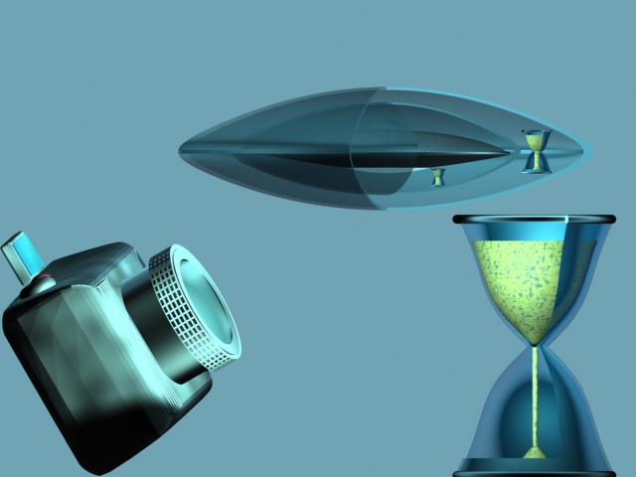

As for speed, a space-time entity is a connection between space and time. Thus a photograph captures the immediate vibratory state of the foreground.

High density of time is in tune with the psychological view of the witness, a view that an ET can influence. Many past appearances corresponded to the technical level of the epoch: chariots, airships, etc. These visions were produced by ETs with the consent of our subconscious, seat of the form-thoughts long emitted, multiplied, and consolidated by our beliefs, that is to say our "imagination" of the moment. In fact, imagination = creation of information = reality. Let us note in fact that there is nothing but creation in the universe. There is no reality without creation, as reality IS creation, whatever the origin may be. Try to demonstrate the converse! I wish you luck. This is precisely the whole problem of the perception that superimposes itself on our own psychological creativity, which is at the same time legitimate, natural, and universal, thus logical. Thus every perception is REAL but more or less shared! This is why Reality is Illusion and conversely. Again, slowly read the preceding once more, as a lot of debates could thus be calmed. The "real" forms of ET ships, in contemporary witnessings, coincide with the massive diffusion of photographic devices, which can not be influenced by a psychological signal, lacking access to the higher densities of time. ETs a priori no longer need adapt our perception, and more and more they present themselves as they are from their own point of view. Liberated from creative beliefs (a deformed description of the witnesses to the course of history), all thus is, for humanity, nothing but a problem of perceptual maturity, including the psychological and spiritual!

Extraterrestrials do nothing but respect the laws of nature.

Radar emits waves that material bodies reflect. A detection module receives in return a weak portion of these waves, which it amplifies and translates in the form of a luminous plot. But then the train of emitted waves encounters a temporal field that causes variation in the frequency itself, and not the direction of the waves (the case of the stealth technology of our airplanes). If this modification is too great, the new frequency will be outside the radar spectrum. Material ships, although confirmed to be present by visual witnesses, are not always detected by a station: the radar frequencies are lower than the luminous frequencies.

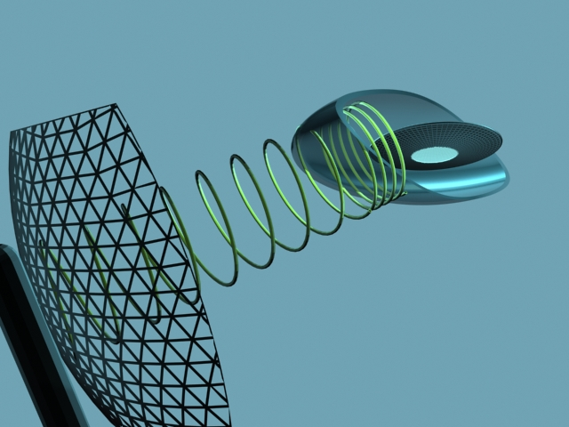

The waves (spires of time) of a radar are changed as they enter the temporal field of a ship. Their detection is erratic.

Several secondary effects follow from the laws mastered by the ETs. Truncated beams of light are among them. Their length is included in the temporal field of the ship. Beyond the bubble, as with sound waves, the light disappears, descending into the infrared.

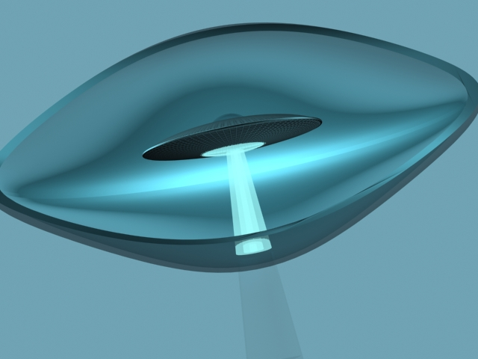

The bubble around a ship is the natural limit of a luminous beam emitted in a specific density of time. Beyond, the frequency "reddens."

UFOs can conceal themselves in the clouds that they themselves form. The temporal field creates a zone of cold by application of a Bose-Einstein condensate. Then condensation of the water vapor (a very different principle) is produced around the nave, as when you remove a bottle of fresh water from a refrigerator. Mist, fog, or even a dense cloud may appear, depending on the external conditions.



The cold reigning around a ship engenders a condensation of the water vapor invisible until then and conceals it in an cloud depending on the atmospheric conditions.

After the phenomena of perception, let us address the technology properly speaking. The sustenance of the naves seems prodigious. But ETs do nothing but respect the laws of nature. The force of gravitation, like every force needing a point of application (contrary to those of quantum mechanics), is expressed as F = ma: mass times acceleration. The latter is distance per unit of time squared. Thus the more time increases, the more force diminishes! The antigravity of the ETs is degravitation in reality. The entire difficulty is in knowing how to produce more time locally. The solution is found in technology.

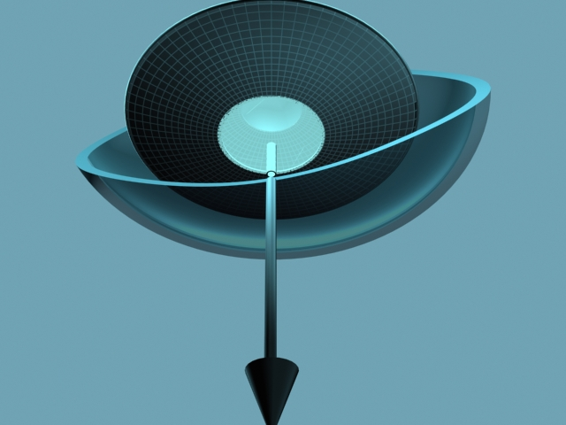

The potential gravitation (arrow) is annulled (directionless tube above). The degravitation grows with time squared.

An ET nave consists of a double rotor with inverted rotation, a superconductor network, a central oscillator, and a peripheral torus. There is not room here to record the detailed description of these that the work provides.

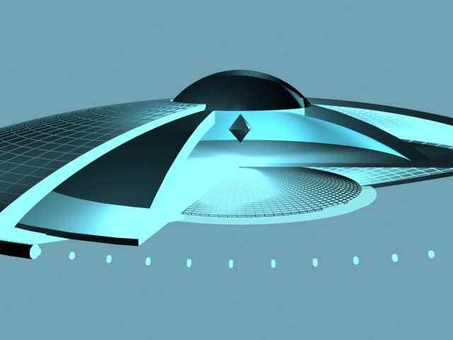

Four technologies: double rotor, superconductors, oscillator, and torus.

ET ships are capable of materialization and dematerialization, in motion or in place. Their behavior is due to variations in the intensity of the temporal field. It is crucial to understand that such a nave does not have ANY PROPULSION in the classic sense of the term. The conjugate operation of the direction adopted and of this variation is what provokes and permits motion and navigation. Once the orientation is stabilized and the initial impulsion of motion is made, the increase in the intensity of the temporal field reduces the size of the universe in which an ET travels. It is in fact the destination that approaches the ship!

Space is, then, neither isotropic nor homogeneous. It is a matter of pure and simple mastery of space and time. What is important is to grasp the mechanism of change in direction. It is assured by the two rotors with inverted rotation. The plane of an UFO is dictated by a temporary differential of speed of rotation of the rotors taken separately. This being out of phase explains the dead-leaf behavior described by witnesses. Well-known gyroscopic effects then produce changes in course in the three dimensions of space. No aerodynamic consideration is useful for piloting an ET ship, not even MHD (MagnetoHydroDynamics). Let us simply recall that lightning-fast accelerations are illusions due to the change in density of time of the ship.
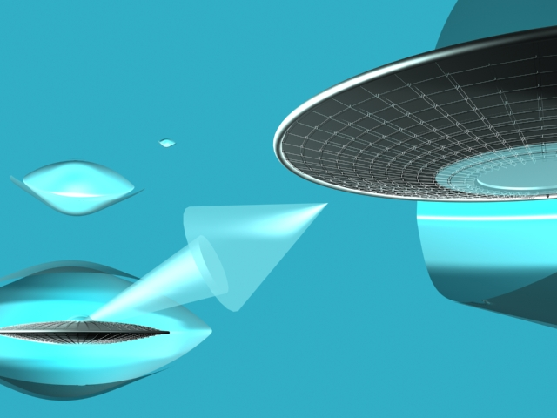

The materialization and acceleration of UFOs are nothing but a simple problem of variation in the intensity of temporal density. The acceleration seems all the greater as the nave shrinks.
No aerodynamic consideration is useful for piloting an ET ship, not even MHD.

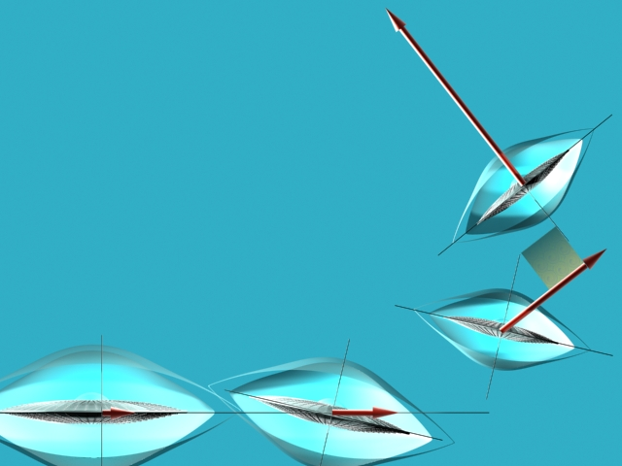

The variation in the plane of an UFO is due to a rotating differential between the two rotors with inverted rotation.

Let us speak of the real crop circles, those circles in wheat that appear before the harvest. They are well and truly a product of the creativity of ETs.

These agroglyphs are generated in conditions that are perfectly identifiable with a single unique principle. A ship of the size of a fat firefly (sometimes invisible), its size adapted to rapid execution of the work, creates a zone of cold above the field of wheat. This done, a light condensation appears permitting the cereals to absorb this humidity in conjunction with a "natural" emission of microwaves (the universal electromagnetic spectrum being the domain of flight of ETs). This situation softens and ionizes the wheat, which is contracted in the temporal field of the ship as the latter passes above ("the more time there is, the less space there is"). The first knot is then mechanically stretched and cooked.

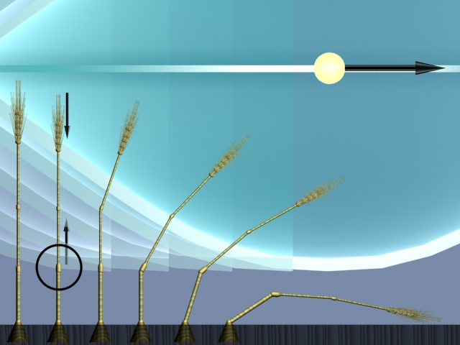
Here, the different phases of a stalk. The representative witness (to the left) sees its size reduced by the temporal field (the second and following stalks toward the left--it is a matter of the same stalk seen in stages).

The UFO describes a trajectory conforming to the shape to be produced. It sucks the soft, ionized stalks into its magnetic field. Once the degravitational influence has passed, they need do nothing but lie down. Certain stalks will become entangled in the zones of intersection of the influence of the ship. In fact, the stalks already on the ground will rise again, orienting themselves sideways at the time of the next passage of the ship-firefly and mixing with the neighboring stalks.

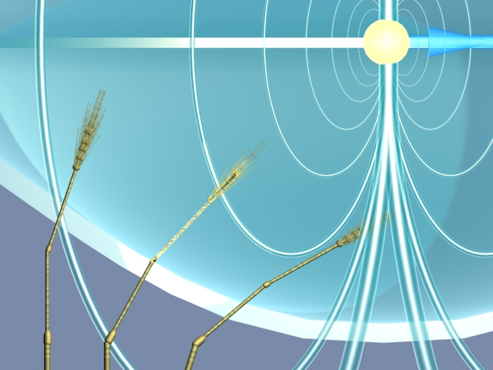

The ions (central stalk in the cut) rise again toward the top, inducing a mechanical falling effect. The ionization of the wheat is weak, but the magnetic field of the artist is considerable.

These explanations, very fragmentary here in relation to the work, in the eyes of many constitute a spectacular advance in the understanding of the UFO phenomenon, and even beyond.

Will the war of the worlds happen? Might this be simply the expression of our fear of the unknown, of our incomprehension of the innermost laws of the universe? In times past, lightning in a thunderstorm represented the anger of the gods. Today, Ufological manifestations produce in us reactions of survival and, beyond that, aggressiveness. Hence our immunological rejection, and hence this mass exorcism in darkened rooms.

Who are the real invaders ? The Science of the Extraterrestrials proves how and why humans are the space (time) invaders through the use of nuclear weapons ! When the core of an atom is broken, it expands time quanta which normally remain below the scale of the quarks. At this scale, which is the one of the quantum vacuum, live many ETs, especially when they use their ships.
But the collapse of billions of billions of atoms is like an Earthquake in their time density. It means that we represent a real threat for ETs. This is why UFOs sightings have been multiplied since the end of the World War II. Many ET races were therefore warned, even if they came from deep space. All our nuclear weapon tests, all our quantum physics experiments could be interpreted as being aggressive, or at least unconscious from the ET point of view. Many nuclear facilities have been visited and even neutralized by ETs. This is a clear sign of their fear.
An important question raises. Why so many nuclear weapons have been manufactured in the past ? We assume that part of the almost 3000 nuclear bombs is not dedicated to humanity since we are able to detroy Earth many times with such an arsenal. Let us remember that only two bombs stopped the World War II. One should see the abductions phenomena according to this human threat, particularly in the USA, first country to test and launch nuclear bombs. Let us note that the Roswell crash occurred close to the first historical nuclear testing place on Earth.
The nuclear question is more than a matter of humanity survival but a true paradigm for the ET presence. From the galactic point of view, in a new potential global war context, exopolitical implications will become the main issue within the next few years. Instead of having bigger UFO sightings catalog, we’d rather usefully think about our universal maturity. Apocalypse could mean “end of times” or “disclosure”. What will be the UFO community reaction once facing this tremendous input giving us only few time to spread it ? Deny, discuss or act through activism ?

The radiant truth can frighten only those who do not cease to justify their beliefs. It can not frighten a free, responsible, and enterprising democracy. The Science of the Extraterrestrials should slake our thirst to evolve toward the level of those that we fear through ignorance. If knowledge protects, it is because it liberates, including from gossip.

Progress will recognize its own. It is a question of time ...

__________

* Translated by Chuck Brandstater

**About the Author: Eric Julien (aka Jean Ederman) is trained as a fighter pilot, has been a military air controller, a twin-engine pilot in commercial aviation, and an airline port chief; he has worked in the framework of operations in large Parisian airports. Holder of a Diploma of Advanced Specialized Studies in Economic Sciences with a concentration in new technologies, he obtained training as a director of international airports at the Ecole Nationale de l'Aviation Civile (National School of Civil Aviation). He confirms having had contacts with extraterrestrials and is sharing his understanding of the universe through this work."

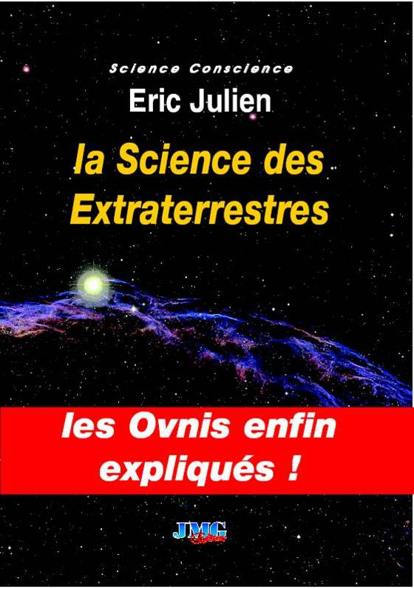
TO LEARN MORE ...
A major book on Ufology: The Science of the Extraterrestrials, by Eric Julien, published July 2005 through JMG Editions (450 pages) ISBN 2-915164-57-6, presents a "theory of the whole" concretely explaining the scientific, paranormal, and Ufological mysteries in a language that is accessible, direct, and abundantly illustrated (more than 140 figures). Its philosophical reach is incalculable and it provides answers to paranormal questions that if correct, according to French Physicist Dr Michel Carmassi, deserve the Nobel Prize in Physics.

